

Modul Profile Manager

MicroStep HDO s.r.o

July 2025

Pracovné postupy

Content

Content 5

1. Profile Manager Application 11

1.1. How to sign up for the application 11

1.2. Top menu bar of the application 12

1.3. Color change of the top bar application 16

1.4. To add on the surface of the window an explorer, table and graph 16

1.4.1. Window naming regulations 17

1.5. I want to log out of the application 18

1.6. Change language version 19

1.7. How to change default settings 19

1.8. To show the profile of the logged-in user 20

1.9. Global date range 21

1.9.1. I want to apply a date filter in the selected window 22

1.9.2. I'm trying to apply date filters across all windows but it's not working 23

1.10. If I could restore visible data 23

1.11. General settings 23

1.11.1. Global general settings 24

1.11.2. General settings for table 28

1.11.3. General settings for graph 31

1.11.4. General settings for the inspector 33

1.12. Christmas preparations 35

1.12.1. How to create a profile for Christmas 35

1.12.2. How to choose a profile for New Year's Eve 39

1.12.3. To remove the profile for holidays 40

1.13. I would like to display information about my status 40

1.14. I will display notifications 41

1.15. I will expand the window of the tree structure 42

1.16. Panel synchronization 44

1.16.1. To synchronize time ranges 44

1.16.2. I synchronize tables 45

1.16.3. Synchronize graphs 47

1.17. To import, export and store stocks 47

1.17.1. I'll assemble an import 48

1.17.2. To compile and export a report 50

1.17.3. I will update the roster 50

1.17.4. I'll create a new lineup 52

1.17.5. How to arrange a committee into columns 54

1.17.6. To gather a team into rows. 56

1.17.7. I want to collect everything into one dashboard 58

1.17.8. How to split the roster into separate panels 58

1.17.9. [OLLAMA FORMATTING ERROR - MANUAL REVIEW NEEDED] Ako nastaviť globálny časový rozsah pri zobrazení zostavy 59

1.17.10. [OLLAMA FORMATTING ERROR - MANUAL REVIEW NEEDED] Ako zatvoriť zostavu 61

1.18. [OLLAMA FORMATTING ERROR - MANUAL REVIEW NEEDED] Ako horizontálne zarovnať okná 62

1.19. To vertically install windows 63

1.20. [OLLAMA FORMATTING ERROR - MANUAL REVIEW NEEDED] Ako zobraziť a stiahnuť exporty 64

1.21. How to display imports 65

1.22. Keyboard shortcuts 67

1.23. How to find a profile in the application 71

1.24. User notification about deregistration 71

1.25. [OLLAMA FORMATTING ERROR - MANUAL REVIEW NEEDED] Ako zobraziť čas, ktorý ostáva užívateľovi do odhlásenia 72

2. Work with directories and profiles 76

2.1. Add new folder 76

2.2. How to rename a folder 78

2.3. How to edit an address book 79

2.4. I want to empty my address book. 80

2.5. I will copy an address book 80

2.6. I need to pull out/ move a folder. 81

2.7. Upload a file 81

2.8. To erase profile data 83

2.9. I filter through address books and profiles 86

2.10. To disable the address and profile filters 87

2.11. Show comments 87

2.12. How to show tooltip 88

2.13. To display character 90

2.14. If I could restore the list 91

2.15. To set up user and group rights 91

2.16. How to create an export 96

2.17. How to create an import 100

2.18. Add a new profile 103

2.18.1. What is the definition for a counted profile type? 107

2.19. To add a new team. 114

2.20. How to change the profile 115

2.21. Edit my profile 115

2.22. To delete profile 116

2.23. To view dependency profile 116

2.24. How to create a new profile 118

2.25. How to set up a political profile 118

2.26. Show information about profile 120

2.27. Copy profile 121

2.28. To pull out/shift profile 123

2.29. How to display timeline overview in tree structure 125

2.30. If I enlarge the window for creating and editing the counted profile 125

2.31. I want to move the windows 126

2.32. How to convert a document 126

3. Shared controlling elements for explorer, table and graph 127

3.1. How to refresh data in windows 127

3.2. Change date range 127

3.3. If I enlarge the window across the entire application area 128

3.4. If I were to close the window 129

3.5. Setting name and color of panel 129

3.6. Export shown data from Explorer window 131

3.7. To hide the top panel with buttons on the explorer window, table and graph 131

3.8. To add profile to graph and table 132

4. Work with an office Inspector 134

4.1. To show profiles from selected recipient in the Explorer window 134

4.2. How to create a new folder 134

4.3. I synchronize the scanner with the tree 134

4.4. I am filtering profiles 135

4.5. Sort data in columns 136

4.6. How to calculate values in columns Min, Max, Sum, Avg and Count in the Explorer window. 136

4.7. A glance into time's sequence. 137

4.8. Move profile from Explorer window into Graph or Table window 140

4.9. How to add, remove or modify columns in the Explorer window 141

4.10. Edit fields Name and Comment 143

4.11. Functions for working with address books in the Explorer window 143

4.12. Functions for work with filters on window Explorer 144

4.13. Branch View Button 145

4.14. How to show deleted items in the Explorer window 147

4.15. I will copy displayed data. 148

4.16. Use as starting setting Explorer 150

4.17. As I filter through columns using the * wildcard 151

5. Work with forms 154

5.1. I want to show my profile in the graph 154

5.2. How to display an information window with values for a specific location in the graph 155

5.3. I would like to change the date range in the graph. 157

5.4. Save graph as JPG 157

5.5. I want to copy the entire graph into a new window 157

5.6. To set graph parameters 158

5.6.1. How to set decimal places for each of the Y axes 160

5.6.2. [OLLAMA FORMATTING ERROR - MANUAL REVIEW NEEDED] Ako vypnúť vodorovné čiary 161

5.7. Functions for work with designated profiles 163

5.7.1. How to pick profiles 164

5.7.2. Show profile properties 164

5.7.3. How do I change the settings marked 165

5.7.4. If I mark all profiles 167

5.7.5. I will mark all profiles 168

5.7.6. I'm going to invert these marked profiles 169

5.7.7. Show only marked profiles 170

5.7.8. Don't show marked profiles 170

5.7.9. If I remove the marked, all or faulty profiles 171

5.7.10. To set the coefficient by designated profile 172

5.7.11. How to set an offset 174

5.7.12. How to display statistical lines 175

5.7.13. As replace the text marked 177

5.8. Functions for work with one profile 178

5.8.1. Adjust settings 179

5.8.2. To remove the profile 181

5.8.3. I'll forward my profile to the beginning 182

5.8.4. To move the profile up 183

5.8.5. Move profile down 184

5.8.6. I'll shut down my profile at the end. 184

5.8.7. To show comments 185

5.8.8. How to find the first value 186

5.8.9. I need to find the last value 187

5.8.10. How to display subprofiles 188

5.8.11. I will open my profile settings 189

5.8.12. Open information window 190

5.8.13. How to set the coefficient 192

5.8.14. What is the offset? 193

5.8.15. To change profile 196

5.8.16. Edit my profile 197

5.8.17. How to set color for profile 199

5.8.18. How to set point size 200

5.8.19. To show profile in table 204

5.9. Rapid change of graph type 206

5.10. To approximate a selected part of the graph 208

5.11. I'm taking a graph 209

5.12. Can I cancel the meeting? 210

5.13. Show/hide legend 210

5.14. Show/hide tooltip 211

5.15. I'll set up the y-axis so that you can see the values 212

5.16. I want to change my profile 214

6. Work with a blackboard 218

6.1. Show profile in table 218

6.2. How to set up column display 219

6.3. To switch to single-profile display 220

6.4. Change time display format 222

6.5. How to set up columns 222

6.6. How to select a method of transmission 224

6.7. Show the first value 225

6.8. Show last value 225

6.9. How to show today's date 225

6.10. How to display a specific date 226

6.11. As of yesterday, last week, last month 227

6.12. Add column Sum, Average, Min, Max 228

6.13. To turn on/off a tooltip 229

6.14. How to turn on/off line highlighting 230

6.15. To correct the value of the profile in the table. 237

6.16. Change profile definition 238

6.17. I will remove my profile from the table. 239

6.18. How to enable automatic column width adjustment 239

6.19. How to open account profile 240

6.20. Add profile 241

6.21. Export the displayed data to CSV 244

6.22. I want to change the definition 245

6.23. Change profile metadata 245

6.24. Remove profile from view 247

6.25. Show profile in graph 248

6.26. How to find my position on the graph 249

6.27. How to open the profile in steam 250

6.28. Mark the block using the left mouse button 250

6.29. If I set it up so that the cursor would move around the table using the mouse wheel 251

6.30. How to change the order of profiles in the table 253

7. Arithmetic counted profiles 256

7.1. Regulations on Preemptive Measures 256

7.1.1. The rules of transferring the entry profile to the output with consideration of character 256

7.2. Calculated profile 257

7.2.1. Method of writing expression 259

7.2.2. Calculation of the expression 259

7.2.3. Arithmetic operations: 260

7.2.4. Functions 260

8. Additional/complementary functions 271

8.1. Monitoring profiles 271

8.1.1. How to create a new monitoring job 271

8.1.2. [OLLAMA FORMATTING ERROR - MANUAL REVIEW NEEDED] Ako editovať job v JMW 277

8.1.3. [OLLAMA FORMATTING ERROR - MANUAL REVIEW NEEDED] Ako zmazať job 278

8.1.4. [OLLAMA FORMATTING ERROR - MANUAL REVIEW NEEDED] Ako exportovať monitorovacie joby a výsledky jobov 279

8.1.5. Show all monitoring jobs 279

8.1.6. How to refresh the list of jobs in the 'Monitoring' window 279

8.1.7. How to display a preview of monitoring job results 279

8.2. Profile Analysis 280

8.2.1. How to create profile analysis 280

8.2.2. To display an existing profile analysis 284

8.2.3. How to change the validity of the created profile analysis 285

8.2.4. Export shown data from analysis profiles 286

8.3. Report Manager 287

8.3.1. How to create a new report 287

8.3.2. Rights for Report Manager 293

8.4. If I restore deleted items from the basket 294

# Profile Manager Application

The 'Profile Manager' application is a tool used for the presentation of profiles (time series) in graphical or tabular form, as well as their basic management. A profile is an unbounded sequence of values of varying significance. Documentation applies to version 4.3.301.

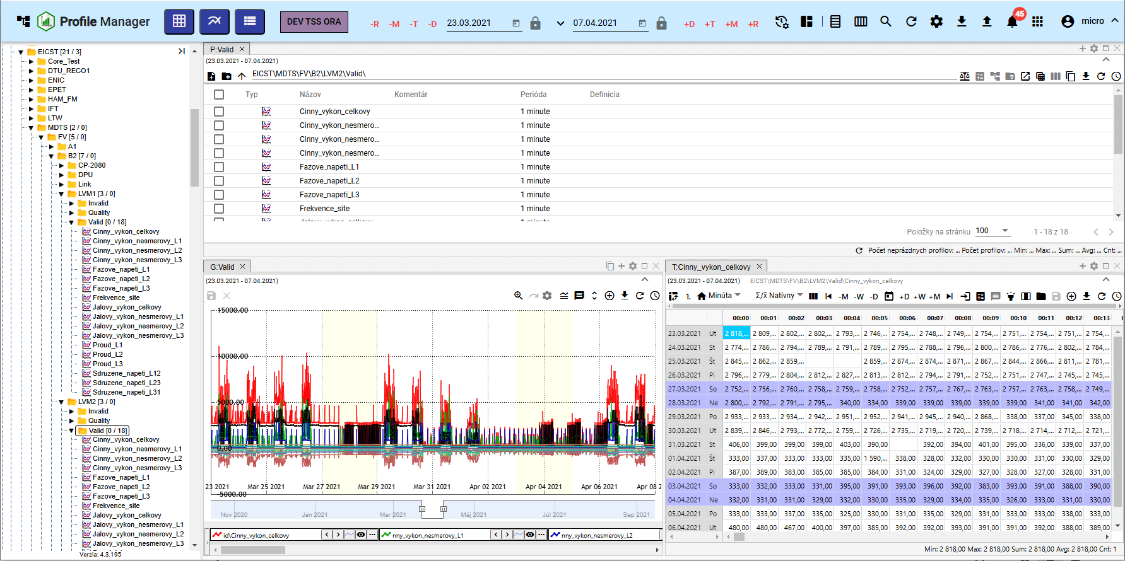

Image 1: Profile Manager Application

## How to sign up for the application

**[TRANSLATION FAILED AFTER 3 RETRIES] Pri spustení aplikácie „Profile Manager“ sa zobrazí prihlasovacia obrazovka. Je potrebné zadať prihlasovacie meno a heslo. Zakliknutie checkboxu „Zapamätať“ spôsobí, že pri ďalšom prihlásení nie je potrebné znova zadávať prihlasovacie údaje. Aplikácia si ich zapamätá. Pre prihlásenie stlačte tlačidlo „Prihlásiť sa“.**

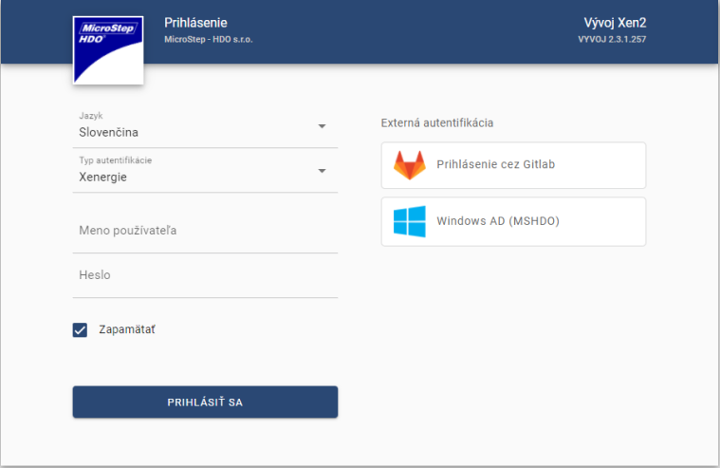

Picture 2: Registration into the application 'Profile Manager'

## Top menu bar of the application

In top navigation bar, there is:

* button that allows minimizing and maximizing the application's menu

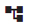

Image 3: Button for hiding and displaying application menu

* The name of the application is “Profile Manager” – upon pressing a button, the “Profile Manager” application reloads itself again.

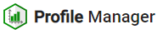

Picture 4: Button "Profile Manager"

* Button 'Add table' - by moving the button to the screen, the window 'Table' will be added.

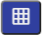

Picture 5: Add table button

* Button 'Add graph' - serves to add the window 'Graph' on the application surface.



Picture 6: Add Graph Button

* Button 'Add Explorer' - by moving the button to the application screen you will add a window 'Explorer'.



Picture 7: Add Scout Button

* The button representing the name of the environment - for the button it is possible to set up text as well as color.



Image 8: Environment Name

* Global date range - represents a date filter, chapter 1.9



Image 9: Global Date Range

* The button "Sync Panels" – allows to synchronize time ranges (1.16.1) and sync tables (1.16.2).



Picture 10: Synchronization Panel Button

* download and import buttons - procedures are elaborated in chapter 1.17



Picture 11: Stay Button

* button for profile search - the description of profile searching is written in chapter 1.23



Picture 12: Button for searching profile

* The 'Restore visible data' button - serves for the recovery of data in an application, chapter 1.10



Image 13: Refresh visible data button

* Button 'Export' – contains list of exports, chapter 1.20.



Picture 14: Export button

* The "Import" button – contains an import list, chapter 1.21.



Picture 15: Import Button

* The "Warnings" button signals performed changes to the application, chapter 1.14



Picture 16: Warning button

* Button to view application list. The list of applications for this environment is here. After clicking on an application in the list, it will open in a new tab of the browser.



Image 17: Button for viewing application list

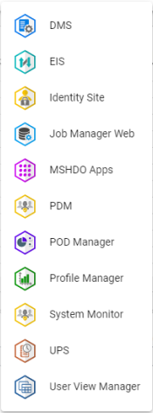

Picture 18: List of applications

* A button with the name of a registered user that allows:
  + Language version menu, Chapter 1.6,
  + Restore preselected settings, chapter 1.7,
  + Display keyboard shortcuts,
  + Profile display, 1.8,
  + Display of application and service status information, Chapter 1.13,
  + **[TRANSLATION FAILED AFTER 3 RETRIES] odhlásenie z aplikácie, kapitola 1.5.**

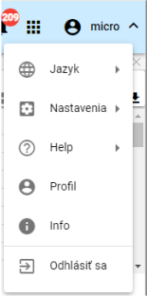

Image 19: Button with the name of the registered user

* The 'Hide Upper Tool Rail' button serves to hide the upper rail. Subsequently, the appearance of the button changes and it is used to display the upper tool bar, Fig. 21.

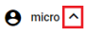

Image 20: Toggle "Hide upper tool bar"

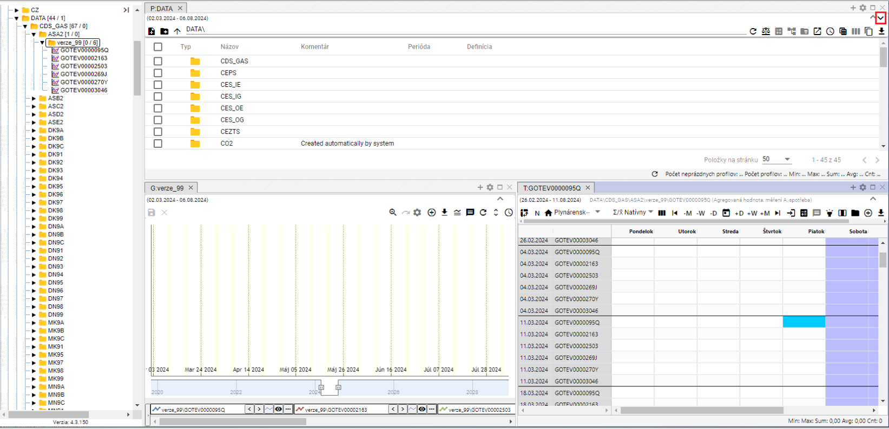

Picture 21: Button for showing upper tool strip



Picture 22: Top bar of the application

## Color change of the top bar application

The customer can request a color change of the top strip of tools. Changing the color of the top strip serves to distinguish the Developmental, Testing and Production Environment.



Picture 23: Top bar of application

## To add on the surface of the window an explorer, table and graph

Windows Explorer, table and graph can be added in any quantity to the surface of the application 'Profile Manager'. Proceed:

1. Click on the left mouse button and drag it onto the application icon.
2. Hold the button above the flat surface and slide to where you want to add a window.
3. Choose a shape that the window should have.

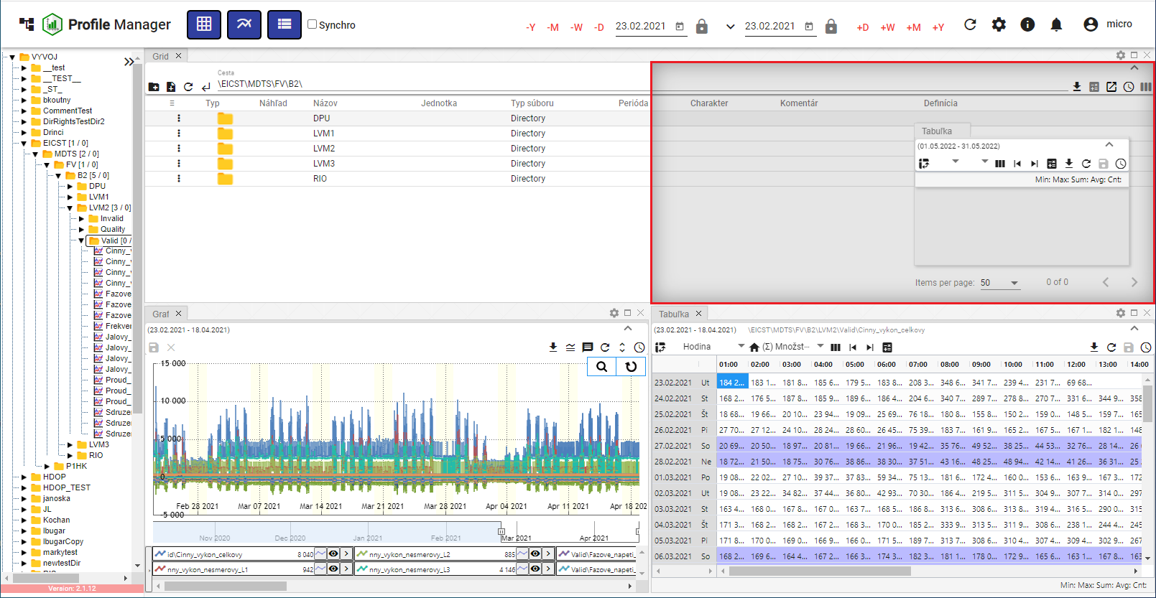

Picture 24: Selection of window shape and placement

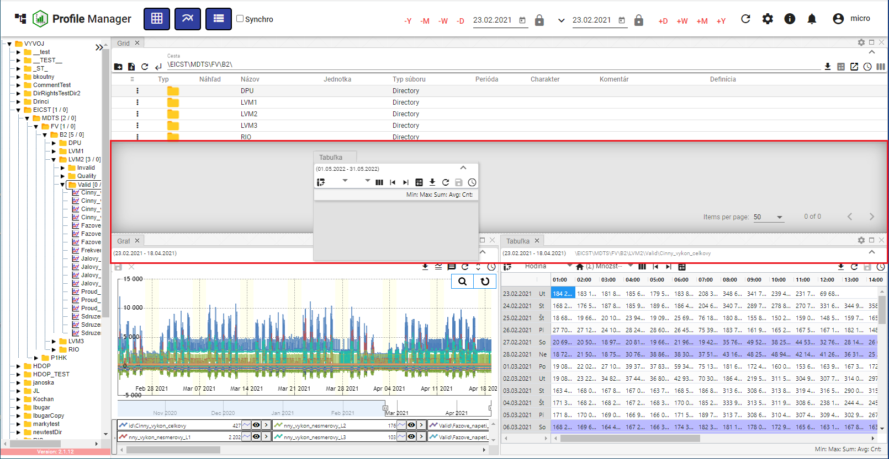

Picture 25: Shape and arrangement of window table

1. Clicking on the button will add a window at the chosen location.

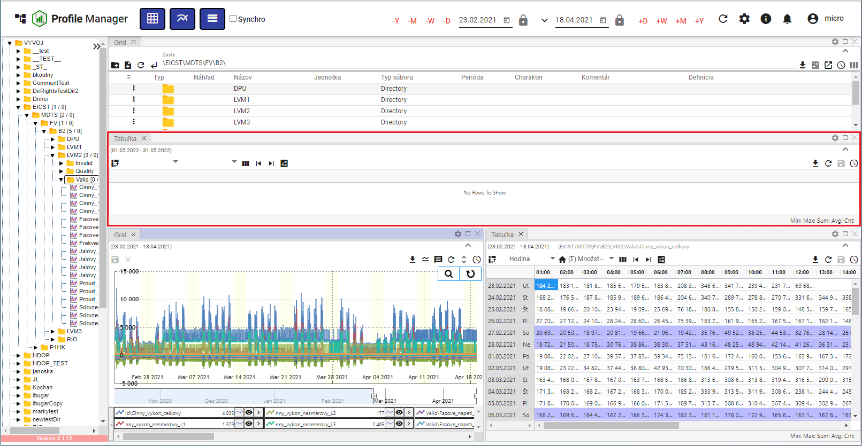

Picture 26: Added taboo table window

### Window naming regulations

The Explorer, Graph and Table windows are automatically named according to the following rules:

Table

The name for the table is 'T: <name of first profile in the table>'.

Example: 'T:ProfilHPFC'.

Graph

The name for the graph is "G: <name of first profile in the graph>"."

Example: "G:Profile HPFC".

Explorer

The name of the probe in Slovak and Czech is “P: <name of addressee to whom I am>”.

Example: "P: Address TEST".

In case of an addresser being root, there will be a word "P:Root".

In English, the explorer has the name "E: <the name of the recipient whom I am talking to>."

Example: "E:\Address TEST".

In case of a root recipient there will be the word "E:Root"

Branch explorer - View of branches

The explorer - Branch view has the name "B: <name of the recipient in which the branch view was started>".

Example: “B:\AdresářTEST”. In the case of a root recipient, the name will be “B:\Root”.

At each change of profiles or addresses, the corresponding window name will be adjusted. If the user enters the window title using the button, from now on, automatic setting will be turned off and will no longer apply.

## I want to log out of the application

Press the user's login button to logout from the application. A window will appear where you press 'Log out'.

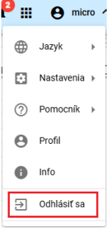

Image 27: Item "Log out"

## Change language version

Before changing the language version, click on the button with the name of the registered user and then position the cursor of the mouse on the item 'Language'. In the displayed window, select the desired language version.

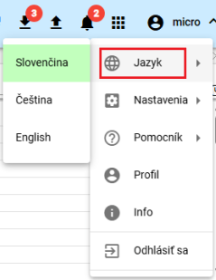

Image 28: Change of language version

## How to change default settings

Default settings in the 'Profile Manager' application can be reset as follows:

1. Press the button with the name of the registered user.
2. Use the mouse pointer to navigate to the "Settings" point.
3. Press the button "Set up Default Settings".

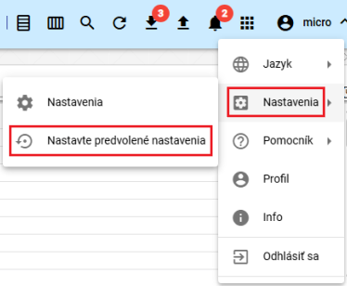

Image 29: Settings item

1. A window will appear for confirmation, where you click the "Yes" button.

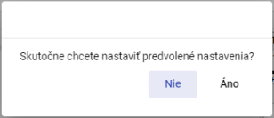

Image 30: Confirmation for adjusting preset settings

## To show the profile of the logged-in user

Show profile of logged-in user:

1. Click on the button with the name of the registered user.
2. Click on the item "Profile".

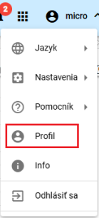

[TRANSLATION FAILED AFTER 3 RETRIES] Obrázok 31: Položka „Profil“

1. In the browser's new bookmark, the user profile from the 'IdentitySite' application will be displayed.

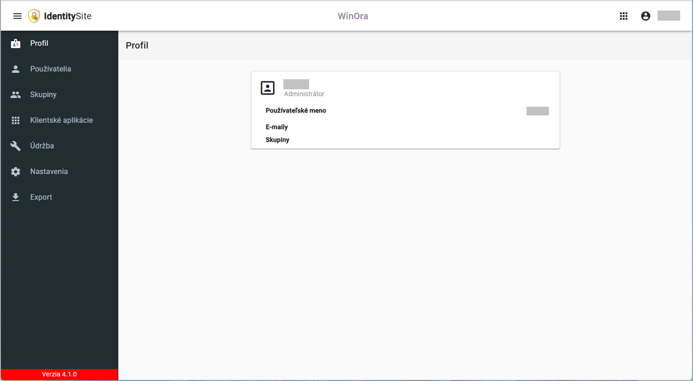

Photo 32: Profile of a logged-in user in the "IdentitySite" application.

## Global date range

The standard date filter is set to the current date.



Image 33: Global Date Range

Click on the button to display the default date range options, Figure 34.

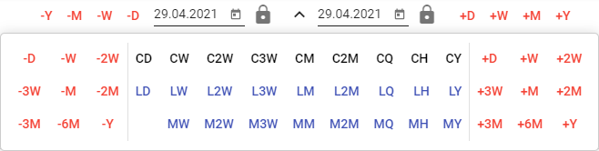

Picture 34: Date Range Presets

You can lock dates. When changing the date range, a locked date will not change.



Picture 35: Locking date

### I want to apply a date filter in the selected window

The date range in the application's top bar is linked to the designated window. If the date range in the designated window changes, it will also change in the application's top bar. If the date range in the application's top bar changes, it will be applied to the designated window.

Follow:

1. Mark the window where you want to apply the filter by clicking on the top part of the window, Picture 36.

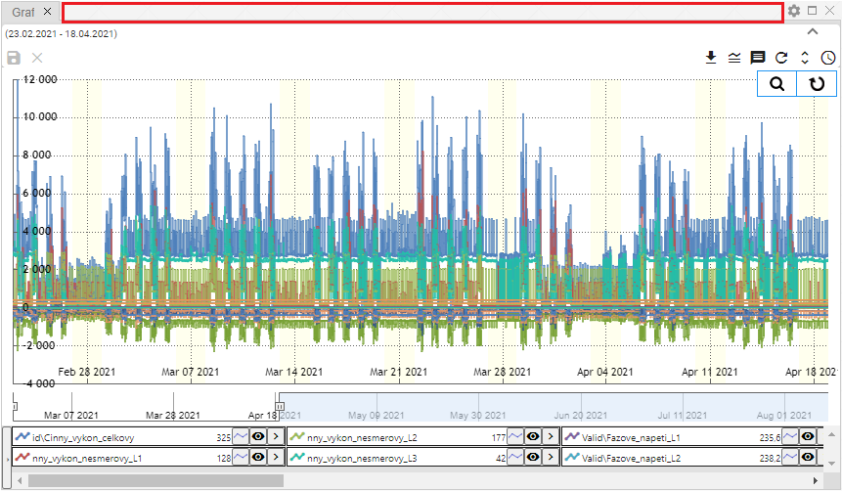

Picture 36: Place for window marking

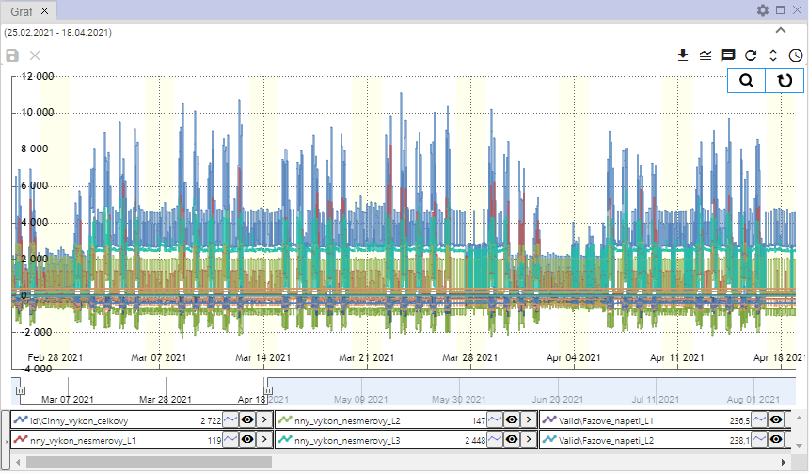

Image 37: Selected window for filtering

1. In the top ribbon, select date filter.



Image 38: Global Time Range

1. Data will be displayed in the specified window according to the selected date filter.

### I'm trying to apply date filters across all windows but it's not working

Proceed:

1. Click on the "Sync" checkbox.



Image 39: Checkbox "Sync"

1. Select one of the Explorer, Table or Graph windows by clicking on the top part of the window, Figure 36 and Figure 37.
2. Then enter the date filter in the top list of the application.



Image 40: Global Time Span

1. The date filter is applied to all windows in the application.

## If I could restore visible data

Before restoring the data in the 'Profile Manager' application, click on the 'Restore visible data' button located at the top of the application window.



Picture 41: Refresh visible data button

## General settings

The "General" tab in the "Settings" window is split into parts.

* Global settings for the application "Profile Manager",
* Table – general settings for table,
* Graph – general settings for graph,
* Surveyor - general settings for surveyor.

Individual settings are listed in the following subchapters.

### Global general settings

#### How to enable automatic refresh after profile modification

If you want to restore data after backup, follow:

1. Click the "logged in user" button at the top menu bar of the application. Using your mouse cursor, navigate to the "Settings" option and click on it within the appearing window.

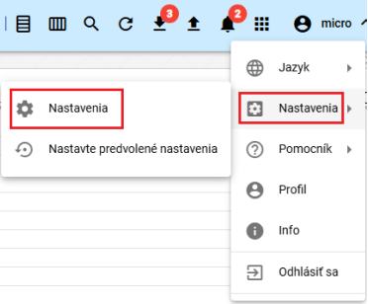

Picture 42: Item "Settings""

1. A settings window will appear.
2. In the part 'General', click on the option 'Restore shown data after saving'.

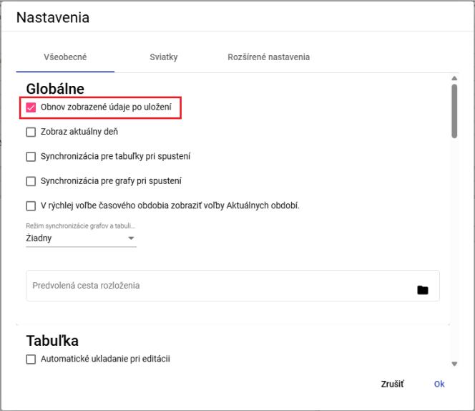

Image 43: Item "Restore displayed data after saving"

1. Save changes by pressing the "OK" button.

#### I would like to display new windows on today's date.

If you want the Explorer, Table and Graph windows to display in today's date, proceed:

1. In the window “Settings” in the tab “General” in the part “Global”, click on the field “Show current date”, Image 43.
2. Press the "OK" button to save changes.

#### Set time for calendar

If you want to synchronize time for tables, proceed:

1. In the 'Settings' window in the 'General' section of the 'Global' part, click the field 'Sync tables on startup', Image 43.
2. Changes will be saved by pressing the "OK" button.
3. Next, restart the application.
4. When you click on the field "Sync for tables at startup", the button "Sync tables" will also be clicked, 1.16.2.

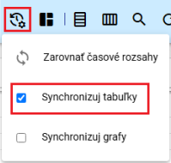

Picture 44: Column "Sync tables"

1. In the window table, the text 'SYNC' will be displayed.

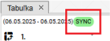

Picture 45: In the table will be displayed the text "SYNC"

#### Synchronize time for graphs

If you want to synchronize time for tables, proceed:

1. Click the 'Synchronization for graphs on startup' field in the 'Global' section of the 'General' tab in the 'Settings' window shown as Figure 43.
2. Changes will be saved by pressing the 'OK' button.
3. Restart the application afterwards.
4. When you click on the field "Synchronization for graphs at startup" the button "Synchronize graphs" will also be clicked, 1.16.3

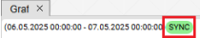

Picture 46: In the graph, the text "SYNC" will be displayed

#### How to turn on synchronization between chart and table

To enable synchronization between the graph and the table, proceed as follows:

1. In the "Settings" window in the "General" section of the "Global" tab, select an item from the "Sync graphs and tables regime" field. You can choose:
   1. Any synchronization between the chart and table is turned off,
   2. The start - synchronizes with the beginning of the graph,
   3. Centers - synchronized with graph center.

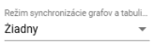

Picture 47: Regime of synchronization of graphs and tables

1. Changes will be saved by pressing the 'OK' button.
2. Restart the application afterwards.

#### How to quickly show elections of the current periods

In the rapid choice of time period, AR, AM, AT, AD elections will appear instead of +R, +M, +T, +D. Instead of -R, -M, -T, -D, MR, MM, MT, MD will appear.

Follow instructions:

1. Click on the field 'Display elections of actual periods in fast choice time range'.
2. Save changes by pressing the "OK" button in the "Settings" window.
3. Restart the application. Then, changes made in the application will be reflected.



Picture 48: Rapid time choice period

#### If I were to set up the path to the pre-arranged distribution

The "Default layout path" pole is used to set the path for the saved Profile Manager application layout. Each time the Profile Manager application is opened, it will display the previously set layout.

Proceed

1. In the 'Settings' window, in the 'General' tab of the 'Global' section, enter a path to your saved layout or click on the button , which will display the 'Layout Selection' window, where you can search for the saved layout.

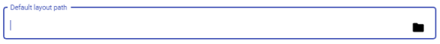

Image 49: Pole "Default layout path"

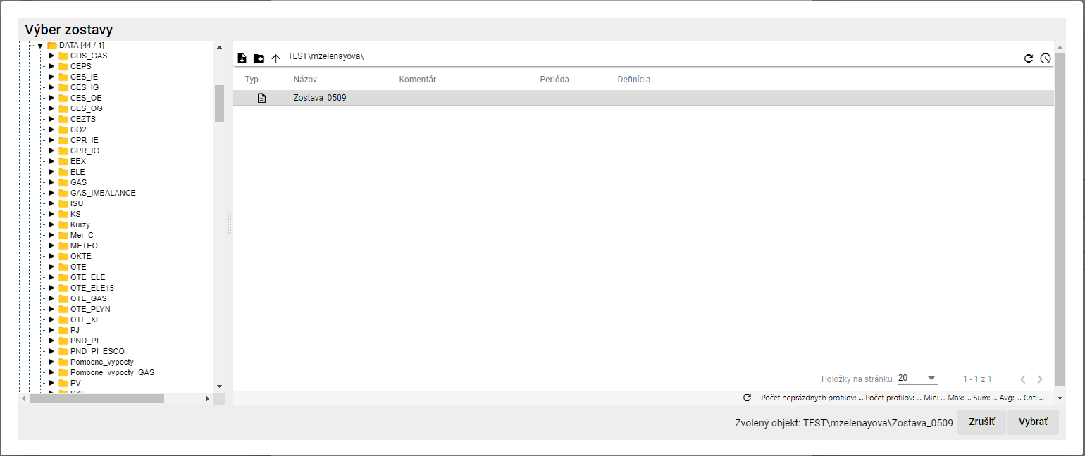

Picture 50: Team selection

1. In the window "Team selection", click on the button "Select".
2. In the 'Default Layout Path', you will find the path to your selected ensemble.



The Picture 51: Selected Squad

1. Before saving changes, click on the 'Settings' window button labeled 'OK'.

### General settings for table

#### How to set up automatic saving changes in a table

By setting up automatic saving in the table, changes made to the table are saved immediately. Proceed:

1. In the window "Settings" in the tab "General" in the section "Table", click on "Automatic saving when editing".

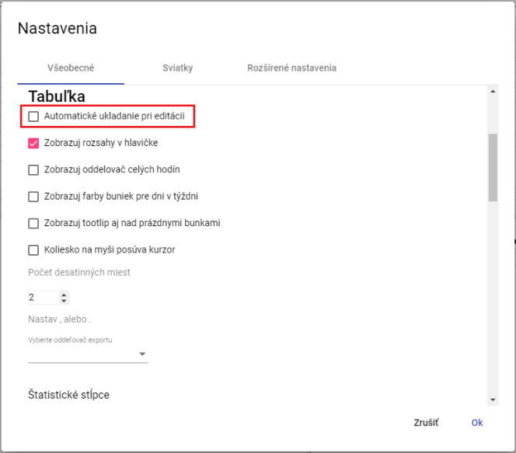

Image 52: Settings for table

1. Save changes by pressing the "OK" button.

#### Show ranges in header for table

You set up the header for the tab window:

1. In the 'Settings' window in the 'General' tab of the 'Table' section, click 'Show header widths', Image 52.
2. Save changes by pressing the "OK" button.

#### How do I set up hour separator for table

Display of separator for all hours in tab window is set:

1. In the 'Settings' window in the 'General' tab of the 'Table' section, click 'Show hour separators', Figure 52.
2. Save changes by pressing the "OK" button.

#### How to set up color display for days of the week on a table

Setting up display of bra colors for days of the week.

1. In the 'Settings' tab in the 'General' bookmark of the 'Table' part, click 'Show cell colors for days in a week', Image 52.
2. Press the "OK" button to save changes.

#### I want to display tooltips also above empty cells in a table.

Before setting up tooltips for display over empty cells in the table, proceed:

1. In the 'Settings' window, in the 'General' tab of the 'Table', click on 'Show tooltip also above empty cells', Picture 52.
2. Save changes by pressing the "OK" button.

#### How to set up so that the wheel on the mouse moves the cursor.

Moving the cursor with mouse wheel is set up:

1. Click on 'Wheel to move the mouse cursor' in the 'Settings' tab in the 'Table' section of the 'General' bookmark.
2. Save changes by pressing the "OK" button.

#### How to set decimal places in the table

Before setting the decimal places in the tab for Window Tabuľka proceed:

1. In the 'Settings' tab in the 'General' section of the 'Table', set the item 'Decimal places', Figure 52.
2. Save changes by pressing the "OK" button.

#### How to set up an exporter separator for the table

Before setting up the exporter for table follow:

1. In the "Settings" window in the "General" tab in the "Table" section of the "Select export delimiter" field, select a delimiter.
2. Press the "OK" button to save changes.

#### How to reset used statistical columns in a table

Before setting which statistical columns will be used in the table, proceed:

1. In the 'Settings' tab in the 'General' section of the 'Table' part, select the statistical columns to be used. You can choose the Sum, Average, Min, and Max columns.

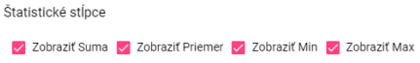

Image 53: Statistical columns

1. Save changes by pressing the 'OK' button.

#### To attach on the right

Adjusting alignment to the right in the table, proceed:

1. Click the 'Show attachment on the right' field in the 'Table' section, in the 'General' tab, in the 'Settings' window.



Image 54: Item "Show attachment on right"

1. Save changes by pressing the "OK" button.

#### How to set default column widths of a table

Before setting the default column width of the table, proceed:

1. If you want to set the default values for column widths, click on the "Use default values" field located in the "General" tab of the "Table" section in the "Settings" window.

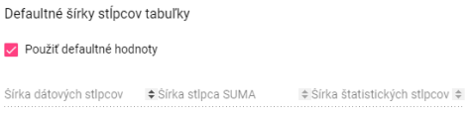

Picture 55: Item "Use default values"

1. If you want to set up your own values for column widths, leave the "Use default values" field unchecked. This will enable fields for setting column widths.

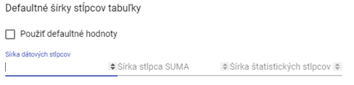

Picture 56: Assigning own values for column widths

1. Enter column width and click OK.

### General settings for graph

#### How to set up standard line type for graph

The standard type of graph line can be "Line" or "Step Line". To set the standard type of line, follow:

1. In the 'Settings' window, in the 'General' tab of the 'Graph' section, you can select a standard line type.
2. By clicking on the field "Default line type", you can select the item "Line" or "Dashed line".

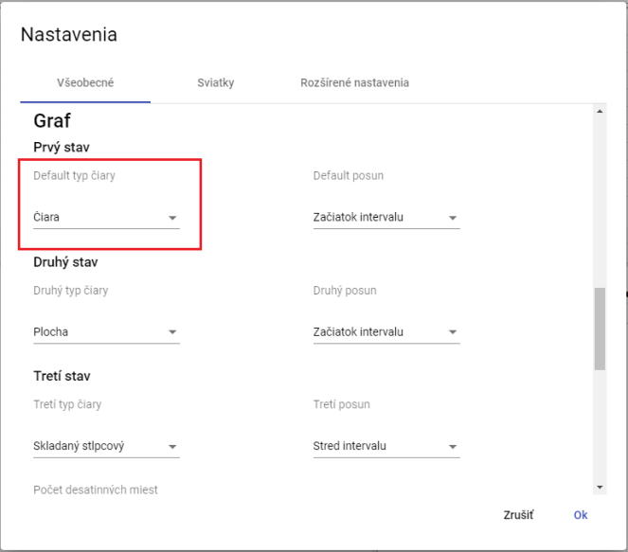

Image 57: Selection of standard line type for graph

1. Changes will be saved by pressing the 'OK' button.

#### To set up the second and third line type for graph

Before setting up the second and third types of line proceed:

1. In the 'Settings' window in the 'General' tab of the 'Graph' section, click on the field 'Second line type', which will display a window where you select the line type.
2. Click on the field 'Third line type' before choosing the third type of line. This will show you a window in which you can choose the line type.
3. Save changes by pressing the "OK" button.

#### To set standard shift, second and third shifts for graph

Proceed:

1. Click in the field 'Default offset' in the tab 'General' in the section 'Graph' on the button 'Settings' and select one of the displayed options.
2. In the country 'Second Spring' choose the item for the second spring.
3. In the game "Third move" choose the item for the third move.
4. Save changes by pressing the "OK" button.

#### How to set decimal places for graph

Follow instructions:

1. In the 'Settings' window, in the 'General' tab of the 'Graph' section, enter the number of decimal places.
2. Save changes by pressing the 'OK' button.

#### Set up date of line start for graph display

Follow directions:

1. Click on the field 'Show start date of line' in the tab 'General' in the section 'Graph' in the bookmark 'Settings'.
2. Save changes by pressing the "OK" button.

#### What is the current time

Proceed:

1. Click the field 'Show current time' in the corner of 'General' section, in the tab 'Graph', in the menu item 'Settings'.
2. Save changes by pressing the "OK" button.

#### To zoom out, press the button on the left

The "zoom" function serves to zoom in on a selected location in the graph. The "zoom out" function will cause the selected location in the graph to move further away. To zoom in on a specific location in the graph, click the left mouse button into the graph and mark the location in the graph by dragging from left to right with the cursor. If you want to zoom out of a location in the graph, proceed in the opposite direction, marking the location in the graph from right down towards up-left.

Proceed:

1. Click the field "Zoom out by marking to the left" in the tab "General" in the section "Graph" in the bookmark "Settings".
2. Save changes by pressing the 'OK' button.

#### To enable automatic switching to slide on approach

The box 'Switch to pan on zoom' means that if you click the 'Zoom in' button in the graph window, it will automatically switch to panning after zooming into a selected area. If the 'Switch to pan on zoom' checkbox is not clicked, clicking the 'zoom' function will start the zoom until you stop it.

Proceed:

1. Click on the 'Settings' window in the 'General' tab of the 'Chart' section and select the box 'Automatically switch to Pan when zooming'.
2. Changes will be saved by pressing the 'OK' button.

### General settings for the inspector

#### How do I set decimal places in the Windows Explorer

Before statistics in the window Explorer you can set the number of decimal places according to the following procedure:

1. In the 'Settings' window in the 'General' tab at the bottom of the 'Settings' window in the 'Sniffer' section, set the decimal places number.

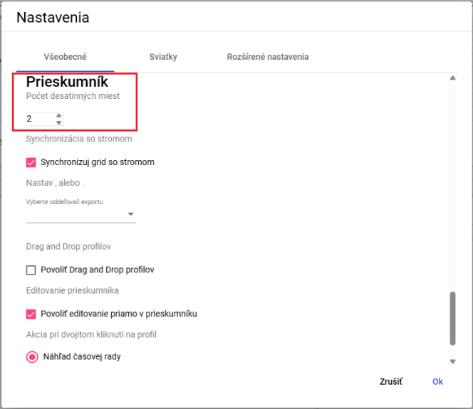

Image 58: Task to count decimal places in the browser window

1. Changes will be saved by pressing the 'OK' button.
2. In the Explorer window, statistics will be displayed with the specified number of decimal places.

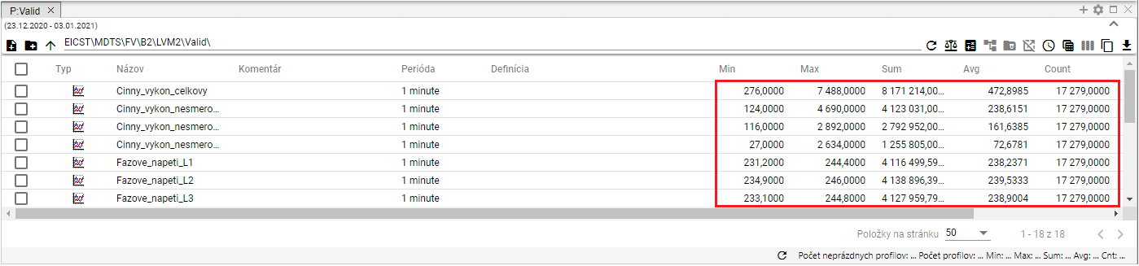

Image 59: Selected decimal places in the Settings window

#### I will synchronize the Explorer window with the tree

Before synchronizing the probe with the tree, proceed:

1. In the lower part of the window 'Settings' in the tab 'General' in the section 'Explorer', click on the field 'Synchronize grid with tree'.
2. Press the "OK" button to save changes.

#### How to set up an exporter separator for a crawler.

Before setting up an exporter for the profiler, proceed with:

1. In the lower part of the window 'Settings' in the tab 'General' in the part 'Explorer', the field 'Select Export Separator' is located, in which you can choose either a point or an underscore as the separator.
2. Press the "OK" button to save changes.

#### Allow functional drag-and-drop for profiles

Before allowing the function of “drag and drop profiles”, proceed:

1. Click the 'Drag and drop profiles' field in the bottom part of the window 'Settings', under the tab 'General', in the section 'Inspector'.
2. Save changes by pressing the 'OK' button.

#### Allow editing directly in the Explorer window

The item 'Allow editing directly in the inspector' is standardly active. It allows for adjusting the fields 'Name', 'Comment', and 'Definition' directly within the Inspector window.

Before disabling function, proceed:

1. Disable the "Allow editing directly in inspector" option.
2. Save changes by pressing the "OK" button.

#### How to take an action on double-clicking on profile

After double-clicking on a profile you can select an action to start. Proceed:

1. In the lower part of the window 'Settings' in the tab 'General' in the section 'Explorer', select one of three actions.

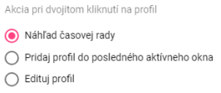

Image 60: Select stock for double-clicking on profile

1. Press the "OK" button to save changes.

## Christmas preparations

### How to create a profile for Christmas

The holiday profile allows viewing of holidays in all profiles. To create a holiday, you need to have created a holiday profile, Figure 61, where on the days when there is a holiday you enter the value 1 and on the days when there isn't, you enter NaN. Create your holiday profile with a period of DAY.

**[TRANSLATION FAILED AFTER 3 RETRIES] Výhodou sviatkového profilu je, že sami rozhodujete, ktoré sviatky chcete zobraziť – slovenské alebo z inej krajiny, alebo z viacerých krajín naraz. Vytvorený sviatkový profil môže byť zdieľaný aj pre iné aplikácie.**

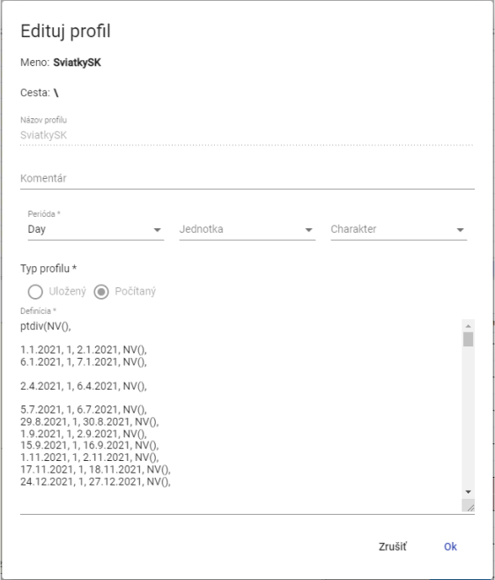

Picture 61: Example of definition of a festive profile

You will create a profile for Christmas.

1. Click the "Registered User" button, located at the top menu bar of the application. Move your mouse cursor to the item "Settings", and in the displayed window click on the item "Settings", Figure 42.
2. A window titled 'Settings' will be displayed, where you click on the tab 'Holidays'.

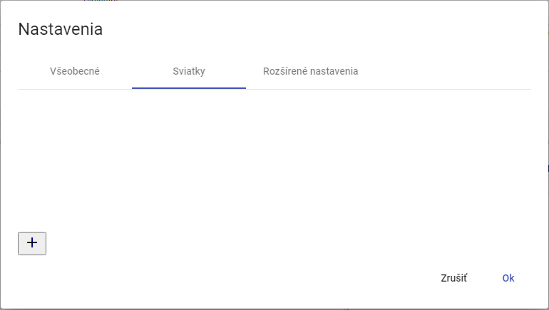

Picture 62: The tab "Christmas"

1. Click the button for creating a profile.

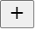

Image 63: Button for creating profile

1. A window 'Festivals' will appear, which is used to create a profile.

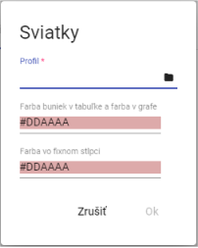

Image 64: Profile creation

1. In the "Profile" menu, enter your profile or press the select-profile button.
2. After pressing the button, a window for selecting a profile will appear.

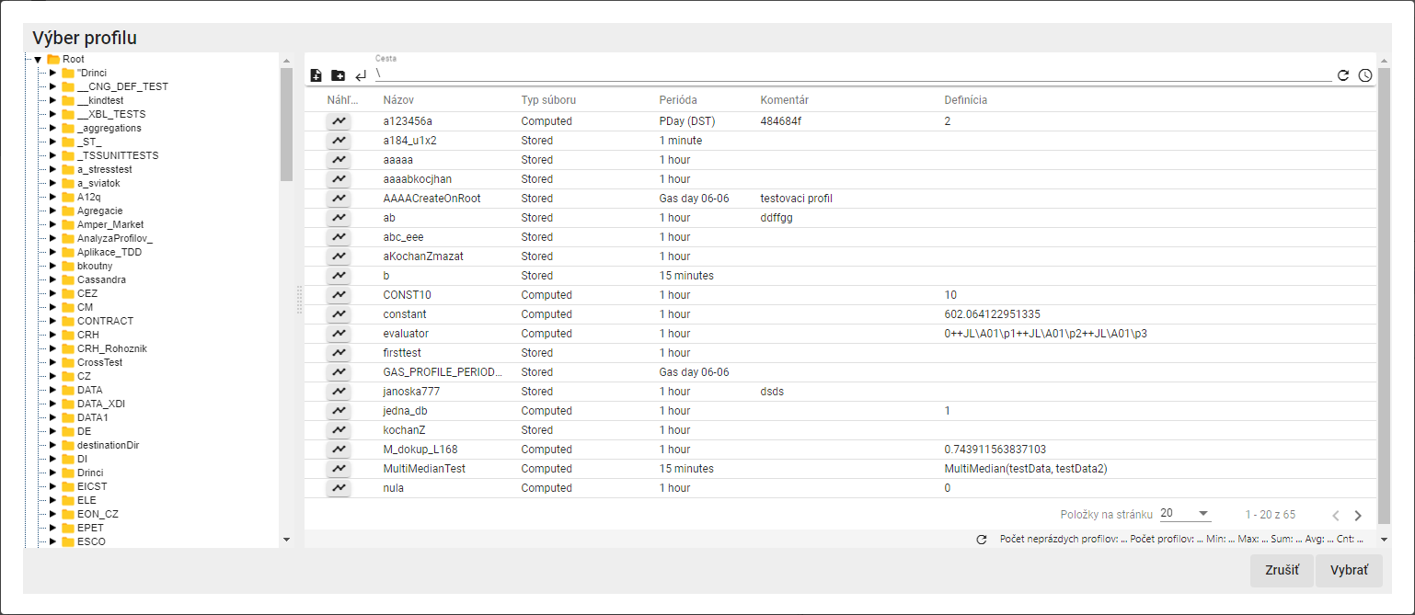

Image 65: Window for choosing profile

1. Select the calendar profile and click on the 'Choose' button.
2. Select the color for fields "Color of table columns and color in graph" and "Color of fixed column".

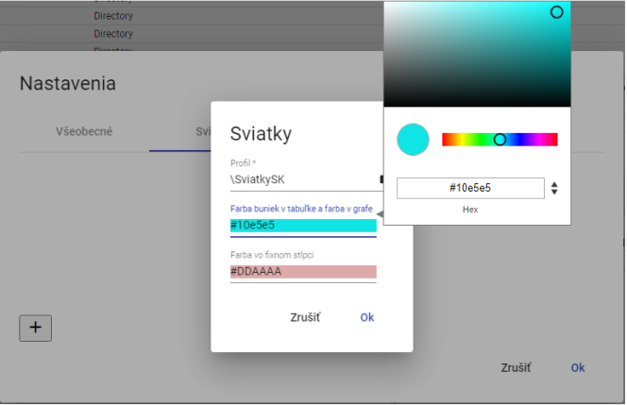

Image 66: Selection of color

1. Create a profile by pressing the 'OK' button.
2. In the window 'Christmas' a created profile for Christmas will be shown.

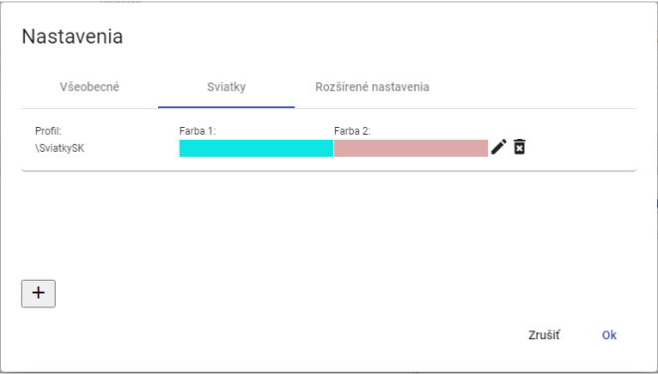

Picture 67: Created profile for Christmas

1. The profile will be saved by pressing the "OK" button.

### How to choose a profile for New Year's Eve

Profile before holidays you will adjust:

1. Click on the button with the name of the registered user located in the top menu bar. Position the mouse cursor on the item 'Settings' and, in the displayed window, click on the item 'Settings', Picture 42.
2. A window called 'Settings' will be shown, where you click on the tab 'Holidays'.
3. Press the edit button next to the profile you want to adjust.



Picture 68: Button for editing profile

1. A window called „Holidays“ will appear for editing a profile.

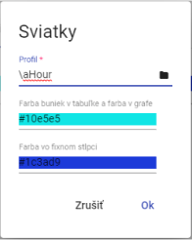

Image 69: Editing profile for Christmas

1. Fix the data.
2. You will save changes by pressing the button "OK".
3. In the 'Settings' window, click the 'OK' button.

### To remove the profile for holidays

You will edit your profile for Christmas?

1. Click on the button named with your registered user name, which is located at the top bar of the application. Point the mouse cursor to the item "Settings" and in the displayed window click on the item "Settings", Picture 42.
2. A window titled 'Settings' will appear, where you click on the tab labeled 'Holidays'.
3. Click on the 'Delete' button for the record you want to delete.



Picture 70: Button for profile deletion

1. A window will appear for profile deletion confirmation, where you press the "Yes" button.

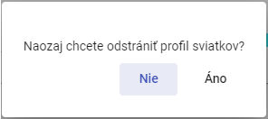

Image 71: Confirmation of profile deletion

1. His profile was removed from the holiday profiles list.
2. Delete your profile by confirming in the window "Settings" with the "OK" button.

## I would like to display information about my status

Before showing information about the application status, click on the button with the name of the logged in user. A menu will appear where you select the item "Info". Subsequently, the window "Status Information" will be displayed, which provides information about the state of the "Profile Manager Web" application and the state of services TSS Service, TSS Core, MSHDO.DMST.API, DMS and MSHDO.Xenergy.UTS.Api.

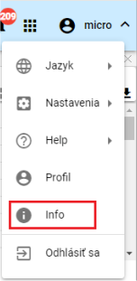

[TRANSLATION FAILED AFTER 3 RETRIES] Obrázok 72: Položka „Info“

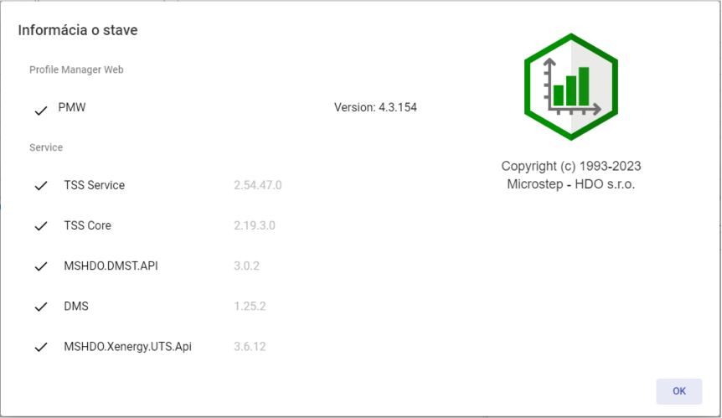

Image 73: Information window "Status information"

## I will display notifications

The 'Notifications' button signals changes made in the system. For example, creation of an address book and similar. If there are notifications in the application, the number of notifications is shown in a red circle at the top right corner of the 'Notifications' button.



Picture 74: Warning button

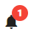

Picture 75: New Warning

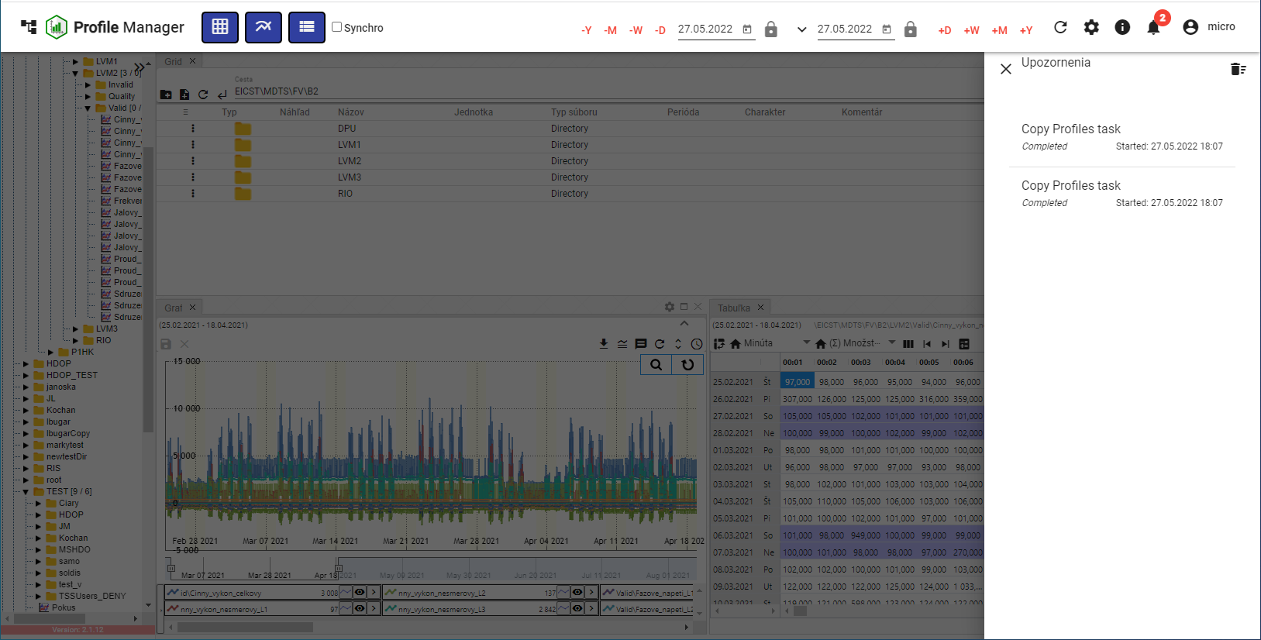

Picture 76: Block of Warning

Remove the notification by clicking on the icon with a trash can in the top right corner of the 'Notifications' block. A confirmation window will appear where you click the 'Yes' button.

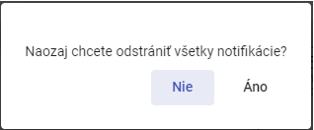

Image 77: Confirmation window for notification removal

## I will expand the window of the tree structure

To enlarge the window of a tree structure, press the button in the top-right corner, Figure 78. The tree structure window will then be enlarged, Figure 80. To restore the tree structure to its standard width, press the button again in the top-right corner of the tree structure, Figure 79.

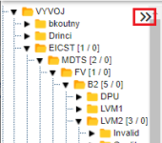

Image 78: Button for expanding tree-like structure

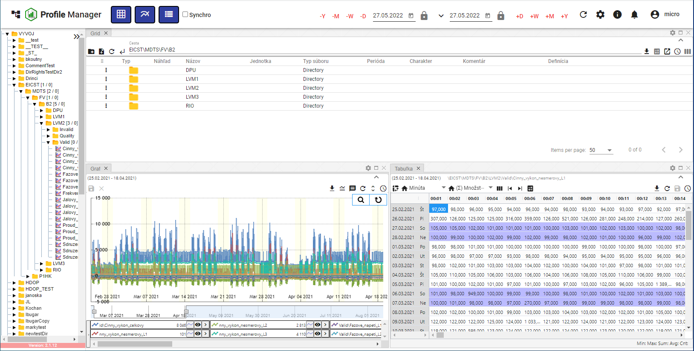

Picture 79: Standard window width of a tree structure

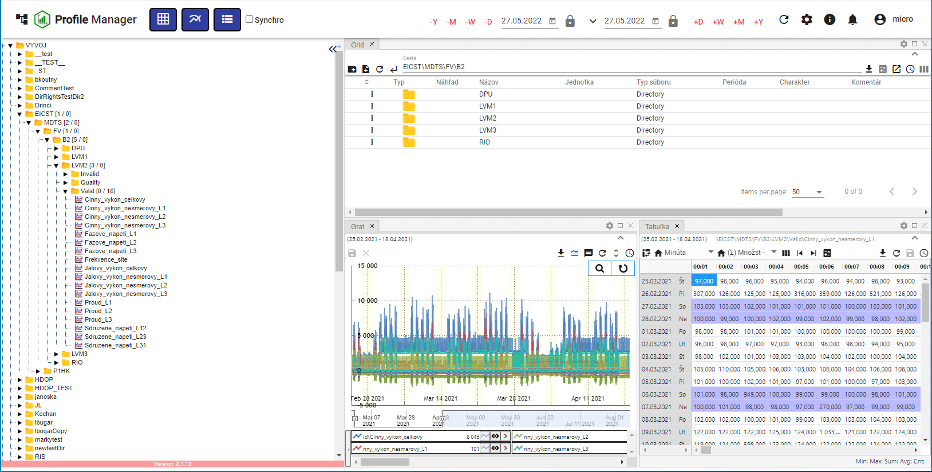

Picture 80: Enlarged window of a tree structure

## Panel synchronization

The "Sync Panels" button serves to synchronize open windows in the "Profile Manager" application. It allows synchronizing time ranges (Chapter 1.16.1) and synchronizing tables (Chapter 1.16.2).

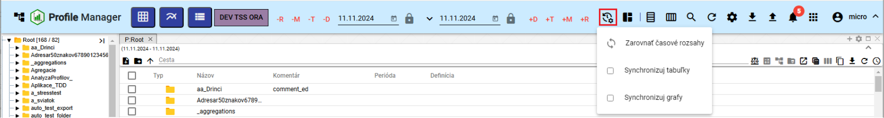

Image 81: Sync Panel Button

### To synchronize time ranges

If the date ranges are set differently in each window and you want to set the same date range for all open windows, proceed:

1. Click on the header of the window whose date range you want to set in other windows.

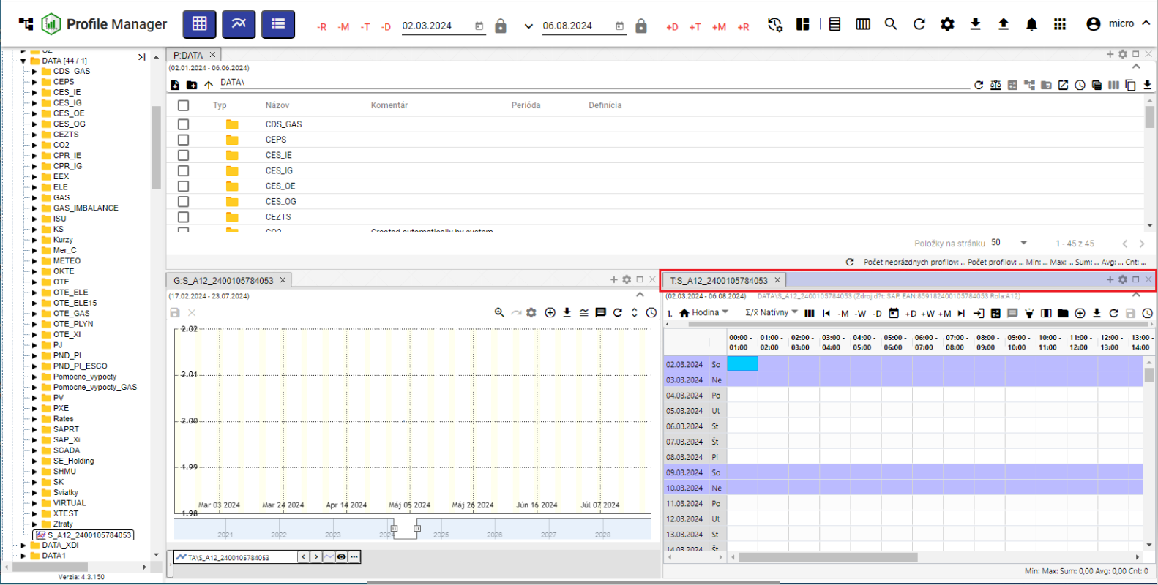

Windows 82: Active Window

1. Press the button "Sync panels" and click on the item "Align time ranges".

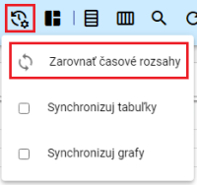

Picture 83: Item "Adjusting Time Ranges"

1. All windows will have the date range set which was set in the active window.

### I synchronize tables

The entry 'Sync tables' means that the beginning of the range and cursor are synchronized with all opened tables.

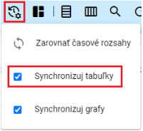

Picture 84: Item "Sync tables"

If you want the tables to synchronize at each launch, in the window "Settings" in the tab "General" in the section "Global", click on the field "Synchronization for tables at startup" (Picture 85). If table synchronization is enabled, the table window will display the text "SYNC" (Picture 86)."

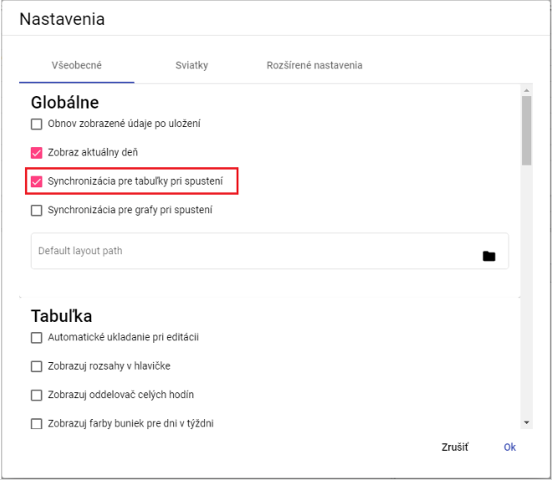

[TRANSLATION FAILED AFTER 3 RETRIES] Obrázok 85: Pole „Synchronizácia pre tabuľky pri spustení“

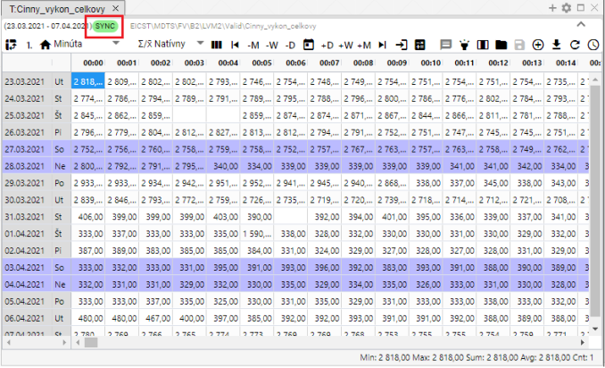

Image 86: The text "SYNC" will be displayed if table synchronization is enabled.

### Synchronize graphs

If you want graphs to synchronize every time it's launched, in the 'Settings' window, under the tab 'General' in the section 'Global', click on the field 'Synchronization for graphs at launch' (Fig. 85). If you set graph synchronization in the 'Settings' window, the box 'Sync graphs' will be checked in the button 'Panel Synchronization' (Fig. 87), and a text 'SYNC' will appear in the graph window (Fig. 88).

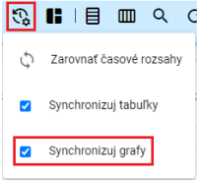

Image 87: Item "Sync graphs"

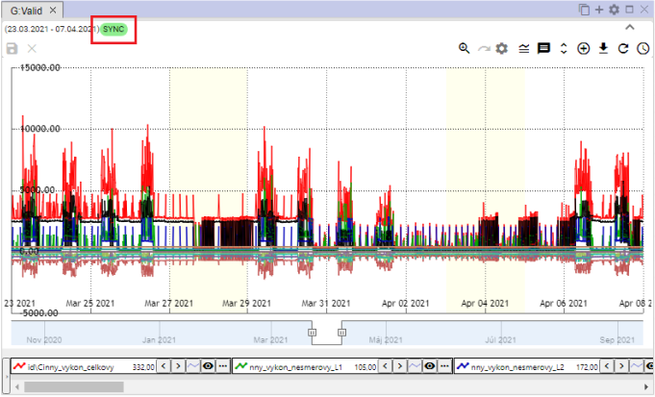

Image 88: The text "SYNC" will be displayed if graph synchronization is turned on

## To import, export and store stocks

Button, Image 89, serves for importing, saving and downloading residues. Importing residues is elaborated in the following Chapter 1.17.1 and downloading residues is described in Chapter 1.17.2.

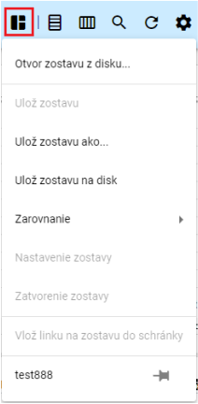

Image 89: Stay-in-Touch Button

### I'll assemble an import

Proceed before import:

1. "Click the button 'Save As', which will open a window in which you select item 'Open assembly from disk...'".

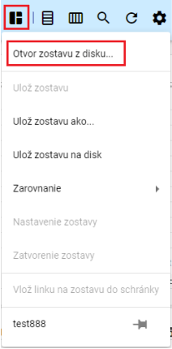

Picture 90: Item "Compose a playlist from disc..."

1. A window will appear where you select the team you want to import.

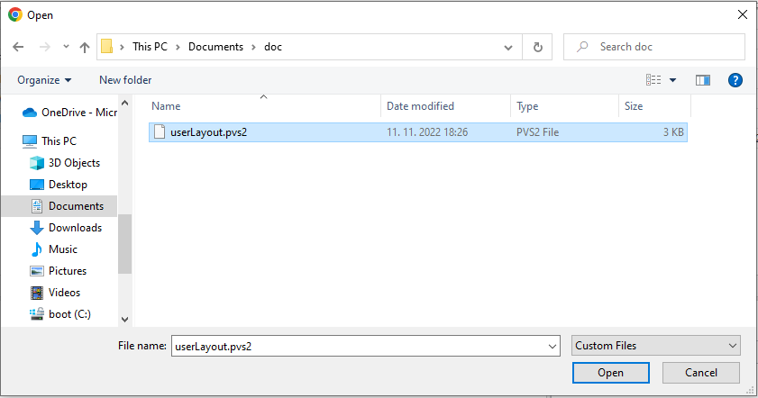

Image 91: Team selection for import

1. Confirm your chosen group for import by pressing the 'Open' button.
2. Selected profile is imported and the appearance of the 'Profile Manager' application changes according to the settings of the selected profile - number and size of windows, data displayed in windows etc.
3. Next to the button 'Stay Report' will appear the name of the imported report.



Picture 92: Name of imported flock

### To compile and export a report

We shall export the following:

1. Press the "Stay Update" button.
2. Choose "Save team roster to disk".

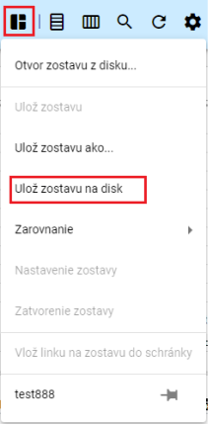

Picture 93: Item "Save settings to disk"

1. Subsequently, she will withdraw from the game.

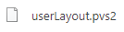

Image 94: Down payment

### I will update the roster

Before updating the roster, proceed with:

1. Click on the profile menu and open the group you want to update. You will open the group by left-clicking on its name in the profile menu.

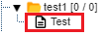

Picture 95: Profile stayed in current

1. Subsequently, at the time of clicking 'The List Remains' will appear the name of the open list.

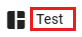

Image 96: Name of Open Prison

1. Make changes to the composition that you want to save.
2. You will save changes by pressing the button 'Save composition' and then selecting the item 'Save as'.

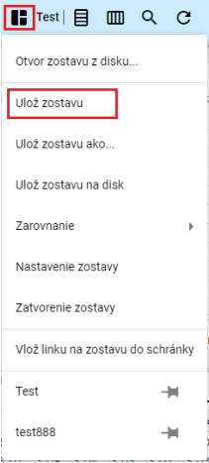

Picture 97: Item "Save Layout"

1. A window will appear to confirm, where you click the 'Yes' button.

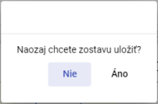

Image 98: Window for confirming account deposit

1. The software is being updated.

### I'll create a new lineup

Appearance of the application 'Profile Manager' - number and size of windows displayed, data shown in the windows can be saved as a layout.

You will store the new team in your profile stream as follows:

1. Set up settings in the application that you want to save as a collection.
2. Press the button "Save as..." and in the shown window select "Save the composition as..."

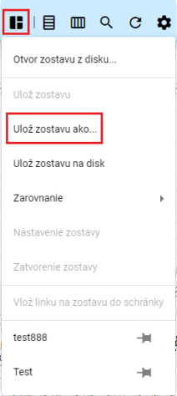

Image 99: Item "Save as a set..."

1. It will display the window “New Team”.

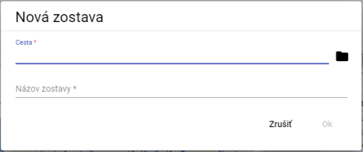

Picture 100: Window "New Lineup"

1. In the menu "Path", write down the path where you want to store your playlist. You can also input it by pressing the button and selecting the recipient in the profile tree, where the playlist is supposed to be stored.

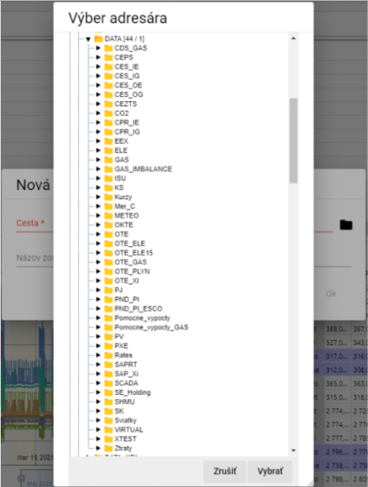

Image 101: Choosing recipient for depositing savings

1. Name the team.

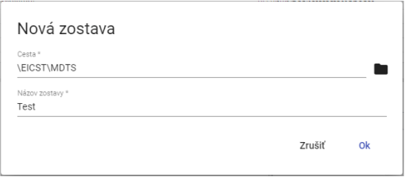

Picture 102: Given Data

1. Save the new configuration by clicking on 'OK'.
2. To refresh your profile stream, click on the directory in your profile stream and select the item 'Refresh'.

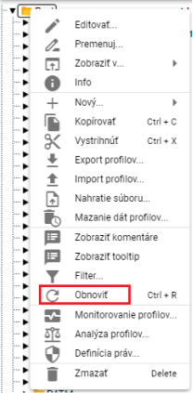

Picture 103: Item "Restore"

### How to arrange a committee into columns

Proceed with

1. Click on the button "Remainder message", which is located in the top bar of the application.
2. "The offer will be displayed, where you set the mouse cursor on the point 'Alignment' and set the mouse cursor on the point 'Into columns...'".
3. The offer will be displayed, where you can select the number of columns.

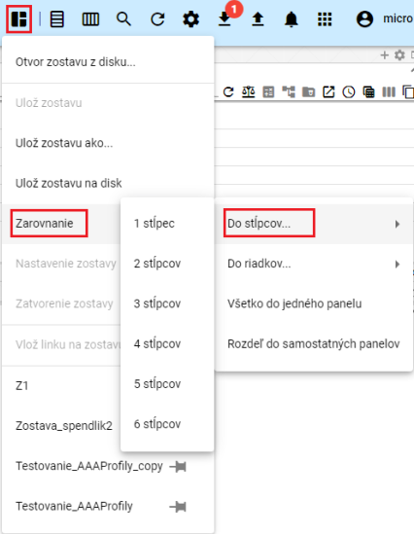

Picture 104: Item "To steps"

1. Windows in the 'Profile Manager' application are aligned to a selected number of columns.

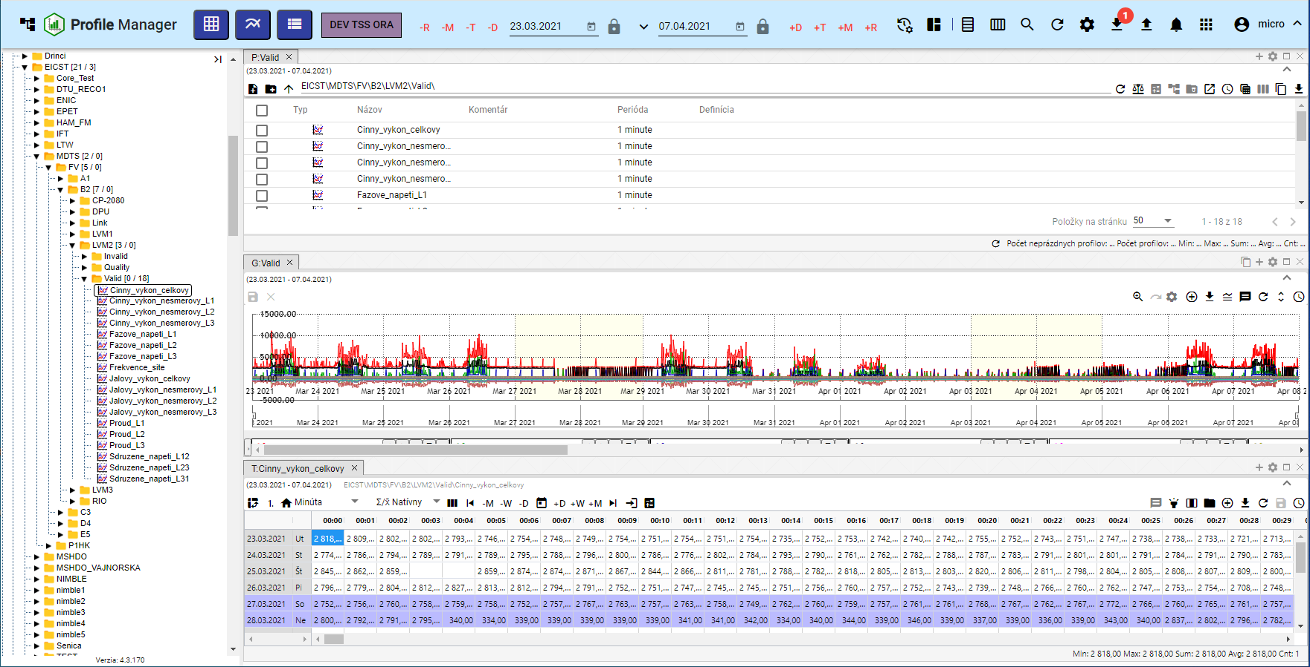

Image 105: Balancing windows into one column

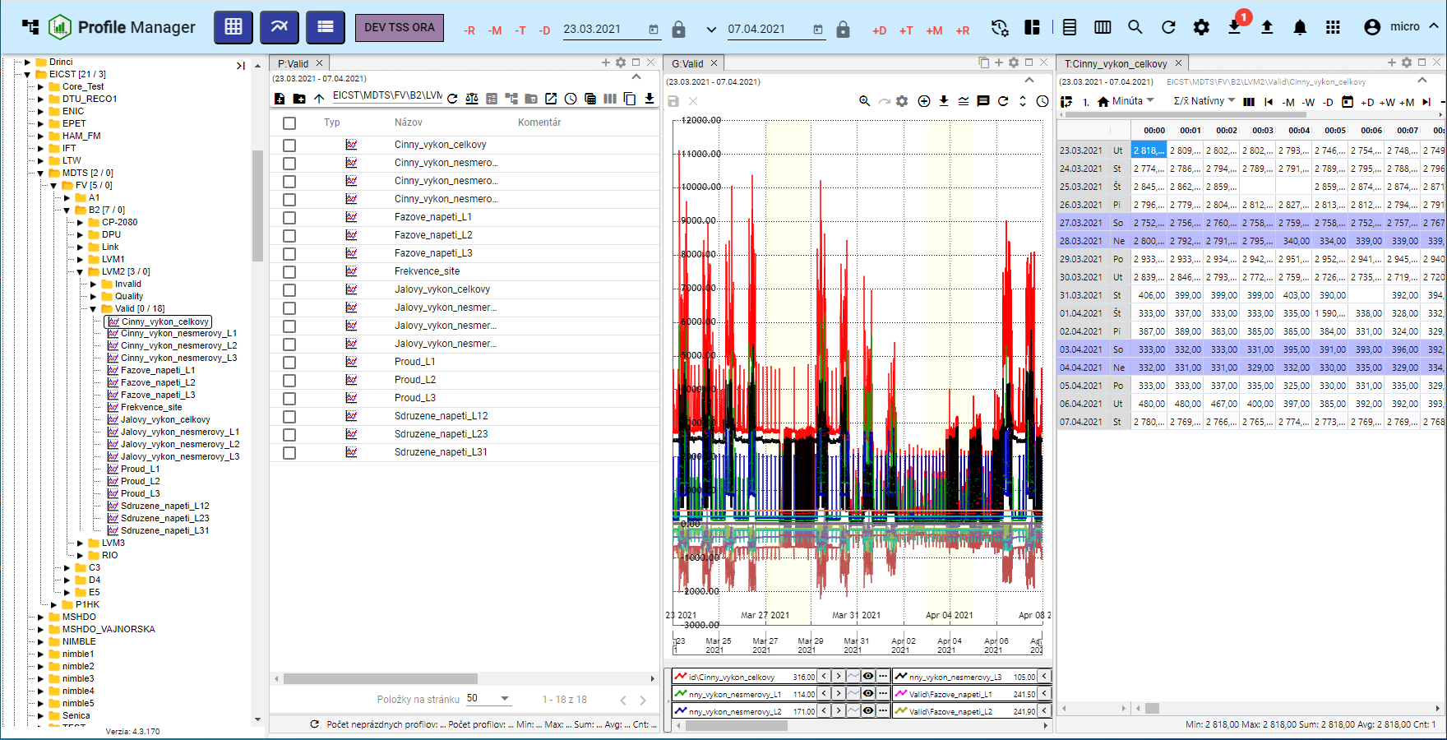

Picture 106: Alignment to three columns

### To gather a team into rows.

Proceed:

1. Click on the button "Stay Message", which is located in the top toolbar of the application.
2. The menu will be displayed where the mouse cursor is moved to the item 'Alignment' and then moved to the item 'To rows'.
3. An offer will be displayed, where you can select the number of rows.

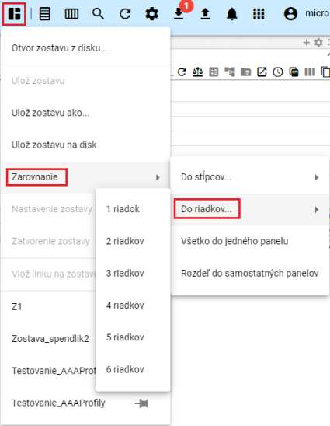

Picture 107: Item "To trenches"

1. The windows in the application are aligned to a chosen number of rows.

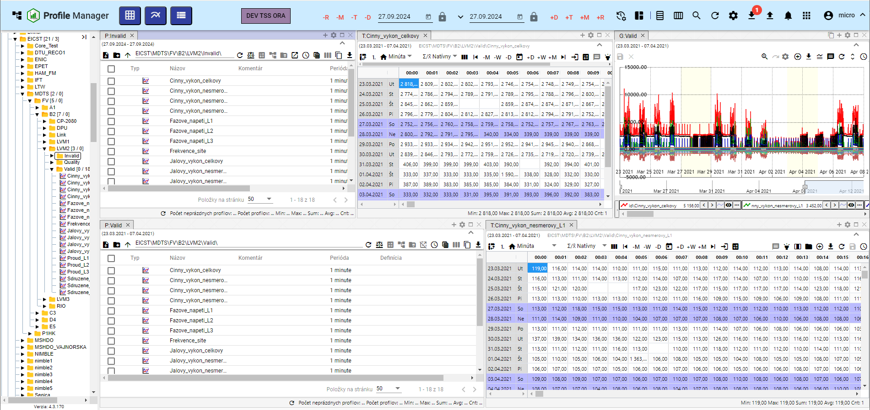

Picture 108: Alignment to two rows

### I want to collect everything into one dashboard

Proceed:

1. Click on the button "Report Absent".
2. "An offer will be displayed in which you can set the mouse cursor to the item "Alignment" and select the item "Everything to one panel".
3. All windows will be displayed on one panel.

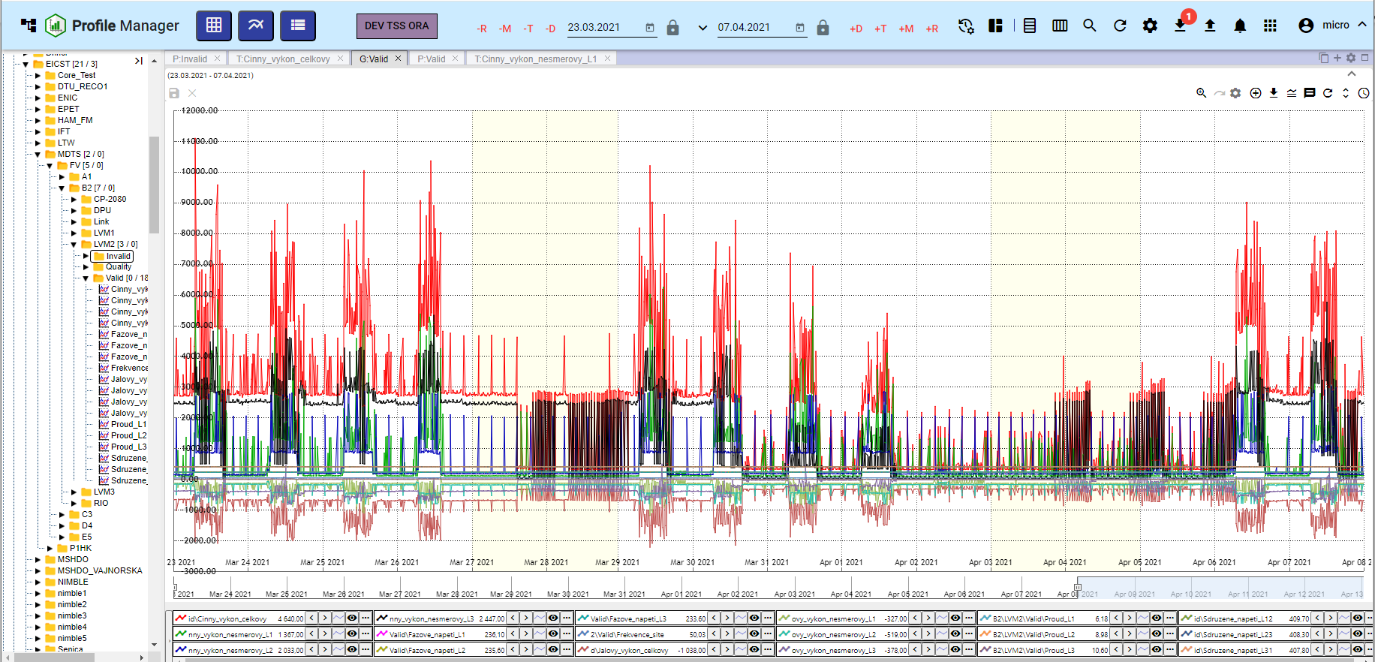

Picture 109: Adjustment to one panel

### How to split the roster into separate panels

Proceed:

1. Click on the button "Remain in place".
2. The menu will appear. Use the mouse pointer to select the 'Alignment' option and choose the 'Break into separate panels' option.
3. Every opened window will be shown on its own panel.

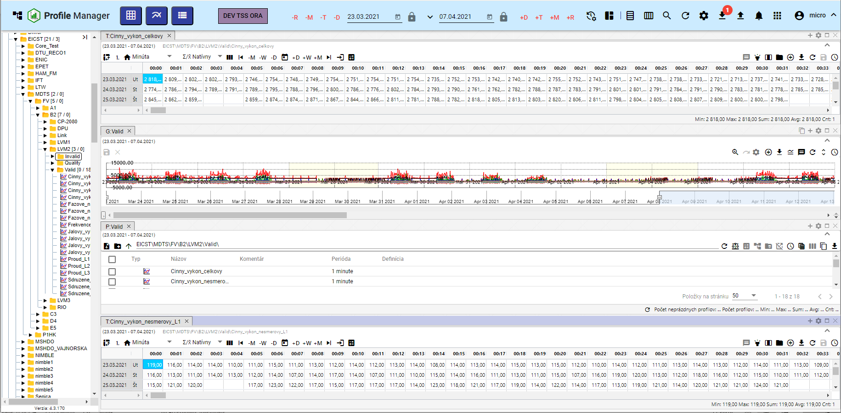

Image 110: Division into separate panels

### How to set the global time range when viewing a report

Before changing the global time scale for saved configuration, proceed:

1. Press the button "Message Remains".
2. Choose item "Team settings".

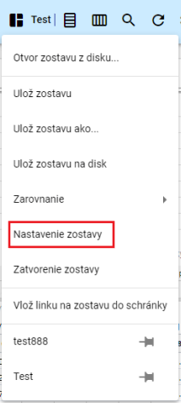

Image 111: Section "Team settings"

1. A settings window for the team will be shown.

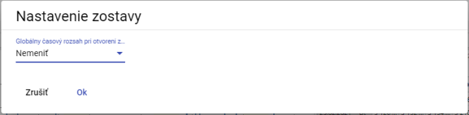

Picture 112: Team Settings window

1. Click on the field "Global time range when opening the roster".
2. A selection will be shown where you can choose a date range.

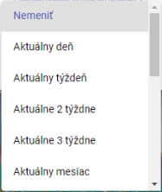

Image 113: Offering for setting up a global time range

1. Press "OK" button to save.
2. A window will appear for confirmation, where you press the 'Yes' button.

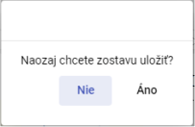

Picture 114: Window for confirmation of saving

### How to close the report Layout

Before closing the dormitory, press the 'Dormitory information' button and select the 'Closing of the dormitory'. The dormitory will then close.

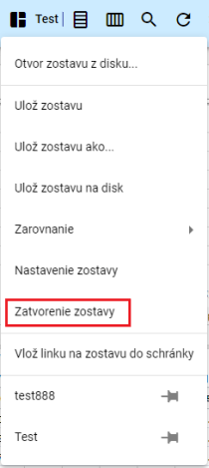

Image 115: Item "Closure of the ghetto"

## How to align windows horizontally

Adjust windows horizontally by clicking the 'Horizontal alignment' button located in the top bar of the application. Opened windows in the 'Profile Manager' application are aligned horizontally, Figure 117.



Image 116: Horizontal alignment button

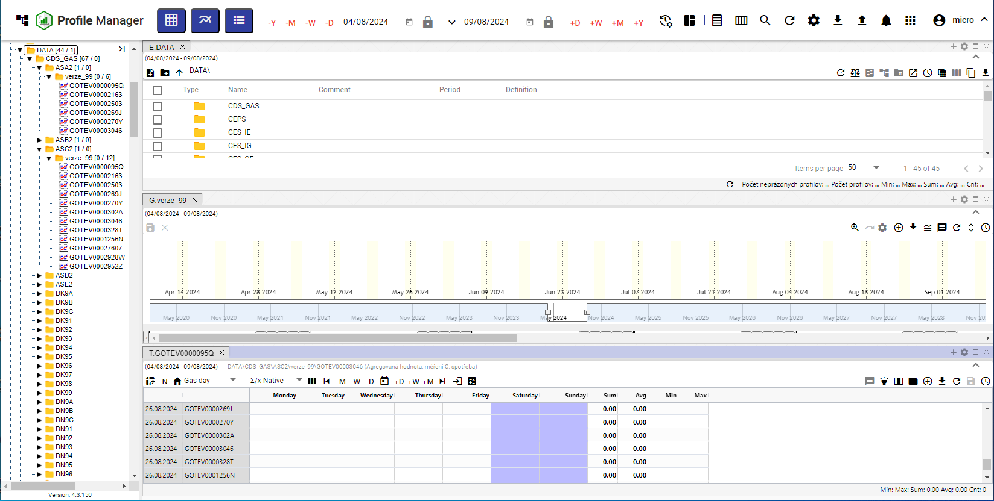

Image 117: Horizontal alignment of windows

## To vertically install windows

Press the 'Vertically align' button located in the top bar of the application to vertically align windows in the Profile Manager application. Open windows in the Profile Manager application are vertically aligned, Figure 119.



Image 118: Button "Vertical alignment"

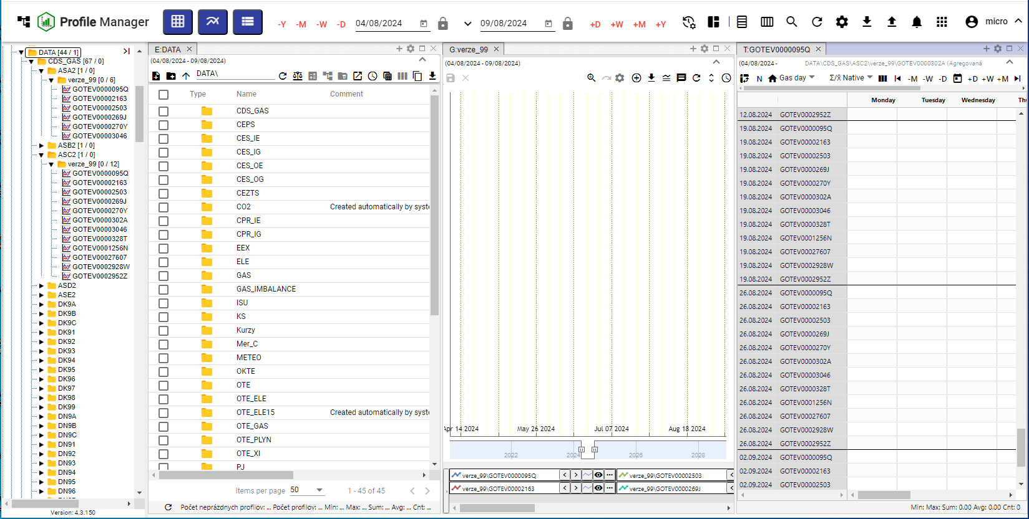

Image 119: Vertical alignment of windows

## How to view and download exports

In the top right corner of the "Profile Manager" application, you'll find a button labeled "Export", which will display an Export List in a new window called "Exports". Once the export has been successfully completed, you can download it by clicking the green "Download" button. The process for creating an export is further detailed in Chapter 2.16.



Image 120: Export button

The number of unexported exports will appear as a number in a red circle next to the "Export" button, Image 121. Unexported export in the "Exports" window has a red "N" at the "Download" button, Image 122.

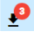

Picture 121: Three exhausted exports

Exports may be in the state:

* Ongoing exports.
* COMPLETED – successfully completed export can be downloaded by pressing the button 'Download'.
* There was an error during the export process.
* OBSCURED – the export was obscured. Information about obscuring the export came from the Export Service application.

The exports menu comes from the Export Service and in the Profile Manager application it serves only for display. The 'Exports' window can be closed by clicking on the 'Cancel' button.

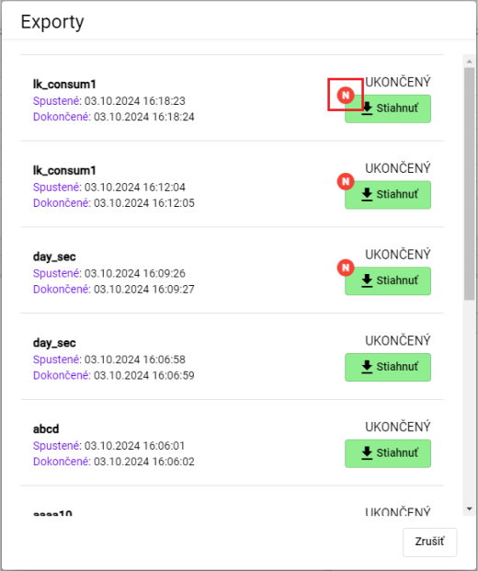

Picture 122: Window "Exports"

## How to display imports

In the top right section of the 'Profile Manager' application, there is a button called 'Import', which serves to show a list of imports in the window 'Imports'. The procedure for creating an import can be found in chapter 2.17.



Image 123: Import Button

After pressing the button "Import", a window called "Imports" will appear, where it is possible to display the details of imports, Image 125.

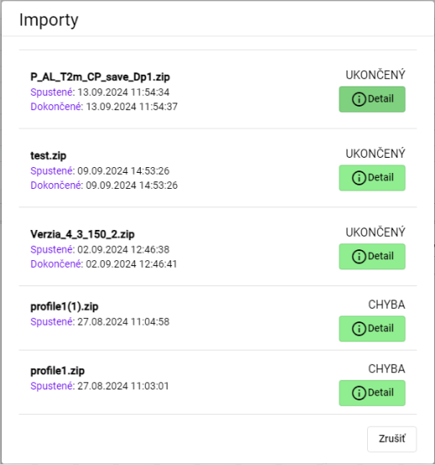

Picture 124: Window "Imports"

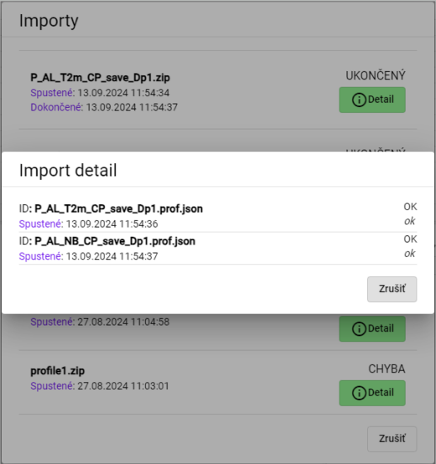

Image 125: Displaying import details

## Keyboard shortcuts

You can display the list of keyboard shortcuts by means of the application 'Profile Manager'.

1. Click the button with the name of the logged-in user, located in the top bar of the application.
2. An offer will be shown where with the mouse cursor you navigate to the item 'Help'.
3. Click on the item "Keyboard shortcuts".

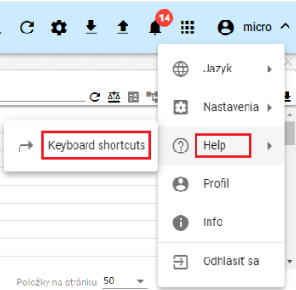

Image 126: Item "Keyboard shortcuts"

1. A window titled 'Keyboard Shortcuts' will appear.

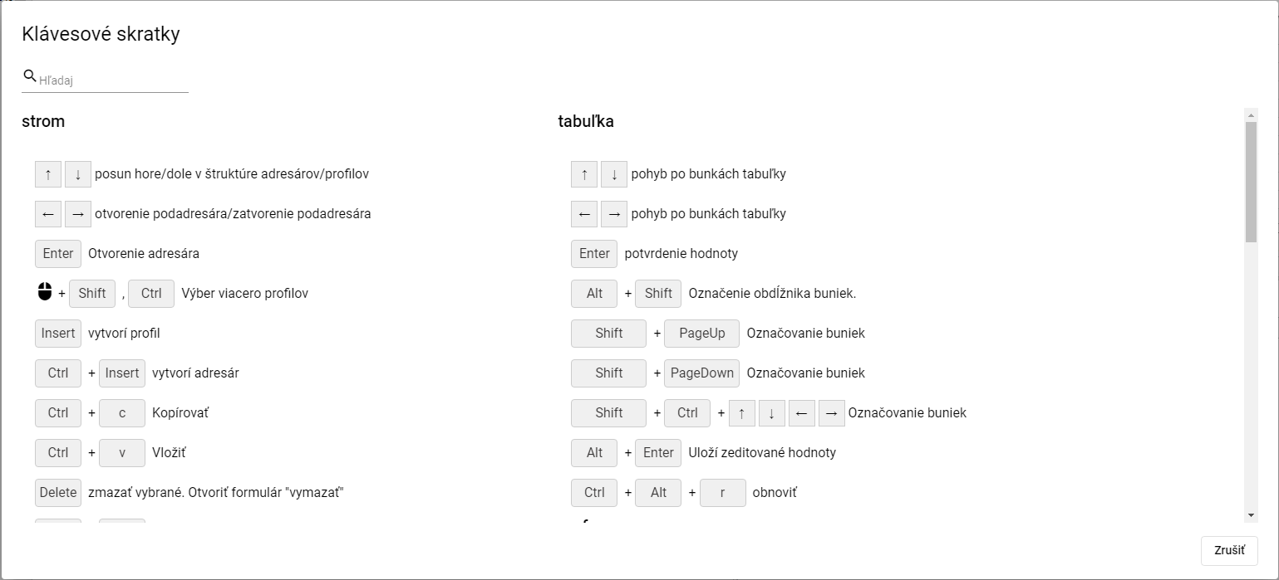

Picture 127: Window "Keyboard shortcuts"

1. Keyboard shortcuts can be searched by entering the text into the "Search" field, which is located in the top left corner of the window. Automatically a list of keyboard shortcuts will appear matching the entered text.
2. Close the window by pressing the 'Cancel' button.

In the 'Profile Manager' application you can use keyboard shortcuts which are located in the following table.

|  |  |  |
| --- | --- | --- |
| Klávesová skratka | Časť aplikácie | Popis |
| šípky HORE/DOLE | strom | Posun hore/dole v štruktúre adresárov/profilov |
| šípky HORE/DOLE | prieskumník | Posun hore/dole v štruktúre adresárov/profilov |
| šípky HORE/DOLE | tabuľka | Pohyb po bunkách tabuľky |
| šípky HORE/DOLE | graf | Hore zoom OUT, dole zoom IN |
| šípky Doprava a doľava | strom | Otvorenie podadresára/zatvorenie podadresára |
| šípky Doprava a doľava | prieskumník | Posun celej tabuľky doľava a doprava, aby bolo možné vidieť schované stĺpce |
| šípky Doprava a doľava | tabuľka | Pohyb po bunkách tabuľky |
| šípky Doprava a doľava | graf | Posun grafu o jedno zobrazené časové okno doľava a doprava |
| ENTER | strom | Otvorenie adresára |
| ENTER | prieskumník | Otvorenie adresára/Otvorenie editačného okna profilu |
| ENTER | tabuľka | Potvrdenie hodnoty |
| ENTER | graf | Bez akcie |
| Výber myšou pomocou Shift, Ctrl | strom | Výber viacero adresárov/profilov |
| Výber myšou pomocou Shift | prieskumník | Výber viacero adresárov/profilov |
| Výber myšou pomocou Shift, Ctrl | graf | Výber viacero profilov |
| Alt + Shift | tabuľka | Označenie obdĺžnika buniek |
| Insert | prieskumník | Založí profil |
| Ctrl + Insert | prieskumník | Založí adresár |
| Insert | strom | Založí profil |
| Ctrl + Insert | strom | Založí adresár |
| Ctrl + ALT + K | graf | Zmena koeficientu označeného profilu / označených profilov |
| Ctrl + ALT + W | graf | Skryje označený profil / označené profily |
| Ctrl + ALT + Q | graf | Odkryje označený profil / označené profily |
| Ctrl + ALT + T | PMW | Nové okno Tabuľka |
| Ctrl + ALT + G | PMW | Nové okno Graf |
| Ctrl + ALT + E | PMW | Nové okno Prieskumník |
| Ctrl + C | strom/ prieskumník | Kopírovať |
| Ctrl + ALT + C | prieskumník | Export prieskumníka do clipboardu |
| Ctrl + V | strom/ prieskumník | Paste |
| Ctrl + S | PMW | Uloženie zostavy. Ak nie je žiadna otvorená ponúkne formulár na uloženie do stromu. |
| Ctrl + O | PMW | Otvorenie zostavy z disku |
| Ctrl + ALT + F4 | PMW | Zavretie grafu/tabuľky |
| Ctrl + šípka NAHORU/DOLŮ | graf | Posun/radenie zobrazovaných profilov pod grafom |
| Alt + ENTER | graf | Uloží rozkreslenú čiaru |
| Alt + ENTER | tabuľka | Uloží zeditované hodnoty |
| Delete | graf | odoberie z grafu vybrané profily |
| Delete | strom/prieskumník | Zmazať vybrané. Otvoriť formulár "Delete" |
| CTRL+ R | strom/prieskumník | Refresh |
| CTRL+ ALT + R | graf/tabuľka | Refresh |
| Koliesko myši | graf | Zmena rozsahu časovej osi |
| Koliesko myši + CTRL | graf | Zmena rozsahu ľavej osi |
| Koliesko myši + CTRL + ALT | graf | Zmena rozsahu pravej osi |
| SHIFT + šípka NAHORU/DOLŮ | prieskumník | Výber adresárov/profilov |
| SHIFT + HOME | prieskumník | Výber viacero adresárov/profilov |
| SHIFT + END | prieskumník | Výber viacero adresárov/profilov |
| CTRL + X | prieskumník /strom | Presun adresárov/profilov |

## How to find a profile in the application

Before searching for your profile, proceed:

1. Click on the button that is located in the top ribbon of the application.
2. A search field for 'profile' will appear, where you type the name of the profile.

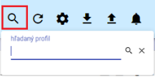

Image 128: Search profile picture

1. Enter the text for which you want to search profiles.
2. Press the Enter key or search button.

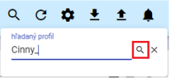

Image 129: Search button

1. In the active window, a tab labeled "B:Root" will appear containing profiles matching the specified text.

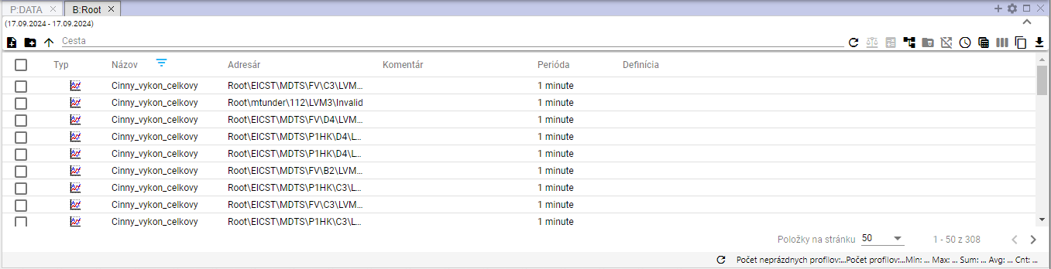

Image 130: Search Profiles

## User notification about deregistration

If the user has an open "Profile Manager" application in several browser tabs and logs out of one of them, a window will be displayed informing the user about the logout. Image 131. To log back in, press the "Log In" button. A login screen will be displayed where you enter your username and password for logging in, image 2. After logging in, the "Profile Manager" application is restored to its state as it was before logging out.

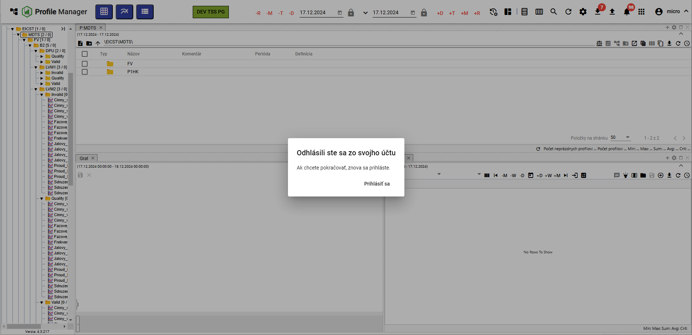

Picture 131: Window 'You have logged off your account'

## How to display the time remaining until the user is logged out.

**If you are not actively working with the 'Profile Manager' application, the time remaining until the user is logged out of the 'Profile Manager' is counted down. If you are working with the application, the timer resets.**

**You can check how much time remains until logout:**

1. **Click the button labeled with the logged-in user's name.**
2. **A menu will appear containing information about when the login session will expire (Figure 132).**

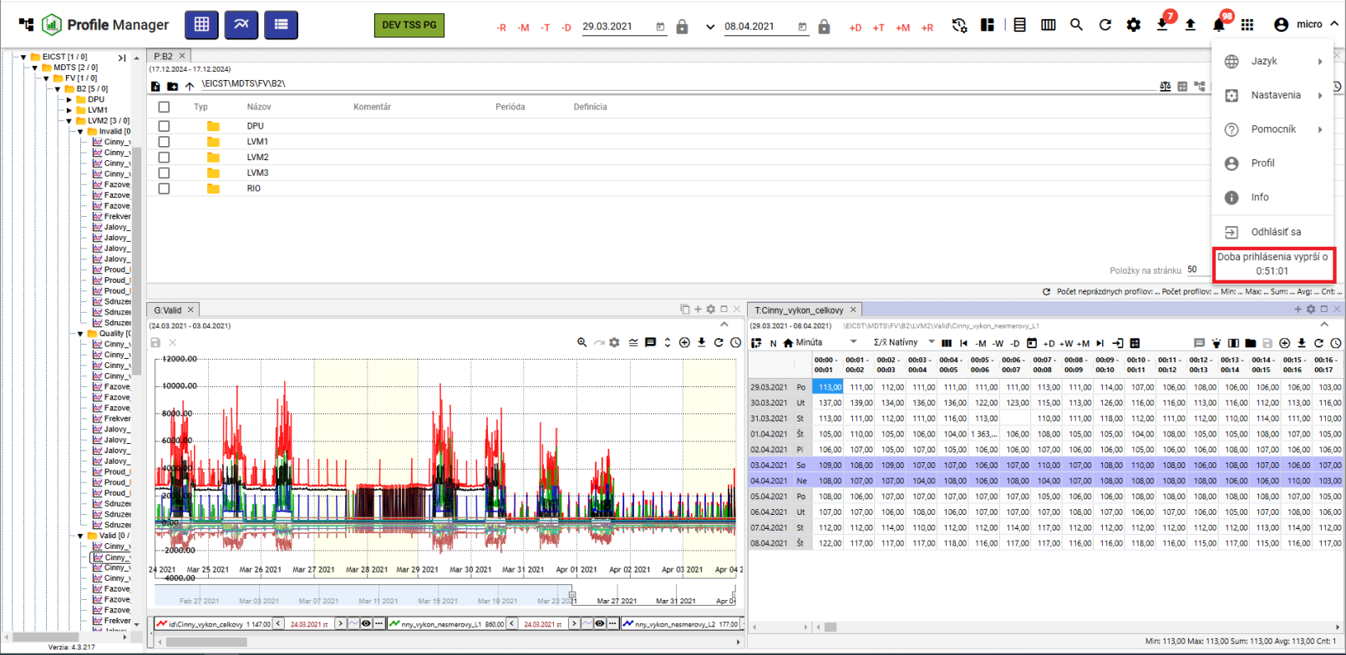

Image 132: Information about the time remaining until user logout

If the user did not work actively with the "Profile Manager" application and the login time has expired, the user is logged out of the application. A window titled "Login period expired" will appear. To log in again, click the "Log in" button.

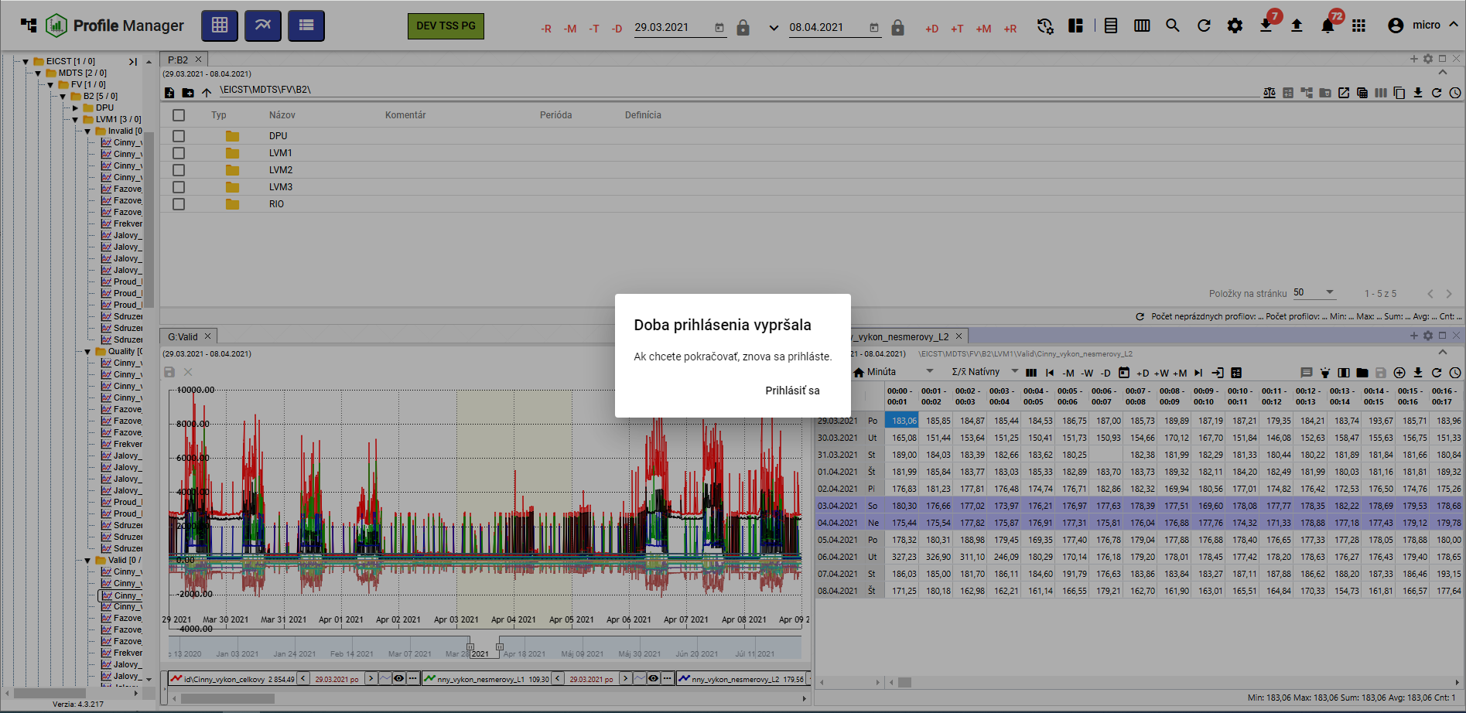

Image 133: Notice of expiration of application deadline

# Work with directories and profiles

In the stormy structure there are addresses and profiles that you can create, convert, edit and delete. You can filter the addresses.

The address book allows logical grouping of data into one group. Each address book can contain further address books or profiles.

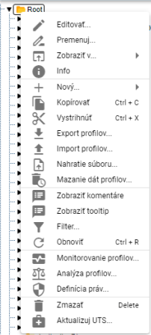

Image 134: Window with functions for recipient and profiles

## Add new folder

Before adding a new recipient, proceed:

1. Click the right mouse button on the address book in the tree structure to which you want to add a new address book.
2. Choose item "New" and then "Address Book".

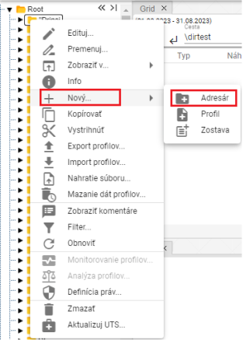

Image 135: Entry "Address book"

1. A window will appear for creating an addressee.

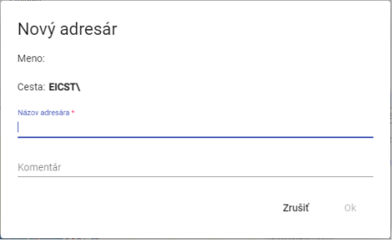

Image 136: Window for creating an addressee

1. Fill in the information. The field "Name of recipient" is mandatory. The name of the recipient must not start with a number. It may contain letters, numbers and underscores. The name must have at least 3 characters and no more than 50 characters. If you do not enter a name or enter an invalid name, the address book entry information for the recipient will be displayed, Figure 137. The rules for entering a recipient's name may vary depending on the configuration of the given environment.

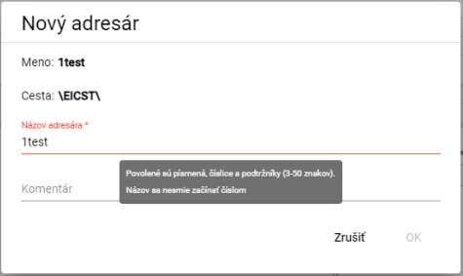

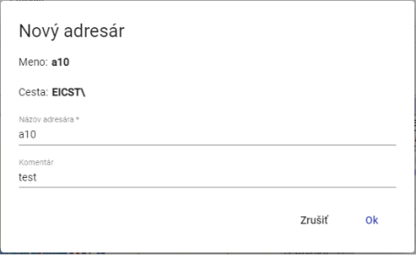

Image 138: Task of assigning name and comment

1. You will create an address book by pressing the "OK" button.

## How to rename a folder

Procedure for changing the recipient:

1. Click the left mouse button on the recipient's name and press the "F2" key or click the right mouse button on the folder you want to rename and select the "Rename" item.

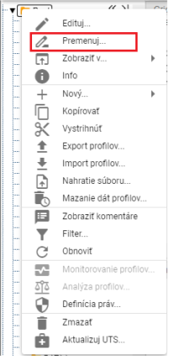

Image 139: Item "Renew"

1. **[TRANSLATION FAILED AFTER 3 RETRIES] Zobrazí sa okno, v ktorom napíšte nový názov adresára. Názov adresára sa nesmie začínať číslom. Môže obsahovať písmená, číslice a podčiarkovníky. Názov musí mať minimálne 3 znaky a maximálne 50 znakov. Ak nezadáte názov alebo by ste zadali neplatný názov, zobrazí sa informácia k názvu pre adresár. Pravidlá pre zadanie názvu adresára sa môžu líšiť podľa konfigurácie daného prostredia.**

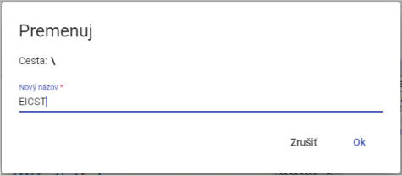

Image 140: Window for address conversion

1. You will save changes by pressing the "OK" button.

## How to edit an address book

Before editing the recipient, proceed:

1. Click on the folder you want to edit with your right mouse button.
2. Choose item "Edit" from the dropdown menu.
3. A window will appear where you can edit the field 'Comment'.

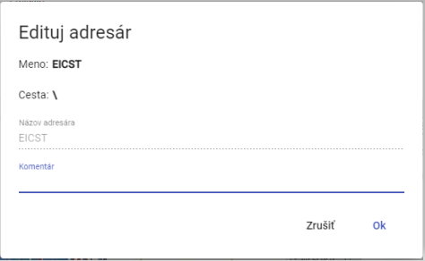

Picture 141: Window for editing of addressee

1. You will save changes by pressing the button "OK".

## I want to empty my address book.

Delete address book

1. Click with the right mouse button on the folder that you want to delete.
2. The offer will appear in which you select 'Delete'.
3. In the window for confirmation of deletion, click on the 'Yes' button.

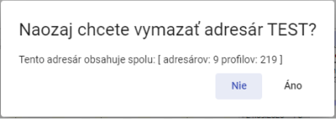

Image 142: Window for confirming deletion

## I will copy an address book

Before copying the recipient, proceed:

1. Click with your right mouse button on the folder you want to copy.
2. Choose item "Copy".
3. Click the right mouse button on the folder you want to insert the copied address book into and select the item "Insert".
4. A window 'Move/Copy' will appear.

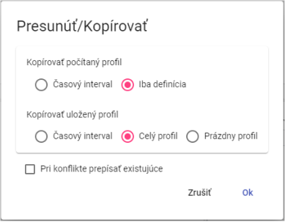

Image 143: Window for copying an address

1. Click the "OK" button.

## I need to pull out/ move a folder.

For the purpose of presuming the addressee's location from one place to another in a tree structure, use the 'Remove' field. To remove the address proceed:

1. Click with the right mouse button on the folder you want to eject.
2. Choose from the list "Expand".
3. Click on the right mouse button on the folder where you want to insert the folder.
4. Select item "Upload".
5. A window will appear for confirmation, in which you click on the 'OK' button.

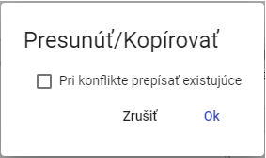

Image 144: Move/Copy window

## Upload a file

Please follow the upload instructions:

1. Click the right mouse button on the location in the tree structure where you want to upload a file.
2. A window will appear where you select 'Upload a file...'.

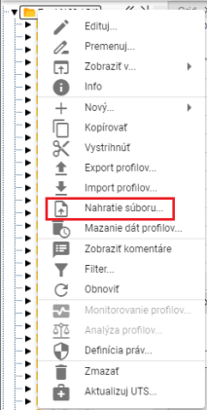

Image 145: Entry "Submission of the society..."

1. A window titled "Upload" will appear, where you click and select the file you want to upload. You can also drag a file into the "Upload" window.

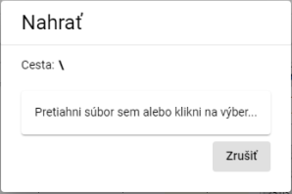

Image 146: Upload window

1. The window is closing and at the bottom of the screen will appear a message saying "The recording request was sent".

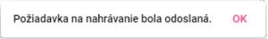

Image 147: The recording request has been sent.

Recognized file extensions:

* PGZ2 - Report
* PVS2 - remains
* XLSX - template for teams

## To erase profile data

The function 'Delete data from profiles' will delete data in all profiles within a specified time interval from the selected column. You can also select multiple columns at once or multiple profiles at once. Data can be deleted even in subdirectories.

Before deleting your profile account, proceed:

1. If you want to delete data only in one selected folder (you can also in its subfolders) or one profile, click the right mouse button on the selected folder or profile. A window will appear where you select the item 'Delete Profile Data...'."

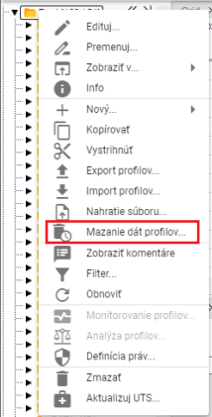

Image 148: Item "Smearing data profiles..."

1. If you want to delete data in multiple sections or profiles at the same time, proceed:
   1. Mark files or profiles where you want to delete the data.
   2. Click the left mouse button on the first folder you want to select, hold down the SHIFT key and then click on the last folder you want to select. All folders in between will be selected.

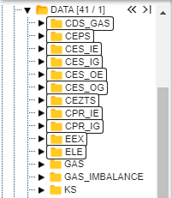

Picture 149: Selection of various crackers

* 1. For objects you want to select that do not follow in sequence, click the left mouse button on the first object, hold down the Ctrl key and use the left mouse button to select the other objects you wish to select.

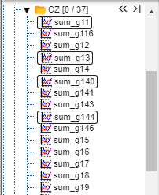

Picture 150: Selection of several profiles

* 1. "Click on the selected profile or account with your right mouse button and select the item 'Clearing all profiles...'".

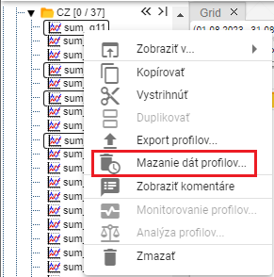

Image 151: Item "Smearing data of profiles..."

1. A window called 'Range Wiping Time' will appear, in which you can select a daily or hourly time period. By default, an hourly time period is selected.

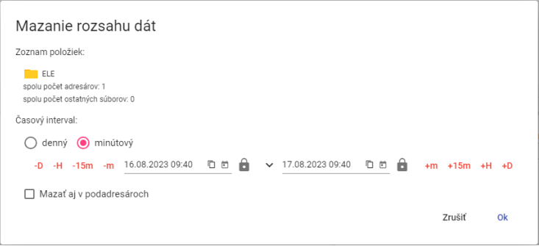

Image 152: Range picker window for one selected folder

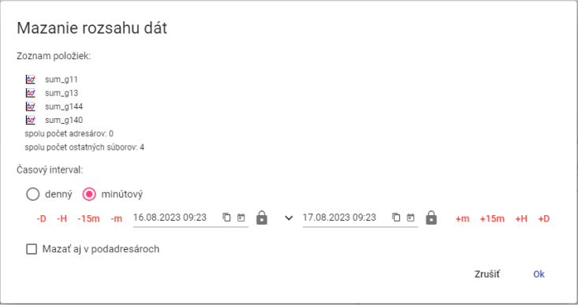

Picture 153: Window "Range of data scraping" for multiple selected profiles

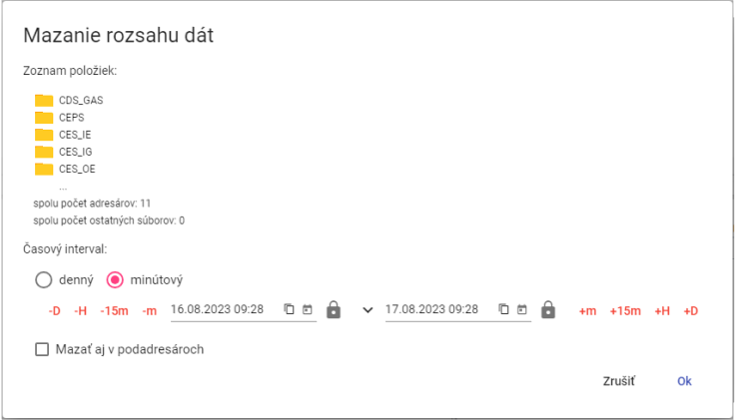

Image 154: Window "Data range scraping" for multiple selected lines

1. Next, specify the time interval during which the data shall be deleted.
2. If you check the box 'Delete also in sub-addresses', then the sub-addresses will be deleted and according to the selected time interval data will be deleted from profiles.
3. Click the 'OK' button.

## I filter through address books and profiles

Before filtering addresses and profiles, proceed:

1. Click on the right mouse button on the folder.
2. Choose item "Filter" from the offer.
3. A window for filtering will appear. To filter contacts, enter the name or part of the contact's name in the 'Filter Contacts' field. To filter profiles, enter the name or part of the profile's name in the 'Filter Profiles' field. Asterisk convention is not used here; any substring is searched. Filtering is also case sensitive - it distinguishes between uppercase and lowercase letters.

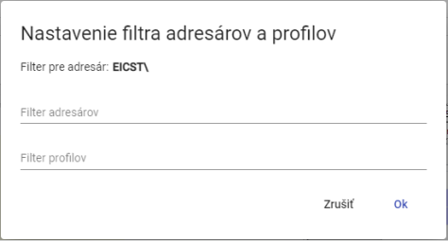

Picture 155: Window "Set up address and profile filters"

1. Confirm by clicking the 'OK' button.

## To disable the address and profile filters

Before filter cancellation proceed:

1. Click on the folder set up with a filter using your right mouse button.
2. Select item "Filter".
3. Turn off the set filter.
4. Save changes by pressing the "OK" button.
5. After the filter was removed, all addresses and profiles are displayed in tree structure.

## Show comments

When creating recipients and profiles, you can enter a comment. Displaying comments in tree structure turn on:

1. Click the right mouse button on any address book or profile in a tree structure.
2. A window will appear, in which you set the mouse cursor to the item "Show" and select "View comments".
3. When showing comments is turned on, the names of addressees and profiles are in round brackets before the comments. If a comment has not been entered, only the names of addressees or profiles are shown in round brackets.



Image 156: Address book with comments switched off



Picture 157: Comment-less address book

1. You can turn off comments by clicking the right mouse button on any folder or profile in your feed. In the window that appears, move the cursor to the item 'Show' and select 'Hide comments'.

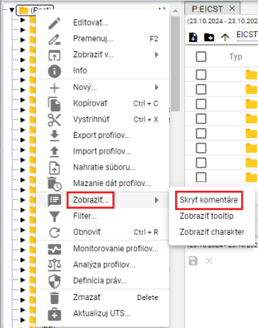

Picture 158: Item "Hide comments"

1. Comments are then hidden and names of recipients or profiles appear without rounded brackets.



Picture 159: Address book with hidden comments

## How to show tooltip

Before displaying tooltips for profiles in a tree structure, proceed with:

1. Click on the right mouse button anywhere you see a folder or profile in the tree structure.
2. A window will appear in which you click on the point 'Show...' with your mouse cursor and click on the point 'Show tooltip'.

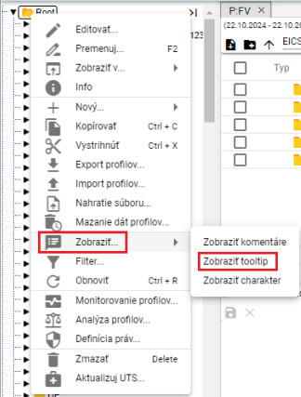

Image 160: Item "Show tooltip"

1. The tooltip will appear when you position the mouse cursor on the name of the profile.

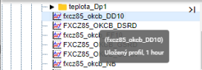

Image 161: Displayed tooltip

1. You can disable the tooltip display by clicking the right mouse button on any directory or profile in the tree. In the window that appears, use your cursor to select the 'Show' item and choose 'Hide tooltip'.

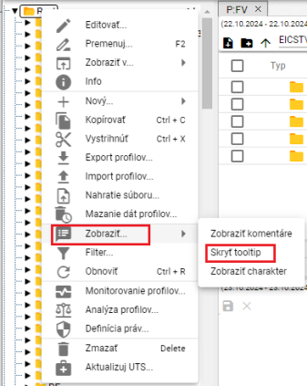

Image 162: Item "Hide tooltip"

## To display character

Character profile can be "Numerical" or "Trend", which are represented by symbols.

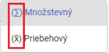

Image 163: Signs representing multiplicative and procedural character

Before displaying character in profile tree structure, proceed:

1. **[TRANSLATION FAILED AFTER 3 RETRIES] Kliknite pravým tlačidlom myši na ktorýkoľvek adresár alebo profil v stromovej štruktúre.**
2. A window will appear where you set the mouse cursor to the 'Show...' option and click on the 'Show character' option, Image 160.
3. Your profile character is displayed before your name.

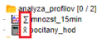

Image 164: Character shown at profiles

1. Display character will be disabled by clicking the right mouse button on any folder or profile in the menu. In the window that appears, navigate with your cursor to the item "Display" and select "Hide Character".

## If I could restore the list

Click the right mouse button on the folder in tree structure and press 'Refresh' button to restore user profiles and address list.

## To set up user and group rights

Rights for users and user groups set:

1. Click with the right mouse button on the folder for which you want to set permissions.
2. Choose the item "Definition of rights".

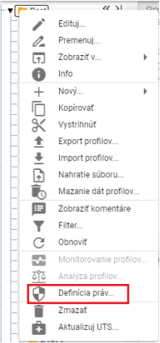

Picture 165: Item "Definition of rights"

1. A window called 'Settings' will be shown.

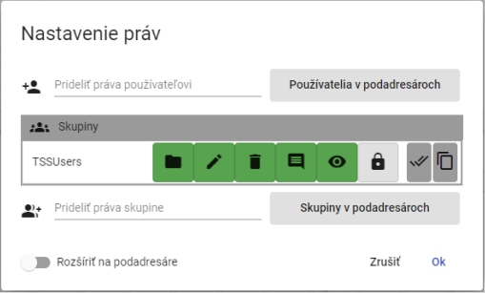

Picture 166: Window Settings Rights

1. Before granting the user rights, click on the "Grant Rights to User" field and start typing in the username. Automatically a list of matching the entered text will appear.

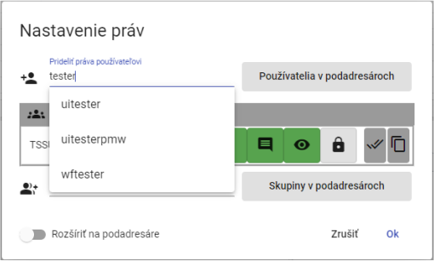

Picture 167: Give user rights in the city of Pridelić start writing user name

1. Select user by which table 'Users' containing the selected user will be shown.

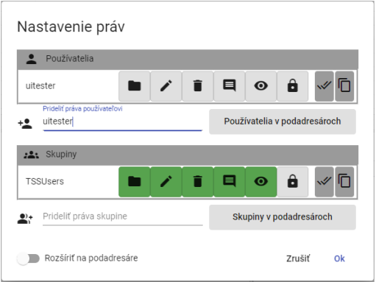

Image 168: Selected user

1. Click on the buttons to add user rights.

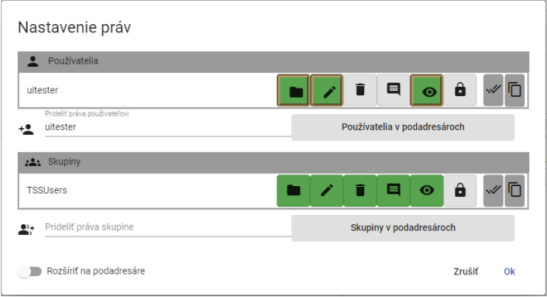

Picture 169: Granting rights to user

1. Before assigning rights to a group, select the group from the field 'Assign rights to group'.

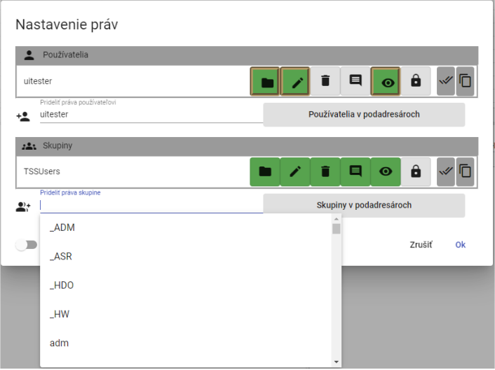

Image 170: Selection of a group

1. The selected group will appear in the table 'Groups'.

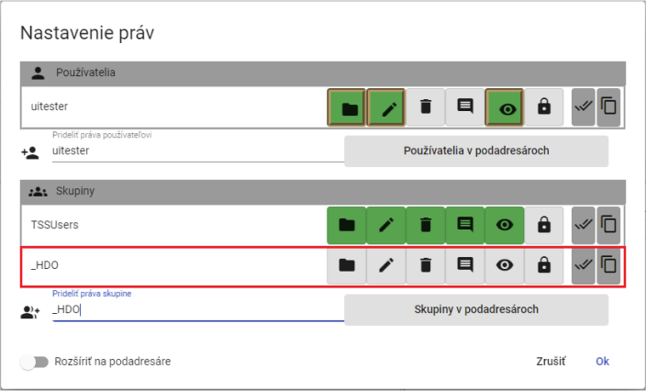

Picture 171: Selected Group

1. Clicking on the buttons, set up rights for the selected group.

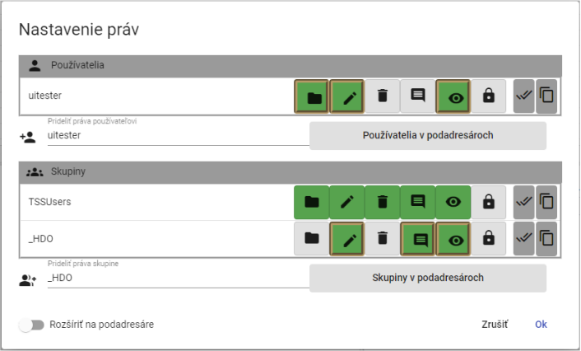

Image 172: Rights Deed of the Group

1. If you want to set rules for sub-distributors as well, click the 'Expand to sub-distributors' button.

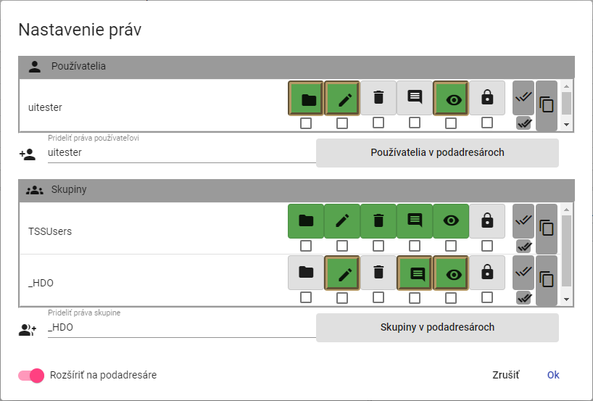

Image 173: Permission to Expand to Subscribers

1. Under the buttons representing user rights and groups checkboxes will appear. Check the boxes under the buttons where you'd like the right to be extended to sub-addressees.

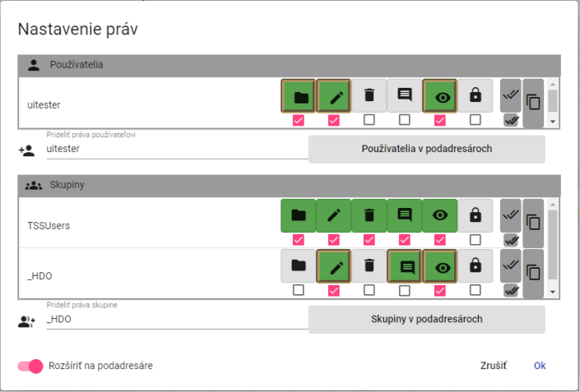

Picture 174: Setting user and group rights for sub-addressers

1. Save changes by pressing the 'OK' button.

## How to create an export

Before exporting profiles, proceed with:

1. Click the right mouse button on a folder in the structure tree or click the right mouse button on the line with an address from which you want to export profiles in the inspector window.
2. Select item "Export profiles..."

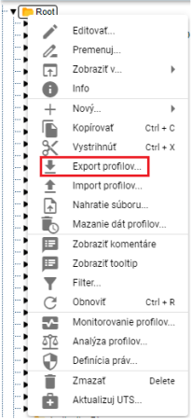

Image 175: Item "Export profiles..."

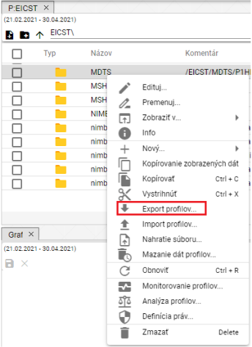

Picture 176: Export item in Explorer window

1. A window called 'Export' will appear, which contains two tabs 'All' and 'Profiles (CSV)'. The tab 'All' is displayed by default. The 'All' tab allows exporting counted profiles in the form of an expression. The 'Profiles (CSV)' tab exports only data.

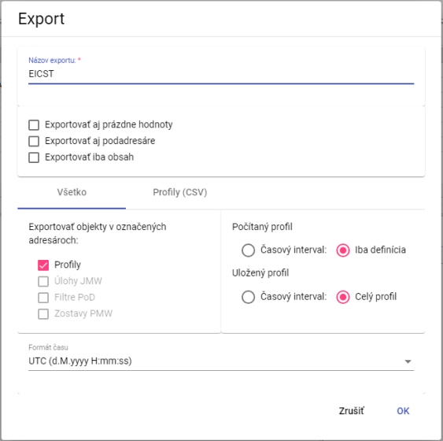

Picture 177: Export window bookmark "Everything"

1. The field 'Export name' is normally filled with the name of the recipient from whom you want to export profiles. You can change the export name.
2. In the top part of the window, select what you want to export (also subaddressers and empty values, just contents).
3. In the tab marked 'All' in the section 'Export objects to selected recipients', select which objects should be exported.
4. Select before "Computed profile", whether to export "Time interval" or "Only definition".
5. In the part "Saved profile", select whether to export "Time interval" or "Full profile".
6. In the 'Time Format' section, select the time format.
7. If you want to export profiles in CSV format, click on the tab "Profiles (CSV)".
8. In the part 'Time Interval (mm/dd/yyyy)' select dates in the fields 'Date From' and 'Date To'.
9. Click into the field “Columns Separator” and select a separator.
10. Click on the field "Decimal Separator" and select the separator.
11. In the "Format Time" poll, select your time format.

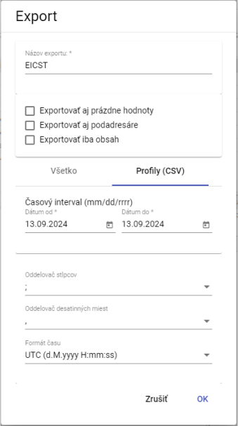

Picture 178: Export window Tab "Profiles (CSV)"

1. Export is initiated by pressing the 'OK' button.
2. Information about the state of exports will be displayed in the "Exports" window, which is covered in chapter 1.20. In the "Exports" window it is possible to download a completed export afterwards.

## How to create an import

Before creating an import, proceed with:

1. Click the right mouse button in the tree structure on the folder you want to import a file into.
2. Select the item "Import profiles..."

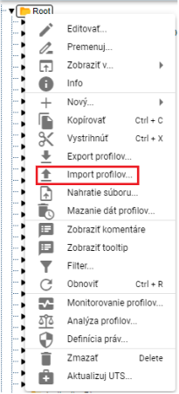

Image 179: Item "Import profiles..."

1. An import window will appear.

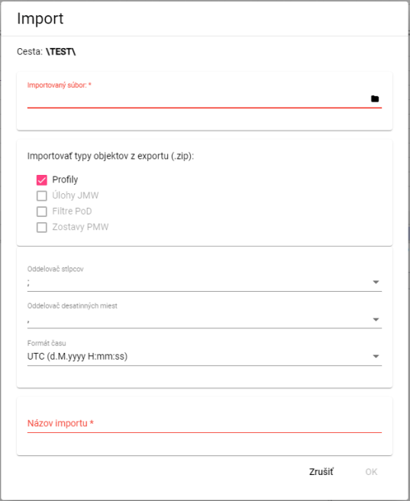

Image 180: Window "Import""

1. **In the “Imported File” section, click the black file icon and select the file you want to import.**
2. In the section "Import types of objects from export (zip)" select what to import. By default, the selected item is "Profiles."
3. Click on the field "Column separator" and select separator.

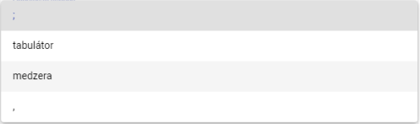

Figure 181: Menu for the “Column Separator” option

1. Click into the field "Decimal separator" and select a decimal separator.
2. In the field "Name of Import", enter a name for the imported file.
3. You import the file by pressing the "OK" button.
4. On the selected recipient, the imported file will be displayed.



Picture 182: Imported file

Information on the state of imports will be displayed in the window "Imports", which is dealt with in Chapter 1.21.

## Add a new profile

Before adding a profile, proceed:

1. Click with the right mouse button on the folder into which you want to add a profile.
2. In the drop-down menu, choose 'New' and then 'Profile'.

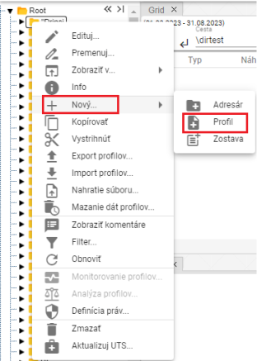

Picture 183: Creation of profile

1. A window for creating profile will appear.

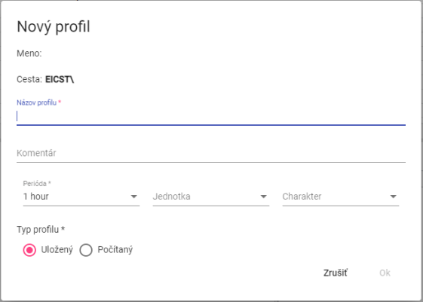

Image 184: Window for creating profile

1. Please enter data.
2. The fields 'Profile name', 'Period' and 'Profile type' are mandatory.
3. **The profile name must not start with a number. It can contain letters, digits, and underscores. The name must be at least 3 characters and no more than 50 characters long. If you do not enter a name or enter an invalid one, a message will be displayed regarding the profile name. The rules for entering a profile name may vary depending on the configuration of the given environment.**

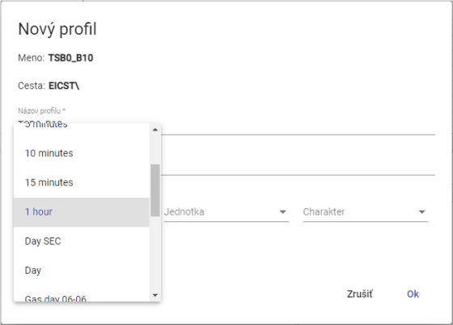

Picture 185: Period selection

1. When you select a calculated profile type, please enter the definition. For example, profileA+2*(profileC-2). The arithmetic options are described in document „Xenergie TSS Kompl_prehl_fnc_G2 R12.xlsx“. Chapter 2.18.1 deals with creating a definition for a calculated profile.

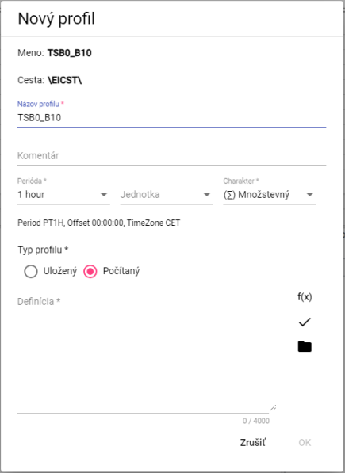

Image 186: Calculated Profile Type

1. Create profile by pressing the "OK" button.

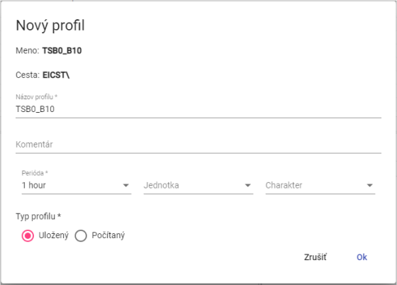

Image 187: Saved profile type

Character profile:

• Quantitative - represents a quantity for example the consumed energy over a certain time period.

Process-oriented - represents the state of a certain quantity at a specific time. For example, temperature process

• Undefined – If the profile does not explicitly define one of the two upper characters, the system behaves towards it as if it were Behavioural. This behaviour was chosen with respect to maintaining backwards compatibility with older versions of the Xenergie system and thus allows for a trouble-free transition to newer versions of the system.

This profile serves for the identification of how values in the profile are to be transferred from coarse to finer sampling. For example, energy values in MWh over a quarter-hour should be added up during conversion, while power values in MW over a quarter-hour should be averaged out.

This character profile is used exclusively and only in connection with the need to synchronize (convert a profile to another period) the profile. In the event of using the profile in its native period, this setting is irrelevant.

### What is the definition for a counted profile type?

Please follow these instructions before setting the calculated profile type:

1. Click the 'Wizard for functions' button on the 'New profile' window, which will display a window to enter a function.



Picture 188: The Wizard button in function

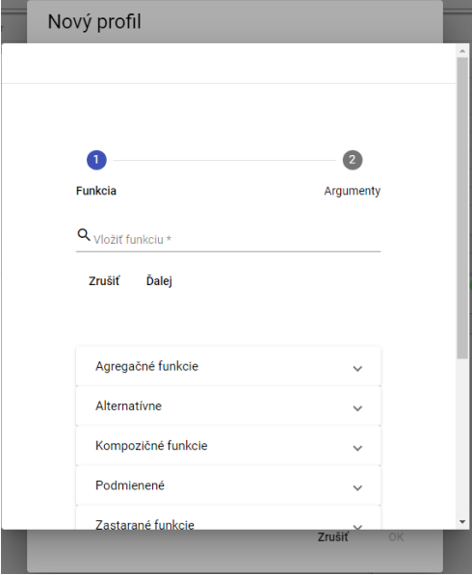

Image 189: Wizard before function assignment

1. Click on the field "Insert Function".

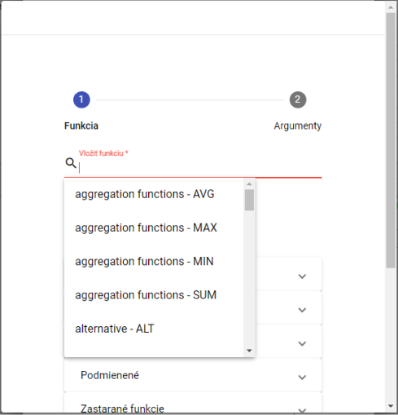

Image 190: Function selection

1. A list of functions will be shown, from which you can select a function.
2. After selecting the function, its description will be displayed.

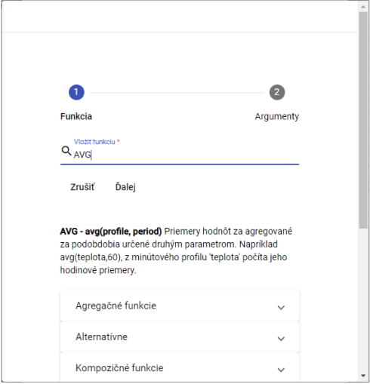

Image 191: A description of the function will appear after selecting the function

1. By clicking on the group of functions, a list of functions with description will be displayed.

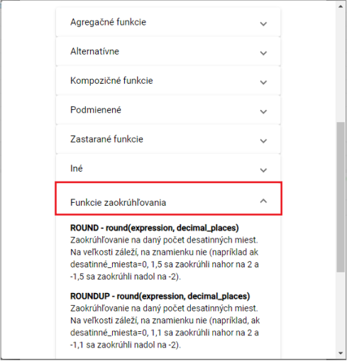

Image 192: Description of functions

1. Write the path to profile or click on button , which will display window "Choose profile", in which you select a profile.
2. Fill out the form.

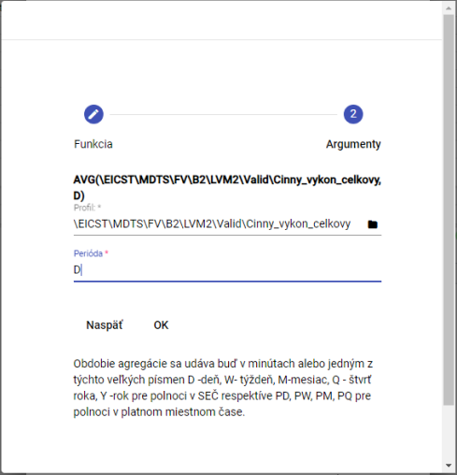

Picture 193: Period task

1. Press the "OK" button.
2. Click on the 'Check definition' button after entering the definition in the 'New profile' window.

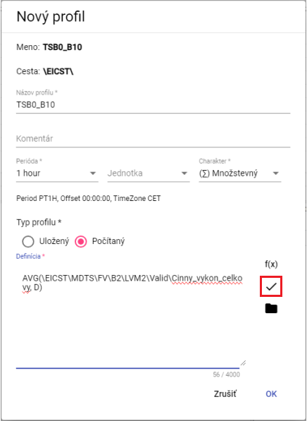

Image 194: Definition checking button

1. A window called 'Status' will appear, which you can close by pressing the 'OK' button.

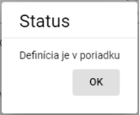

Image 195: Status Window

1. The button serves for adding a profile.
2. **You can save the profile by clicking the “OK” button.**

## To add a new team.

You will create a new team:

1. Click on the folder where you want to add a new composition with your right mouse button.
2. Choose item "New..." and then item "Remains".

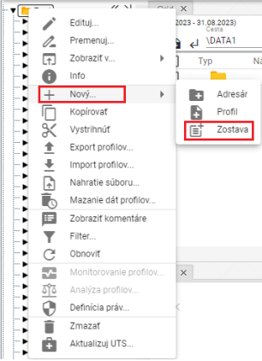

Picture 196: Entry "Stays"

1. It will show the window "Name of the group".

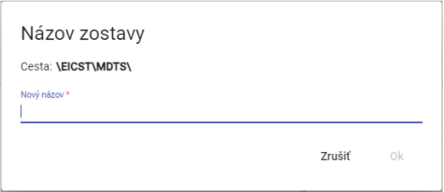

Picture 197: Window "Team name"

1. Please enter a name for the new team. The team name must not start with a number and may contain letters, numbers and underscores. The name must be at least 3 characters long and no more than 50 characters long. If you do not enter a name or if you enter an invalid name, information about the rules of the name will be displayed. The rules for entering a name may vary depending on the configuration of the given environment.

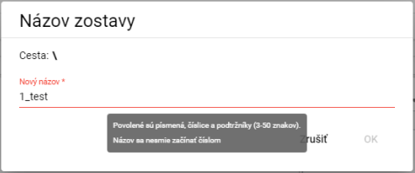

Image 198: If the name is invalid, an information with rules for naming will be displayed

1. Click OK to confirm.
2. A new team will be added to the chosen player.

## How to change the profile

Profile menu switched:

1. Click on the right mouse button on the profile you want to change.
2. Click on 'Rename'.
3. **[TRANSLATION FAILED AFTER 3 RETRIES] Zobrazí sa okno, v ktorom zadajte nový názov. Názov profilu sa nesmie začínať číslom. Môže obsahovať písmená, číslice a podčiarkovníky. Názov musí mať minimálne 3 znaky a maximálne 50 znakov. Ak nezadáte názov alebo by ste zadali neplatný názov, zobrazí sa informácia k názvu pre profil. Pravidlá pre zadanie názvu profilu sa môžu líšiť podľa konfigurácie daného prostredia.**

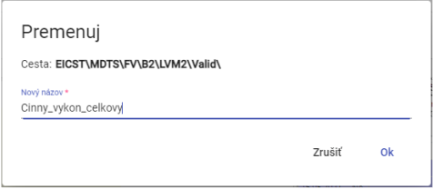

Picture 199: Profile Modification

1. You will save changes by pressing the button "OK".

## Edit my profile

Before editing the profile, proceed:

1. Click on the right mouse button on the profile you want to edit.
2. In the menu, select the item "Edit."
3. A window will appear where you can edit the data.

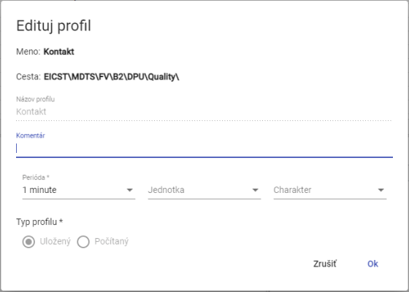

Image 200: Edit window for profile

1. You will save changes by clicking on the button "OK".

## To delete profile

Procedure for deleting profile:

1. Click with the right mouse button on the profile you want to delete.
2. Choose item "Delete" on purpose.
3. A window will appear, in which you confirm the deletion of your profile by clicking on the button “Yes”.

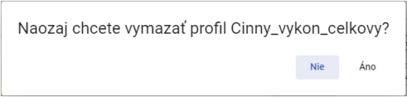

Picture 201: Window for confirmation of erasure

## To view dependency profile

Dependency profile will be displayed:

1. Click on the right mouse button at the profile in the tree structure.
2. Select the item "Dependencies".
3. A window with three tabs 'Used profiles', 'Full definition' and 'Dependent profiles' will be displayed. The first tab contains a list of used profiles.

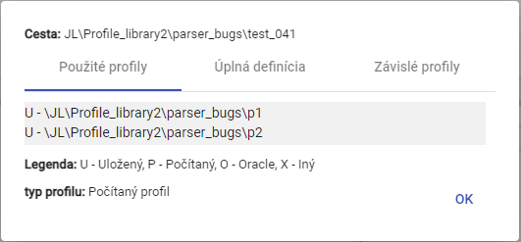

Picture 202: Bookmark "Used Profiles"

1. The second tab "Full definition" contains the profile definition specified at profile creation.

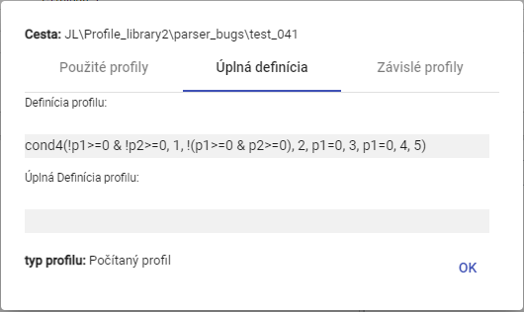

Picture 203: Bookmark "Full Definition"

1. The third tab "Dependent profiles" contains a list of dependent profiles.

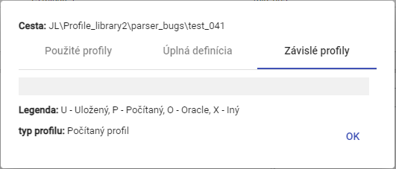

Picture 204: Bookmark "Dependent Profiles"

## How to create a new profile

In the inspector window, you create a new profile by clicking the "create new profile" button located in the upper left corner of the inspector window. A "new profile" window will be displayed. The procedure for creating a profile is detailed in Chapter 2.18.

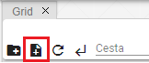

Image 205: Button "Create new profile"

## How to set up a political profile

The policy defines special behavior of the profile. Policies are added to the system based on special customer requirements.

Time Policy Profile:

The time policy of a profile is the property of the profile which allows to solve very specific cases of data transformation in profiles.

**[TRANSLATION FAILED AFTER 3 RETRIES] Jedným z využití politiky je možnosť zmeniť periódu uloženému profilu z 1h na 15minútový bez potreby zdĺhavej a pomalej transformácie dát. Po aplikácii politiky „1h to 15min“ sa z pôvodne hodinového uloženého profilu stane 15minútový a to na celom rozsahu. Všetky aplikácie, ktoré daný profil používajú ho od momentu transformácie vidia už len ako 15minútový. Politika je teda pre ostatné aplikácie mimo TSS plne transparentná.**

The '1h to 15min' policy must have a firmly set date of change, from which the profile will be used as fully 15-minute one. Before that date, the profile will appear as 15-minute one, but all four values in an hour will always be the same. Their value will depend on the assigned character of the profile.

Example:

The original hourly profile had a value of 100 MWh. If the character profile is set to 'Quantitative', then a 15-minute profile returns in each 15 minute a value of 25 MWh.

If the profile type is set to 'Profile by time', then a 15-minute profile after setting up a policy will return a value of 100 MWh every 15 minutes in a given hour.

Proceed with policy setting:

1. Click on the right mouse button on a profile in the tree structure to which you want to set a policy.
2. Select the item "Policy".
3. A window 'Policy settings' will appear.

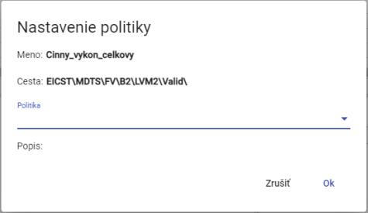

Image 206: Window "Policy Setting"

1. Currently two policies are available

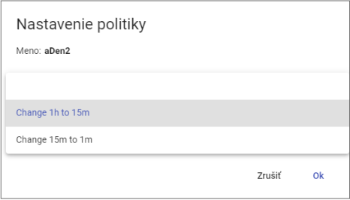

Picture 207: Selection of Policy

1. You will save changes by pressing the "OK" button.

## Show information about profile

Before viewing information about your profile progress, proceed:

1. Click with the right mouse button on the profile you want to display information for.
2. Choose the item "Info".
3. An information window will be shown.

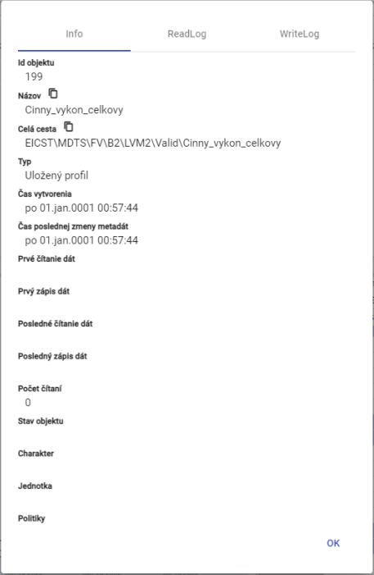

Picture 208: Profile Information

## Copy profile

Before copying your profile, proceed with:

1. Click with the right mouse button on the profile you want to copy.
2. Choose the item "Copy".
3. **[TRANSLATION FAILED AFTER 3 RETRIES] Kliknite pravým tlačidlom myši na adresár, do ktorého chcete vložiť skopírovaný profil a vyberte položku „Vložiť“.**
4. The "Move/Copy" window will appear.

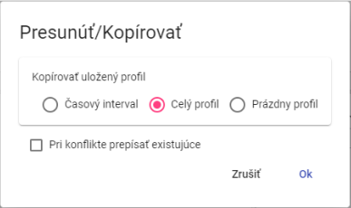

Image 209: Window "Move/Copy"

1. Select whether to copy only the time interval, the entire profile or an empty profile. The standard selected item is 'Entire Profile'.
2. Press the button "OK".

The saved profile can be copied from one recipient to another by clicking the left mouse button and dragging it over to the folder where you want to copy it.

Before copying the recipient, proceed:

1. Take your address book and move it to the address book from which you want to copy the profile.
2. Then clear the address book over the addressee, by which the window 'Move/Copy' will be displayed.

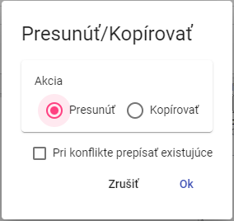

Picture 210: Window for profile transfer

1. Click on the "Copy" action.

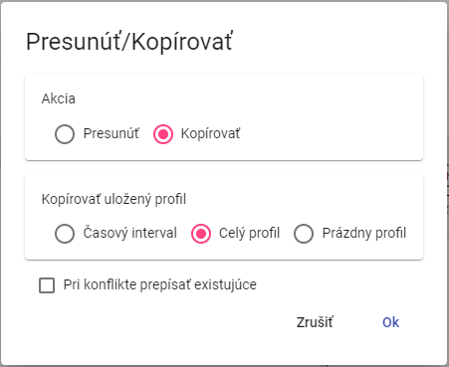

Picture 211: Window for copying profile

1. In the section 'Copy saved profile', choose whether to copy the entire profile, a time interval of the profile or an empty profile.
2. Please enter the time interval that you wish to copy.

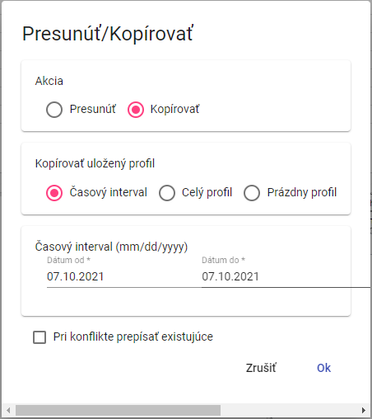

Image 212: Window for copying a stored time profile

1. Checking the "Overwrite existing in conflicts" checkbox means that if there is a profile with the same name as the one you want to copy in the address book, it will be overwritten. If you do not check this box and a conflict arises, the original profile will remain unchanged.
2. Copy the profile by clicking on the 'OK' button.

## To pull out/shift profile

Before publishing your profile, proceed:

1. Click on the right mouse button on the profile you want to pull out.
2. Choose item "Eject" under Properties.
3. Click on the folder where you want to add the profile with the right mouse button.
4. Choose the item "Upload"
5. A window will appear for confirmation, where you click the 'OK' button.

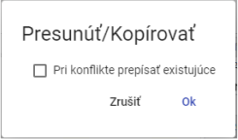

Image 213: "Move/Copy Window"

You can transfer the saved profile from one recipient to another by clicking on it with the left mouse button and dragging it into the address book where you want the profile to be transferred.

Proceed with assumption of addressee:

1. Take the profile and move it into the folder you want to transfer the profile to.
2. Next, click on the recipient's profile, which will display a window called 'Move/Copy'.



Image 214: Window for profile transfer

1. Checking the box "Rename existing in conflict" means that if there is an account profile with the same name as the one you want to move, it will be renamed. If the box is not checked and a conflict arises, the original profile will remain."
2. You will save the profile by clicking on the "OK" button.

## How to display timeline overview in tree structure

Click on the profile in tree structure twice with left mouse button before displaying time grid preview. The 'Time Grid Preview' window will appear. The 'Time Grid Preview' window is described in Chapter 4.7.

## If I enlarge the window for creating and editing the counted profile

You can enlarge the window for creating and editing the calculated profile. Follow:

Click the left mouse button to select an option - and drag. Resize the window to your required size and click the left mouse button again.

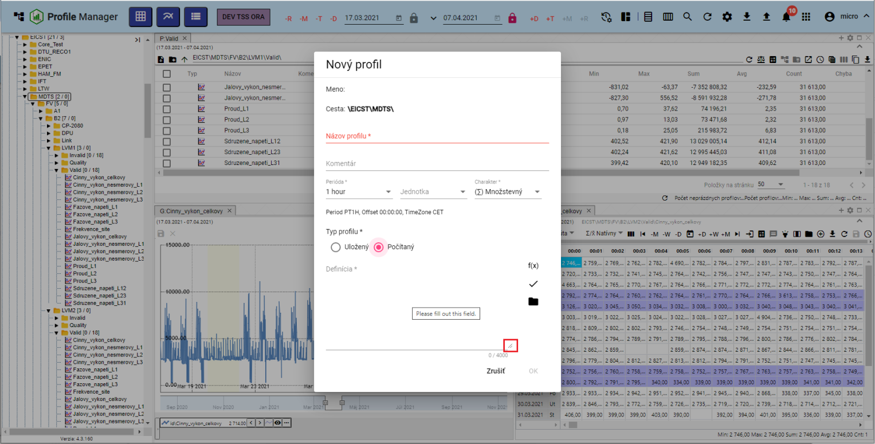

Image 215: Button for enlarging window "New Profile"

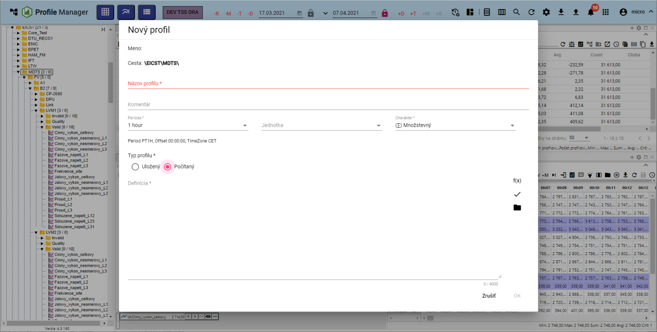

Image 216: Enlarged window of "New Profile"

## I want to move the windows

Drag the window of the 'Profile Manager' application to your desired location by clicking on the top-left corner of the window and dragging it with the left mouse button.

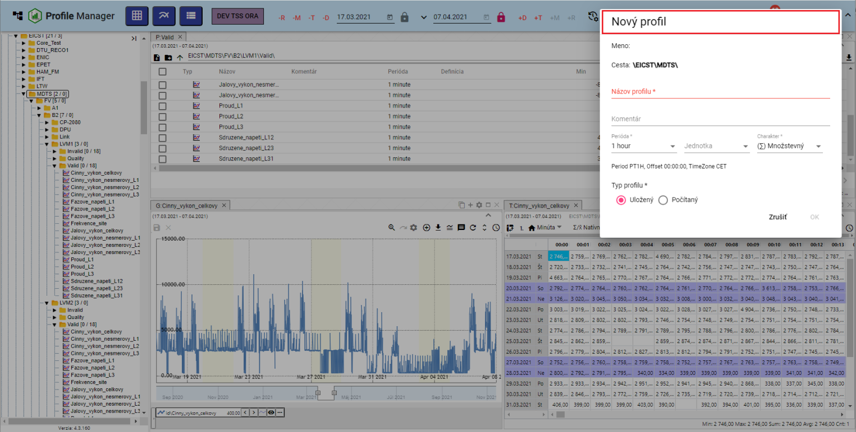

Picture 217: Rearranging of the window "New Profile"

## How to convert a document

Document (e.g. agenda, report) please translate:

1. Click on the right mouse button on the document you want to convert.
2. Choose item "Rename" in options.
3. A window called 'Rename' will appear.

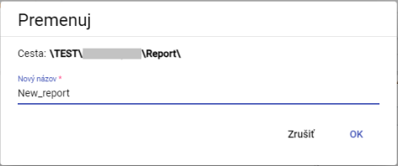

Picture 218: Window "Reform"

1. Change the name.
2. Press the "OK" button.

# Shared controlling elements for explorer, table and graph

In the top part of the window, a scout, table, and graph are located below buttons for manipulating windows. Work with buttons is further developed in the following subchapters.

## How to refresh data in windows

Before automatic loading of data in windows click the button showing Image 219.



Image 219: Restore button for data in Explorer window, table, graph.

## Change date range

Change the date range in the explorer window, table or chart:

1. Click on the button “Adjust time range” which is located in the top right corner of the window.



Picture 220: Time Range Change Button

1. A window for setting date range will be shown.

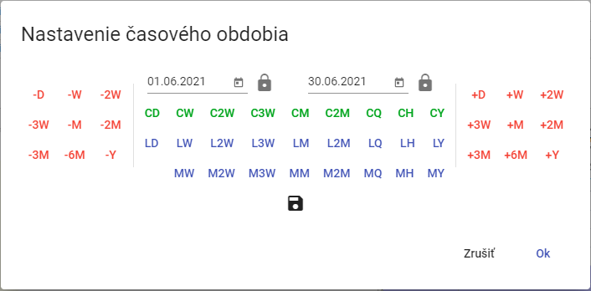

Picture 221: Window for changing date range

1. You can set the date by pressing buttons, selecting a date or directly entering the date.
2. You can save a new date range by pressing the floppy disk button. A maximum of three date ranges can be saved.



Image 222: Save date range button

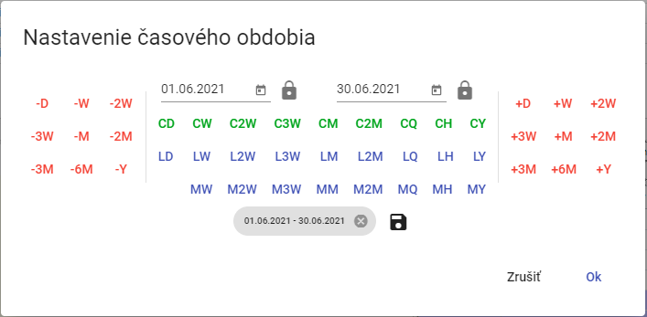

Picture 223: Saved date range

1. Date range is activated by pressing the 'OK' button.

## If I enlarge the window across the entire application area

Clicking the 'Maximize' button (Figure 224) or double-clicking on the top panel bar, Figure 226, will enlarge the chart, viewer and table. The window then appears across the entire application area. After clicking the 'Maximize' button, a 'Restore Size' button appears in its place, which serves to restore the window to its original size. An enlarged window can also be reduced by double-clicking on the top panel bar.



Image 224: Maximize button



Image 225: Resize button

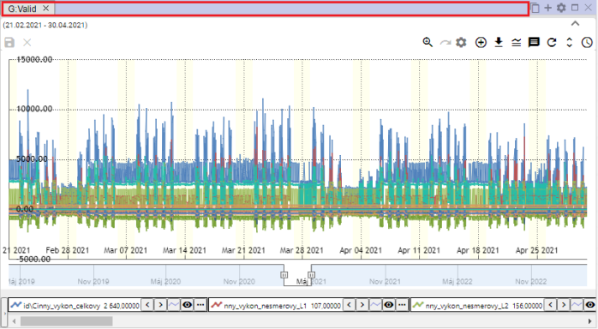

Picture 226: Top strip of the panel

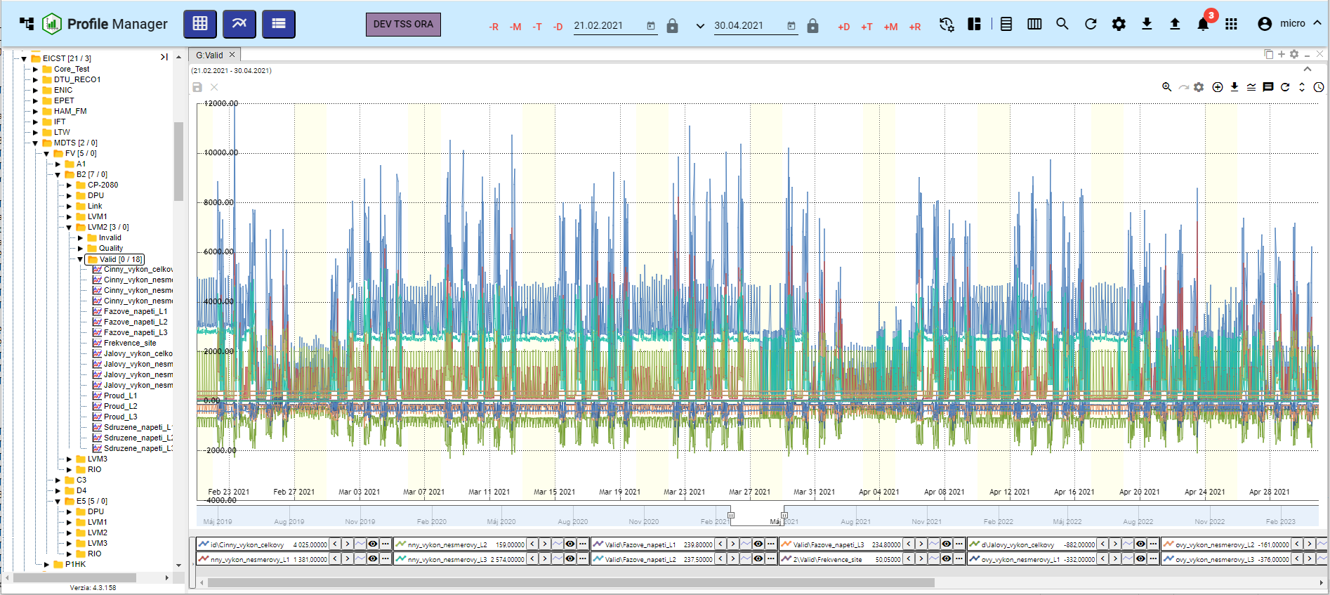

Picture 227: Window enlargement graph

## If I were to close the window

Click the 'x' button located at the title bar and top-right corner of the window to close the graph, explorer and table.



Image 228: Close button for closing the window

## Setting name and color of panel

They have standard names Explorer, Table and Graph. You can change the name and color of the pane as follows:

1. Press the button "Panel settings", which is located in the top right corner of the window.



Picture 229: Button "Panel settings"

1. A window named 'Panel settings' will appear.

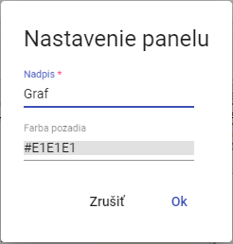

Image 230: Window "Panel settings"

1. Fill in the title of the "Header" field.
2. To adjust the color of the background, click on the field 'Background Color' and select a color.

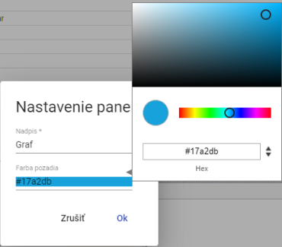

Image 231: Color selection

1. Save changes by pressing the "OK" button.

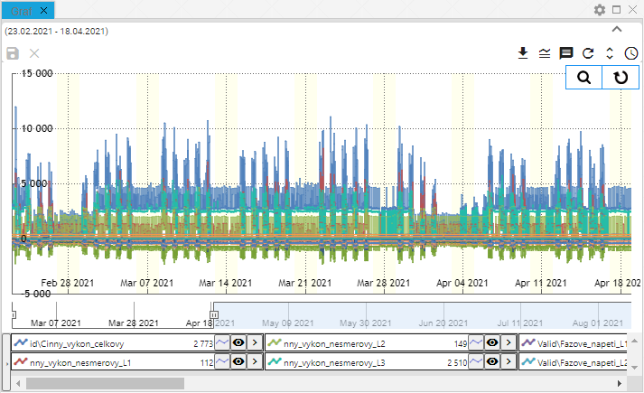

Picture 232: Altered color of the panel

## Export shown data from Explorer window

You can export the displayed data to windows explorer, table or graph by clicking on the export button, Image 233.



Image 233: Export button

## To hide the top panel with buttons on the explorer window, table and graph

The header bar in the windows, table and chart can be hidden using a button that displays Picture 234. To display the top part again, click on the button again, Picture 235.

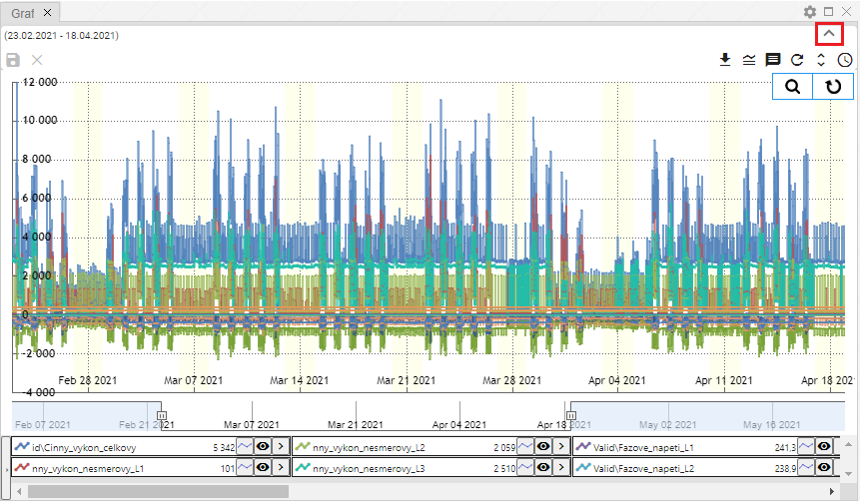

Image 234: Toggle button for hiding the top part in windows explorer, table and graph

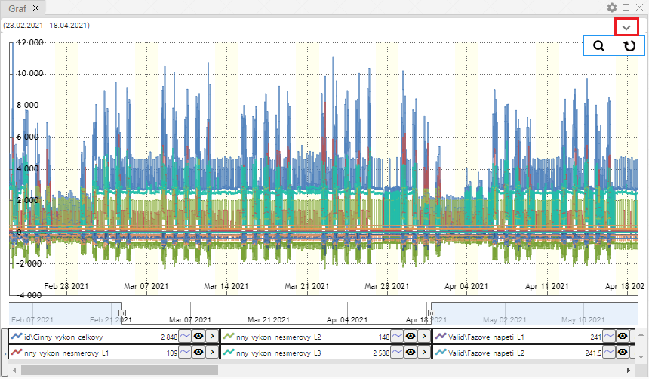

Image 235: Toggle button for upper part in explorer windows, table and graph

## To add profile to graph and table

On the graph and table, you can add a profile according to the following procedure:

1. Click on the 'Add profile' button, which is located in the top part of the chart or table.



Photo 236: Add Profile Button

1. A window 'Add profile' will appear.

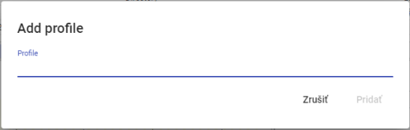

Picture 237: Window "Add profile"

1. Provide the path where the profile is stored.

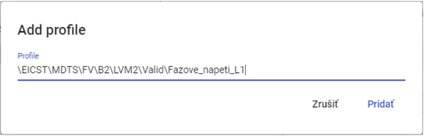

Image 238: Task route to profile

1. Click on the 'Add' button.
2. The selected profile will be added in the graph/chart window.

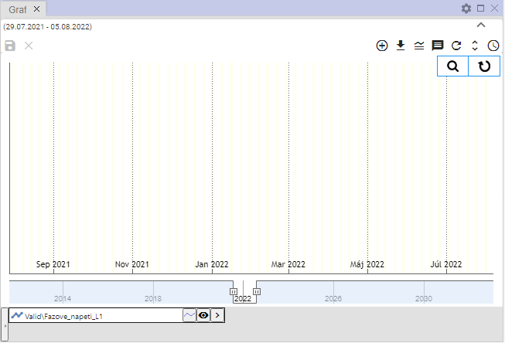

Image 239: Added profile in graph window

# Work with an office Inspector

After launching the 'Profile Manager' application, the Explorer window is filled with directories and profiles from a tree structure. During work with the application you can add any number of Explorer windows.

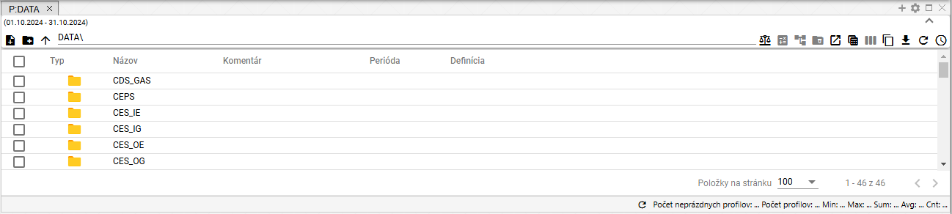

Image 240: "Explorer" Window

## To show profiles from selected recipient in the Explorer window

In the Prieskumník window, standardly displayed are addresses and profiles from a tree-like structure. You can display the profile of the selected address by double-clicking the left mouse button on the "Type" button in the column.

Click on the arrow icon to show list of recipients

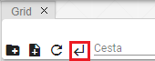

Picture 241: Button for step back

## How to create a new folder

In the Prieskumník window you can create a new folder by clicking the 'create new folder' button. A 'new folder' window will appear. The process of creating a folder is described in chapter 2.1.

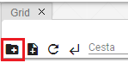

Picture 242: Create New Folder button

## I synchronize the scanner with the tree

The button "Sync with Tree" means that the explorer is synchronized with the tree. The unchecked button "Sync with Tree" means that if a folder changes in the tree, this change will not be reflected in the explorer window.



Image 243: Synchronization button with tree



Image 244: Disrupted synchronization with the tree

## I am filtering profiles

The profiles shown in the explorer window can be filtered according to individual columns. Proceed:

1. Move the mouse cursor to the name of the column you would like to apply the filter.
2. Click on the button, which will display the window for entering a filter.



Image 245: Filter button

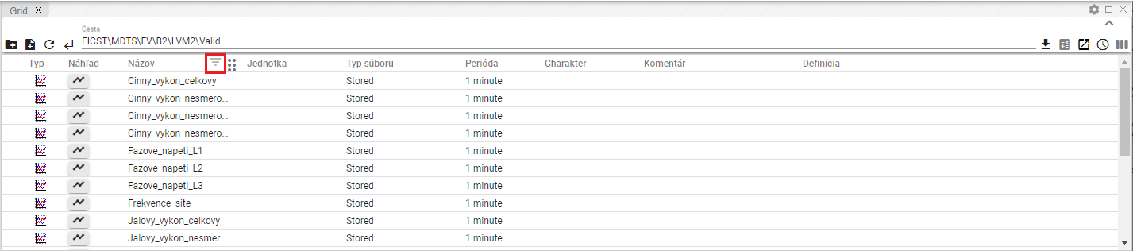

Image 246: Button for filtering over column "Name"

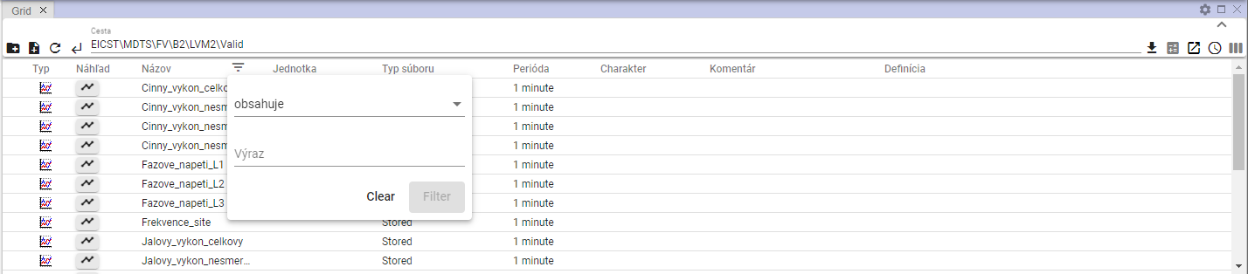

Image 247: Window for filtering

1. Write filtering criteria.

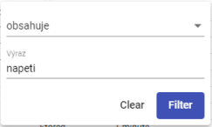

Image 248: Task of filtering criteria

1. Press the "Filter" button or press the Enter key.
2. Profiles are shown that meet filtering criteria.

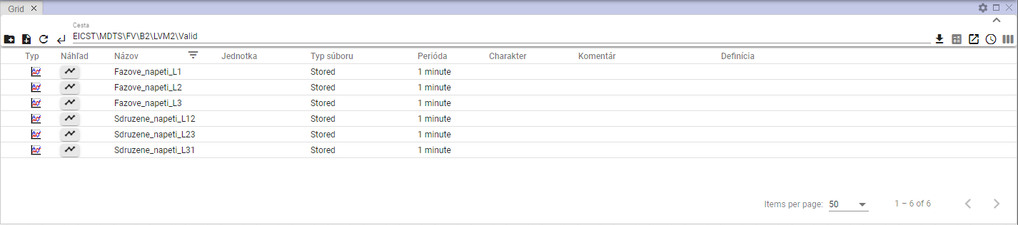

Image 249: Applied Filter

1. Above the button on which an applied filter is displayed.
2. By clicking on the button, it will be deleted, and by displaying the filtering window and then pressing the "Clear" button.

## Sort data in columns

Before sorting data in the column, place the cursor of your mouse on the name of the column and click on the arrow that will appear next to the name of the column.



Image 250: Sort button for dates in column

## How to calculate values in columns Min, Max, Sum, Avg and Count in the Explorer window.

Before calculating values in columns in the window, browse:

1. In the window, show the profiles of the recipients to whom you want to calculate the summary values.

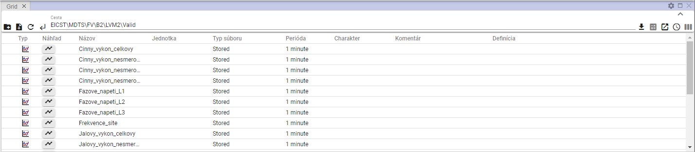

Picture 251: Displaying the addressee in the Explorer window

1. Press the button "Statistics".



Image 252: Statistics button

1. Additional values are added in the columns "Min", "Max", "Sum", "Avg", and "Count".

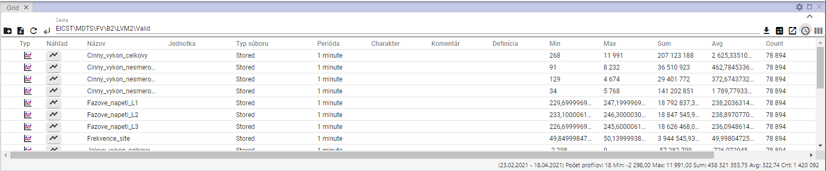

Image 253: Calculation of statistics in a debugger window

## A glance into time's sequence.

Before viewing a time table, proceed:

1. Click twice with the left mouse button on the button next to the profile whose time graph preview you want to display in the 'Type' column of the 'Prieskumník' window.

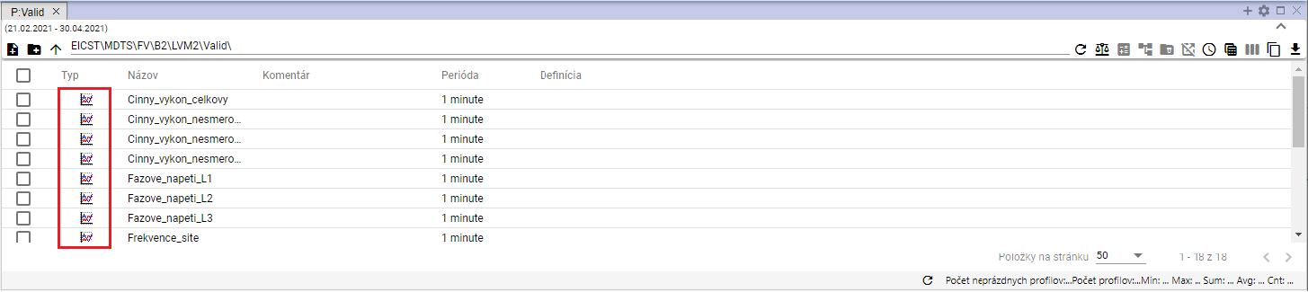

Image 254: Button for displaying the "Time Bar" window

1. A window 'Timeline View' will appear.

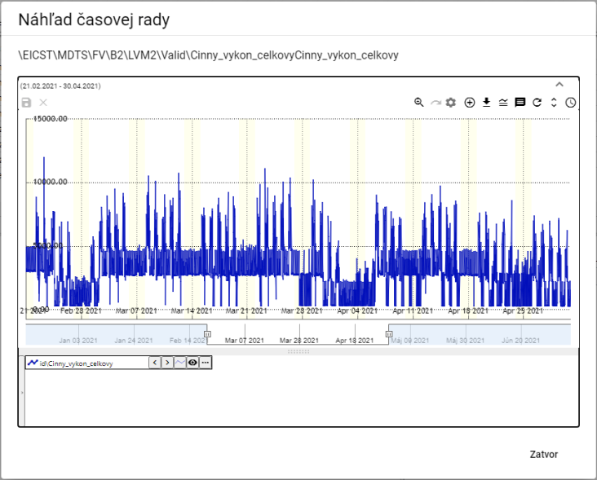

Picture 255: Window "Preview Timeline"

1. Activities concerning the buttons located at the top-right corner of the graph are discussed in chapter 5.



Picture 256: Pressing tools for work with graph

1. At the bottom of the window, there is a profile name. Clicking on the right mouse button next to the profile name will display a list of functions for working with the profile. Functions are elaborated in chapter 5.7.

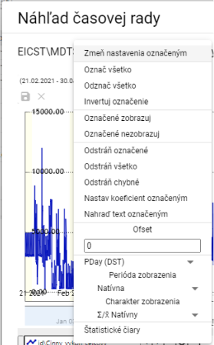

Image 257: Functions for working with profiles

1. By clicking on the arrow next to the profile name, you will display a window with functions that are detailed in chapter 5.8.

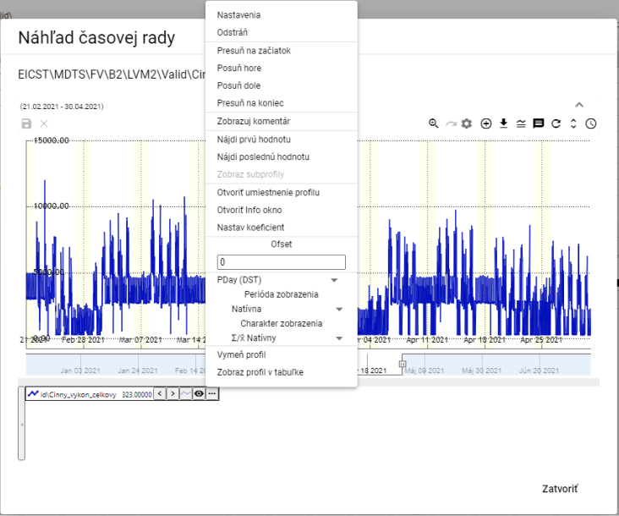

Picture 258: List of functions for working with profile

## Move profile from Explorer window into Graph or Table window

You can move the Explorer Bar to windows of Explorer or Table. You can move the address bar from the window of Explorer to the window of Graph. The profile, which is located in the window of Explorer, you can grab and move it to the window of Graph or Table.

Proceed:

1. In the explorer window, click on the address bar or profile you want to move into the Graph or Table window with your mouse cursor.

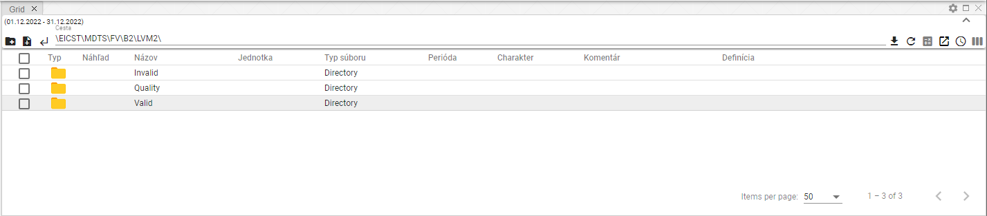

Image 259: Selected Profile

1. Click the left mouse button on the row in the Explorer window and drag it to the window in which you want to see it and start.

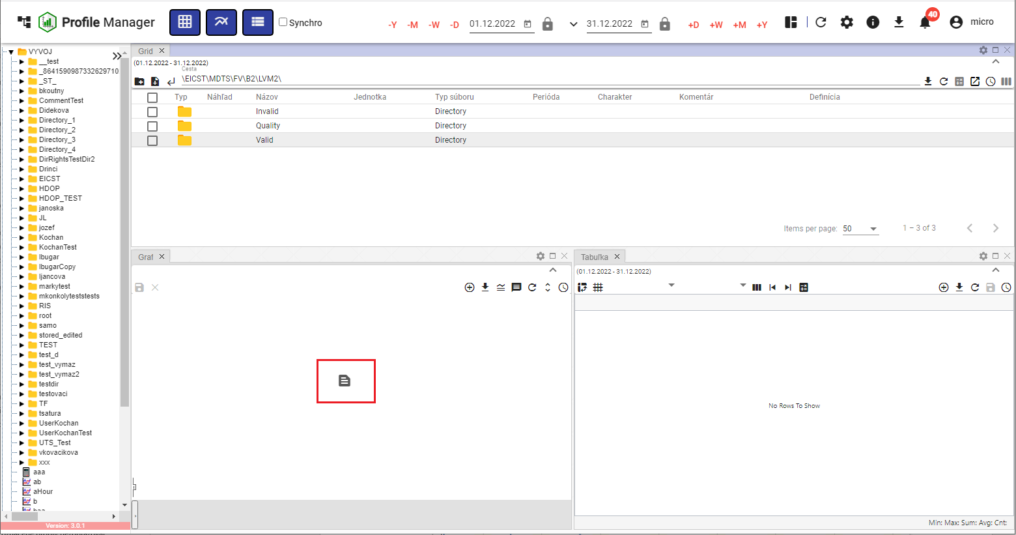

Image 260: Profile migration to Graph window

1. The profile will be displayed in selected window.

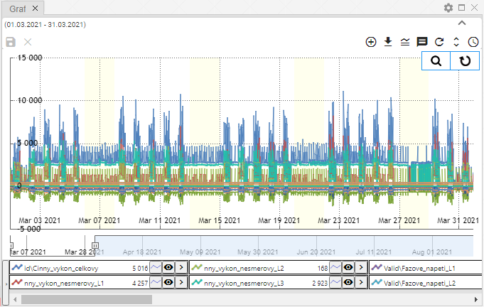

Image 261: Profile moved from Spyglass window to Graph window

## How to add, remove or modify columns in the Explorer window

You can change the list of columns shown in the Prieskumník window. You can add or remove columns.

Before changing the columns displayed:

1. Press the 'Choose columns' button, which is located in the top-right corner of the Finder window.

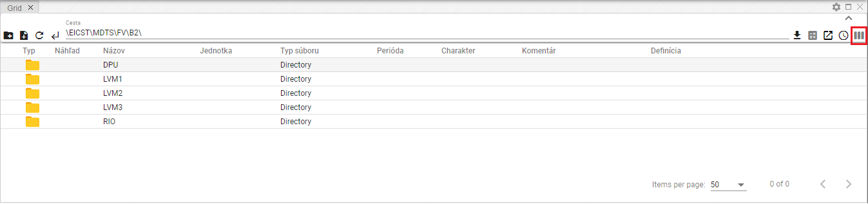

Image 262: Button "Select Columns"

1. It will display a block with a list of columns.

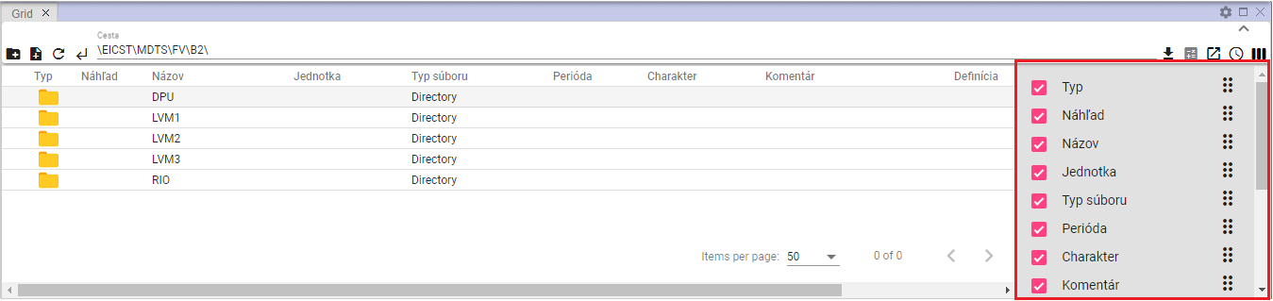

Image 263: Column list

1. Add/Remove columns that should be displayed. While editing the list of selected columns, a change will automatically occur in the inspector window.
2. You can change the column order in the 'Prieskumník' window. To change the column order, click on the 'Move column' button and move the column to its desired position in the list.

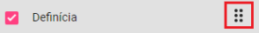

Image 264: Button for column shift

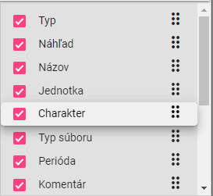

Image 265: Character column migration

## Edit fields Name and Comment

You can edit the 'Name' and 'Comment' for profiles and addresses in the Properties window.

Before making adjustments, please proceed:

1. Click twice with the left mouse button on the field to access it for editing.

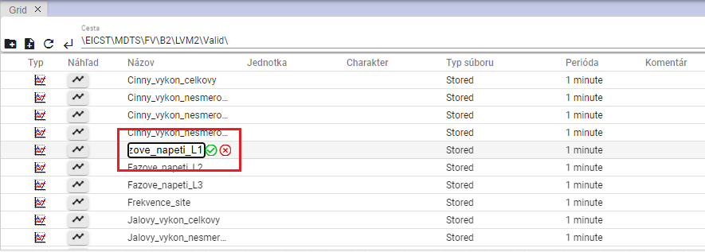

Picture 266: Profile Name Correction

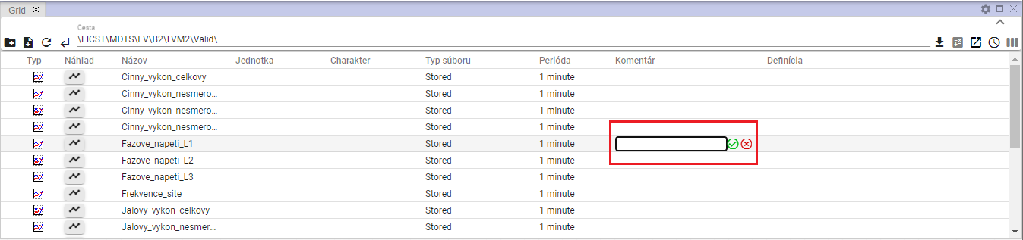

Image 267: Task for commentator's profile

1. Edit the text.
2. Save changes by pressing the button.

## Functions for working with address books in the Explorer window

To view functions for work with your address, click the right mouse button on the address bar in the Explorer window. Work with functions is detailed in Chapter 2.

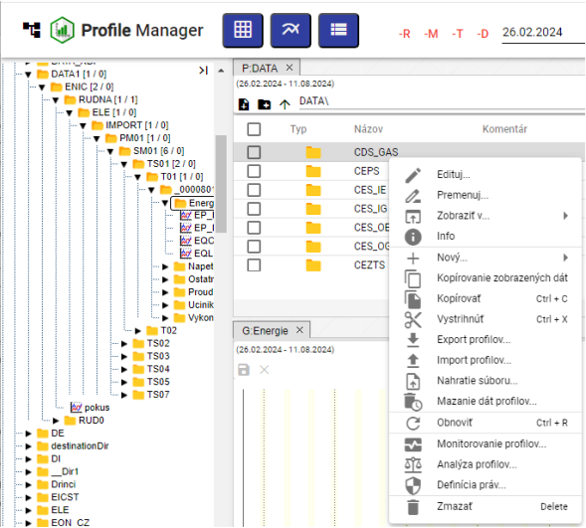

Image 268: List of functions for working with directories

## Functions for work with filters on window Explorer

Functions for working with profiles can be displayed by clicking the right mouse button on a profile in the Explorer window. Working with functions is detailed in Chapter 2.

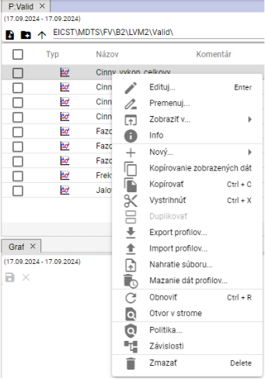

Picture 269: List of functions for working with profiles

## Branch View Button

The 'Branch view' button allows performing batch operations on all profiles in the database, regardless of which address book the profile is in. From the batch operation, you can use 'Edit' and 'Delete'.

The 'Branch view' button displays items from the selected folder without categorization into subfolders, Image 271. For a standard display of folders in the Explorer window, click the 'Branch view' button again.

Procedure for mass editing of profiles:

1. Click on the 'Branch view' button, which will display a list of profiles without addressors.

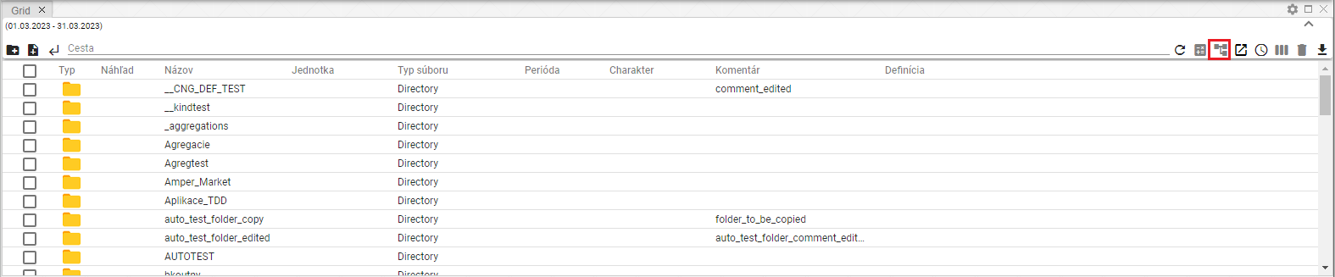

The image 270: Button "Branch View"

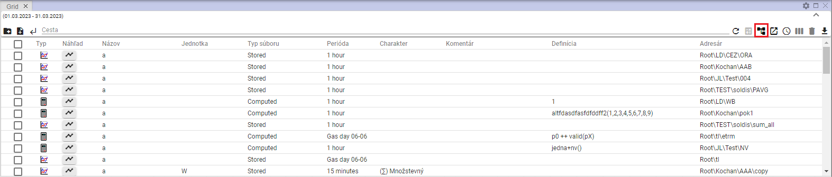

Image 271: Displaying profiles without segmentation of recipients

1. Apply a filter to get the list of profiles you want to perform batch operations on.

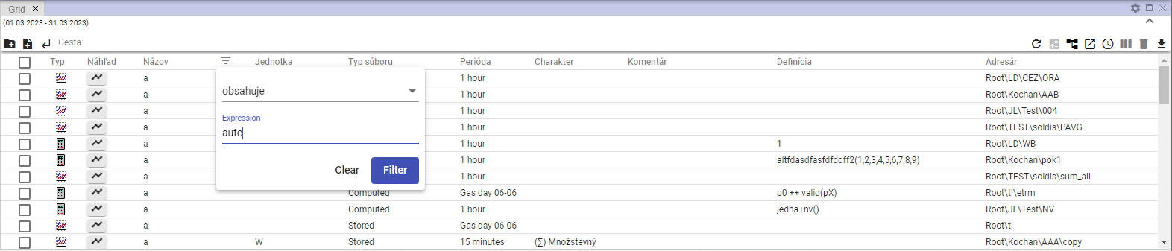

Image 272: Filter Task

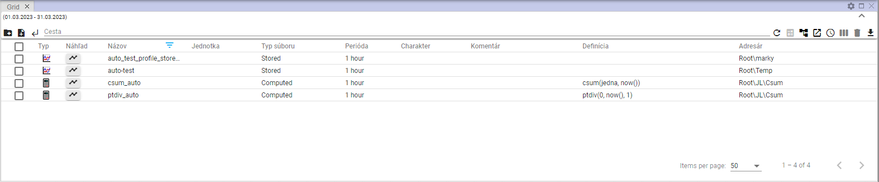

Image 273: Filtered items

1. By clicking the checkbox in the first column, select profiles on which bulk operation will be performed. If you want to select all profiles, click the topmost checkbox and other checkboxes will be marked automatically.

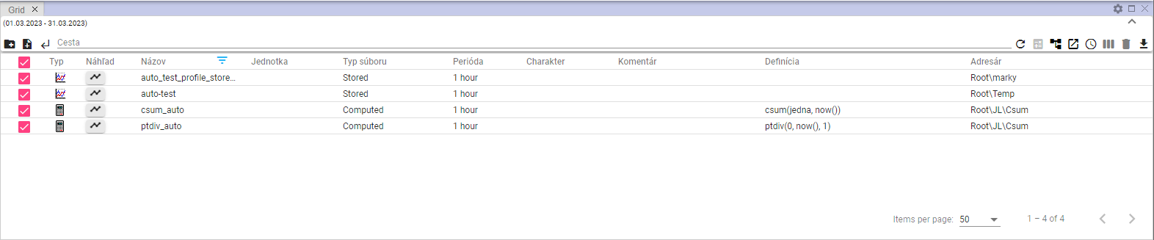

Image 274: Selected Profiles

1. Click the right mouse button on any place on selected profiles and select the item "Edit".

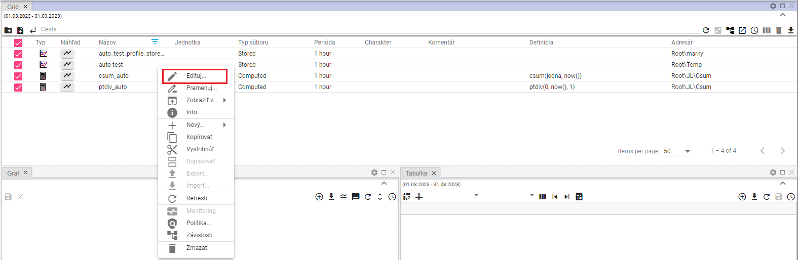

Image 275: item "Edit"

1. A 'Mass Editing' window will be shown.

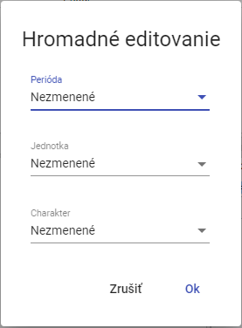

Picture 276: Window of "Mass editing"

1. You can edit fields "Period", "Unit" and "Character".
2. Save changes by pressing the "OK" button.

## How to show deleted items in the Explorer window

The "Trash" button in the Explorer window serves to show deleted items. The button is standardly inactive – grey. After clicking, it becomes black. To cancel showing deleted items, click on the "Trash" button again. Subsequently, addresses and profiles from a tree structure will appear in the Explorer window.



Picture 277: "Stop" button - inactive



Image 278: "Stop" button - active

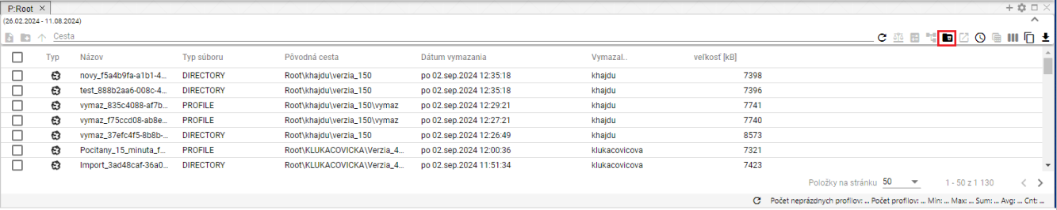

Image 279: Displaying contents of button "Box"

## I will copy displayed data.

The 'Copy displayed data' button, Image 280, serves to copy data from the 'Searcher' window. Image 282 shows the copied data.

Proceed:

1. In the window, show the data that you want to copy.
2. If you want to copy all shown data, press the "Copy Shown Data" button.

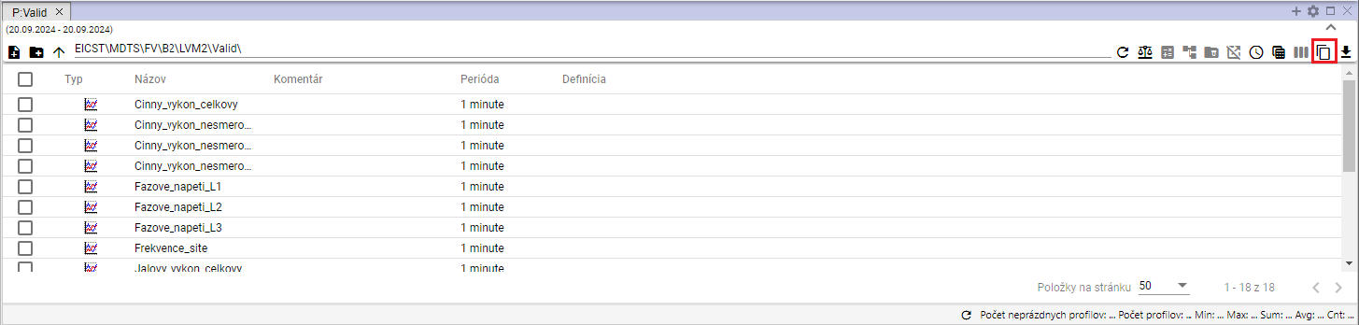

Image 280: Button "Copy shown data"

1. If you want to copy a specific folder or folders, select the selected files in the file explorer window. Click on the selected files with the right mouse button and select the 'Copy shown data' item.

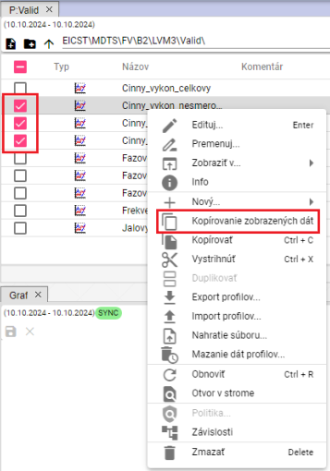

[TRANSLATION FAILED AFTER 3 RETRIES] Obrázok 281: Položka „Kopírovanie zobrazených dát“

1. Copied data can be inserted into the Microsoft Excel program.

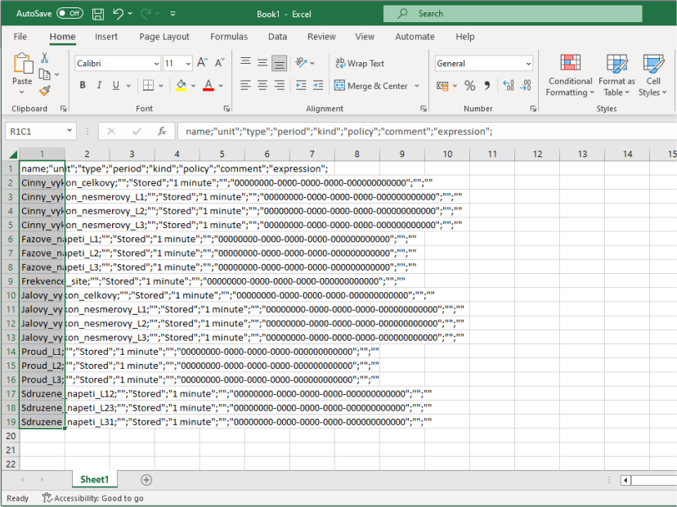

Image 282: Data copied into Microsoft Excel

## Use as starting setting Explorer

The current column settings can be set as the default. Each time a new scanner is opened or the 'Profile Manager' application is opened, it will display saved column settings.

If you want to set the current Explorer column layout as default, proceed:

1. Click the 'Use as Explorer Default Settings' button, which is located in the top right corner of the Explorer window.



Image 283: Set "Use as Explorer's home page" button

1. A window will appear for confirmation, where you click the 'Yes' button.

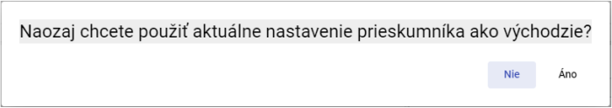

Image 284: Window for confirming the saving of explorer settings

## As I filter through columns using the * wildcard

In the window you can filter through columns using wildcards, using *.

Examples:

* Everything that starts with the given text will be searched
* *Text – everything that ends with the entered text will be searched for.
* \**Text* – everything that contains the entered text will be searched for

Example: Cinny* - search everything starting with "Cinny"

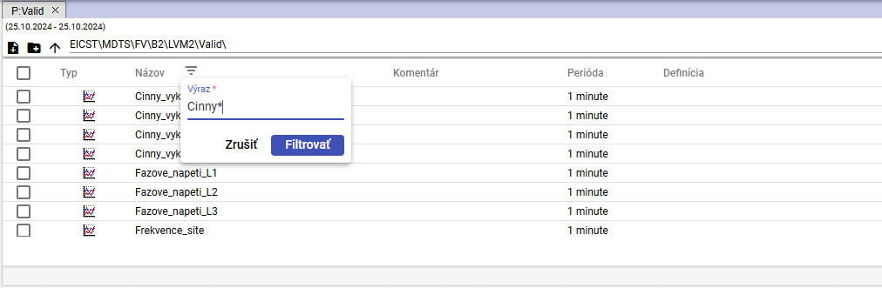

Image 285: Task for filter searching profile names starting with "Cinny"

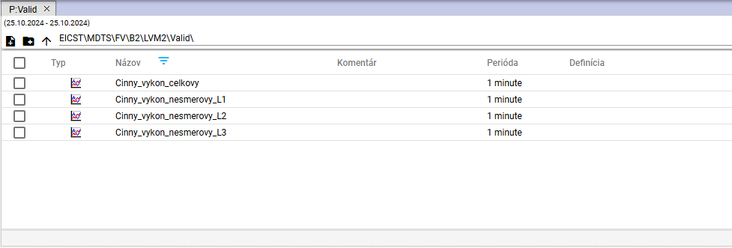

Image 286: Search profiles starting with "Cinny"

**Example: *L2 – searches for everything that ends with the text “L2”.**

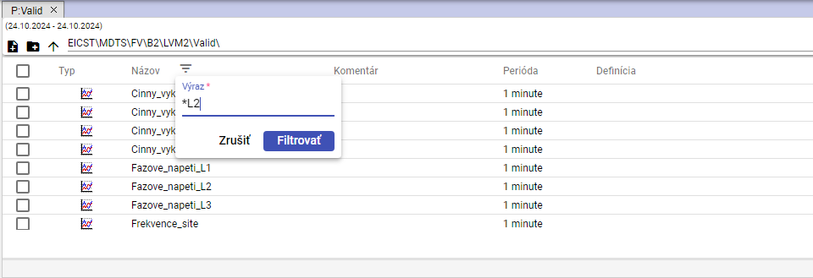

Picture 287: Task of the filter for searching profile names ending in "L2"

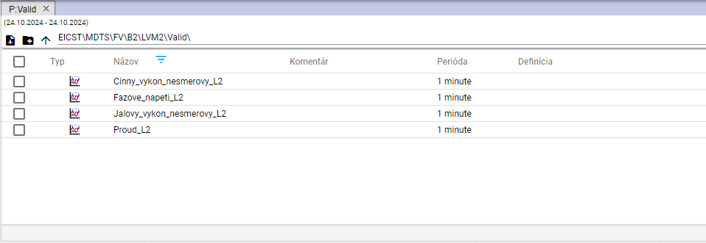

Picture 288: Search profiles ending on 'L2'

Example: *tension* - search everything that contains the text 'tension'

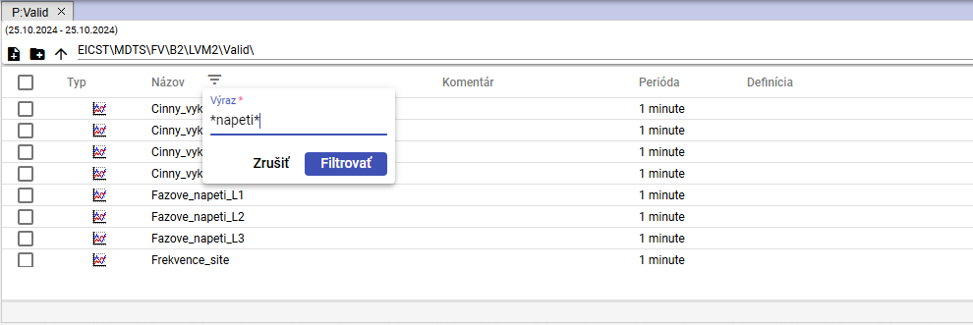

Image 289: Filter task for searching profile names containing the text "napeti"

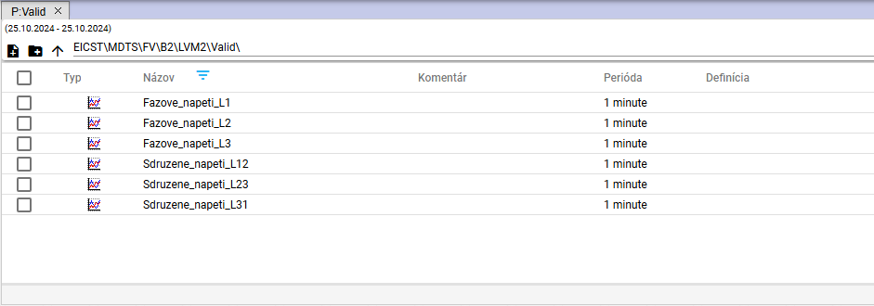

Image 290: Searching for profile names containing the text "napeti"

# Work with forms

After running the 'Profile Manager' application, a new window with an empty graph will open. During work with the application, you can add any number of graph windows. In one graph, you can display any number of profiles.

## I want to show my profile in the graph

Before displaying the profile in the graph window, proceed with:

1. The standard window graph is empty.

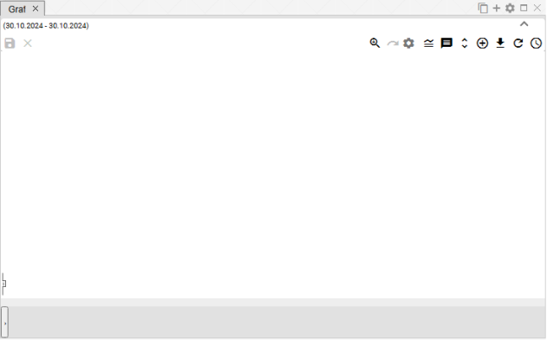

Image 291: The window for displaying a graph is normally empty

1. Click on the profile stream with your left mouse button on the profile or directory of profiles and move it to the graph window. The moved profile or directory of profiles in the graph window click.

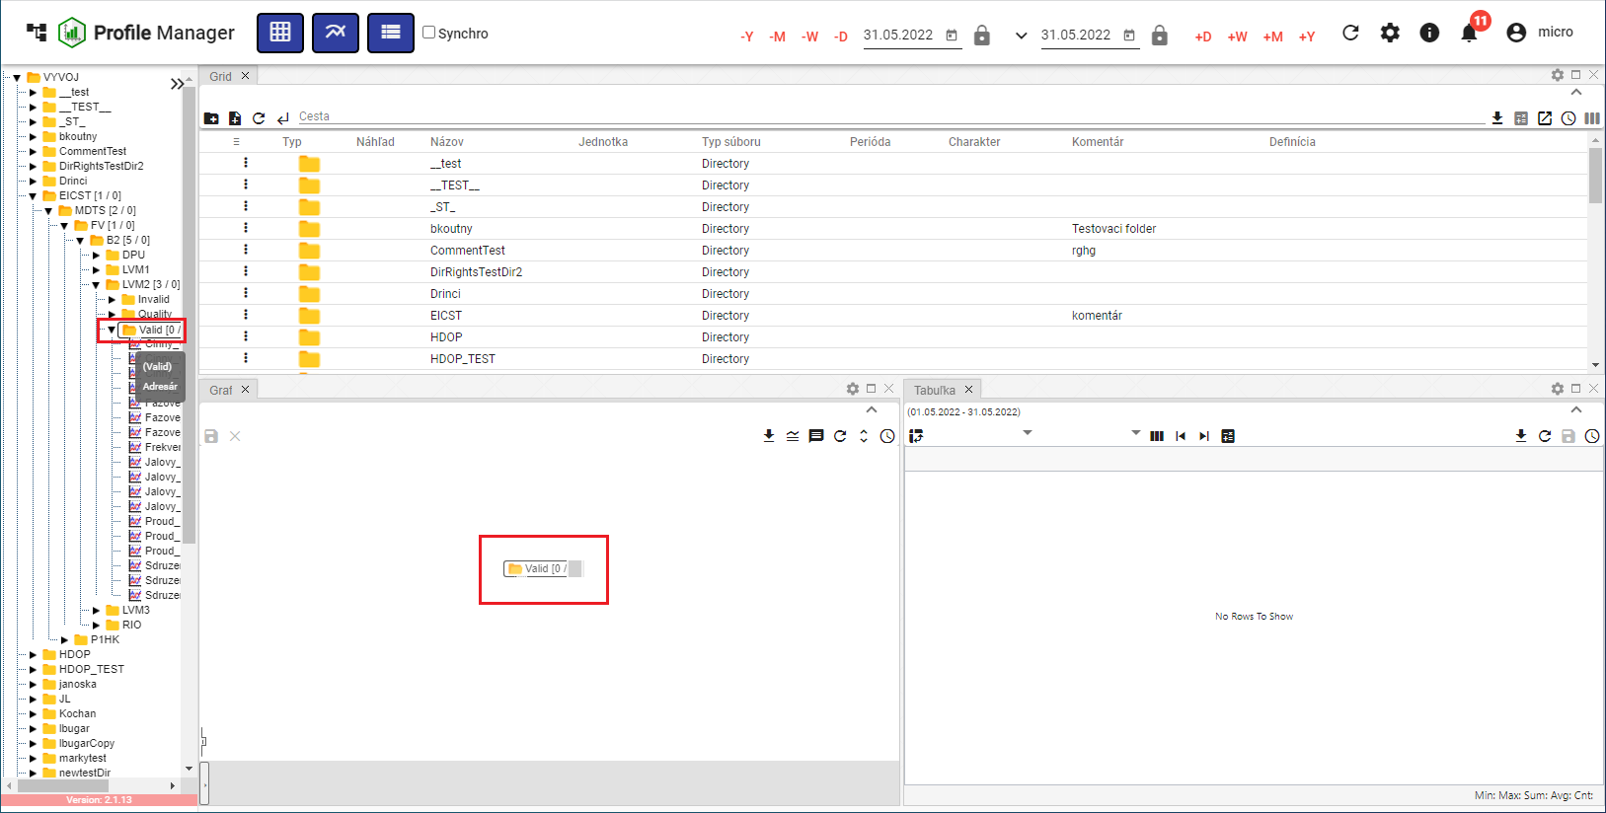

Image 292: Shift of addresser onto the graph plane

1. In the graph window, it will draw a graph.

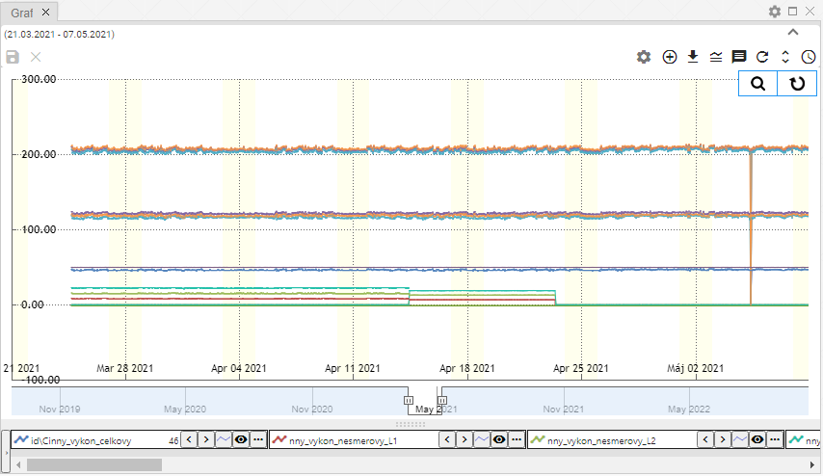

Picture 293: Graphical display of profiles

## How to display an information window with values for a specific location in the graph

If you want to show the values for a specific location in the graph, set your mouse cursor at the chosen location.

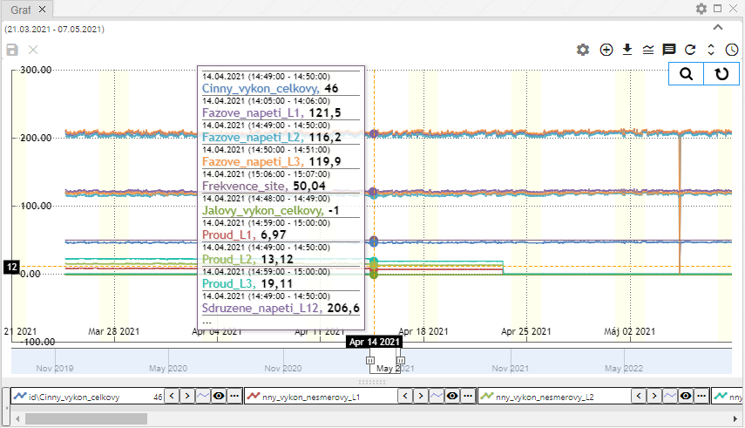

Picture 294: Displaying profile values on a specific point in the graph

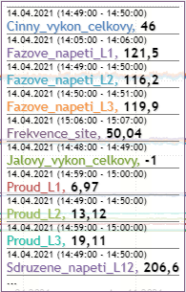

Image 295: Values of profiles at a selected location on the graph.

The data is incomplete within this scope (decimal places), a yellow warning sign will be displayed.

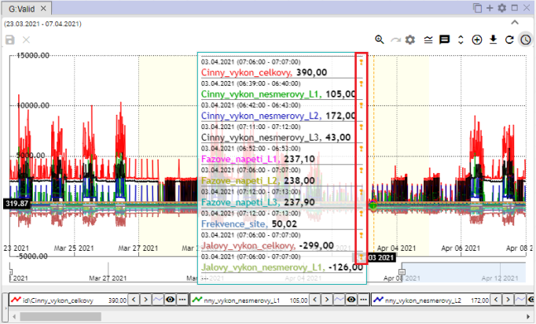

Picture 296: Yellow Trumpetflower

## I would like to change the date range in the graph.

Time range, for which the graph is shown, you can change using the 'Change time range' button, which is located in the top right corner of the window with the graph. The procedure is described in chapter 3.2.



Picture 297: Time range button

## Save graph as JPG

You can save it as an image in JPG format. Proceed:

1. Click on the button 'Export graph to JPG' that is located in the top right corner of the graph window.



Image 298: Button "Export graph to JPG"

1. An image of the graph will be created and saved among downloaded files on the computer.

## I want to copy the entire graph into a new window

The entire graph can be copied into a new window:

1. Click on the button 'Copy entire graph to a new window'.
2. The graph is copied and displayed in a new tab in the graph window.

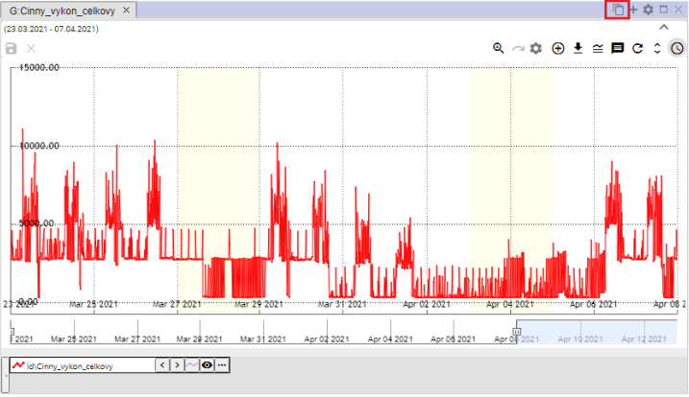

Image 299: Copy entire graph to new window button

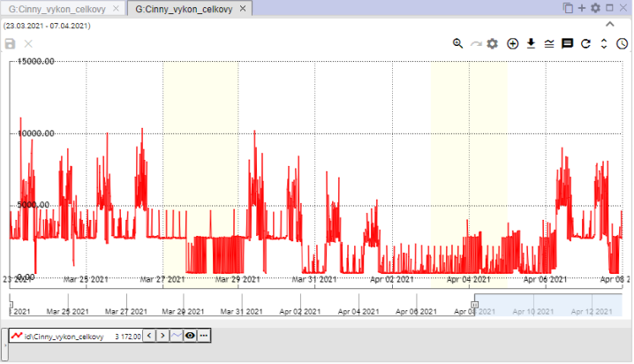

Image 300: Copied graph in a new tab

## To set graph parameters

You can set parameters for the graph, such as font size for the chart title,:

1. Click on the button 'Set Graph', which is located in the top-right corner of the window 'Graph'.



Image 301: Settings button for graph

1. A window called 'Graph Legend' will appear, where you can set parameters.

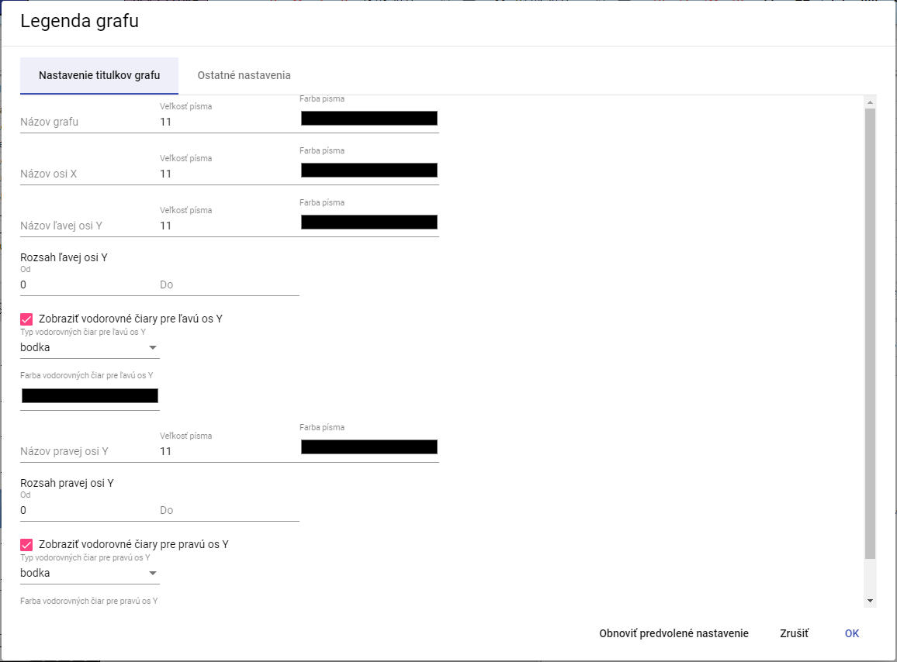

Picture 302: Window "Legend of Graph""

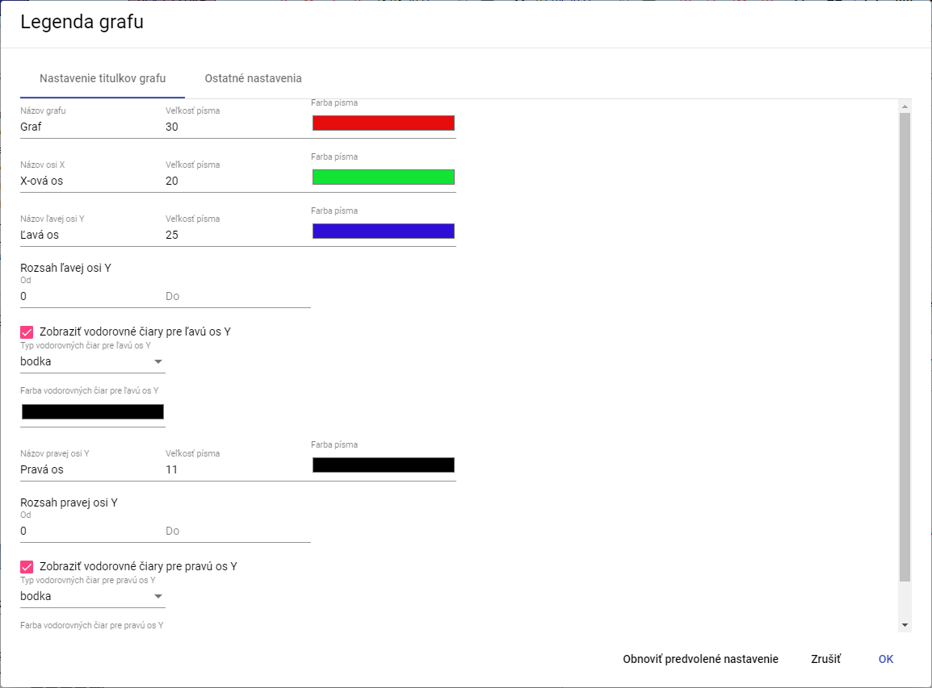

Image 303: Changes in the window of the "Legend of Graph"

1. Changes will be saved by pressing the "OK" button.

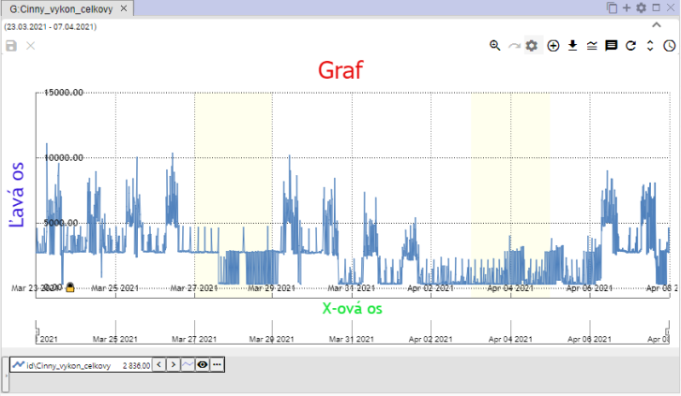

Picture 304: Changes in the window Graphics

### How to set decimal places for each of the Y axes

**Follow these steps:**

1. **In the “Chart Legend” window, enter the number of decimal places for the left and right Y axes.**

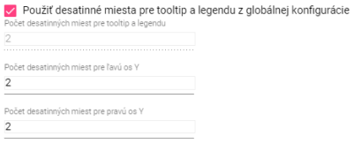

Image 305: Settings for Y-axis

1. **enter a value for the “Number of decimal places for tooltip and legend” field, uncheck the “Use decimal places for tooltip and legend from global configuration” option.**

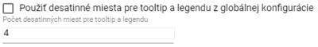

Picture 306: Task for setting a new value for the field "Decimal places for tooltip and legend"

1. **Save the changes by clicking the “OK” button.**

### How to disable horizontal lines

**To disable horizontal lines in the chart, follow these steps:**

1. **Click the “Chart Settings” button, Figure 301.**
2. **In the “Chart Legend” window, uncheck the boxes for “Show horizontal lines for left Y axis” and “Show horizontal lines for right Y axis.”**

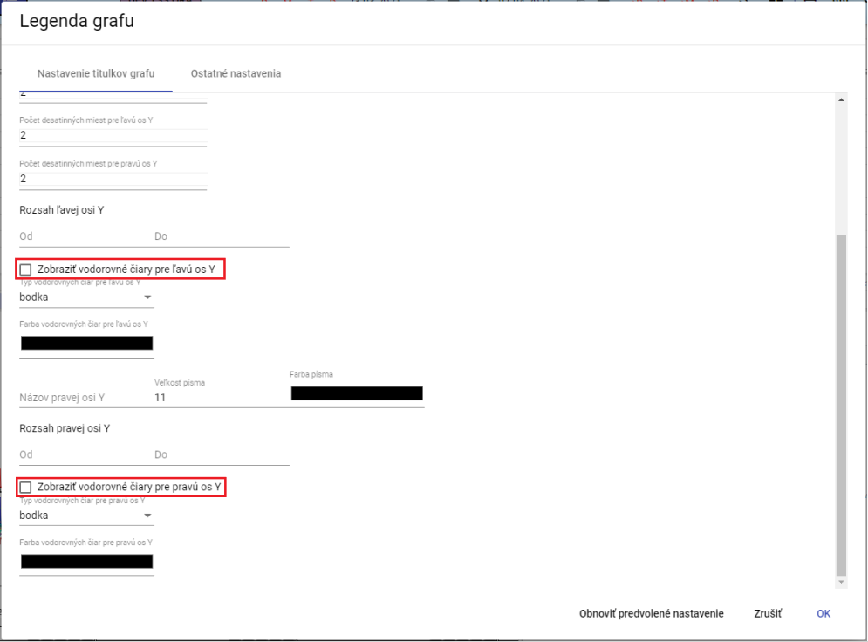

Picture 307: Turning off horizontal lines in chart

1. **Save the changes by clicking the “OK” button.**

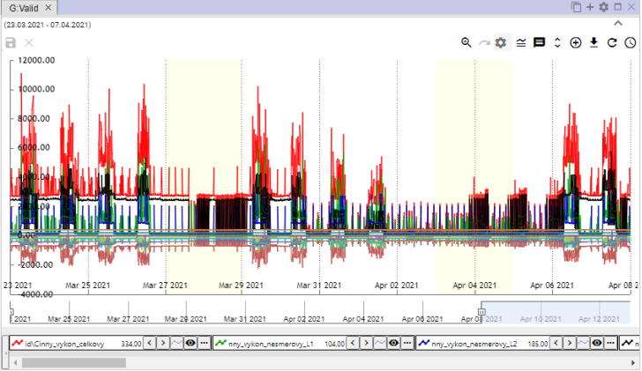

Image 308: Dotted horizontal lines on the graph are turned off

## Functions for work with designated profiles

Before displaying functions over multiple profiles, proceed with:

1. Press the Ctrl key and mark the selected profiles by clicking the left mouse button on the names of the selected profiles. Once marked, the profile name will have a blue color.
2. Click on the button located at the bottom left corner of the chart window.

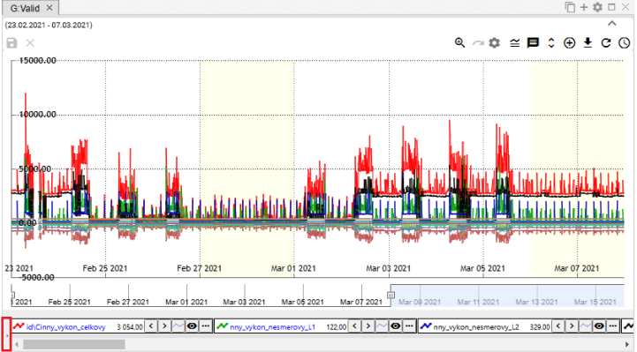

Image 309: Button for displaying functions for marked profiles

1. A list of functions will be displayed for marked profiles. Functions are elaborated in the following chapters.

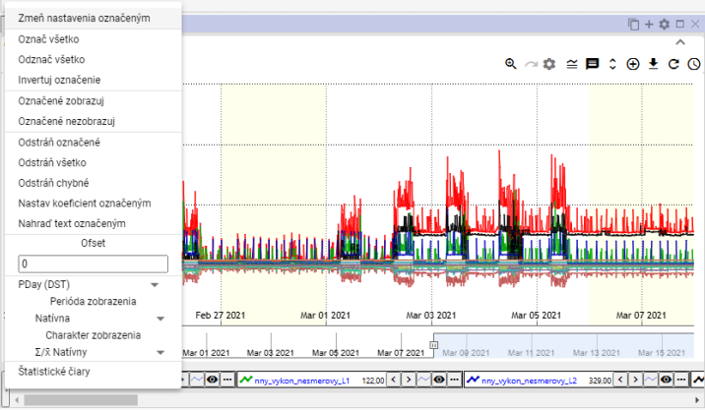

Image 310: List of functions for marked profiles

### How to pick profiles

Click the Ctrl key and click on the name of the profile to select it. You can select multiple profiles at once. The selected profile's text color will change from black to blue.

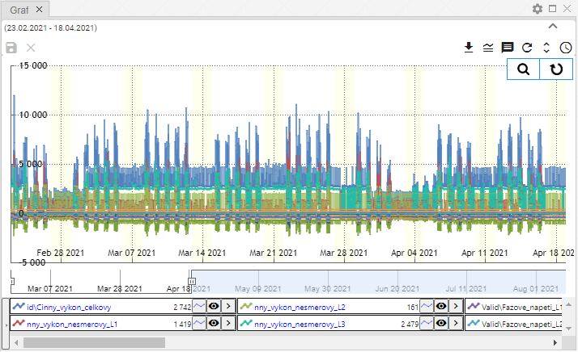

Picture 311: Marking multiple profiles

### Show profile properties

Profile properties will be displayed:

1. Click on the button located before the name of your profile in the lower part of the Windows Explorer window.

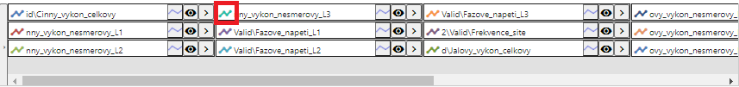

Image 312: Button for displaying profile properties

1. A window called 'Properties of the line profile' will appear.
2. Fix the data.
3. You will save changes by pressing the "OK" button.

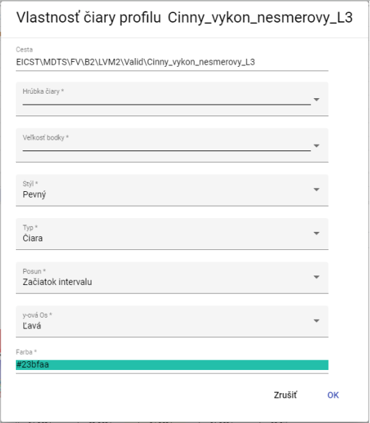

Picture 313: Window "Line Profile Property"

### How do I change the settings marked

Changing settings for multiple marked profiles at once will also be modified:

1. Mark profiles that you want to change settings for.
2. Click with the right mouse button on the name of one of your profiles.
3. In the displayed window, select the item 'Change settings indicated'.

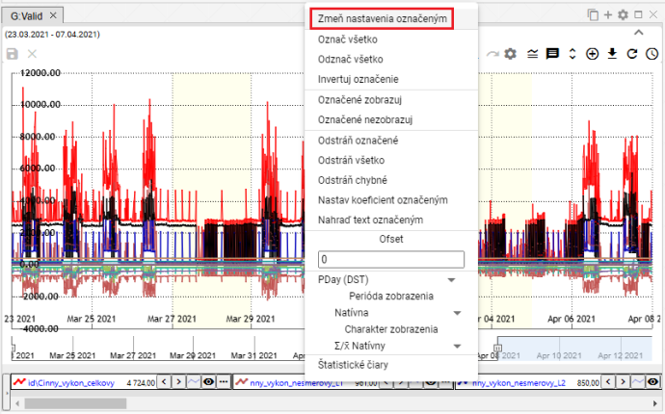

Picture 314: Item "Change settings marked"

1. A window will appear where you can change settings for the marked profiles.

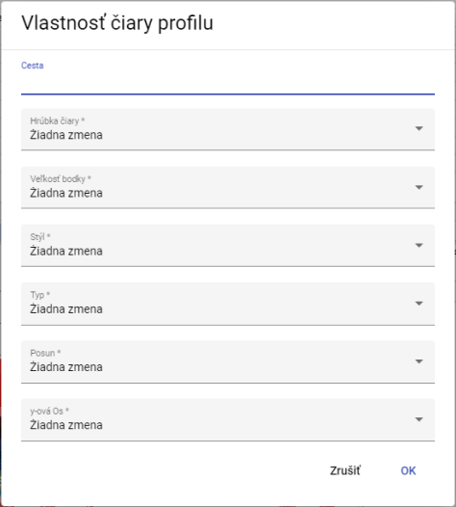

Picture 315: Window for setting marked profiles

1. You will save changes by pressing the "OK" button.

### If I mark all profiles

Click the right mouse button on the name of the profile and select 'Mark all' to mark all profiles, Picture 316. All profiles are highlighted, Picture 317.

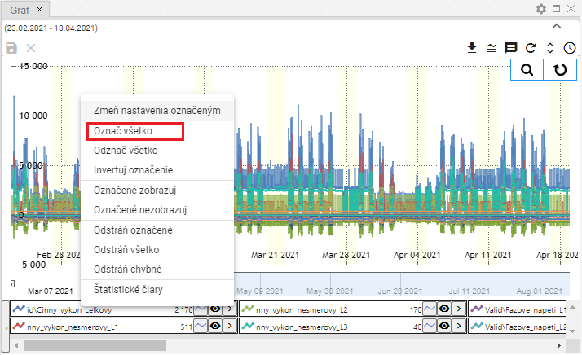

Image 316: Item "Mark everything"

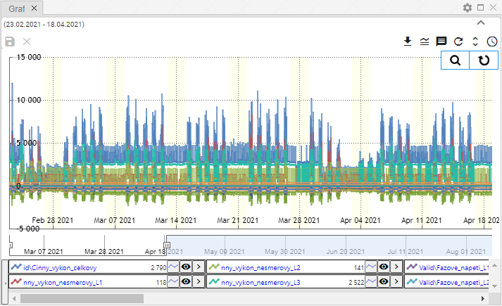

Image 317: Marked profiles

### I will mark all profiles

The entry 'Unflag everything' serves to cancel the labeling of all flagged profiles.

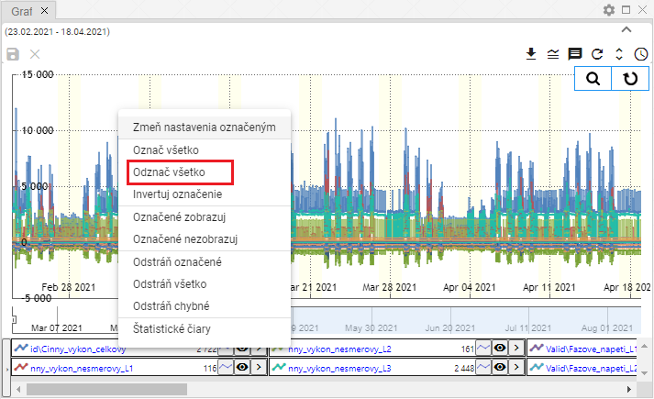

Image 318: Item "Mark all as removed"

### I'm going to invert these marked profiles

The 'Invert Label' option will swap the label of profiles. Profiles which were labeled will be unlabeled and unlabeled profiles will be labeled, Image 320.

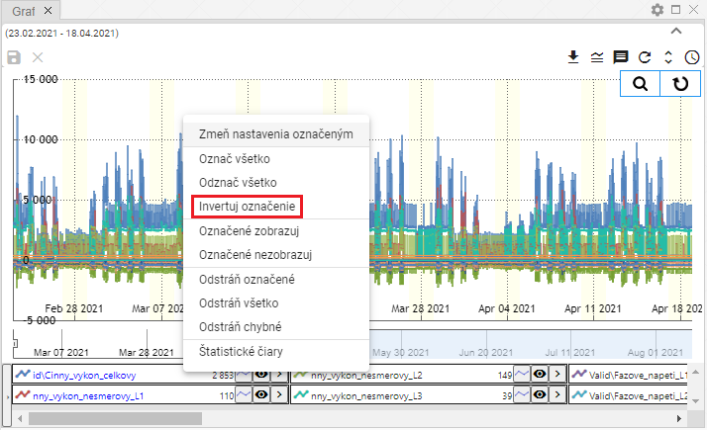

Image 319: Item "Invert Label"

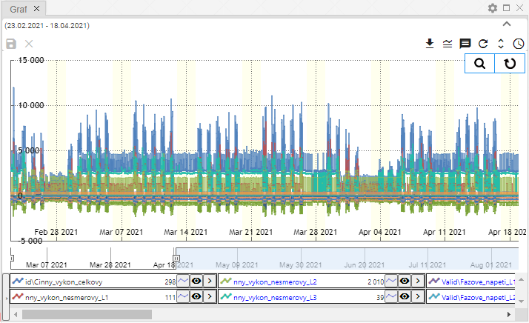

Picture 320: Profile inverse naming

### Show only marked profiles

The item 'Show marked profiles' serves for displaying marked profiles.

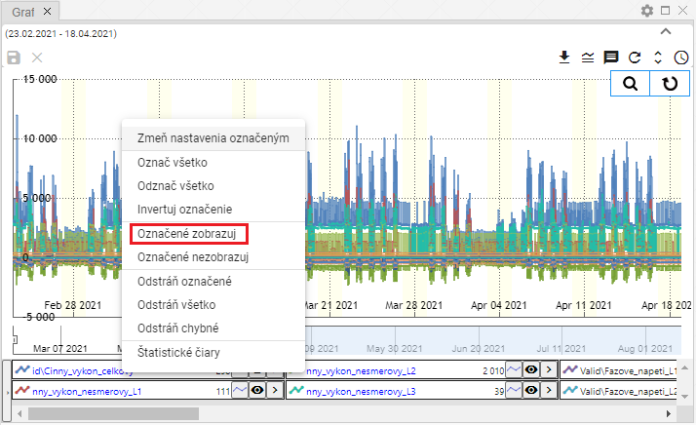

Image 321: Item "Marked as Display"

### Don't show marked profiles

If you do not want to show marked profiles on the graph, proceed:

1. Mark profiles which you do not want to display.
2. Click on the name of the profile with your right mouse button.
3. Select item "Marked do not display."

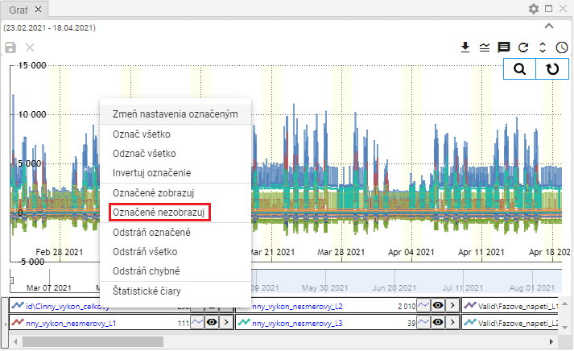

Image 322: Entry "Marked not visible"

1. The selected profiles hide themselves.

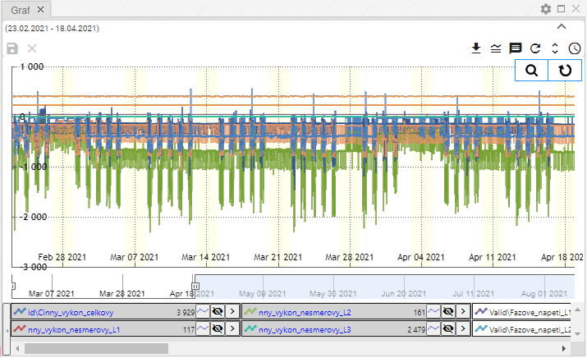

Picture 323: Unclear Profiles

### If I remove the marked, all or faulty profiles

Before removing profiles, you can use three functions:

* Remove marked - serves for removal of marked profiles,
* Remove everything - all profiles will be removed,
* Remove incorrect - only correct profiles will be removed.

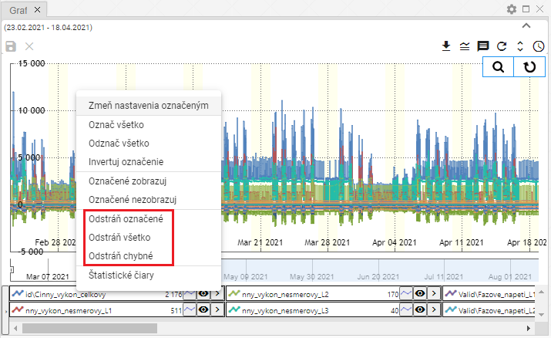

Image 324: Checkboxes for "Remove marked", "Remove all" and "Remove incorrect"

Before deleting profiles, proceed:

1. If you want to delete the marked profiles, mark the profiles you want to delete.
2. **[TRANSLATION FAILED AFTER 3 RETRIES] Kliknite pravým tlačidlom myši na názov profilu.**
3. Choose the item "Remove marked", "Remove all" or "Remove incorrect".
4. The profile will be removed.

### To set the coefficient by designated profile

Before setting the coefficient, proceed:

1. By clicking on the profile name, mark the profiles for which you want to set the coefficient.
   1. If you want to mark more profiles, click the left mouse button on the name of the profile, hold down the Ctrl key and by clicking the left mouse button select the names of the profiles you want to choose.
   2. You can mark multiple profiles simultaneously by clicking the left mouse button on the name of the first profile while holding down the Shift key and clicking the left mouse button on the last profile. All profiles between them will be selected.
2. The designated profile names will be highlighted blue.
3. **[TRANSLATION FAILED AFTER 3 RETRIES] Kliknite pravým tlačidlom myši na názov jedného z označených profilov.**
4. A window will appear where you select 'Set the coefficient marked'.

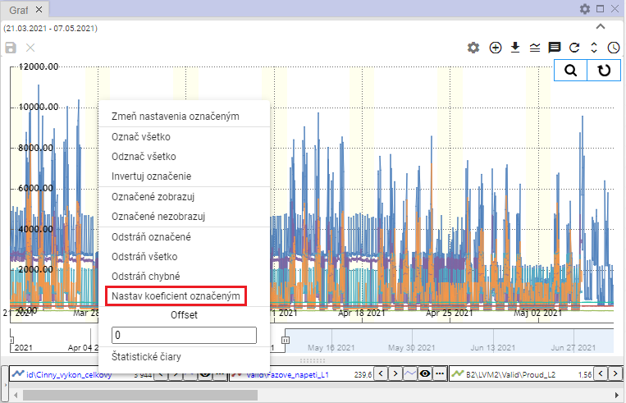

Image 325: Item "Set coefficient marked"

1. A window called 'Setting coefficient' will appear.
2. Continue coefficient and save by pressing the 'OK' button.

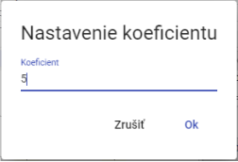

Picture 326: Settings window for coefficient setup

1. The coefficient will be set for the selected profiles. In profile names, information about the set coefficient will be displayed.

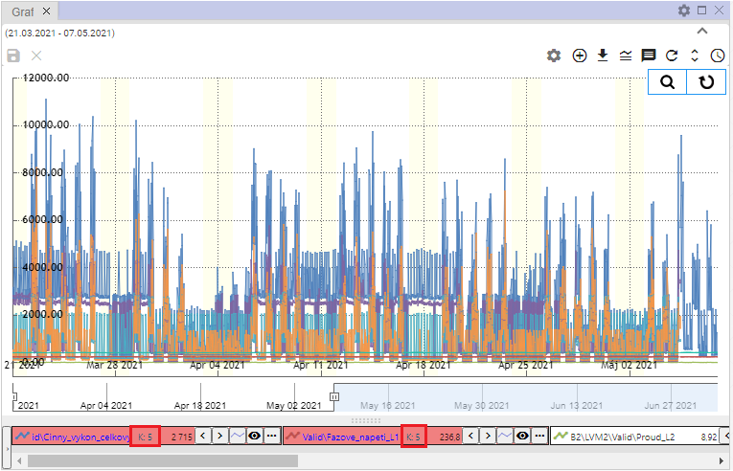

Image 327: Set coefficient

### How to set an offset

**To set the offset, follow these steps:**

1. Click on the profile names to mark profiles for which you want to set an offset.
2. Right-click on the name of one of the selected profiles.
3. A window will appear in which you enter the offset and press the Enter key.

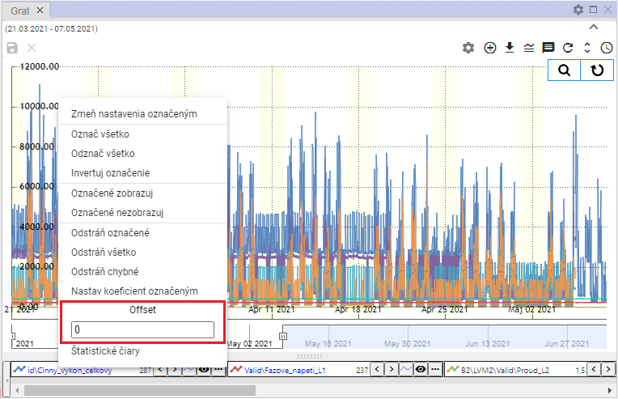

Image 328: Pole "Offset"

1. On selected profiles, information about the set offset will be displayed.

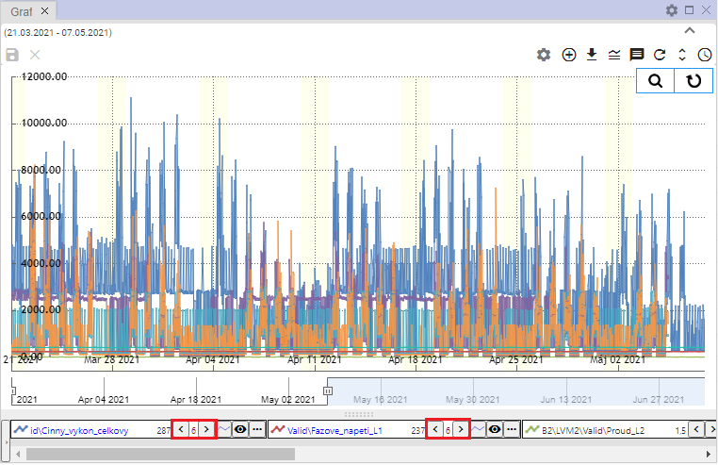

Image 329: Set Offset

### How to display statistical lines

Before showing statistical lines proceed:

1. If you want to show statistical lines only for some profiles, hold down the Ctrl key and click on the profile names that should have statistical lines shown.
2. Click on the right mouse button on the profile name.
3. Select the item "Statistical lines".

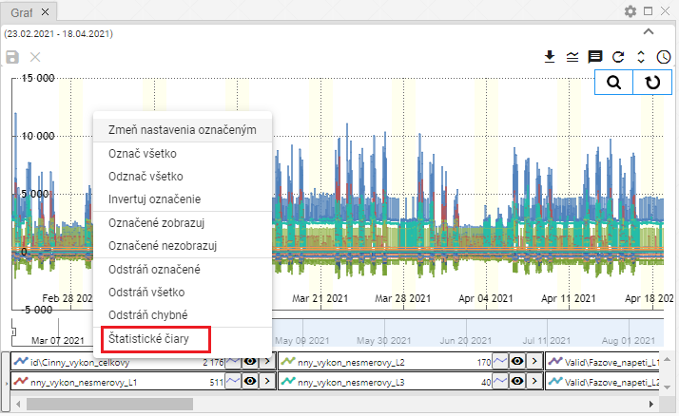

Image 330: Item "Statistical lines"

1. A window titled 'Statistical lines' will be shown.

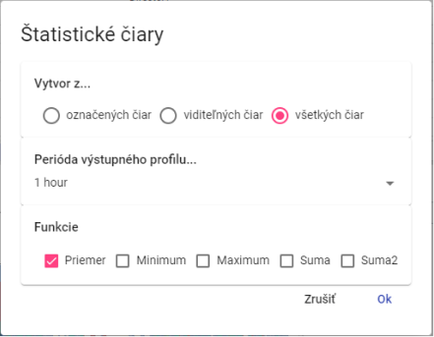

Picture 331: Window "Statistical lines"

1. Choose whether to create statistical lines from the marked visible or all lines.
2. Select a function. You can select multiple functions at once.
3. Press the "OK" button.

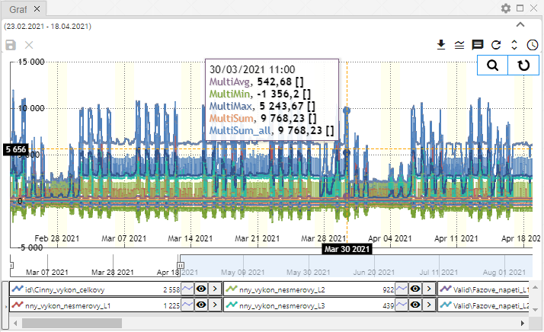

Image 332: Statistical lines

### As replace the text marked

Function serves for mass change of profile names. Proceed:

1. Mark profiles that you want to change text in profile path.
2. Click on the right mouse button on the profile name.
3. A menu will appear, where you select the item 'Replace highlighted text'.

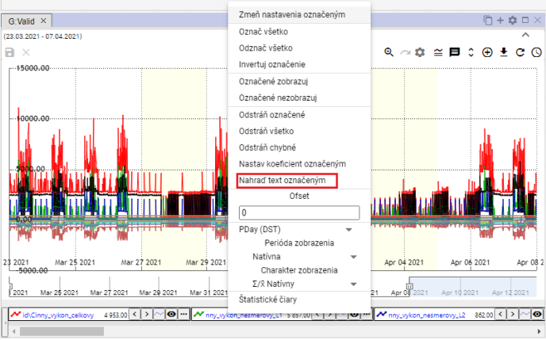

Image 333: Item "Replace with marked text"

1. A window titled "Replace Text in Profile Path" will appear.
2. In the app "Find" enter the text you want to replace.
3. In the field "Replace", enter the text that should replace the text in the field "Find".

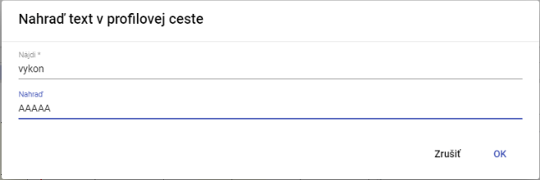

Image 334: Window "Replace text in Profile path"

1. Click the "OK" button.
2. The assigned text will be replaced with new text.

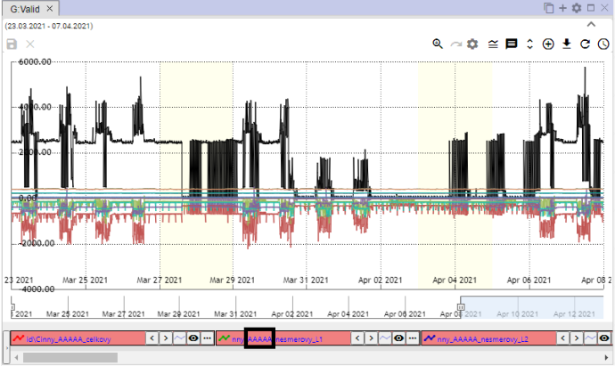

Image 335: Replaced text

## Functions for work with one profile

Every profile has a button next to its name that serves for displaying functions. The functions serve for working with the selected profile.

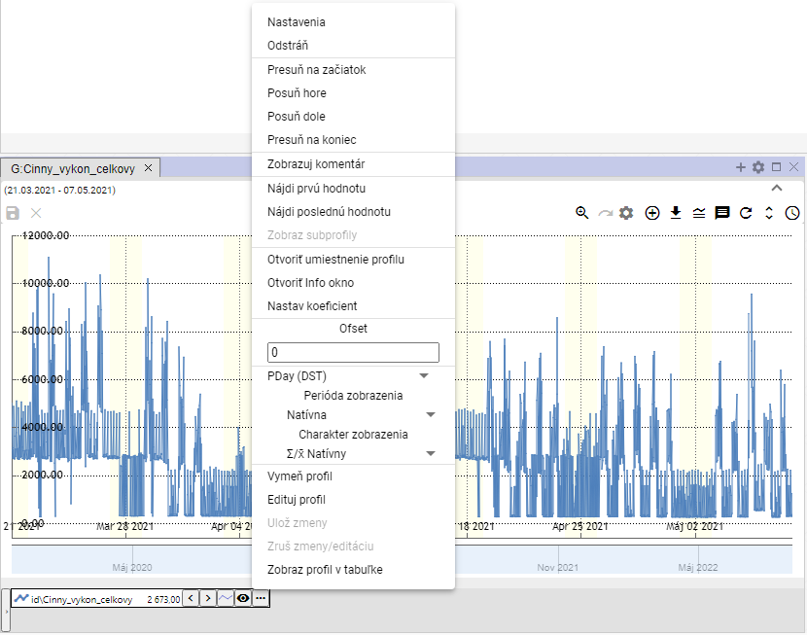

Image 336: Functions for working with profile

### Adjust settings

You can change the display of profile data in a graph in the settings window. For example, you can change the color with which the profile is displayed, line style...

Before changing settings, proceed:

1. Click on the button next to the profile name that you want to change settings for.
2. A window will appear in which you select the item 'Settings'.

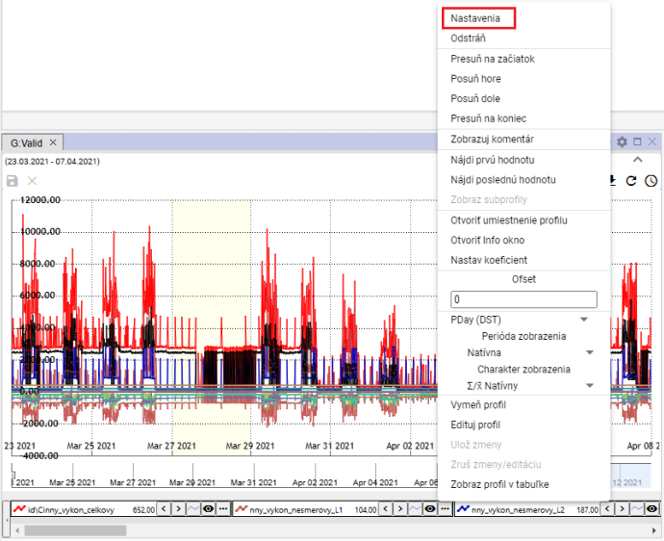

Image 337: Item "Settings"

1. In the window that appears, change profile settings.
2. Save changes by clicking on the button "OK".

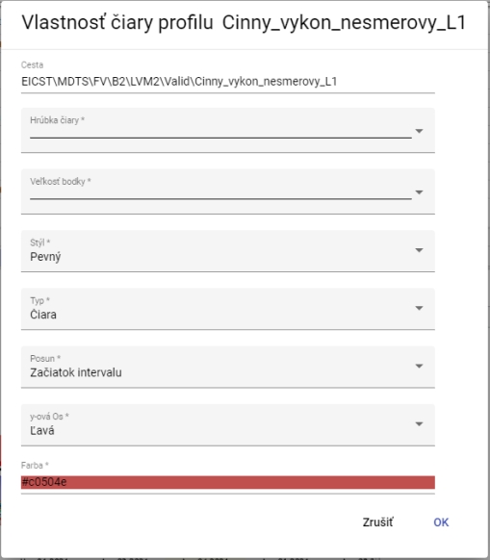

Profile settings #338

### To remove the profile

Remove profile:

1. Click on the delete button next to the profile name you want to remove.
2. The profile will be removed from the list of profiles in the bottom part of the Graph window and from the display of profiles.

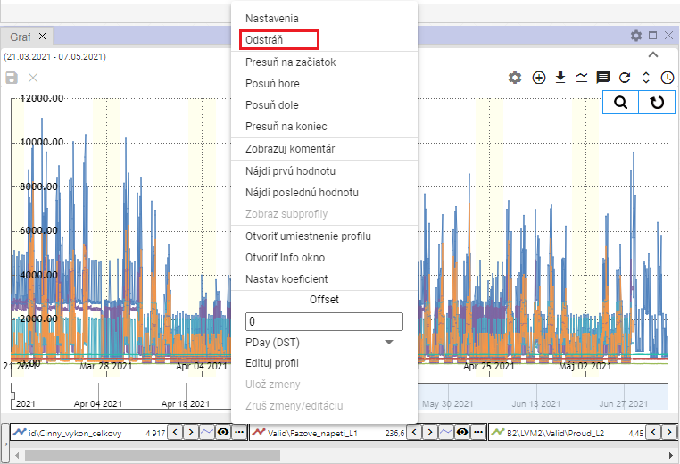

Image 339: Item "Remove"

### I'll forward my profile to the beginning

If you'd like to move your profile to the beginning of the list of profiles, proceed:

1. Click on the button next to the profile name that you want to move to the beginning.
2. Select the item "Move to top".
3. The chosen profile will be moved to the top of the list.

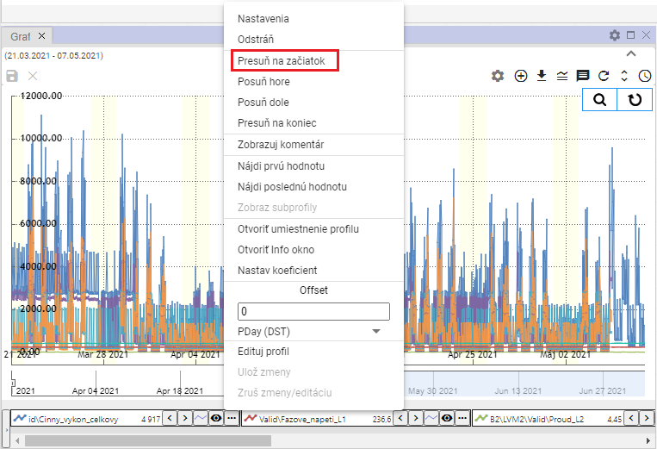

Image 340: Position "Move to start"

### To move the profile up

The item 'Move Up' serves to move the profile name in the profile list at the bottom of the window 'Chart' one position higher, for example from the third position to the second.

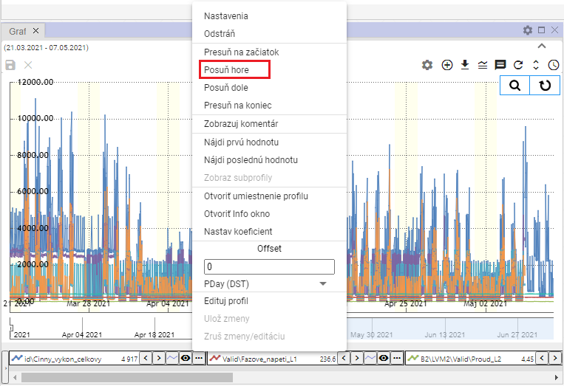

Picture 341: Item "Move forward"

### Move profile down

The 'Move Down' item serves to move the profile name in the list of profiles at the bottom of the 'Chart' window down one place, for example from second position to third.

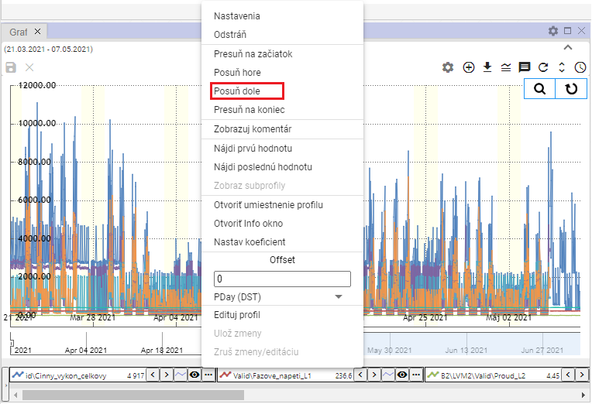

Image 342: Option "Slide Down"

### I'll shut down my profile at the end.

The item "Move to end" serves for moving the profile to the end of the list of profiles in the bottom part of the "Chart" window.

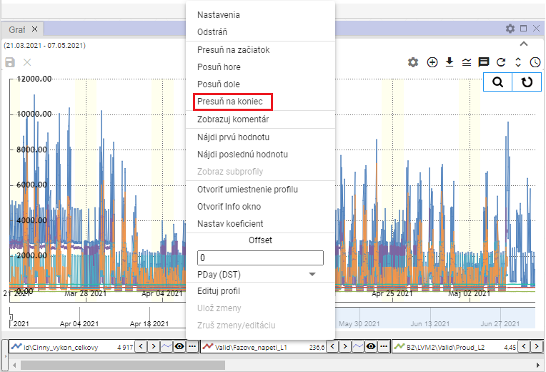

Picture 343: Item "Move to end"

### To show comments

The 'Show comment' item determines the display of a profile name. After selecting the 'Show comment' item, instead of displaying the profile name, the comment, Image 345 will be displayed. To show the profile name again, click on the 'Show comment' item once more.

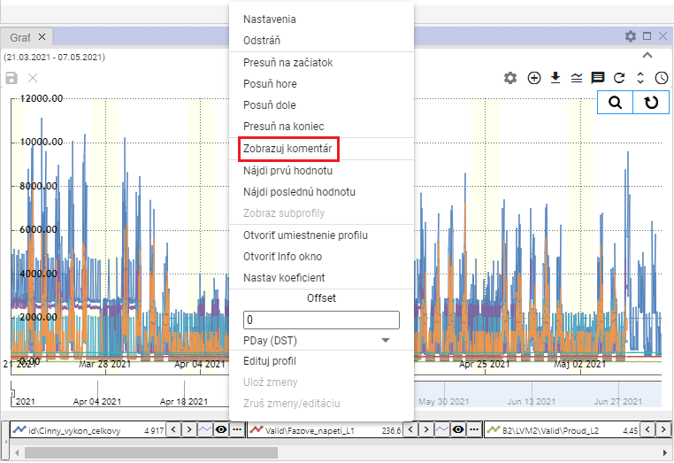

Image 344: Item "Show comments"

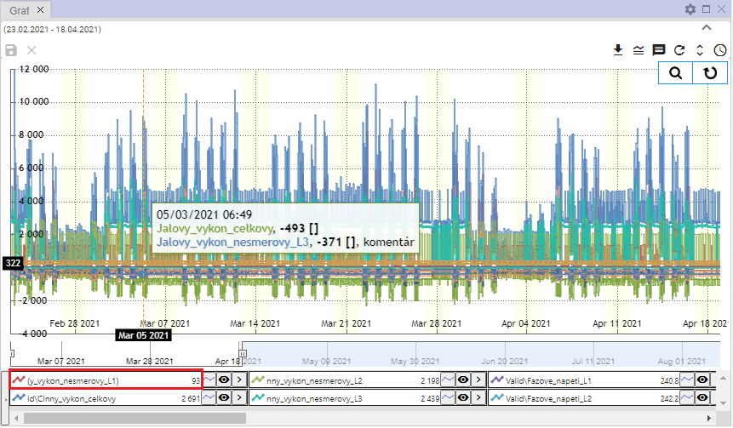

Picture 345: Displayed comment profile picture

### How to find the first value

The 'Find first value' item is used to find the first profile value in a graph.

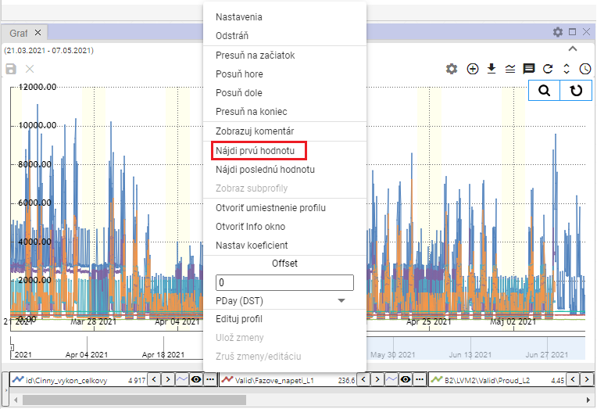

Image 346: Item "Find First Value"

### I need to find the last value

The "Find Last Value" entry serves to find the last profile value in a graph.

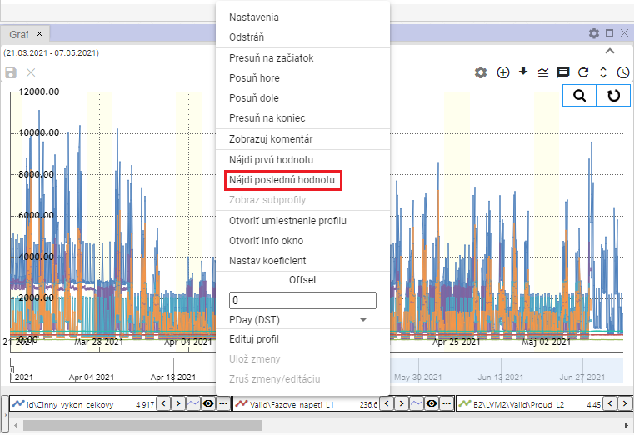

Image 347: Item "Find Last Value"

### How to display subprofiles

A calculated profile may have other profiles, called subprofiles, used in its definition. To display them, proceed:

1. Click on the button next to the name of the profile you want to change settings for.
2. A window will appear where you select the item 'Show sub-profiles'.
3. All profiles used in the definition of the calculated profile are shown.

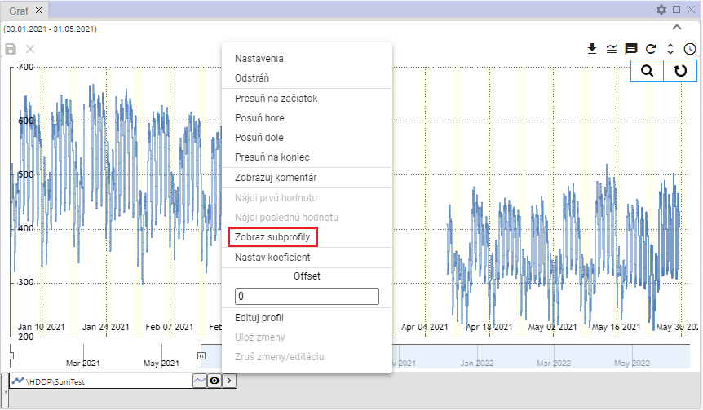

Image 348: Item "Show sub-profiles"

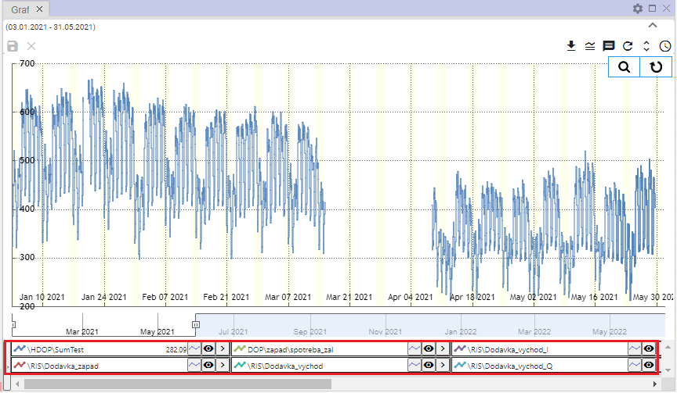

Image 349: Shown underprofiles

### I will open my profile settings

Displaying profile setting within stream structure will be shown:

1. Click on the button with the name of the profile you want to open in the tree.
2. A window will appear where you select the option 'Open profile settings'.

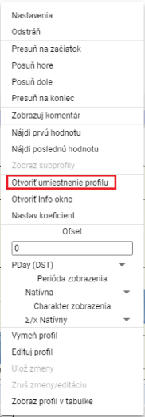

Picture 350: Item "Open location profile"

1. In the stormy structure a directory will open, in which is located the profile.

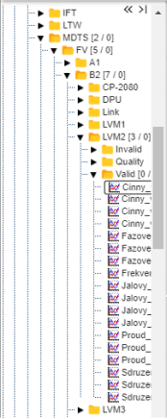

Image 351: Placing a profile within a stream structure.

### Open information window

You can open a window with information for each profile, for example the name of the profile, path to the profile, type of profile.

Open window with information:

1. Click on the button with three dots that is located next to each profile.



Image 352: Button for function display

1. Select item "Open info window".

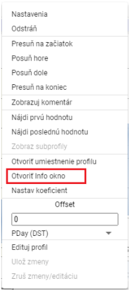

Image 353: Open info window option

1. In the river structure, an address book will open in which a profile is located, Image 351.
2. Next will appear a window with profile information, which contains three tabs: 'Info', 'ReadLog' and 'WriteLog', Image 354.
3. In the "Info" tab, you can copy the name of the profile and path to the profile by clicking on the button.

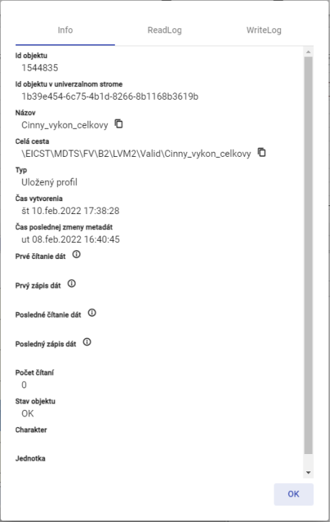

Image 354: Bookmark "Info"

### How to set the coefficient

Set up coefficient before proceeding:

1. Click on the button next to the profile name for which you want to set the coefficient.
2. Select item "Set coefficient".

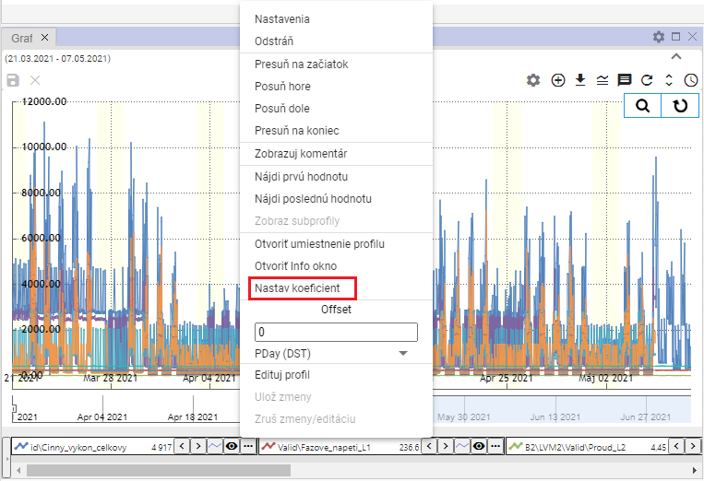

Image 355: Item "Setting coefficient"

1. A window will appear where you enter the coefficient.

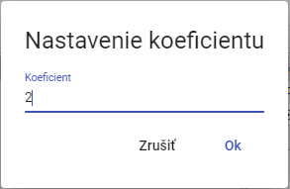

Image 356: Setting coefficient

1. Press OK to save.
2. The profile name will display information about the set coefficient.



Image 357: Adjusted coefficient

### What is the offset?

Proceed with printing before setting an offset.

1. You can enter the offset by clicking on the arrows next to the profile name or by clicking on the button and entering a value in the 'Offset' section and pressing the 'Enter' key.



Image 358: Adjustment dials for setting up offset

1. The value you've entered for the offset via arrows next to the profile name will also be displayed after clicking on the button in the 'Offset' section.

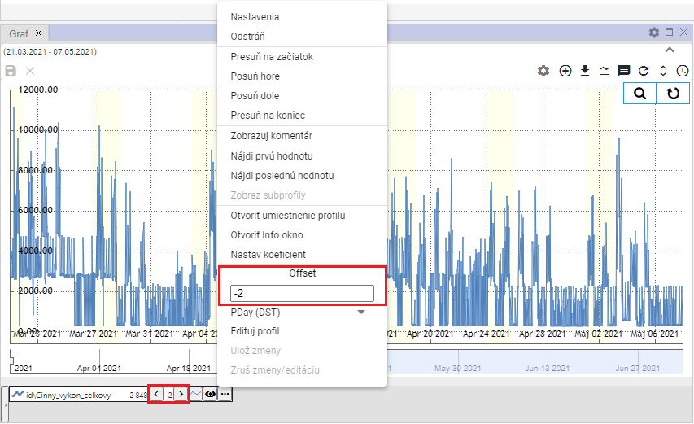

Image 359: Set Offset

1. Below the forest of Offset there is a field for selecting an off-set period, Image 360. After expanding the field, a list of time periods for offset will be displayed, Image 361.

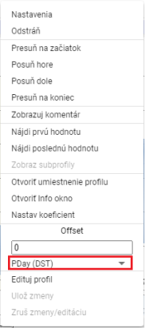

Image 360: Select period for offset

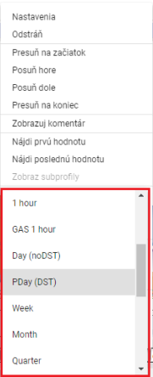

Image 361: Selection of time period for offsetting

### To change profile

Please proceed with profile exchange from one profile to another:

1. Click on the button next to the profile name that you want to change.
2. Choose item "Edit profile".

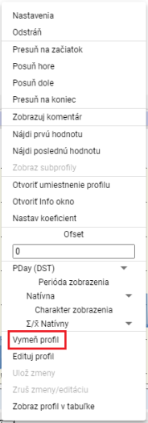

Picture 362: Item "Crop profile"

1. It will show the window "Edit Profile".

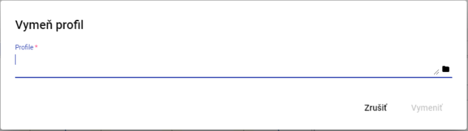

Picture 363: Profile window

1. Write the path to profile or click on button .
2. Click the "Replace" button after confirming.

### Edit my profile

Before editing your profile, proceed:

1. Click on the button next to the profile name you want to edit.
2. Choose item "Edit Profile".

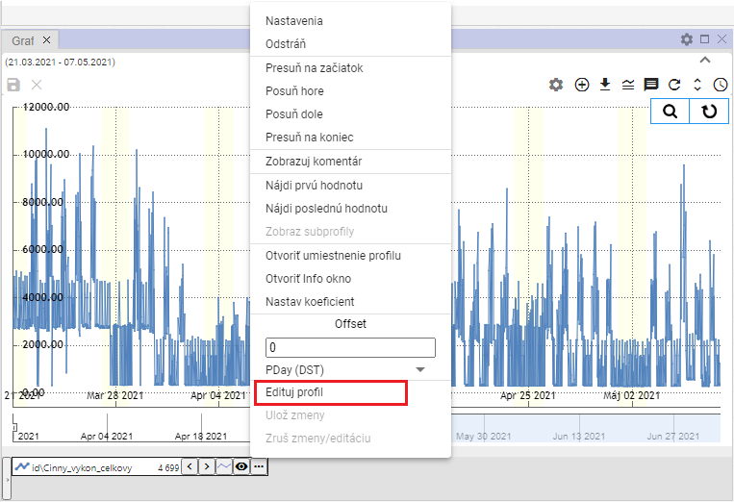

Image 364: Item "Edit Profile"

1. A copy of the profile will be created. Fields with the names of the original and copied profiles will be highlighted in green color.

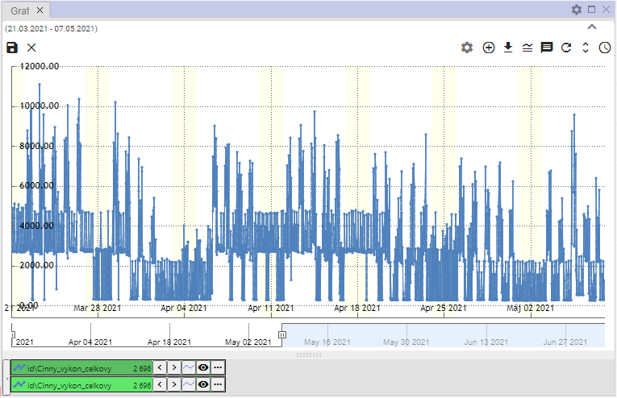

Image 365: A copy of the profile is created

1. Edit profile.
2. You will save the changes by clicking on the button and selecting "Save Changes" or by pressing the disc icon located in the top left corner of the graph.

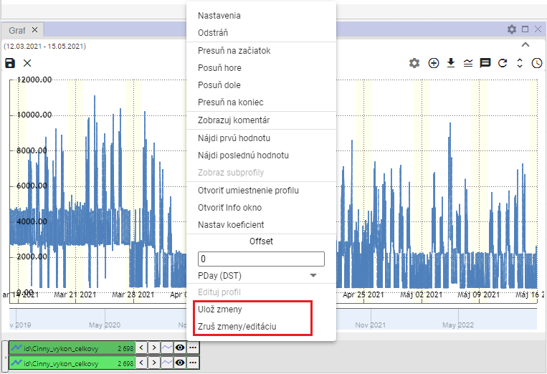

Image 366: Menu items "Save changes" and "Revert changes/edits"

1. If you want to cancel the changes, select the item 'Cancel changes/editing' or by pressing the 'x' button in the top left corner of the graph.

### How to set color for profile

Set profile color settings:

1. Press the button next to the profile you want to set the color for.
2. Select the item 'Settings', which will display the window 'Line profile properties'.



Image 367: Setting Item

1. Click on the field "Color" in the window "Line Profile Property".
2. A window for selecting a color will appear. At the bottom, there is a color palette for quick selection of colors.

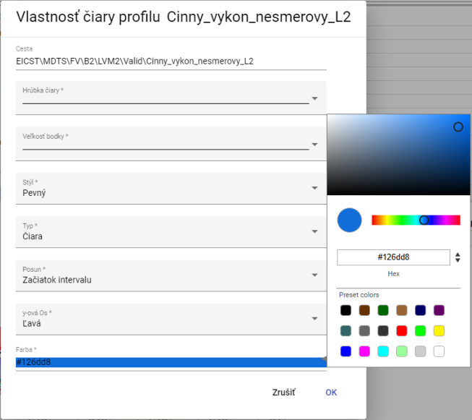

Picture 368: Color Selection

1. Click on the selected color.
2. Changes will be saved by pressing the "OK" button.

### How to set point size

Before setting size, proceed with dots:

1. Click on the button next to the profile name you want to set the font size for.
2. Select the item "Settings", which will display the window "Properties of profile line".



Image 369: Settings item

1. Click on the field "Size of dot".

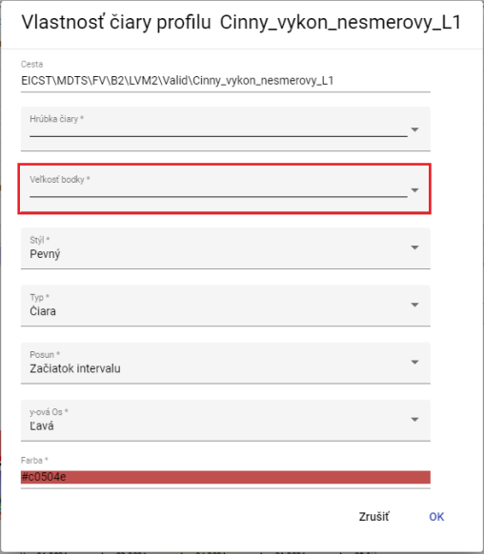

Picture 370: Pole of the "point size"

1. A window will appear where you can select the size of viewing for that point by clicking.

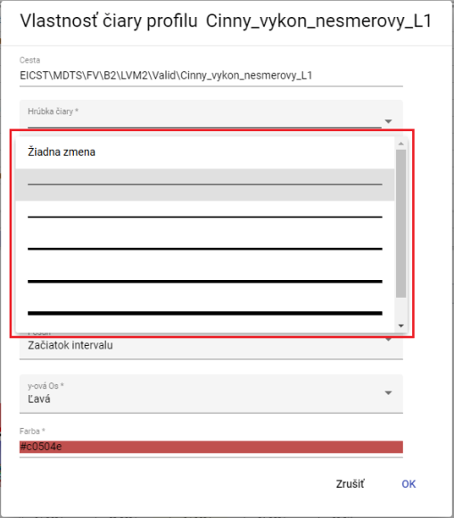

Image 371: Selection of point sizes

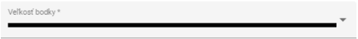

Image 372: Selected size

1. You will save changes by pressing the "OK" button.

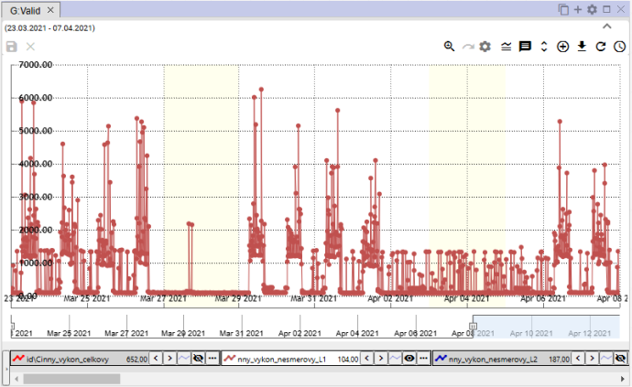

Image 373: Set point size

### To show profile in table

Profile in the graph window will be displayed in the table as follows:

1. Click on the button next to the profile name you want to display in the table.
2. Select the item 'Show profile in table'.

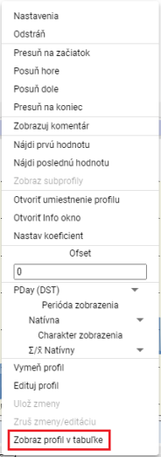

Picture 374: Item "Show profile in table"

1. In the window of Graph, a new tab titled Table will be added.

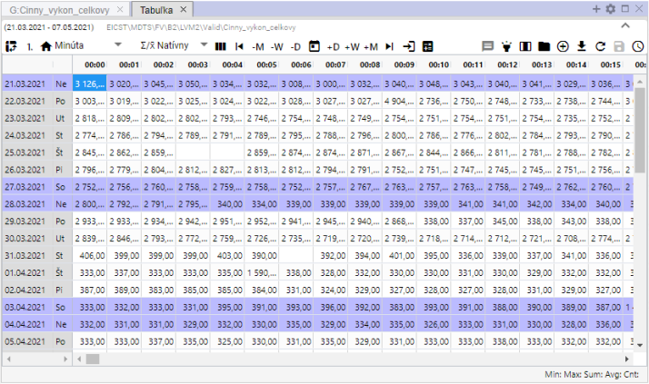

Image 375: Displaying profile in table

## Rapid change of graph type

At the bottom of the window, Graph has a button next to each profile name that allows for quick switching between graph types. The graph icon button enables switching between StepLine, StepArea, and StackedColumn graphs. The graph type can also be switched via the 'Type' field in the 'Profile properties' window; the procedure is detailed in chapter 5.8.1.



Image 376: Button for rapid change of graph type

The standard graph type in the Graph window is "StepLine", Figure 377. Pressing the button will change it to "StepArea", Figure 378 and the button's appearance will change to. Subsequent pressing of the button will set the graph type to "StackedColumn", Figure 379 and the button's appearance will change to.

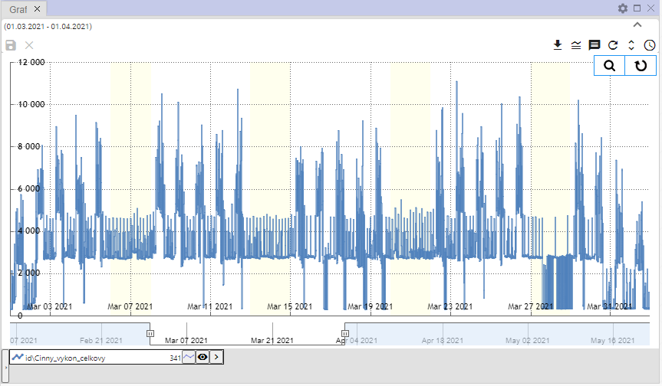

Picture 377: Type of graph "StepLine"

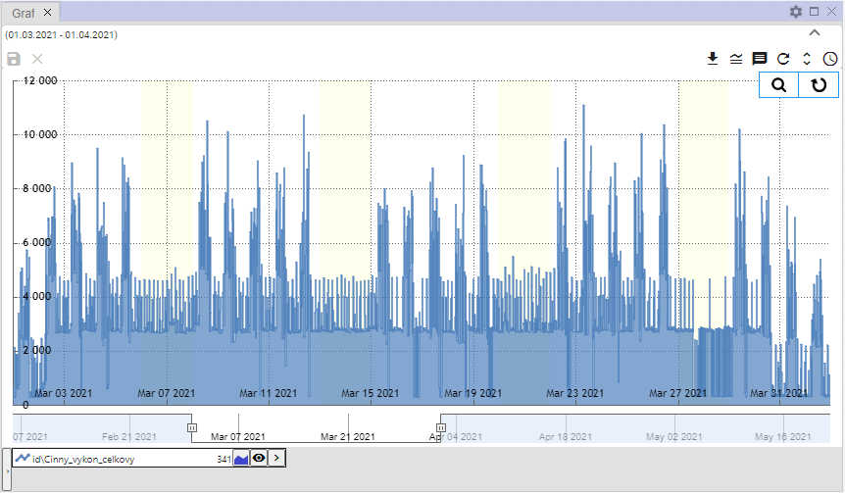

Image 378: Graph type "StepArea"

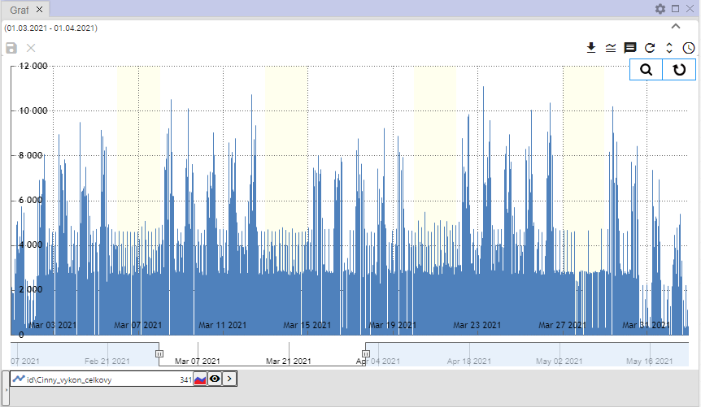

Picture 379: Type of graph "StackedColumn"

## To approximate a selected part of the graph

Before enlargement of selected part in graph:

1. Click on the button 'Join Zoom', which is located in the top right corner of the graph.

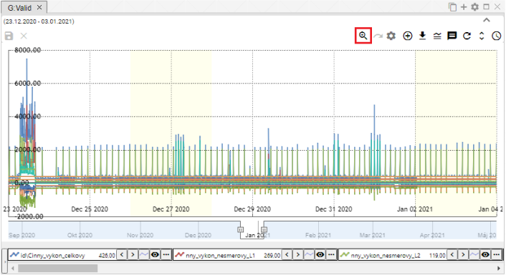

Image 380: Button "Connect to Zoom"

1. Click on the left mouse button and highlight an area of the graph.

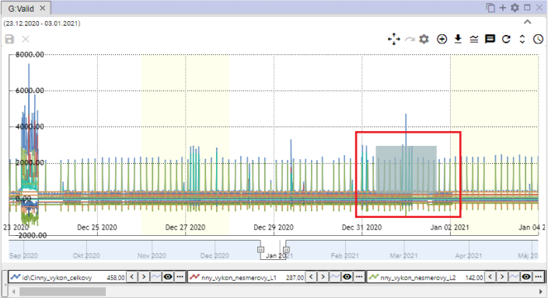

Picture 381: Marked location in graph

1. Click on the left mouse button.
2. The selected area will be approached.

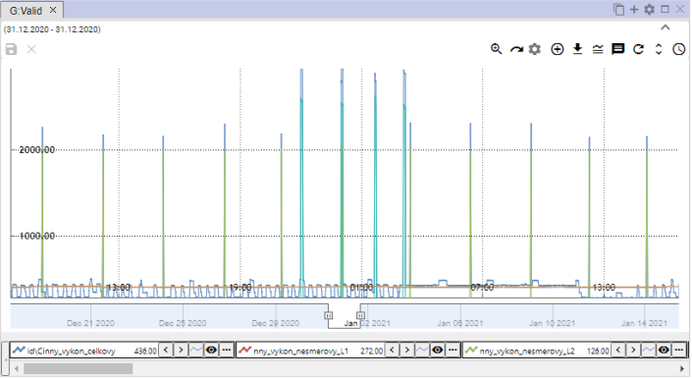

Image 382: Enlarged area in graph

1. Before restoring the y-axis, press the "Reset zoom" button, chapter 5.12.

## I'm taking a graph

By clicking on the button 'Zoom to', image 380, the button will change from 'Zoom' to 'Slide to', image 383. It allows you to move along the graph. To slide along the graph, hold down the left mouse button and drag the graph.

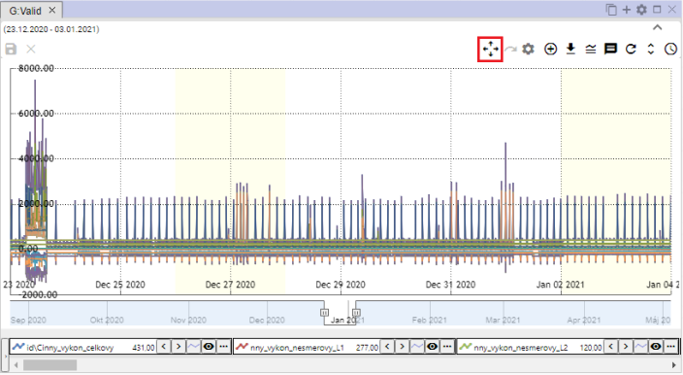

Image 383: Button "Slide into"

## Can I cancel the meeting?

After you have got close to the selected area in the graph by using the zoom function, restore the graph by pressing the 'Reset zoom' button.

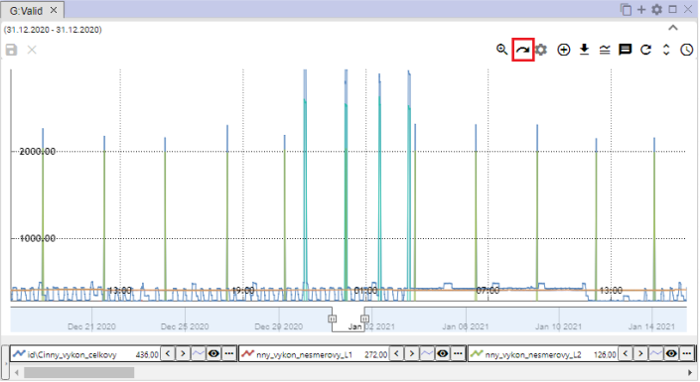

Picture 384: Reset zoom button

## Show/hide legend

At the bottom of the graph window, you will find a list of displayed profiles called legend. To hide the profile list, press the "Show/Hide Legend" button located in the top right corner of the Graph window. Pressing this button again will display the legend.



Image 385: Button Show/Hide Legend

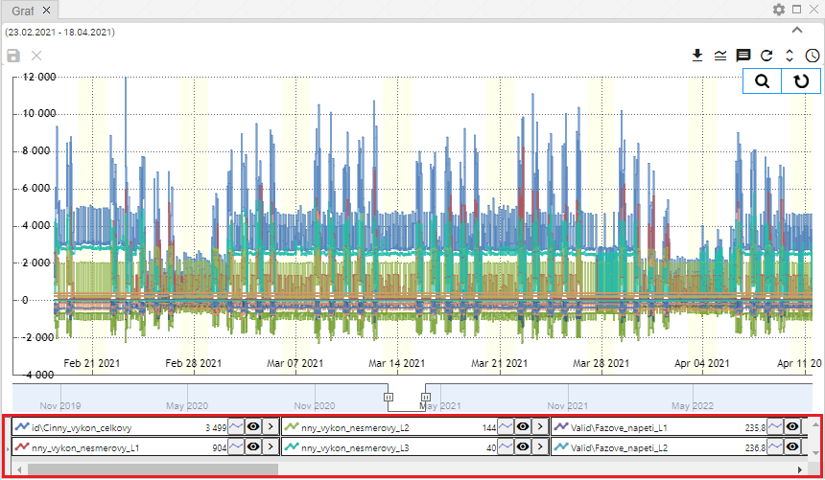

Image 386: Displayed legend

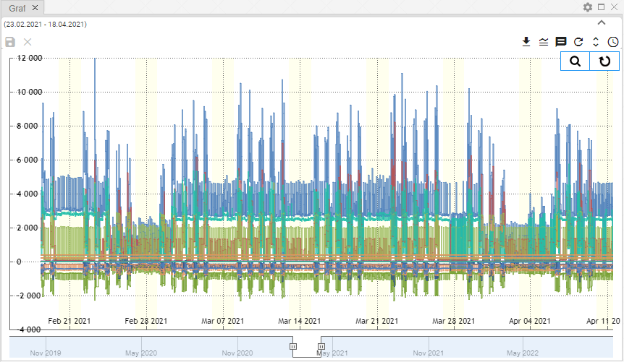

Image 387: Hidden Legend

## Show/hide tooltip

If you want to see the values (tooltip) for a specific location on the graph, place your mouse cursor on the chosen location on the graph. You can hide the tooltip by clicking on the 'Show/hide tooltip' button located in the top-right corner of the Graph window. To show the tooltip again, click on the 'Show/hide tooltip' button once more.



Picture 388: Button "Show/Hide tooltip"

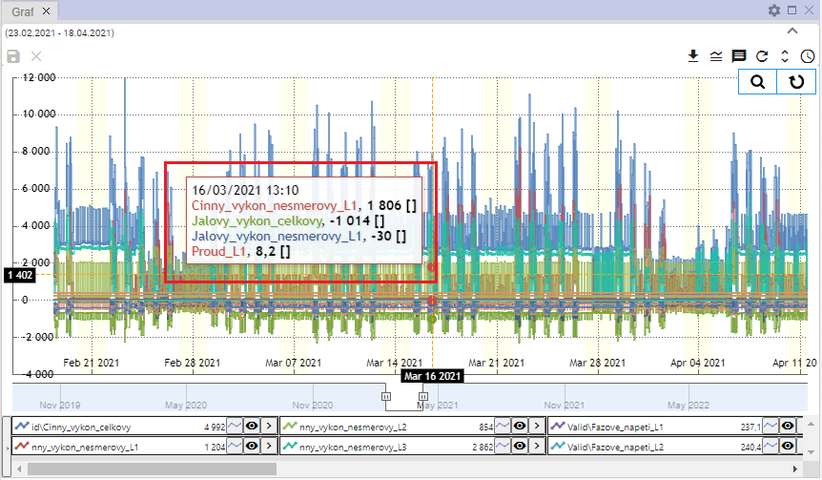

Image 389: Shown tooltip

## I'll set up the y-axis so that you can see the values

The 'Set y-axis scale visible' button serves to zoom out the y-line in case of zooming it is not well seen all values (all lines). The y-axis is zoomed out so that all values are visible. The x-axis remains unchanged.

Proceed with:

1. Click on the "Zoom" button, which is located at the top right corner of the Graphics window.



Image 390: Zoom button

1. Please mark the place on the chart that you would like to zoom in.

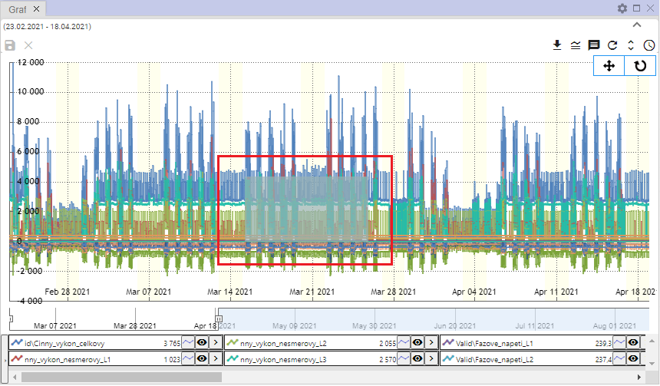

Picture 391: Find my location on the graph

1. The place in the village is approaching.

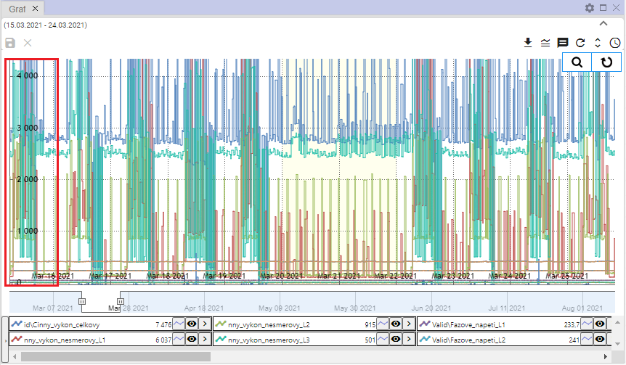

Picture 392: Enlarged area from graph

1. Press the button "Set up Y-axis so that it's visible"



Image 393: Button "Set Y-axis label visible"

1. The woman's dress is being unzipped.

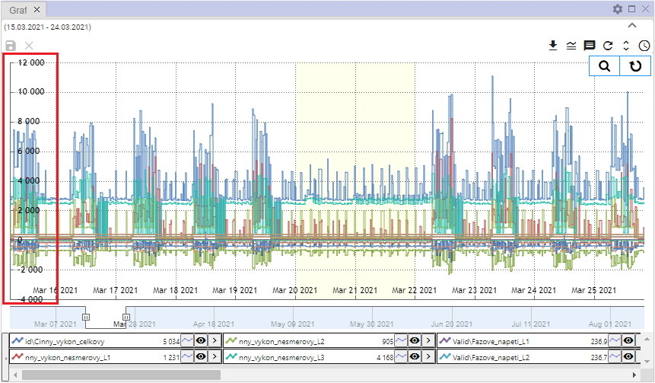

The Image 394: Y-axis Modified

## I want to change my profile

Before profile exchange, proceed with:

1. Click on the button next to the profile you want to replace.
2. Choose the item "Change profile".

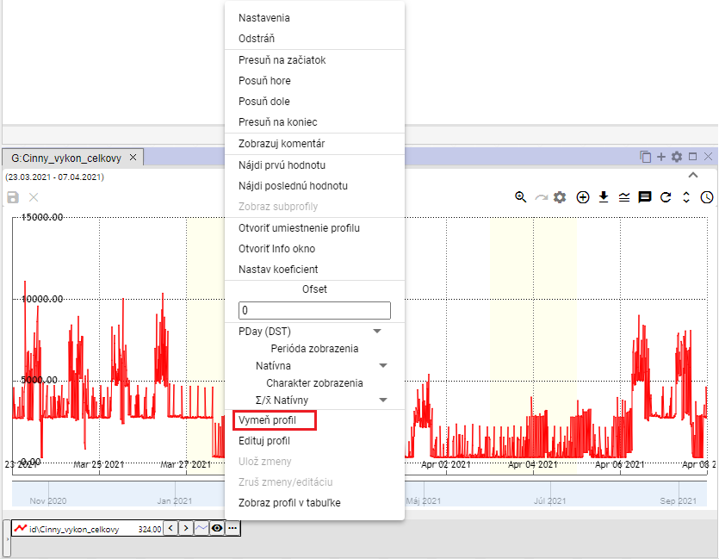

Image 395: Item "Mark Profile"

1. A window 'Edit profile' will be shown.

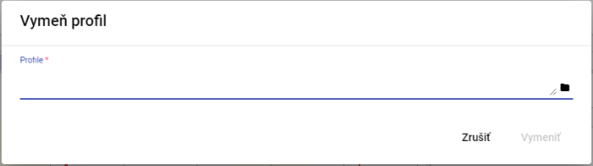

Image 396: Profile Window

1. Please enter the path to the profile or click on the button and search for the profile.

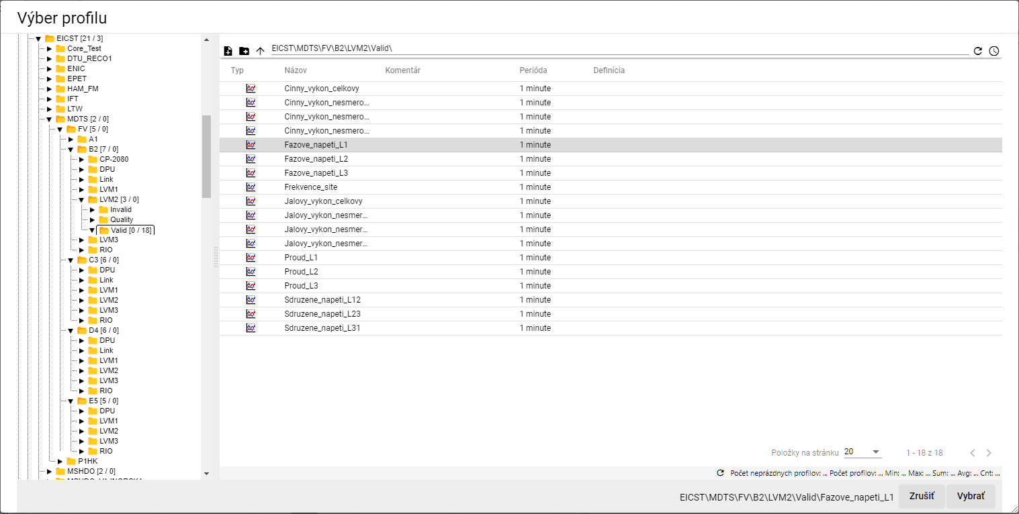

Picture 397: "Profile selection window"

1. In the window 'Change profile' click on the button 'Replace'.

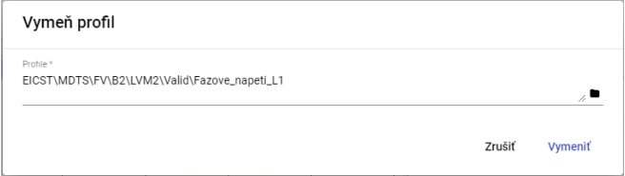

Picture 398: Selected Profile

1. The profile over the window graph is replaced with the selected profile.

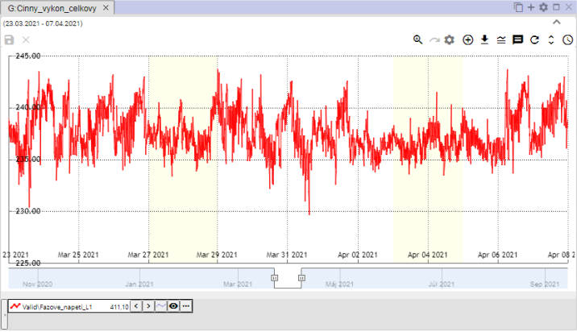

Picture 399: Blown-up profile

# Work with a blackboard

The 'Profile Manager' application offers, in addition to work with a graph and explorer, the possibility of working with data in a table. Each table contains data from one profile and is created in a separate window.

The user closed the table with unclosed data, a window - Image 400 will be displayed.

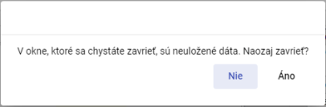

Image 400: Announcing non-compliant data

## Show profile in table

You can view the profile in a table by transferring the profile from the scanner to the table (Chapter 4.8) or by transferring the profile from the profile tree to the table.

Before viewing the profile from the profile tree in the table, proceed:

1. The standard window is an empty table.

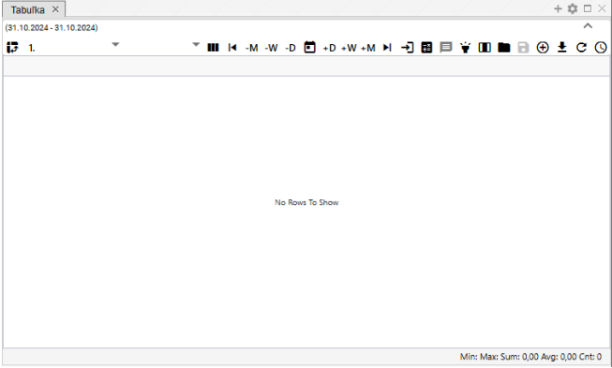

Image 401: Normally, the window for displaying the table is empty

1. Drag the profile with your left mouse button into the table which you want to display.
2. Move the profile above the table window and turn it on.

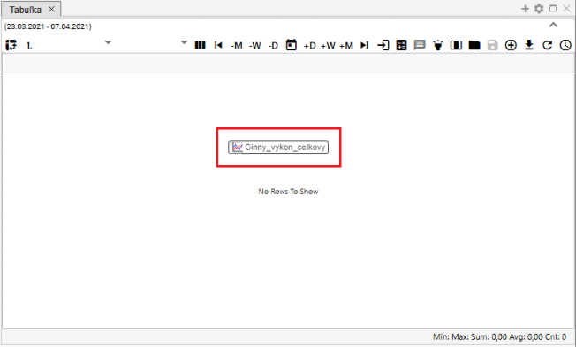

Picture 402: Adding profile to table

1. On the window table, the profile values will be displayed.

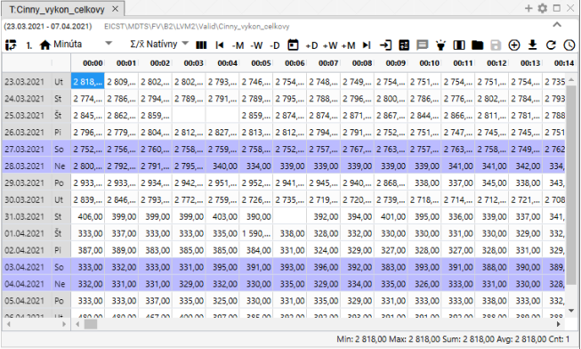

Image 403: Displaying profile in table

## How to set up column display

Standard view is set in the table. Column view can be switched on by pressing the button "Switch to column view". To switch back to standard view, press the button "Switch to column view" again.

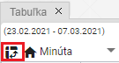

Image 404: Button "Switch to column view"

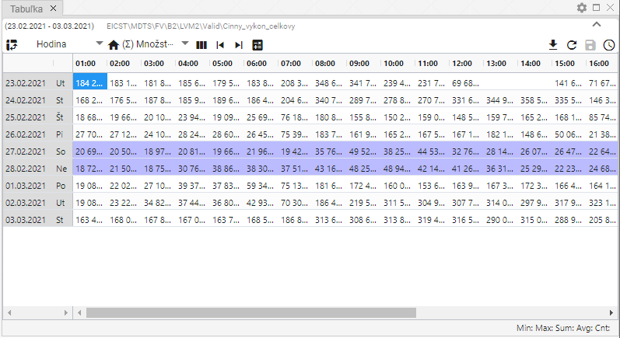

Picture 405: Emergency Display

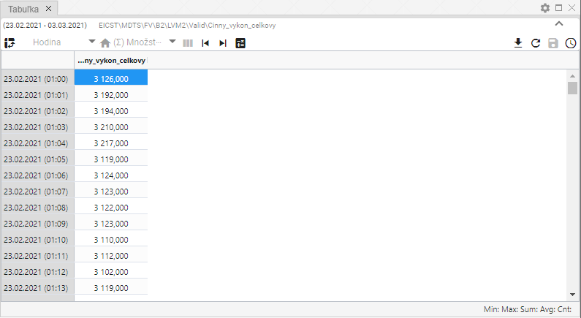

Picture 406: Columnar display

## To switch to single-profile display

Normally the table in the window 'Table' is set to single-profile display, Image 409. Pressing the button that displays Image 407 will switch the table to multi-profile display, Image 410. Switching to multi-profile display will change the appearance of the button Image 407 to button Image 408, which serves to switch the table back to single-profile display.



Image 407: Button "Switch to Multi-profile display"



Image 408: Button "Switch to single-profile display"

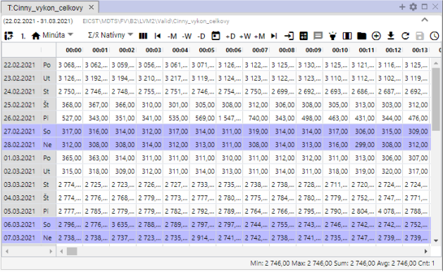

Picture 409: Single-profile display

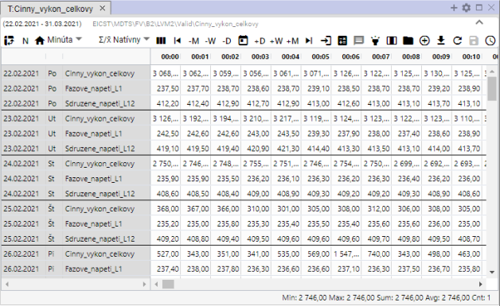

Image 410: Multifunctional display

## Change time display format

**[TRANSLATION FAILED AFTER 3 RETRIES] Dáta sa v tabuľke štandardne zobrazia v takej perióde, ako je vytvorený profil, ktorého dáta zobrazujete v tabuľke, vždy jeden deň v jednom riadku. To znamená, že pre hodinový profil sa zobrazí 24 stĺpcov, pre 15 minútový sa zobrazí 96 stĺpcov, pre 1 minútový sa zobrazí 1440 stĺpcov a pre sekundový profil sa zobrazí  900 stĺpcov.**

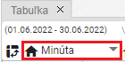

Image 411: Button for time format change

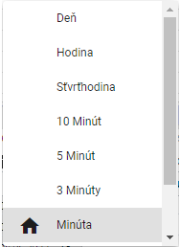

Picture 412: List of time formats in table

Data can also be preserved even in periods:.

* Day - daily overview of data
* Hour - hourly overview of events
* Quarter-hour - 15-minute overview of data
* 10 Minutes – 10-minute Overview of Data
* 5 minutes - 5-minute overview data
* 3 minutes - 3-minute overview of data
* Minute - minute overview of data
* Second - second overview of data
* Unknown – it will be shown if the table does not recognize the profile period. In that case, the values of the profile are stretched into one column and the column over time is filled according to the data.

## How to set up columns

In the window 'Tabuľka' you can set how many columns should be displayed. Proceed:

1. Click the 'Number of columns' button, which is located in the top part of the Tab window.

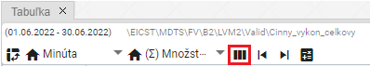

Picture 413: Button "Number of columns"

1. A window titled 'Set column count' will be shown.

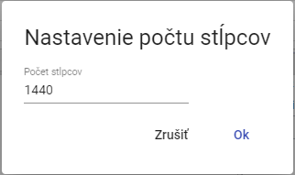

Picture 414: Window "Settings for number of columns"

1. Set the number of columns to be displayed.

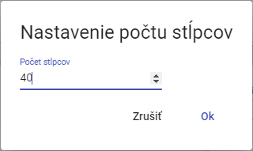

Image 415: Altered number of columns

1. The number of columns will be adjusted. Above the button "Number of Columns" the set number of columns will be displayed.

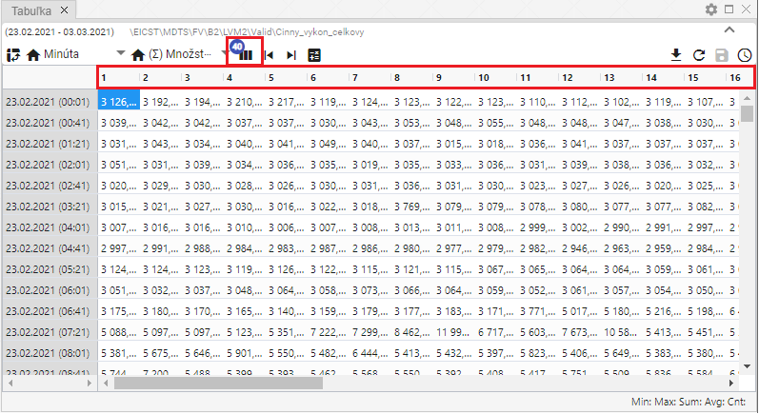

Image 416: Number of columns set

1. Press the 'Number of columns' button before restoring the number of columns, and in the 'Configure the number of columns' window press the 'Cancel' button.
2. Then, the original number of columns will be restored.

## How to select a method of transmission

The method of forecasting determines how the forecast profile will be updated when viewed in other periods than its 'natural' period.

In the 'cumulative' mode of sampling, the underlying profile will be treated as cumulative (e.g., energy) and when displayed in smaller periods, the value of the profile will be divided by the appropriate ratio. In the case of the 'piezoelectric' method of sampling, the underlying profile will be treated as piezoelectric (e.g., temperature), and when sampling at lower periods, the value of the profile will remain at the same level.

**[TRANSLATION FAILED AFTER 3 RETRIES] „Natívny“ spôsob znamená, že sa vyberie charakter profilu, ktorý je pre daný profil nadefinovaný. To znamená, že pre priebehový profil sa použije priebehový charakter a pre množstevný profil sa použije množstevný charakter. Táto voľba je dôležitá hlavne v prípade ak mám zobrazených viac profilov s rôznym charakterom. Vtedy sa zobrazuje každý podľa svojej definície.**

This setting only affects the display of the profile in a table. Changing it does not affect the behavior of the underlying profile in the system or profiles that depend on it.

To choose the mode of operation, select the 'Mode of operation' button and then choose from the window that appears, Figure 418.

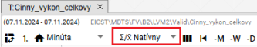

Picture 417: Button "Method of copying"

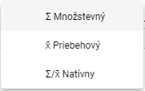

Image 418: Selection of methods for photocopying

## Show the first value

The button 'Go to first value' serves for displaying the first measured profile value.

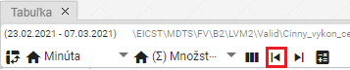

Image 419: Button "Go to first value"

## Show last value

The "Set to last value" button serves for displaying the last recorded profile value.

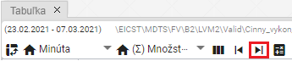

Image 420: Button "Go to minimum value"

## How to show today's date

Click the button 'Go to current date' for today's date display. The cell in the table that highlights the present time will be marked.

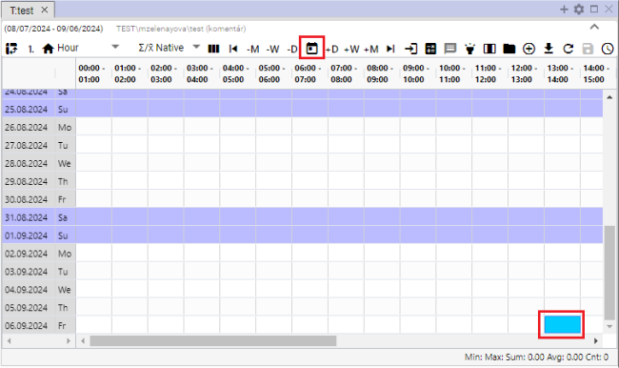

Image 421: Item "Go to current date"

## How to display a specific date

Show specific date in table:

1. Click on the button "Go for a specific date".

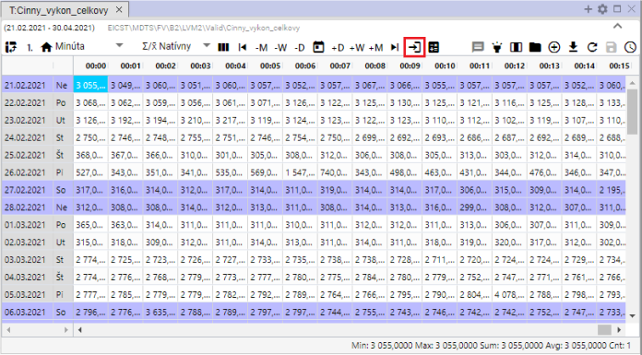

Image 422: Button "Go to specific date"

1. Choose a date.

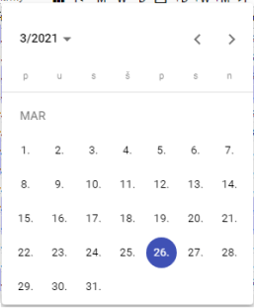

Picture 423: Task date

1. The selected date will be displayed and the first character in the selected date is highlighted in blue.

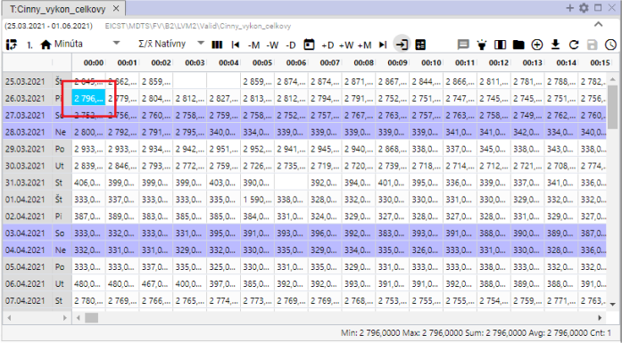

Image 424: Display of selected date

## As of yesterday, last week, last month

Date range, for which the data shown in the table can be shifted using the sliders:

* "-M" offsets one month from the chosen date.
* **[TRANSLATION FAILED AFTER 3 RETRIES] „-W“- odpočíta od vybraného dátumu jeden týždeň,**
* **[TRANSLATION FAILED AFTER 3 RETRIES] „-D“ - odpočíta od zvoleného dátumu jeden deň,**
* **[TRANSLATION FAILED AFTER 3 RETRIES] „+M“ - pripočíta k vybranému dátumu jeden mesiac,**
* **[TRANSLATION FAILED AFTER 3 RETRIES] „+W“ - pripočíta k zvolenému dátumu jeden týždeň,**
* **[TRANSLATION FAILED AFTER 3 RETRIES] „+D“ - pripočíta k zvolenému dátumu jeden deň.**

Follow:

1. Click on the bar that represents the date from which you want to add or subtract the selected time period. The highlighted bar is blue in color.
2. Press the selected button for date shift.
3. The display of data in the table will shift by the selected date range.

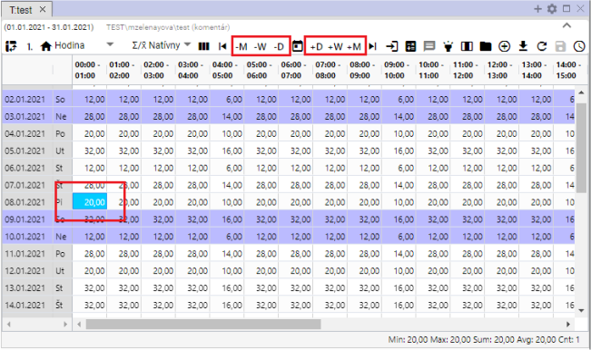

Picture 425: Buttons for shifting date by day, week, month

## Add column Sum, Average, Min, Max

You can add columns:

* Total - toggles counting daily total values in the table. In the table, a 'Total' column is added.
* Average – enables/disables daily average calculation in the table. An extra column 'Average' will be added to the table.
* Press/Unpress the display of minimum values for a given day. A new column called 'Min' will be added to the table.
* Max – enables/disables the display of the maximum value for a given day. In the table, a new column 'Max' will be added.

The standard table does not include columns Sum, Average, Min and Max. To add them, proceed:

1. Click on the button "System Statistics" at the top of the table.
2. A window will appear where you can select which columns should be displayed.
3. You can attach columns to the right side of the table by clicking on the field „Attached to the Right“. If you do not select the item „Attached to the Right“, the Sum, Average, Min and Max columns will be added at the end of the table. If you select this item, the selected columns will be attached to the right side of the table.

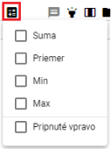

Image 426: Emergency Statistics Button

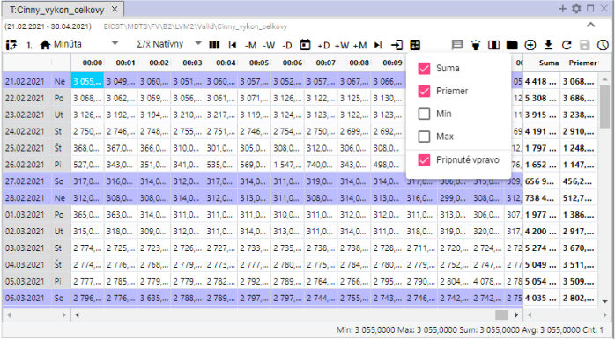

Image 427: Attached columns of "Sum" and "Average"

## To turn on/off a tooltip

Tooltip is disabled by default in the table. You can enable it by clicking the "Enable/Disable tooltip" button located at the top-right corner of the window Table. To display values (tooltip) for a specific location in the table, place your cursor on the selected location with your mouse. To hide the tooltip again, click the "Enable/Disable tooltip" button once more.

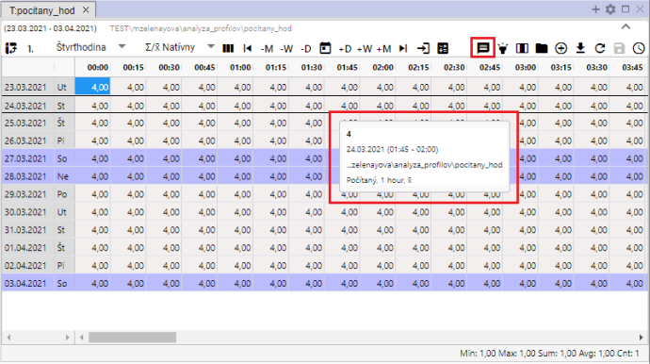

Picture 428: Tooltip displayed in table

## How to turn on/off line highlighting

Highlighting the row means that the row will be highlighted if you set your mouse cursor on it. If the "Turn highlight on/off" button is black, highlighting is turned on. The button is off when it's gray.

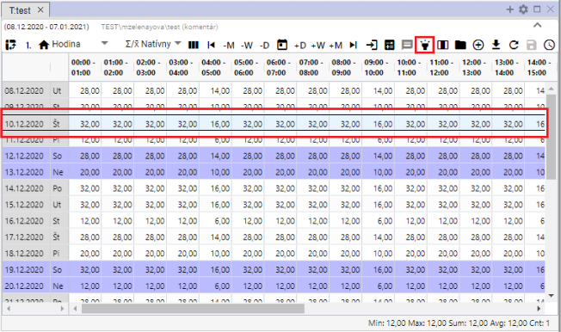

Picture 429: Toggle button "Turn on/off line highlighting" and highlighted row

## To correct the value of the profile in the table.

You can edit the values of the stored profile in the table window. The calculated profile cannot be edited.

Proceed:

1. Click to select the cell in the Table window.

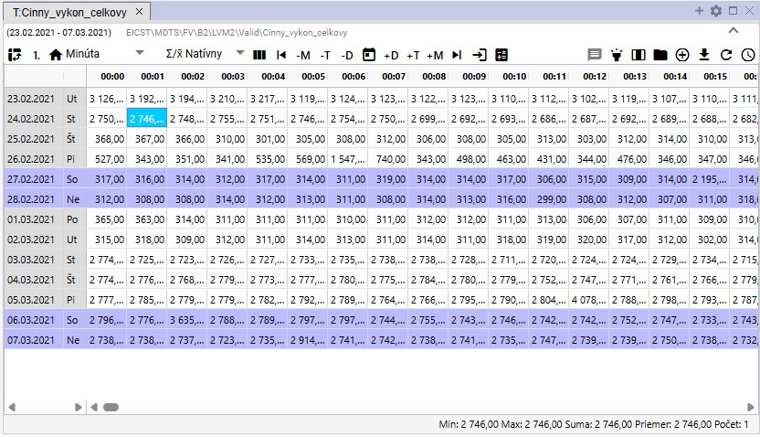

Image 430: Selection of bunker

1. Click twice on the bunker and write the value.

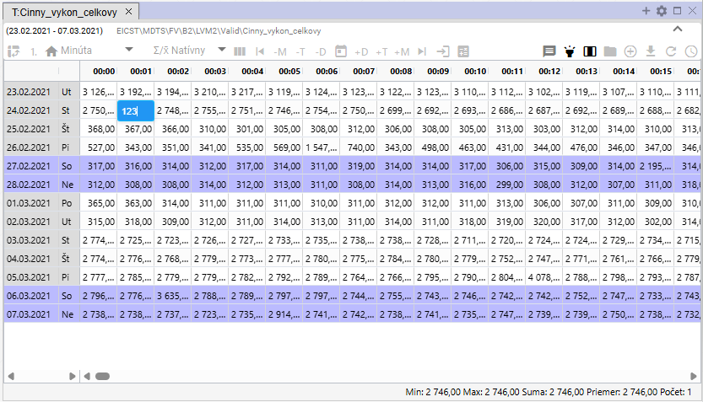

Picture 431: Inserting value

1. Click into another cell of the table after adjusting the value. The floppy drive icon button will become active.

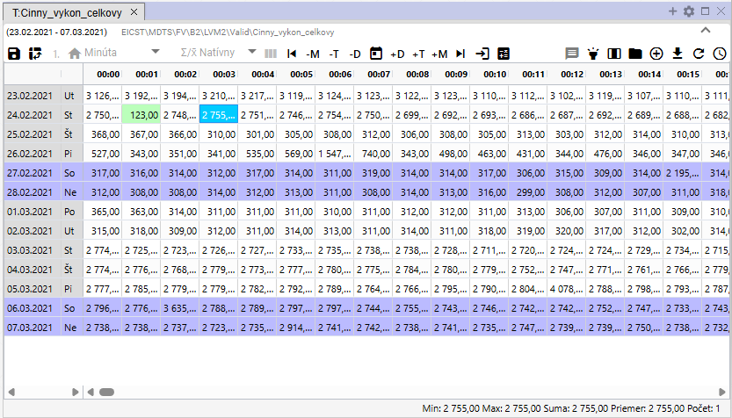

Picture 432: Edited value in table

1. You will save changes by pressing the button "Save changed values", which is located in the top part of the Table window.



Image 433: Save changed settings button

## Change profile definition

For calculated profile, you can edit definition in window Table. Proceed:

1. Click on the right mouse button on the profile in the window Table.
2. A window will appear, where you select the item 'Edit definition'.

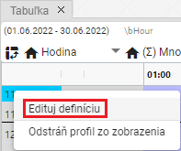

Image 434: Item "Edit definition"

1. A window titled 'Change Profile Definition' will appear.

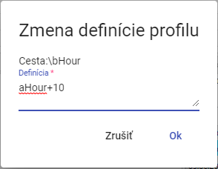

Picture 435: Change Profile Definitions window

1. Adjust the definition and confirm by pressing the 'OK' button.

## I will remove my profile from the table.

Before deleting your profile, proceed:

1. Click on the right mouse button on the profile row you want to delete.
2. A window will appear where you select the option 'Remove profile from view'.

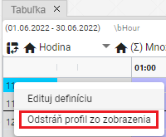

Image 436: Remove profile from display

1. The profile has been removed from the window "Table".

## How to enable automatic column width adjustment

Normally cells in a table have a fixed width. With the 'Automatic column width setting' button, Image 437, you can set it so that the entire content of the cell is visible, Image 438.

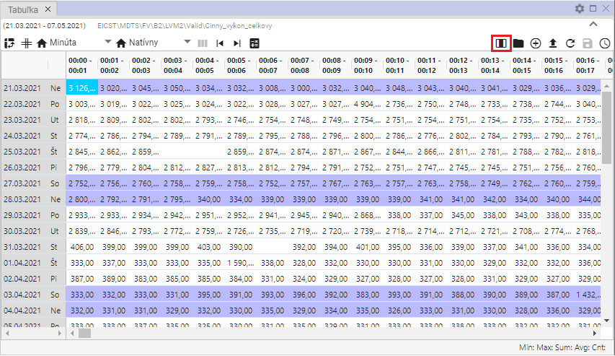

Image 437: Button "Set column width automatically"

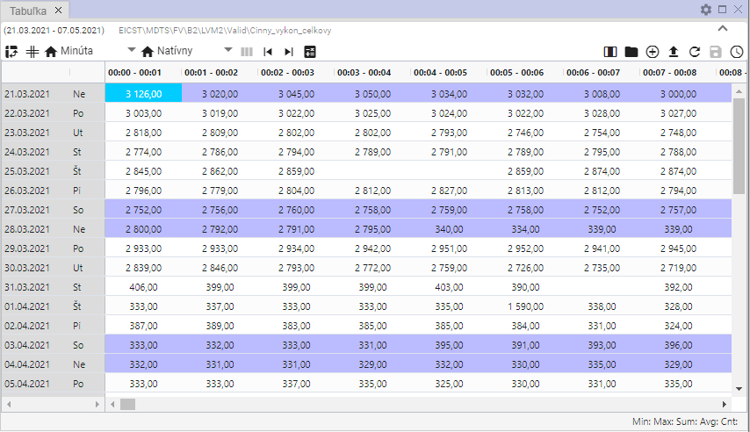

Picture 438: Columns width automatically set

## How to open account profile

The 'Open profile settings' button, Image 439, serves to open the profile from a table window in a tree structure, Image 440.

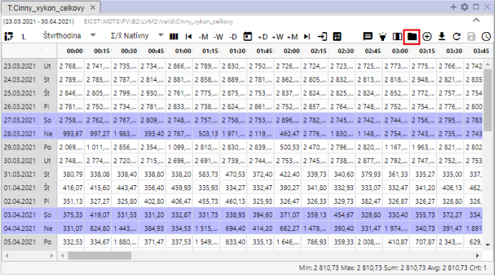

Picture 439: Button "Open user profile"

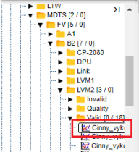

Picture 440: Opening profile in web structure

## Add profile

Before adding profile to window 'Table', proceed:

1. Click the 'Add Profile' button, which is located in the top-right corner of the 'Table' window.

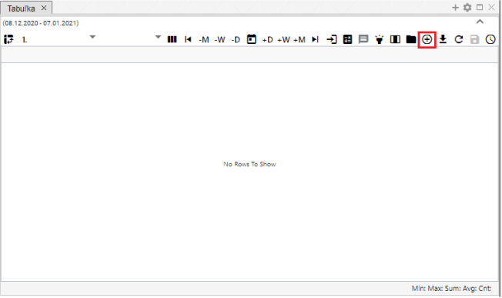

Picture 441: Button "Add profile"

1. A window titled 'Add profile' will appear, in which you can enter the path to the profile in a tree-like structure or click on the button that will show a window titled 'Select Profile'.

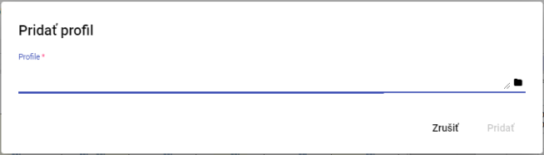

Image 442: Add profile window

1. In the window 'Select profile' search for the profile and click on the 'Select' button.

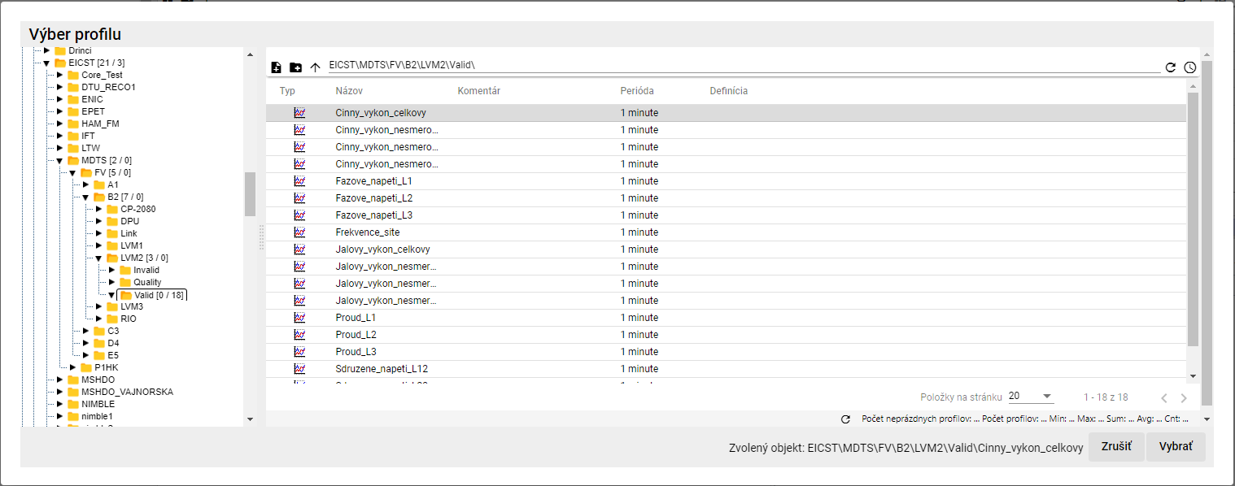

Image 443: Profile Selection Window

1. In the window 'Add profile' will be displayed a path to profile.

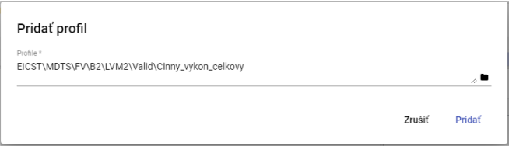

Image 444: Roadmap to Profile

1. Press the "Add" button.
2. In the window 'Table' an added profile will be displayed.

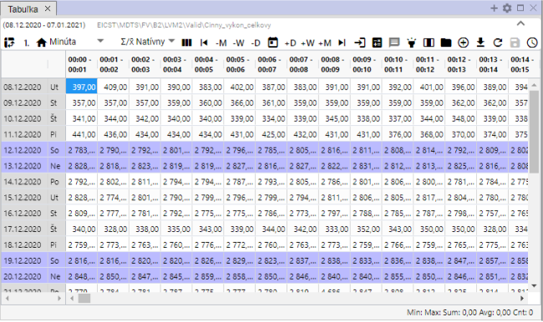

Image 445: Added profile in window 'Table'

1. If the profile is shown in the table and you add another profile, the multi-profile display will be activated automatically.

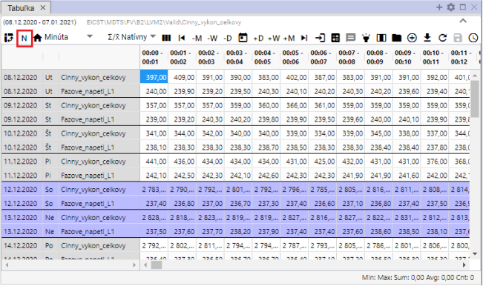

Picture 446: Multi-profile display

## Export the displayed data to CSV

The data displayed in the "Table" window can be downloaded by clicking on the "Export displayed data to CSV" button. Subsequently, a file will download, Image 448.

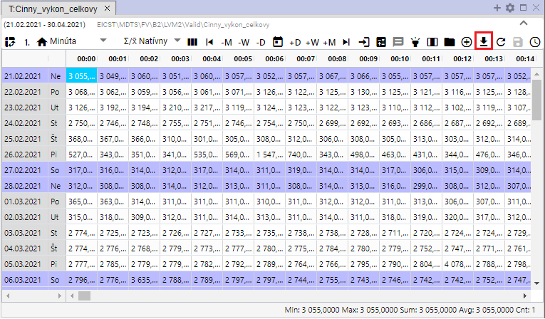

Image 447: Button "Export shown data to CSV"



Picture 448: Exported download

## I want to change the definition

Before the calculation profile you can adjust definition:

1. Click with the right mouse button on any cell in the table.
2. An offer will be displayed where you select the item 'Change definition'.

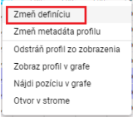

Picture 449: Item "Change definition"

1. A window titled 'Profile Expression Change' will appear, where you can modify the definition of the profile being counted.

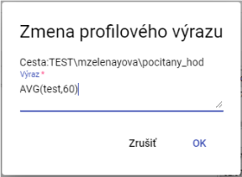

Picture 450: Change Profile Expression window

1. You will save changes by pressing the "OK" button.

## Change profile metadata

Proceed:

1. Click on the right mouse button on the cell in the table.
2. An offer will be shown where you click on the item 'Change profile metadata'.

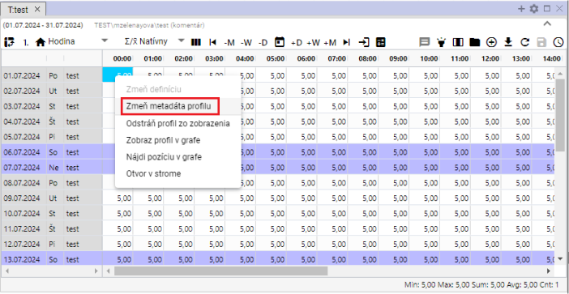

Image 451: Change profile metadata item

1. A window called 'Edit profile' will appear.

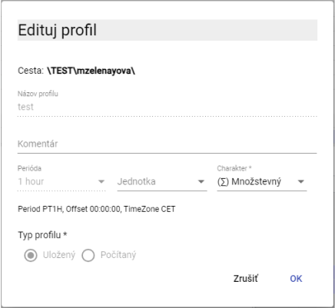

Image 452: Edit profile window for saved profile

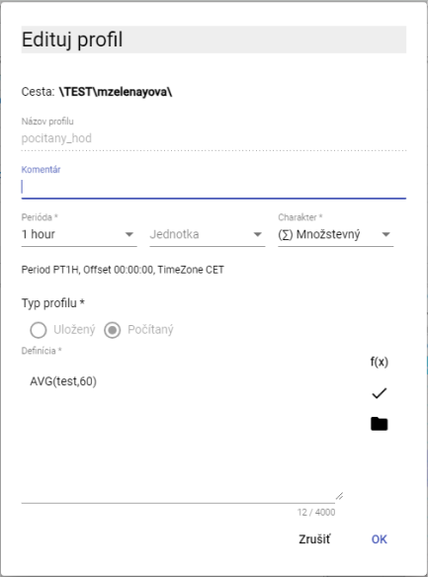

Picture 453: Edit Profile window for calculated profile

1. You can edit the fields: Comment, Unit and Character for a saved profile. For a calculated profile you can also edit the field "Definition".
2. You will save changes by pressing the "OK" button.

## Remove profile from view

Before deleting profile from list:

1. Click on any cell in the table with your right mouse button.
2. A list will appear where you select 'Remove profile from view'.

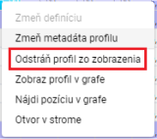

Image 454: Option "Remove profile from view"

1. His profile was removed from the table.

## Show profile in graph

If you want to display the profile from the table as a graph, proceed:

1. Click on the window heading in which you want to display a graph. This will make that window active. If the table window is active, the graph will be displayed in the table window.

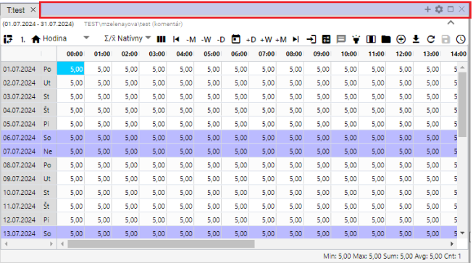

Window 455: Active window

1. Click with your right mouse button on any cell in the table.
2. An offer will be displayed, from which you can select the item 'View Profile in Graph'.

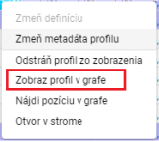

Profile picture: Item "Show profile in graph"

1. In an active window, a new tab with graph display will be added.

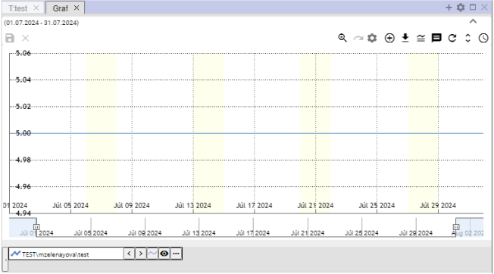

Picture 457: Displaying profile from table in graph

## How to find my position on the graph

Follow:

1. Show profile in table and chart also.
2. Click on the right mouse button in a cell/table spot where you want to display the graph.
3. The offer will be displayed where you select the item 'Find position in graph'.

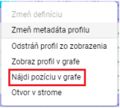

Image 458: Item "Find position on graph"

1. In the graph will be displayed a place representing a cell from the table. The graph will shift so that the selected place is in the center of the graph. In the center of the graph, a line for one second will appear.

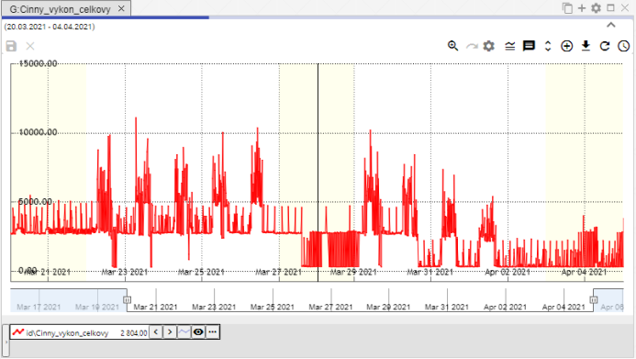

Image 459: It will show a line in the middle of the graph representing the selected cell from the table.

## How to open the profile in steam

Before opening the profile in stream:

1. Click on the right mouse button on any cell in the table window.
2. The offer is opening, in which you select the item 'Open in stream'.

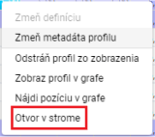

Image 460: Item "Electricity Grid Opening"

1. In the stream, the address book will open in which the profile shown in the table is located.

## Mark the block using the left mouse button

To select a block in the table, click the left mouse button on the selected cell in the table and hold it down while selecting the block.

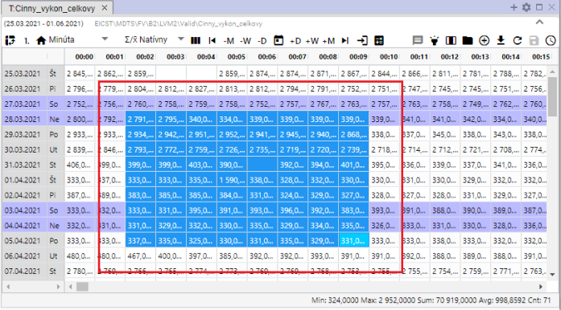

Image 461: Marking cells in a table

## If I set it up so that the cursor would move around the table using the mouse wheel

You can navigate through the table using your mouse cursor. The navigation is on a per-day basis. You can also navigate outside of the set range in the table. It's necessary that an active cell is set up in the table.

Proceed:

1. Click on the 'Settings' button, which is located in the top menu bar of the application.



Picture 462: Settings button

1. A settings window will appear.
2. In the part of „Table“, click on the item „Wheel moves cursor“."

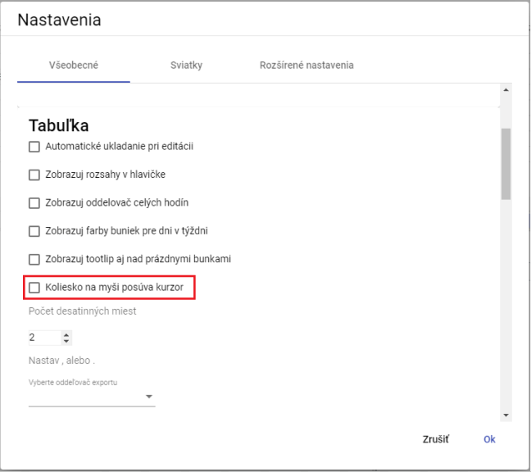

Image 463: Item "Wheel on mouse moves cursor"

1. Press the "OK" button.
2. Then, you move the cursor in the table using the mouse wheel. The cursor is an active cell in the table. This cell has a blue color.

Without checking the checkbox "Move cursor with mouse wheel", lines in a table are moved by scrolling the mouse.

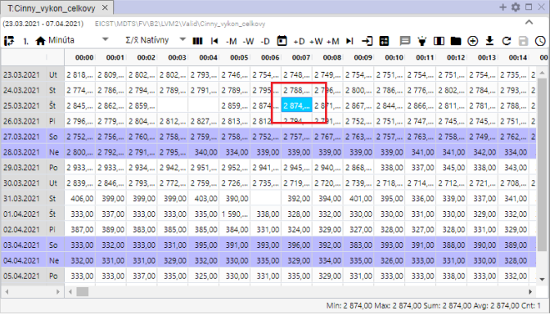

Image 464: Active cell in culture plate

## How to change the order of profiles in the table

Before changing the order of profiles in the table, you need to switch display from rows to columns. Each profile represents one column. The order of columns can be changed. After changing the order of columns, you can turn display back on rows again.

Proceed:

1. Show desired profiles in the table.
2. Click on the button 'Switch to column display'.

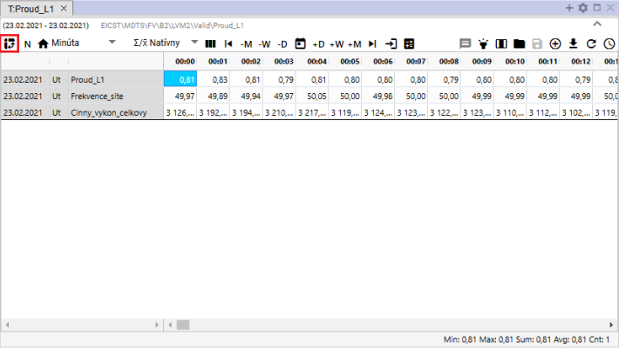

Image 465: Button "Switch to column view"

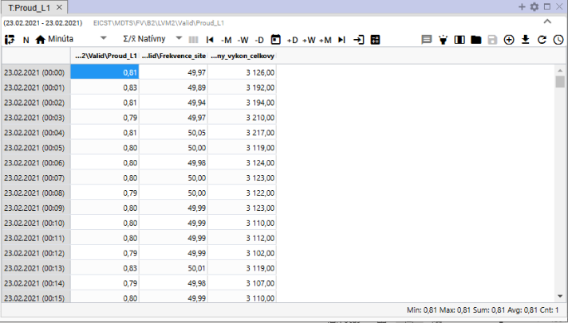

Image 466: Column chart in a table

1. Click on the column header with your left mouse button and move the column to its desired position. Then let it go.

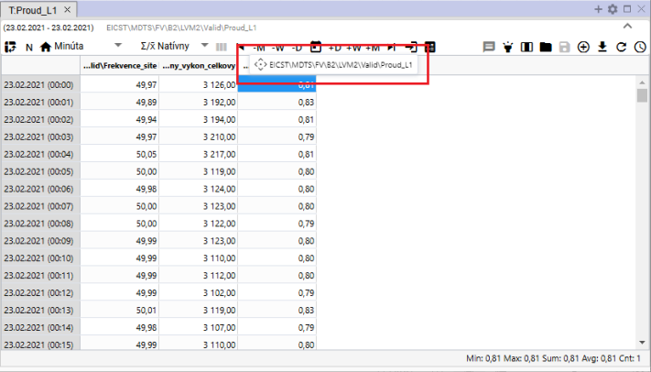

Image 467: Pillar pressure testing

1. After moving the column, you can switch back to the list view of profiles.

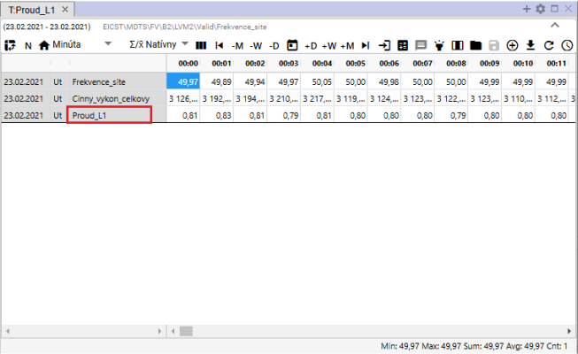

Image 468: Changed order of profiles

# Arithmetic counted profiles

## Regulations on Preemptive Measures

In arithmetic operations with profiles having different periods, during their calculations there comes a carry-over at the result of their computation. This carry-over has its rules which depend mainly on the set character of input profiles into operation. The detailed rules of carry-over are described in the following text.

### The rules of transferring the entry profile to the output with consideration of character

Example: Output_profile := Input_profile1 + Input_profile2 * Input_profile3 ...

1. If the input profile is within an aggregate function (avg, sum, min, max, count) or cp(), its interpolation is determined by its parameter explicitly and the following rules are not taken into account.
2. If not, the input profile is still converted to sampling of output profile according to following rules before applying arithmetic:
3. Characterless profile is considered as procedural. This is the default character, and thus it was also looked at before introducing characters.
4. If the input and output profiles are identical, there is no overlap and no characteristics are taken into account at all. The values are copied 1:1.
   1. They have profiles of different character and we want to perform a conversion between them, so we have to do it manually using the pattern in profile arithmetic. The most common is the conversion from ¼-h power to ¼-h energy by input_profile / 4
5. Although the periods of entry and exit are different, it will be changed accordingly:
   1. Down-sampling: it involves converting finer to coarser sampling.
6. In quantity, it will be used aggregation via SUM
7. According to procedures, aggregation will be used via AVG
8. Up-sampling: it involves taking coarse and turning into finer sampling.
9. In proportional mode, the input value is multiplied by the ratio of the output to input period
10. The input value increases with the number of cases (unchanged).
11. Only the character of the input profile is taken into account during the pre-processing. The character of the output is not considered at all.

## Calculated profile

Profile you will create according to the following procedure:

1. In the stormy structure, click with the right mouse button on the name of the addressee in which you want to create a new counted profile. A window will appear with items, where the cursor is set by clicking on the item "New" and select "Profile", Picture 469. The window "New Profile" will open, Picture 470.

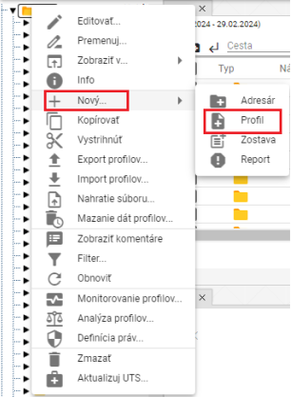

Picture 469: Item "Profile"

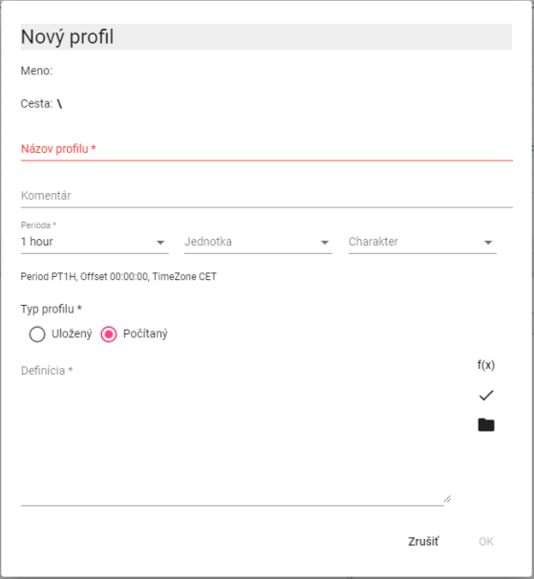

Image 470: Window for creating calculated profile

1. In the "Profile name" field, enter a name for the profile. The profile name must start with a letter, followed by numbers and underscores "_" as optional characters. The profile name can contain up to 22 characters. The profile is identified by its name or optionally by entering a path to the profile and the name (path/profile).
2. You can enter a comment.
3. Choose period, unit and character.
4. Choose "Calculated" in the section "Profile Type".
5. When defining the calculated profile, we can use buttons:
6. if we want to work with standard functions for the computed profile
7. if we want to use a different saved or computed profile in the definition. For a computed profile, we can also use another computed profile in the definition.
8. You will create a profile by pressing the "OK" button.

The profile is designated by name, optionally with the path to the profile and its name (path/profile).

* You can also use plug-in functions (described below) in the configuration profile beforehand.

Warning notice

It is not possible to create Oracle profiles for Vo verzii Xenergie G2. Depending on the specifics of a particular implementation of Xenergie G2, it is possible to preserve their back compatibility.

### Method of writing expression

We write down the definition of calculation into the window 'Definition'.

The name of the profile must start with a letter, then it can also contain digits and an underscore symbol "_". The name of the profile can contain up to 22 characters. The profile is designated by its name, or by specifying the path to the profile and its name (path\profile).

In making definitions, capital and small letters are not distinguished.

Examples:

**\cez**

A link to your profile in the main folder (or directory)

**..\cez**

a link to your profile one level up in the address book

**..\..\oprava\cez**

Link to profile above 2 levels of address holders, in subaddresser 'correction'

**100**

The profile will contain the value of 100 for the entire time period.

The number format is [-]nnn.mmm[ E[-]eee].

The expression may contain spaces, tables and newline characters. These are ignored.

### Calculation of the expression

The expression is specified for each time period (hour, minute) separately for the required time period.

In an estimated time, its value is zero, work is being done with a non-existent value.

If any of the values entering operation +, -, *, /, >, <, >=, <=, =, <>, |, &, ! is invalid, the result is an invalid value.

Division by zero produces an invalid value.

The program always calculates all values, even if they are not necessarily needed, so for example alt(100.0,unknown_profile) is an incorrect expression

### Arithmetic operations:

* Census + increment
* Subtraction
* Multiplication
* Division //
* Parentheses.

Operations are counted from left to right. The highest priority have (), then "*", "**", and "/","//"

The operations "++, --, **, // replace an invalid value with a value of 0."

### Functions

By clicking on the button, a window will open where you can choose one of the standard functions. The functions are stored in categories:

* Aggregate functions
* Alternative
* Compositional functions
* Conditional
* Deprecated functions
* Other functions
* Rounding functions
* Character functions

After selecting a category, a list of features with hints to the functions will be displayed.

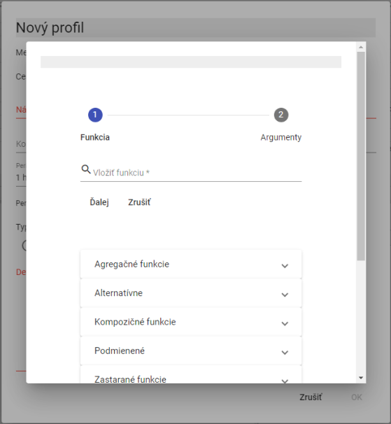

Image 471: Function list

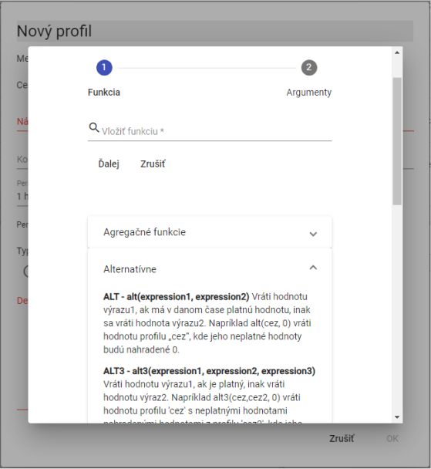

Picture 472: List of functions with guidance to functions

#### Aggregating functions

Aggregating functions have two parameters.

1. profile – profile name
2. period – the period with which the given function should be calculated. The period is specified using the following constants (for calculation in real time, constants starting with the letter “P” are used):

Constants for setting a period need to be entered always in capital letters.

**D, PD – daily period (in CET and in real time – in summer in CEST)**

**W, PW – weekly period /week starts on Monday and ends on Sunday/**

**E, PE – weekly period /week starts on Saturday and ends on Friday/**

**M, PM – monthly period**

**Q, PQ – quarterly period**

**Y, PY – yearly period**

We can input the period to each calculated profile in minutes. It does not need to be shortened.

**sum(profile, period)**

Scheduling with given period in CET.

(Period: D, W, E, M, Q, Y, although in calculated profiles you can enter period in minutes.)

Note that we calculate the function sum(merging, M) with a hourly period for the profile measurement. The resulting profile will have a sum of values from the profile measurement in every month.

**[OLLAMA FORMATTING ERROR - MANUAL REVIEW NEEDED] avg(profil, perioda)**

Simulation for given period in CET

We will then calculate the function avg(temperature, 60) where the temperature profile has a minute period. In the resulting profile we get hourly averages of temperature.

**[OLLAMA FORMATTING ERROR - MANUAL REVIEW NEEDED] min(profil, perioda)**

The minimum price for the period in CET.

For each period, the minimum value is calculated.

**[OLLAMA FORMATTING ERROR - MANUAL REVIEW NEEDED] max(profil, perioda)**

Maximum value within period. Function works in CET (Central European Time).

For each period, the maximum value is calculated.

**[OLLAMA FORMATTING ERROR - MANUAL REVIEW NEEDED] csum(profil, perioda)**

Cumulative summation of the profile values on time units given by parameter period. The output profile at a given time point gives a value which is the sum of all preceding input profile values, from the start of the time interval (defined by parameter period) up to the specific time point (inclusive).

Note that if this is an input profile with a one-hour period, then the output profile defined by "csum(profil_vstup, PD)" will have in every day, at its last hour (in local time), a value equal to the sum of values for the entire day).

**[OLLAMA FORMATTING ERROR - MANUAL REVIEW NEEDED] pavg(profile,perioda)**

Synchronization with given period in real time.

**[OLLAMA FORMATTING ERROR - MANUAL REVIEW NEEDED] pcsum(profile, perioda)**

Scheduling with a given period. The function works in real time.

At any given moment, the current period is determined by the sum of values from the beginning of the period up to time t.

**[OLLAMA FORMATTING ERROR - MANUAL REVIEW NEEDED] pmax(profile,perioda)**

The maximum rate during a full period of time.

**[OLLAMA FORMATTING ERROR - MANUAL REVIEW NEEDED] pmin(profile,perioda)**

Minimum value within a period of full time.

**[OLLAMA FORMATTING ERROR - MANUAL REVIEW NEEDED] psum(profil ,perioda)**

Scheduling with given period in real time.

(Period: D, W, E, M, Q, Y, while in counted profiles it's possible to enter period in minutes.)

Functions with P at the start of the radius cause a division of time into intervals that need to be aggregated.

P means Valid time, which switches to UTC+1 from UTC+2 in summer.

The functions of PSUM, PAVG, PMIN, PMAX are obsolete. (others like PHOUR, PDAY, PTDIV, etc. are not.)

We recommend using functions without P in their name instead, and to use P as a time parameter prefix.

Instead of using the term PAVG (profile, X), we recommend using AVG (profile, PX).

Under the term 'obsolete', we mean that these functions are no longer recommended for use when setting up new calculations.

Those 'archaic' functions within the system will remain as they are. Their behavior, however, we will no longer adjust.

Functions without P, which we recommend as a replacement, have wider application and will gradually be extended to new periods.

The old functions can still be used. However, for creating new patterns, we recommend using the newer universal versions instead.

#### Alternative

**[OLLAMA FORMATTING ERROR - MANUAL REVIEW NEEDED] alt(vyraz1,vyraz2)**

**[OLLAMA FORMATTING ERROR - MANUAL REVIEW NEEDED] alt3(vyraz1,vyraz2,vyraz3)**

**[OLLAMA FORMATTING ERROR - MANUAL REVIEW NEEDED] ...**

**[OLLAMA FORMATTING ERROR - MANUAL REVIEW NEEDED] alt9(vyraz1,vyraz2,...,vyraz9)**

This expression has no valid value, the calculation continues with expression 2 and if it doesn't have a valid value either, then the next expression is used...

**[OLLAMA FORMATTING ERROR - MANUAL REVIEW NEEDED] alt(vyraz1,vyraz2)**

This expression 1 does not have a valid value, it is replaced with expression 2.

ALT(DGC2000 Data, 0)

The profile "...cez" does not have a valid value, the function will use value 0 during processing.

**[OLLAMA FORMATTING ERROR - MANUAL REVIEW NEEDED] alt3(výraz1, výraz2, výraz3)**

If expression 1 has no valid value, expression 2 will be used, if it also has no valid value then expression 3 will be taken.

Alternative functions can sometimes be suitably replaced by:

Example:

**[OLLAMA FORMATTING ERROR - MANUAL REVIEW NEEDED] alt(dodavatel1,0)+alt(dodavatel2,0)**

They will replace it.

Supplier 1, plus supplier 2

Sum two profiles by replacing invalid value with 0.

Example:

If ( ceiling of 2 * ceiling of 3, 0)

Or

Alt key (alternate, alternate 2, 0)

The non-valid value in profile 'cez' will be replaced by the value from profile 'cez2', or if neither of 'cez2' contains a valid value, it will use the value 0. The second variant is, of course, more efficient.

#### Error containment/containment of error spread

**[OLLAMA FORMATTING ERROR - MANUAL REVIEW NEEDED] nv()**

Function that returns an empty (invalid) value. (NO_VALUE). All operations with an invalid value produce an invalid value.

**[TRANSLATION FAILED AFTER 3 RETRIES] Príklady:**

**[OLLAMA FORMATTING ERROR - MANUAL REVIEW NEEDED] nv()**

**[OLLAMA FORMATTING ERROR - MANUAL REVIEW NEEDED] nv()+100**

The result will be a profile containing invalid values. (Not containing any values).

Valid (profile)

If there was an error when obtaining the profile values (for example, they do not exist), then the result is invalid values. If the function VALID has not been used and the specified profile does not exist, the program will display an error message (the definition of the calculated profile is incorrect) and the expression will not be executed.

Example:

**[OLLAMA FORMATTING ERROR - MANUAL REVIEW NEEDED] test**

Or

**[OLLAMA FORMATTING ERROR - MANUAL REVIEW NEEDED] alt(test,0)**

If the profile is called "test" (or does not exist), the program will notify an error when the following expressions are entered.

If the profile "test" becomes incorrect after entering this term, an error message will be displayed in the info window of the resulting profile.

Example

Validate (test)

The resulting profile will be correct, but it won't contain a valid value.

alt(valid(test), 0)

The resulting profile will be alright and will contain values of 0.

#### Simple condition

**[OLLAMA FORMATTING ERROR - MANUAL REVIEW NEEDED] cond(logicky_vyraz,vyraz1,vyraz_nepravda)**

If the logical expression is true, then expression1 will be executed. If it is false or has an invalid value, then expression_false will be executed.

A logical expression can contain

* Expressions and numerical values
* Comparison operators : “>”, “<”, “>=”, “<=”, “=”, “<>”

Logical expressions can be connected through logical operations:

* logical product (and at the same time): &
* Logical sum (or): |
* Negotiation: !

The evaluation order of logical operations is: ! & | and we can adjust it using ( ).

**[TRANSLATION FAILED AFTER 3 RETRIES] Príklad:**

Ceiling of (the square root of the absolute value of 'cez'), where 'cez' is an undefined variable.

All values below 0 in the profile will be replaced with a value of 0.

**[TRANSLATION FAILED AFTER 3 RETRIES] Príklad:**

SELECT *, ROW_NUMBER() OVER () FROM cez WHERE 1 = 1

The account profile within contains a valid value, the result will be 1, otherwise the result will be 0.

**[TRANSLATION FAILED AFTER 3 RETRIES] Príklad:**

If ((price<0) or (price>1000)), then not valid, price

If ((cez >= 0) and (cez <= 1000)), then use cez; otherwise, use nv.

The resulting profile in both cases will not contain values smaller than 0 and larger than 1000. Brackets in these cases are not necessary.

#### Conditional multiple

**[OLLAMA FORMATTING ERROR - MANUAL REVIEW NEEDED] cond2(logický_výraz1, výraz1,logický_výraz2, výraz2, výraz_nepravda)**

**[OLLAMA FORMATTING ERROR - MANUAL REVIEW NEEDED] ...**

**[OLLAMA FORMATTING ERROR - MANUAL REVIEW NEEDED] cond9(logický_výraz1, výraz1,…logický_výraz9, výraz9, …výraz_nepravda)**

If logical_expression1 is true, then execute expression1. If logical_expression2 is true, then execute expression2.... If none of the logical_expressions are true, then execute not_truth.

Example:

If (true<zjed*1.02,1,If (true<zjed*1.05,1.1,1.2)))

**[TRANSLATION FAILED AFTER 3 RETRIES] cond2(real<zjed*1.02,1,real<zjed*1.05,1.1,1.2)**

In both cases, if the profile value is less than 102% of the z-score profile value, return 1; if greater than 102% and less than 105%, return 1.1; otherwise return 1.2.

#### Warehousing functions

**[OLLAMA FORMATTING ERROR - MANUAL REVIEW NEEDED] day(výber_dní)**

The output is a profile containing units and zeros. The function writes 1 for the days of the week that are specified in the argument. The function works in CET. Day of the week is identified by the number in order: Mo (1), Tu (2), We (3), Th (4), Fr (5), Sa (6) and Su (7).

Record day(136) will create such a 0-1 profile that will have units in Mo (Monday)(1), We (Wednesday)(3) and Su (Sunday)(6).

**[OLLAMA FORMATTING ERROR - MANUAL REVIEW NEEDED] hour(výber_hodín)**

The output is a profile containing units and zeros. The function returns 1 for the hours of day specified in the argument. The function operates in UTC.

Record for the calculated profile: hour(1, 5 - 10, 18, 24) will write value 1 for hours 1, 5, 6, 7, 8, 9, 10, 18 and 24.

**[OLLAMA FORMATTING ERROR - MANUAL REVIEW NEEDED] month(výber_dní)**

The output is a profile containing ones and zeros. The function writes a 1 for those days of the month listed in the argument. The function works in UTC.

Entry: The function month(1, 3, 10 – 13, 30) will return the value 1 for days 1, 3, 10, 11, 12, 13, 30.

**[OLLAMA FORMATTING ERROR - MANUAL REVIEW NEEDED] pday(výber_dní)**

The output is a profile containing units and zeros. The function returns 1 for the days of the week specified in the argument. The function operates within working hours. Day of the week is identified by a digit in order: Mo (1), Tu (2), We (3), Th (4), Fr (5), Sa (6) and Su (7).

Record : pday(136) will return such a 0-1 profile, which will have units on Monday (Po), Wednesday (St), and Sunday (So)

The function works during office hours.

**[OLLAMA FORMATTING ERROR - MANUAL REVIEW NEEDED] phour(výber_hodín)**

The output is a profile containing units and zeros. The function writes 1 for the hours on day which are listed in the argument. The function works within valid time.

Note: phour(1, 5 - 10, 18, 24) returns the value 1 for hours 1, 5, 6, 7, 8, 9, 10, 18 and 24.

The function works during working hours.

**[OLLAMA FORMATTING ERROR - MANUAL REVIEW NEEDED] pmonth(výber_dní)**

The output is a profile containing ones and zeros. The function returns 1 for the days in the month that are listed in the argument. The function works with standard time.

Note: pmonth(1, 3, 10 - 13, 30) will return a value of 1 for days 1, 3, 10, 11, 12, 13, and 30.

The function works during business hours.

**[OLLAMA FORMATTING ERROR - MANUAL REVIEW NEEDED] ptdiv(výraz0, čas1,výraz1,...., časX, výrazX )**

Profile creation based on time. Up to time time1 will use profile values of expression0, from time1 (inclusive) to time2 will use profile values of expression2, ..., from timeX (inclusive) will use profile values of expressionX.

Time is given in the format DD.MM.YYYY[YY] [HH:MM]. The year can be entered in full form (1990-2030), but also shortened (00-30, 90-100).

The function for dividing points works in online time.

**[OLLAMA FORMATTING ERROR - MANUAL REVIEW NEEDED] tdiv(výraz0, čas1,výraz1,...., časX, výrazX)**

Creating profiles by time. Until time time1, the profile value of expression0 will be used, from time1 (inclusive) to time2 the profile value of expression2 will be used, ..., from timeX (inclusive) until the profile value of expressionX will be used.

Time is entered in the format DD.MM.YYYY[YY] [HH:MM]. The year can be specified in full form (1990-2030), or abbreviated (90-100, 00-30).

The TDI function is working on EAT.

**[OLLAMA FORMATTING ERROR - MANUAL REVIEW NEEDED] vdiv(vstupny_výraz, výraz0, hodnota1, výraz1,... hodnotaX, výrazX)**

Profile creation based on value. If the input_expression is smaller than value1, it will be replaced with expression0. If it is greater (equal) than value1 and smaller than value2, it will be replaced by expression1, ... . If it is greater (equal) than valueX, it will be replaced by expressionX.

Before calculated profile, the function will assign the value NO_VALUE to the value NO_VALUE.

#### Smoothing functions

This parameter determines the position up to which rounding occurs. If it is positive, we round up to ones, tens,..., if negative, we round up to tenths, hundredths...

If a number represents two tenths of a place, then rounding functions will round to whole hundreds.

**[OLLAMA FORMATTING ERROR - MANUAL REVIEW NEEDED] round(výraz, počet_desatinných_miest)**

Rounding (absolute value from the top down). If the parameter number_of_decimal_places = 0, the number 1.5 rounds to 2. The number -1.5 rounds to -2.

**[OLLAMA FORMATTING ERROR - MANUAL REVIEW NEEDED] roundup(výraz, počet_desatinných_miest )**

Rounding up always in absolute value. If the parameter 'number_of_decimal_places' equals zero, the number 1.1 rounded up is 2. The number -1.1 rounded up is –2.

**[OLLAMA FORMATTING ERROR - MANUAL REVIEW NEEDED] trunc((výraz, počet_desatinných_miest )**

Rounding the assigned number of digits. If parameter number_of_decimal_places is equal to 0, then number 1.1 will be rounded to 1 and number -1.1 to -1.

#### Warning functions

**[OLLAMA FORMATTING ERROR - MANUAL REVIEW NEEDED] abs(výraz)**

Absolute value from each value in profile.

**[OLLAMA FORMATTING ERROR - MANUAL REVIEW NEEDED] minus(výraz)**

Values greater than 0 will replace 0.

**[OLLAMA FORMATTING ERROR - MANUAL REVIEW NEEDED] plus(výraz)**

Values less than 0 will be replaced with 0.

**[TRANSLATION FAILED AFTER 3 RETRIES] Príklad:**

condition (if condition not, then condition)

I'm like off (out) of it

Example:

Without warning (literally "without knocking")

It's just like plus-minus (odch = minus)

**[TRANSLATION FAILED AFTER 3 RETRIES] Príklad:**

change (undo, change, undo)

It is as if it were a minus (off).

# Additional/complementary functions

Additional features are not a standard part of the delivery "Profile Manager", but are ordered separately.

## Monitoring profiles

This function serves for monitoring profiles. The monitoring job serves to protect profiles. For example, it ensures that the value in the profile does not fall below zero or exceed 100. The following chapters deal with creating, modifying, deleting and exporting the monitoring job.

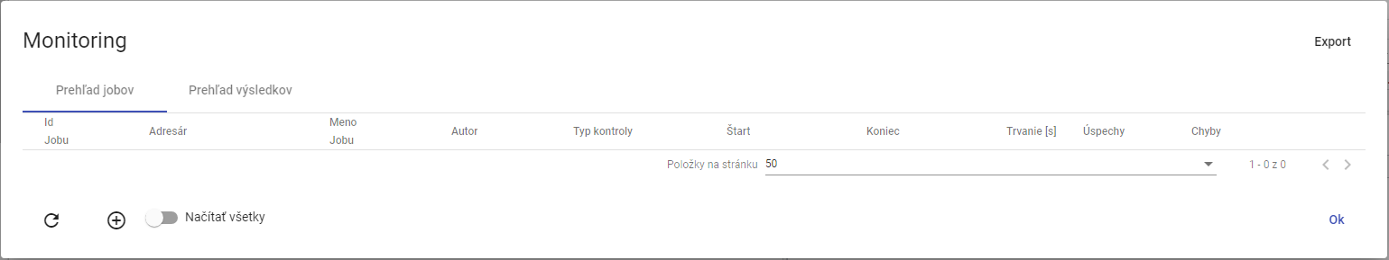

Picture 473: Window "Monitoring""

### How to create a new monitoring job

**[OLLAMA FORMATTING ERROR - MANUAL REVIEW NEEDED] Pre vytvorenie nového monitorovacieho jobu postupujte:**

1. Click with the right mouse button on the folder in the tree structure.
2. The offer will be displayed, where you select the item 'Monitoring profiles'.

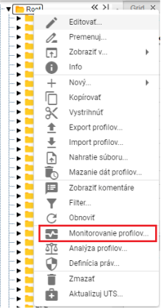

Image 474: Item "Monitoring profiles"

1. A window called "Monitoring" will appear.
2. Click the button or right-click on an existing job and select "Create new job".

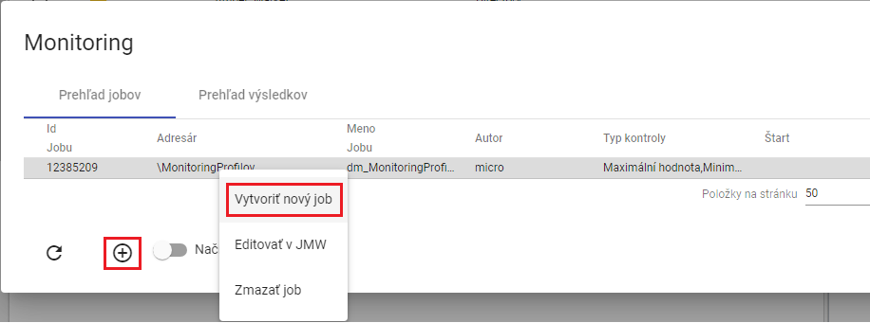

Image 475: Item "Create new job"

1. A window titled ‘New Monitoring Job’ will appear. Explanation of fields:

* **[OLLAMA FORMATTING ERROR - MANUAL REVIEW NEEDED] „Kritériá“ - kritéria podľa ktorých sa profil monitoruje,**
* **[TRANSLATION FAILED AFTER 3 RETRIES] „Zmena hodnoty“ - kritérium kontrolujúce zmenu hodnoty v monitorovanom profile. Profil je monitorovaný v stanovenom časovom intervale, ak sú všetky hodnoty v intervale rovnaké, zobrazí sa chybové hlásenie.( Profile: „Názov profilu“ No change in value in interval 27.3.2017 1:00:00 - 27.3.2017 4:00:00),**
* **[OLLAMA FORMATTING ERROR - MANUAL REVIEW NEEDED] „Monotónne“ - kritérium kontrolujúce monotónnosť hodnôt v monitorovanom profile v stanovenom intervale. Ak sa pri zvolenej stúpajúcej monotónnosti v časovom úseku nachádzajú hodnoty porušujúce stúpajúcu monotónnosť, zobrazí sa chybové hlásenie. (Profile: „Názov profilu“ Monotony condition of the series is not fullfilled at time point 6.4.2017 11:00:00),**
* **[OLLAMA FORMATTING ERROR - MANUAL REVIEW NEEDED] „Stúpajúce“ – kritérium kontroluje stúpavosť. Profil musí stále rásť.**
* **[TRANSLATION FAILED AFTER 3 RETRIES] „Maximálna hodnota“ - kritérium kontrolujúce dosiahnutie maximálnej hodnoty v monitorovanom profile. Ak sa v hodnotách zvoleného profilu v stanovenom časovom intervale nachádza hodnota presahujúca zvolenú maximálnu hodnotu, zobrazí sa chybové hlásenie.(Profile: „Názov profilu“ 1.1.2013 0:00:00 > 14 is larger than allowed max: 8),**
* **[OLLAMA FORMATTING ERROR - MANUAL REVIEW NEEDED] „Minimálna hodnota“ - kritérium kontrolujúce dosiahnutie minimálnej hodnoty v monitorovanom profile. Funguje analogicky ako kritérium maximálnej hodnoty,**
* **[OLLAMA FORMATTING ERROR - MANUAL REVIEW NEEDED] „Chýbajúca hodnota“ - kritérium kontrolujúce počet chýbajúcich hodnôt v monitorovanom profile v stanovenom intervale. Ak počet chýbajúcich hodnôt v stanovenom intervale presiahne parameter „Chýbajuca hodnota“, zobrazí sa chybové hlásenie.(Profile: „Názov profilu“ Interval 1.1.2013 0:00:00 - 2.1.2013 0:00:00 contains 3 empty values.),**
* **[OLLAMA FORMATTING ERROR - MANUAL REVIEW NEEDED] „Rozdielna hodnota“ - kritérium kontrolujúce rozdiel medzi maximálnou a minimálnou hodnotou v monitorovanom profile v stanovenom intervale. Ak rozdiel max a min hodnoty v stanovenom intervale presiahne parameter „Rozdielna hodnota“, zobrazí sa chybové hlásenie.( Profile: „Názov profilu“ Difference in values was 12),**
* **[OLLAMA FORMATTING ERROR - MANUAL REVIEW NEEDED] „Začiatok intervalu (D:H:M:S)“ - je Interval začiatku monitorovania dát v profile. Vzťahuje sa relatívne k času spustenia akcie alebo k zadanému absolútnemu času,**
* **[TRANSLATION FAILED AFTER 3 RETRIES] „Koniec intervalu (D:H:M:S)“ - je Interval konca monitorovania dát. Vzťahuje sa relatívne k času spustenia akcie alebo k zadanému absolútnemu času,**
* **[TRANSLATION FAILED AFTER 3 RETRIES] „Časová zóna“ - je zóna v ktorej sa nachádza server na ktorom beží JMW. Zóna sa zohľadňuje pri posuvnom časovom okne, kedy sa podľa nej určuje lokálny čas spustenia akcie,**
* **[OLLAMA FORMATTING ERROR - MANUAL REVIEW NEEDED] „Zarovnanie“ - voľba zarovnanie umožňuje zarovnať časové okno dát monitorovaného profilu na nasledovné časové obdobia:**
  + **[OLLAMA FORMATTING ERROR - MANUAL REVIEW NEEDED] deň v platnom čase**
  + **[OLLAMA FORMATTING ERROR - MANUAL REVIEW NEEDED] hodinu v platnom čase**

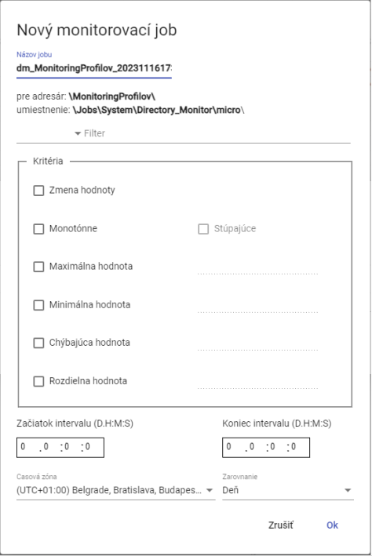

Picture 476: Window "New Monitoring Job"

1. The job title is pre-filled by standard. In the field "Job Title" you can enter a name for the job.
2. Click to the field on the left of the word 'Filter', a window will appear where you select the condition for filtering.

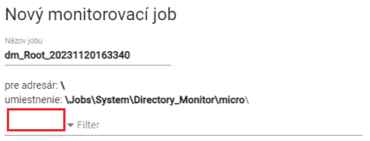

Image 477: Select filter

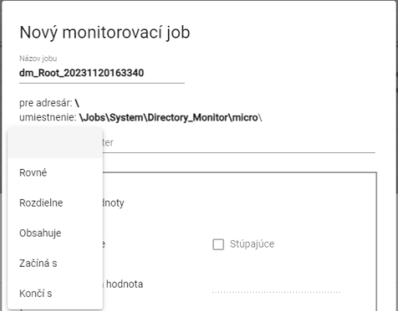

Picture 478: Window for selecting conditions into filter

1. **[TRANSLATION FAILED AFTER 3 RETRIES] Kliknite do poľa „Filter“ a zadajte hodnotu pre filter. Napríklad: Začína s písmenom A – bude prechádzať len profily, ktorých názov začína písmenom A.**



Image 479: Pole for assignment of value for filter

1. In the block "Criteria", specify criteria for monitoring.

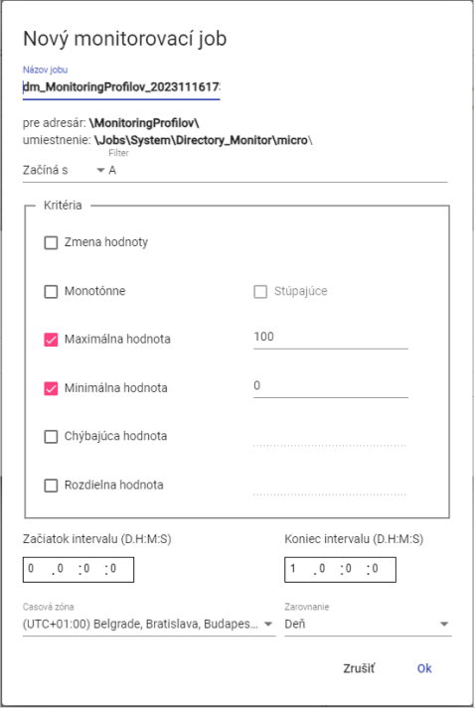

Image 480: Task for the right-hand side

1. Enter the start and end of the interval.
2. You can select time zone and adjustment.
3. Before creating a monitoring job, click on the 'OK' button.
4. In the window "Monitoring" will be displayed a new monitoring job.

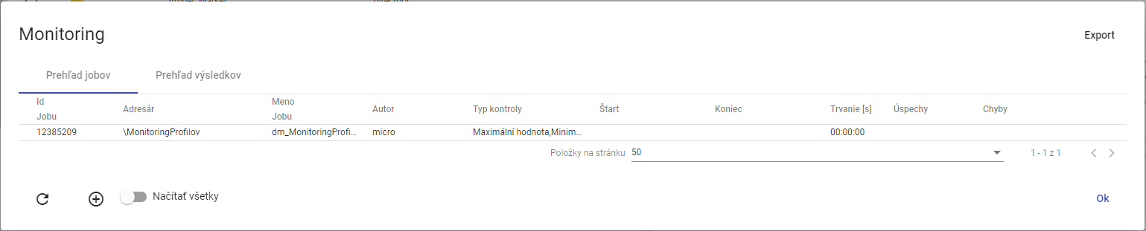

Image 481: Created monitoring job

### [OLLAMA FORMATTING ERROR - MANUAL REVIEW NEEDED] Ako editovať job v JMW

**[OLLAMA FORMATTING ERROR - MANUAL REVIEW NEEDED] Pre úpravu jobu postupujte:**

1. **[OLLAMA FORMATTING ERROR - MANUAL REVIEW NEEDED] Kliknite pravým tlačidlom myši na job a vyberte položku „Editovať v JMW“.**

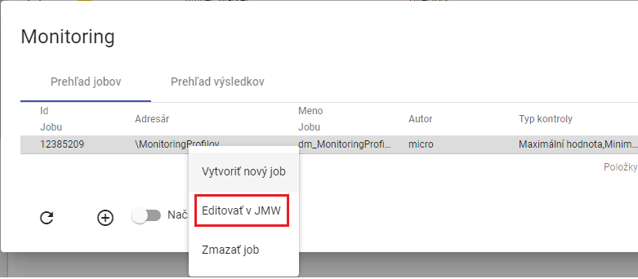

Image 482: Entry "Edit in JMW"

1. **[OLLAMA FORMATTING ERROR - MANUAL REVIEW NEEDED] V novej záložke v prehliadači sa otvorí job v aplikácii „Job Manager“.**

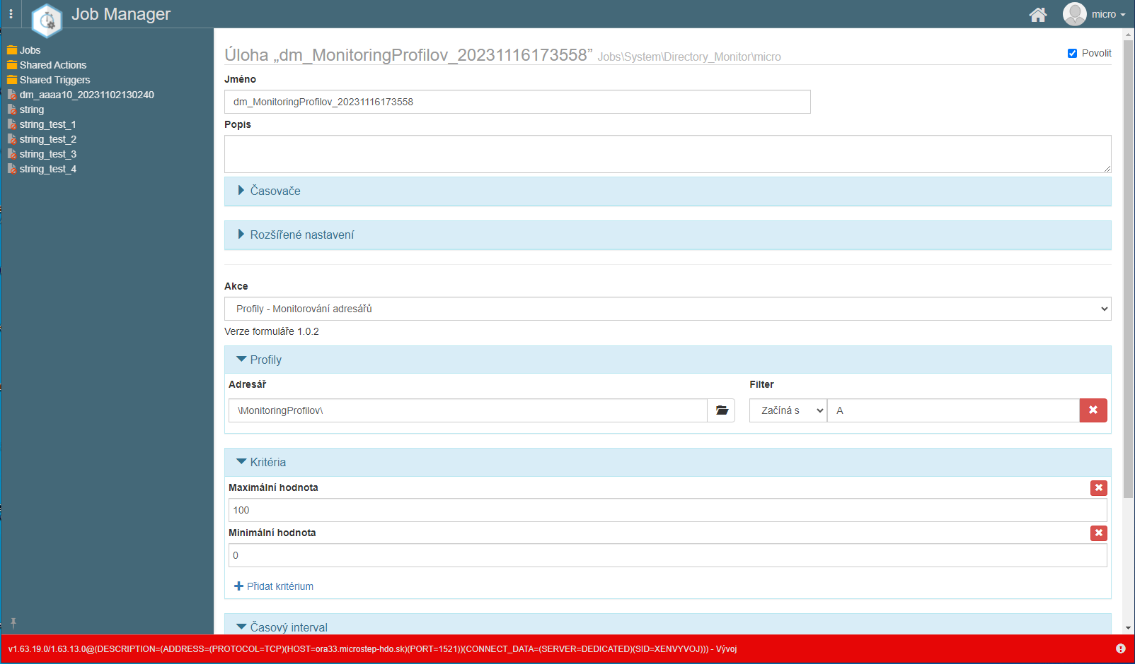

Image 483: Right adjustment in application "Job Manager"

1. **[OLLAMA FORMATTING ERROR - MANUAL REVIEW NEEDED] Postup pre úpravu jobu sa nachádza v dokumentácii k aplikácii „Job Manager“.**

### [OLLAMA FORMATTING ERROR - MANUAL REVIEW NEEDED] Ako zmazať job

**[OLLAMA FORMATTING ERROR - MANUAL REVIEW NEEDED] Pre zmazanie jobu postupujte:**

1. **[OLLAMA FORMATTING ERROR - MANUAL REVIEW NEEDED] Kliknite pravým tlačidlom myši v okne „Monitoring“ na job, ktorý chcete zmazať.**

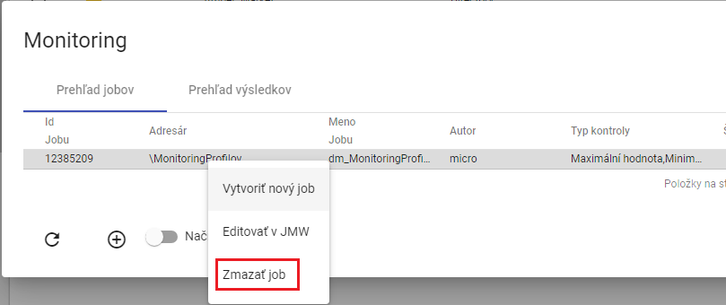

Picture 484: Item "Bullshit"

1. **[OLLAMA FORMATTING ERROR - MANUAL REVIEW NEEDED] Zobrazí sa okno pre potvrdenie vymazania, v ktorom stlačte tlačidlo „Áno“.**

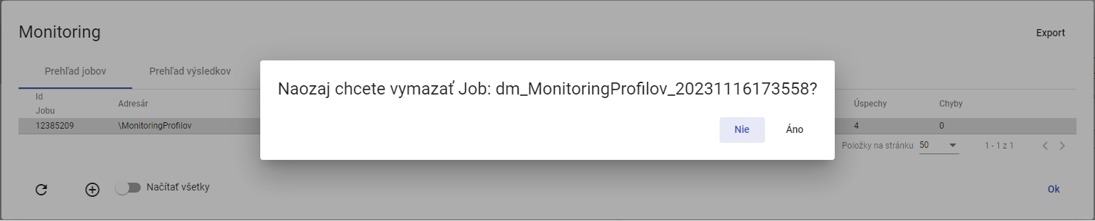

Image 485: Window for confirming deletion of a job

### [OLLAMA FORMATTING ERROR - MANUAL REVIEW NEEDED] Ako exportovať monitorovacie joby a výsledky jobov

**[OLLAMA FORMATTING ERROR - MANUAL REVIEW NEEDED] Pre exportovanie jobov v záložke „Prehľad jobov“ stlačte tlačidlo „Export“, ktoré sa nachádza v pravom hornom rohu okna „Monitoring“. Pre exportovanie výsledkov jobov zobrazte záložku „Prehľad výsledkov“ a stlačte tlačidlo „Export“. Stiahne sa CSV súbor.**

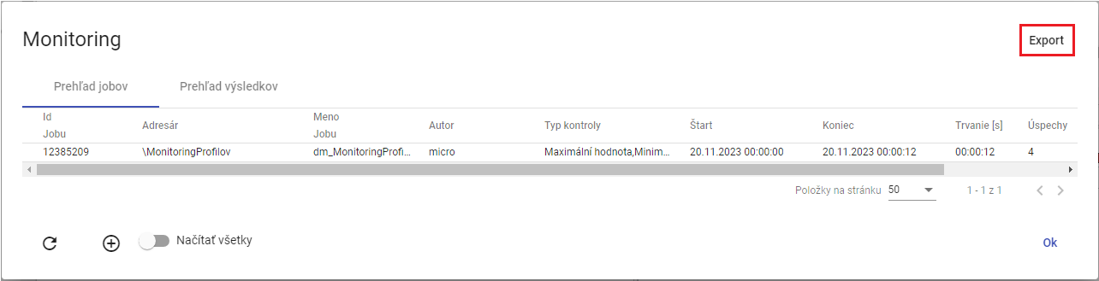

Image 486: Export button

### Show all monitoring jobs

Before displaying all monitoring jobs, click the 'Load all' button. In the 'Monitoring' window, all monitoring jobs from the tree structure will be displayed.

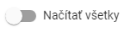

Image 487: Load All Button

### How to refresh the list of jobs in the 'Monitoring' window

Before preloading the job list click on the button located in the bottom left corner of the 'Monitoring' window.

### How to display a preview of monitoring job results

In the 'Monitoring' window, display the 'Results Overview' tab. There is a list of running monitoring jobs here. If the criteria by which the profile is being monitored have been violated, the text 'ERR' will be displayed in the 'Result' column and a description of the error will be found in the 'Detail' column. If the criteria have been met, the result is 'OK'.

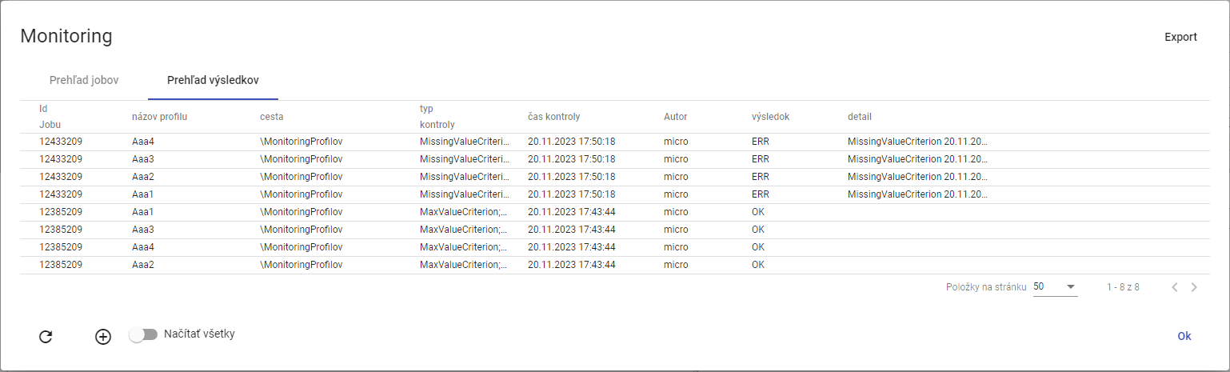

Image 488: Bookmark "Results Overview"

## Profile Analysis

Analysis of profiles presents a static image at a given time of calculation. This means that if someone erased the profile, then analysis of profiles remains preserved. The analysis of profiles allows users to filter and sort data as well. Chapter 8.2.1 is concerned with creating the analysis of profiles.

If you close the profile analysis, you can reopen it. The opening of an existing profile analysis is described in Chapter 8.2.2.

Analysis of profiles has a validity of 15 minutes after creation. You can extend the validity. The procedure is located in chapter 8.2.3.

Exporting shown data in the analysis of profiles is elaborated in Chapter 8.2.4.

### How to create profile analysis

Before creating a profile analysis, proceed with:

1. Click the right mouse button on the folder with profiles to which you want to create a profile analysis.
2. A window will appear where you click on the item 'Profile Analysis'.

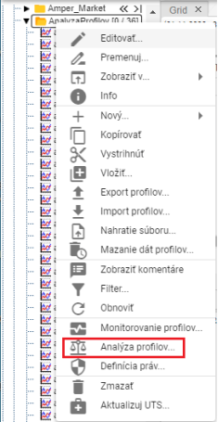

[TRANSLATION FAILED AFTER 3 RETRIES] Obrázok 489: Položka „Analýza profilov“

1. The other option is to display the directory with profiles in the 'Inspector' window and click on the 'Statistics' button, which can be found in the top right corner of the 'Inspector' window.



Image 490: Statistics button

1. An analysis window will appear.
2. The standard option is 'Create new for period'.

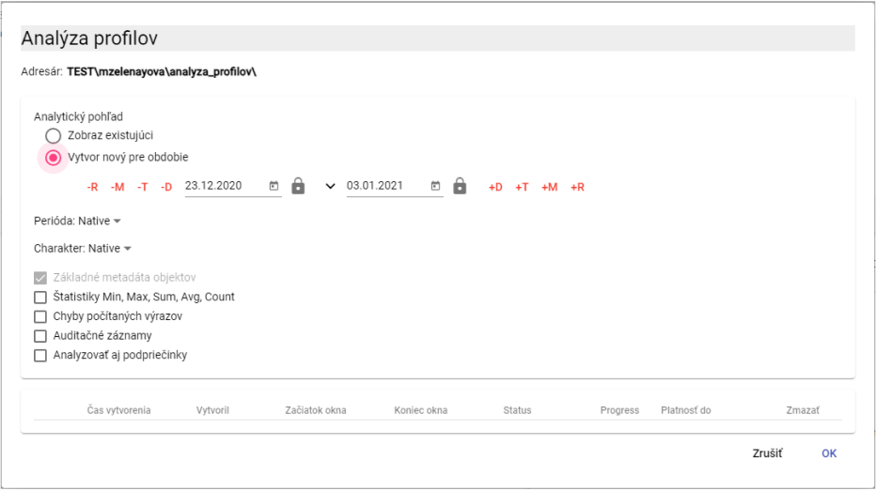

Picture 491: Window of "Profile Analysis"

1. Continue with the period for which profiles analysis will be performed. Click on the button to display preset date range options.

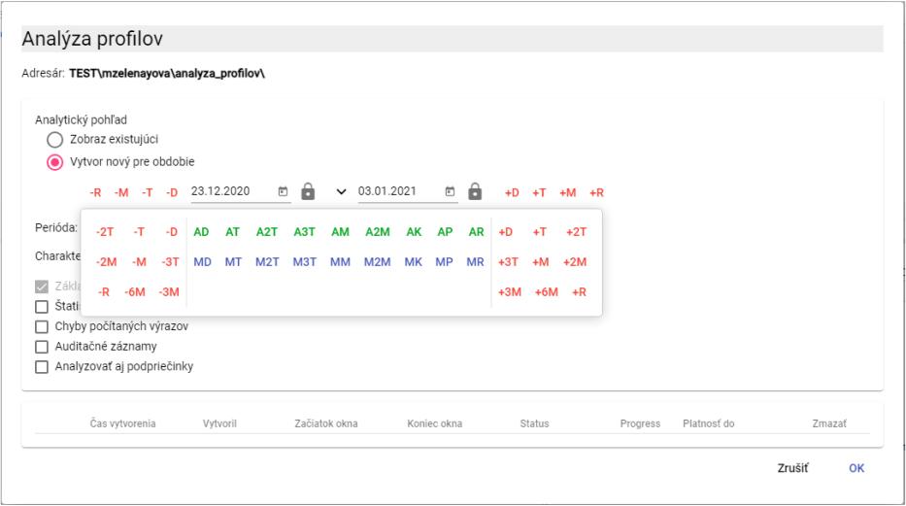

Picture 492: Date selection

1. The standard value for the field "Period" is "Native". If you want to enter another period, click on the "Period" field and select a period.

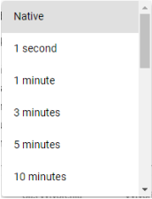

Picture 493: Selection of the Period

1. Character profile is used to identify how values in the profile are inherited to finer or coarser sampling. Standardly, in the "Character" field, the value is "Native". For selecting character, click into the "Character" field and select either "Quantitative" or "Qualitative".

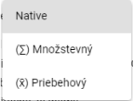

Image 494: Character selection

1. If you want to calculate statistics in the analysis, click on the field 'Statistics Min, Max, Sum, Avg, Count'.

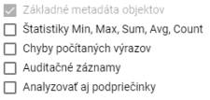

Picture 495: Optional items in analysis

1. If you want to have an error appear in case of a mistake, please check the box 'Errors counted expressions'.
2. Choose the "Audit Trail" policy if you want to print out the data: First read, Last read, First registration and Last registration.
3. All subdirectories should be included in the analysis, click on the button 'Analyze also subdirectories'.
4. Click 'OK' before creating the profile analysis.
5. In the window "Spy", a new tab with the title "The name of the addressee" will be created. Profile analysis presents a static image at any given time of calculation.

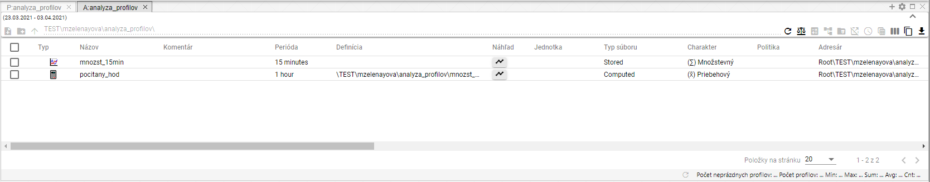

Image 496: Created profile analysis

1. In the analysis window profile you can filter data. Move your mouse cursor to the name of the column in which you want to apply a filter. A button will appear for entering a filter.



Picture 497: Filter submission button

1. Before ordering data in a column, click on the column name with your mouse pointer. An arrow icon will appear. Clicking on it will sort the data in the column.



Picture 498: Sorting button for arranging data in columns.

### To display an existing profile analysis

If you have already finished analyzing profiles and want to open it again, that is possible during the validity of profile analysis. Profile analysis has a validity of 15 minutes from creation. This validity can be extended.

Before opening an existing profile analysis, proceed:

1. In the 'Profile Analysis' window, click on 'Show Existing'
2. Click to mark the analysis you want to display.

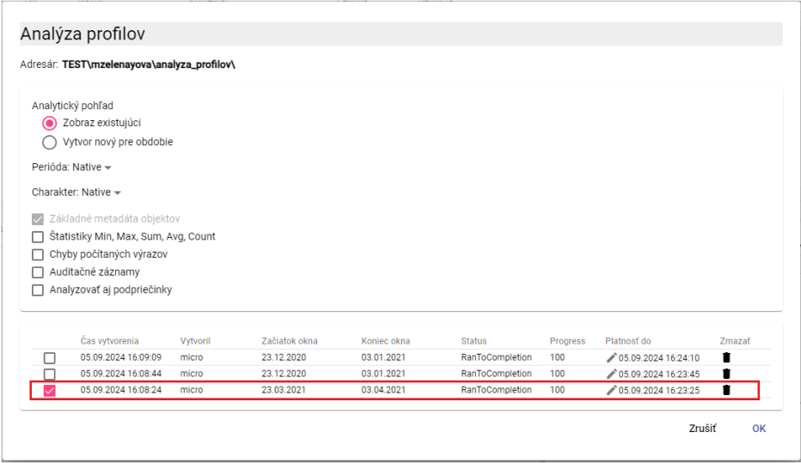

Image 499: Display of existing profile analysis

1. Click on the "OK" button.
2. In the window 'Explorer' will be displayed profile analysis.

### How to change the validity of the created profile analysis

The validity of the profile analysis is standardly 15 minutes, but you can extend it.

Before extending the validity of profile analysis, proceed with:

1. In the 'Analysis of profiles' window in the row of the analysis you want to extend its validity, click on the button with a pencil icon.

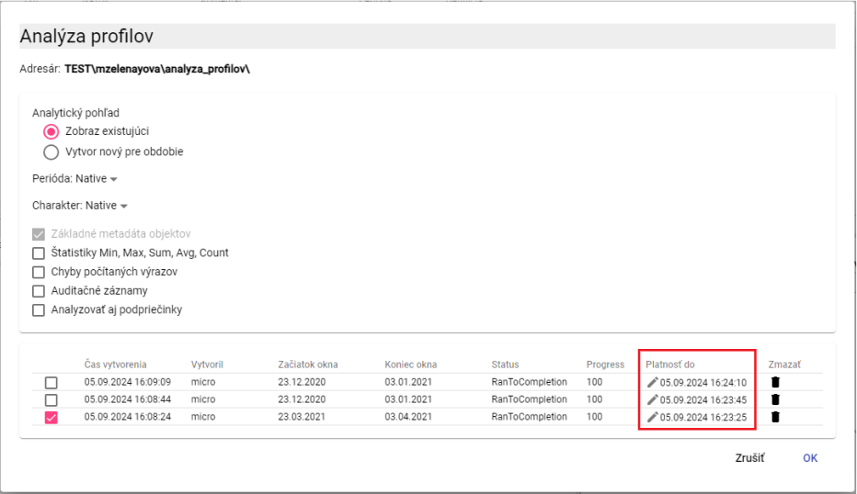

Image 500: Polish "Validity Until"

1. The 'Payment to' pole will become available for editing.

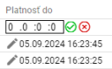

Image 501: Extension of Analysis Profiles validity

1. The first field represents days, the second field hours, the third minutes, and the fourth seconds. If you want to extend its validity by 2 days, enter the value '2' into the first field. If you wanted to extend its validity by 6 hours, fill in the value '6' into the second field.
2. Press the button .
3. The validity of profile analysis will be extended.

### Export shown data from analysis profiles

Before exporting data from profile analysis, proceed:

1. Press the button located in the top right corner of the "Explorer" window.

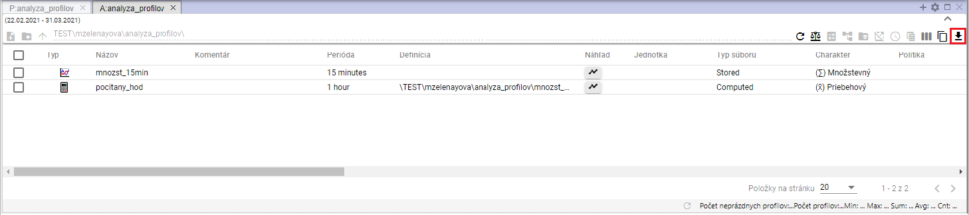

Picture 502: Export Button for Profile Analysis

1. A window titled 'Export' will appear.

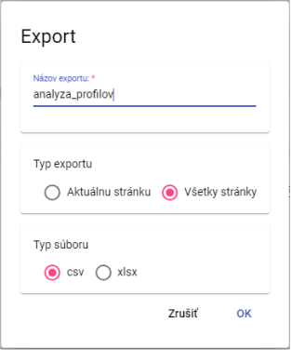

Image 503: Export Window

1. In the part 'Export type', the standard setting is 'All pages'. All data are exported. If you choose the item 'Current page', only shown data are exported.
2. Choose event type for export under "Event Type" section.
3. Press the "OK" button after confirming the export.

## Report Manager

### How to create a new report

Before creating the report, proceed:

* 1. In the tree structure click the right mouse button on the folder where you want to add a new report.
  2. An offer will be displayed where you click on the item "New" with your mouse cursor and then select the item "Report".

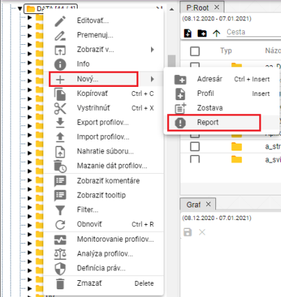

[TRANSLATION FAILED AFTER 3 RETRIES] Obrázok 504: Položka „Report“

* 1. The Bookmark "Report Manager" will appear, where you enter data for a new report.

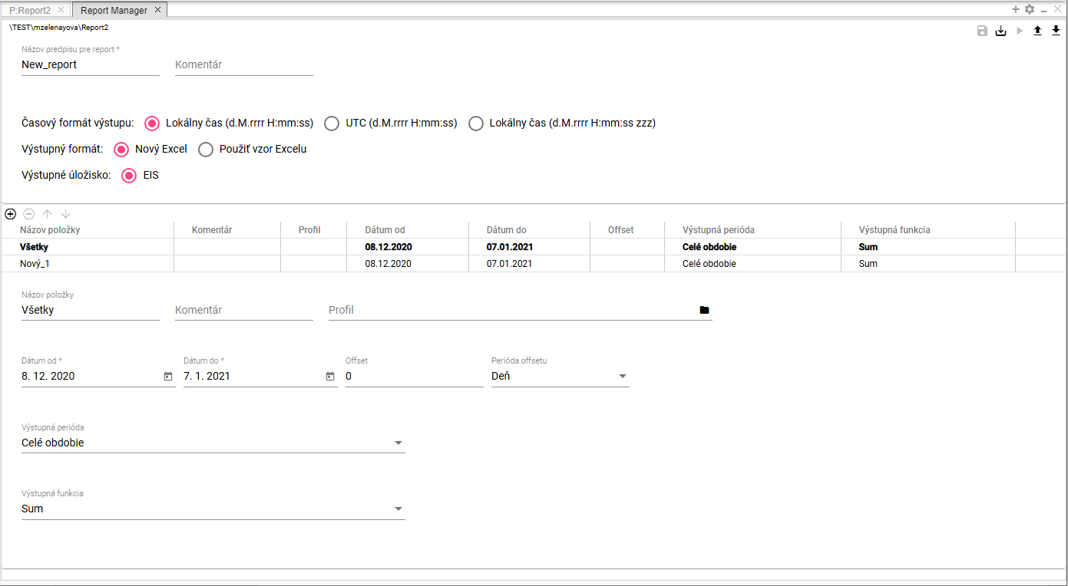

Image 505: Bookmark "Report Manager"

* 1. In the field "Name of regulation for reporting", enter the name "New report". You can change this name.

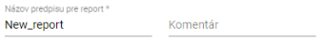

Image 506: Fields "Name of Prescription for Report" and "Comment"

* 1. You can write a comment in the "Commentary" section.
  2. Choose the output time format. The standard is to select "Local time (dd.mm.yyyy HH:mm:ss)".



Image 507: Field "Time Format Output"

* 1. In the field "Output format" select the output format for the report. By default, the choice is set to "New Excel".



Image 508: Tab "Output Format"

* 1. If you select the item 'Use Excel template', fields 'Excel name' and 'Excel sheet name' will be displayed.

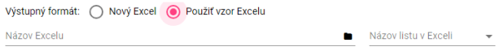

Picture 509: Fields for Excel task

* 1. In the 'Excel Name' field, click on the button, which will display a window called 'Select xlsx', in which you can search for Excel in the tree structure.

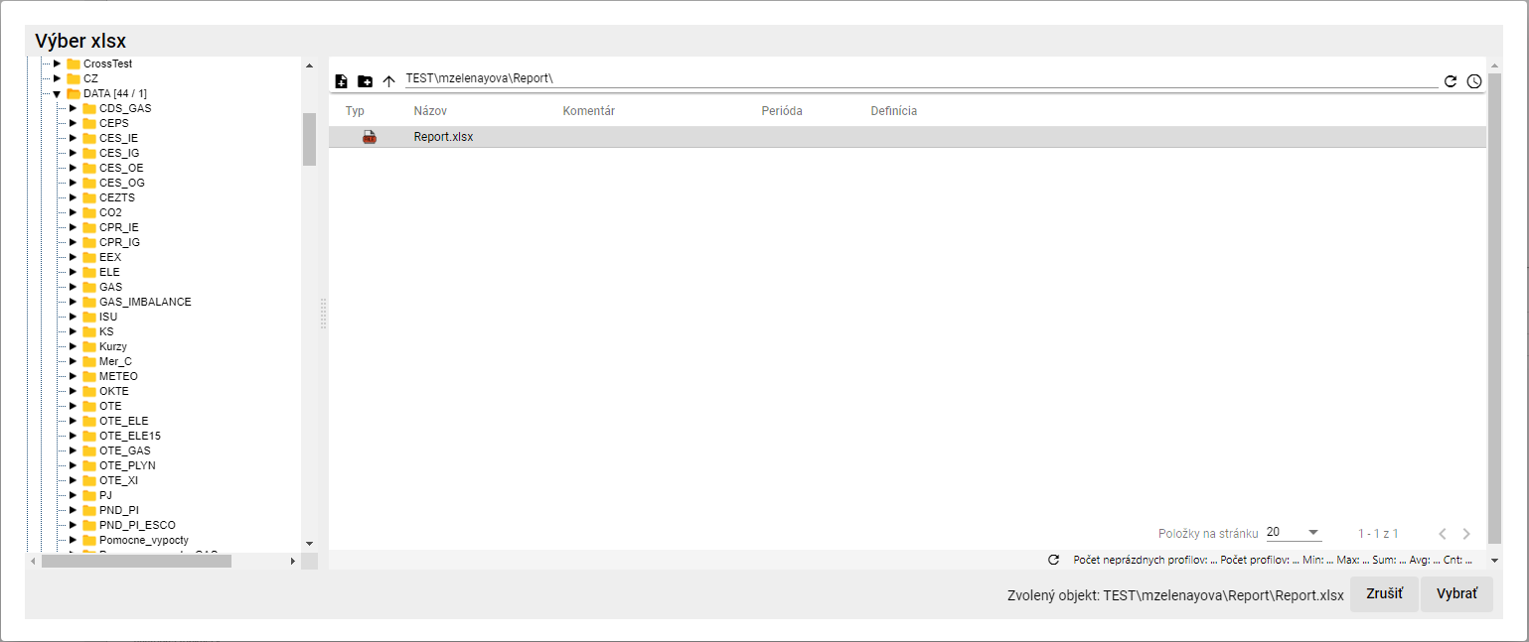

Image 510: Window "Choose XLSX"

* 1. In the window 'Choose xlsx' after searching for Excel, click the 'Select' button. The path to Excel will be filled in the field 'Excel name', Figure 511.
  2. Click on the field "Sheet name in Excel" and select the sheet name.



Image 511: Filled fields 'Name in Excel' and 'Sheet name in Excel'

* 1. Fill in the data for items.

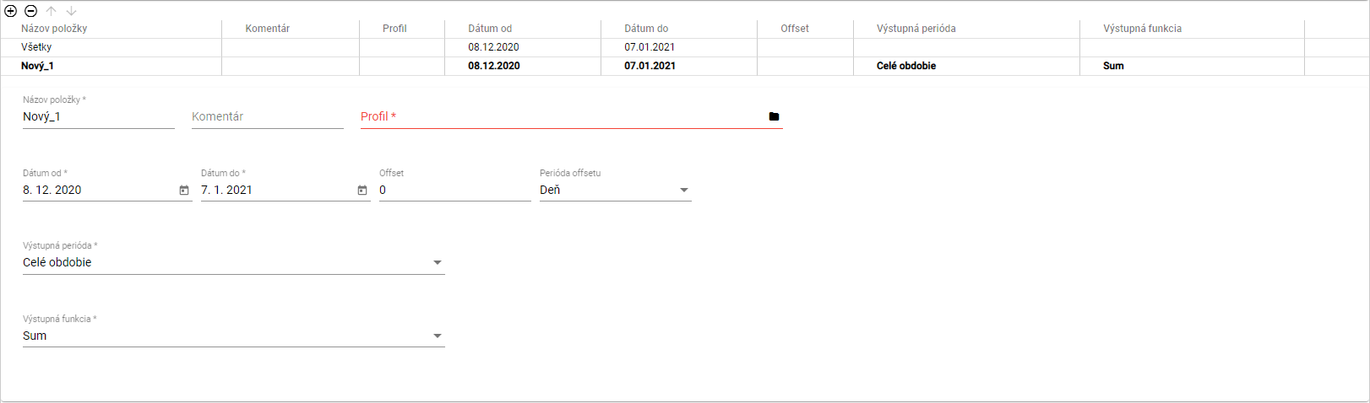

Image 512: Task data for items

* 1. If you want to enter the same information for all items at once, click on the item 'All'. The information you enter will be filled in for all profiles.
  2. If you want to fill in data for each profile separately, click on the item in the table that you want to enter data for.



Picture 513: Selected item from table

* 1. Fill in the data below the table. Automatically, the data is filled into the table.
  2. In the field "Item name" is automatically filled with "New_1". You can change the name.
  3. In the blog 'Commentary' you can write a comment.
  4. In the "Profile" panel, click on the button to select your profile or write the path to the profile.
  5. In the 'Profile Selection' window, search for the profile and click on the 'Select' button.

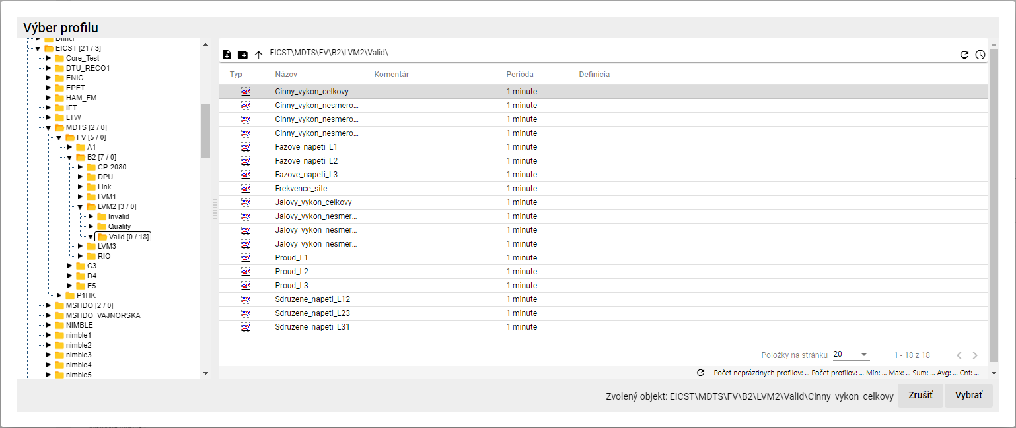

Picture 514: Profile selection window

* 1. Select dates "Date from" and "Date to".
  2. In the "Offset" field, you can specify an offset.
  3. Choose a period in the “Offset Period”.
  4. Click on the field “Output period” and from the shown list select a period.
  5. Click on the field "Output function" and select the function.

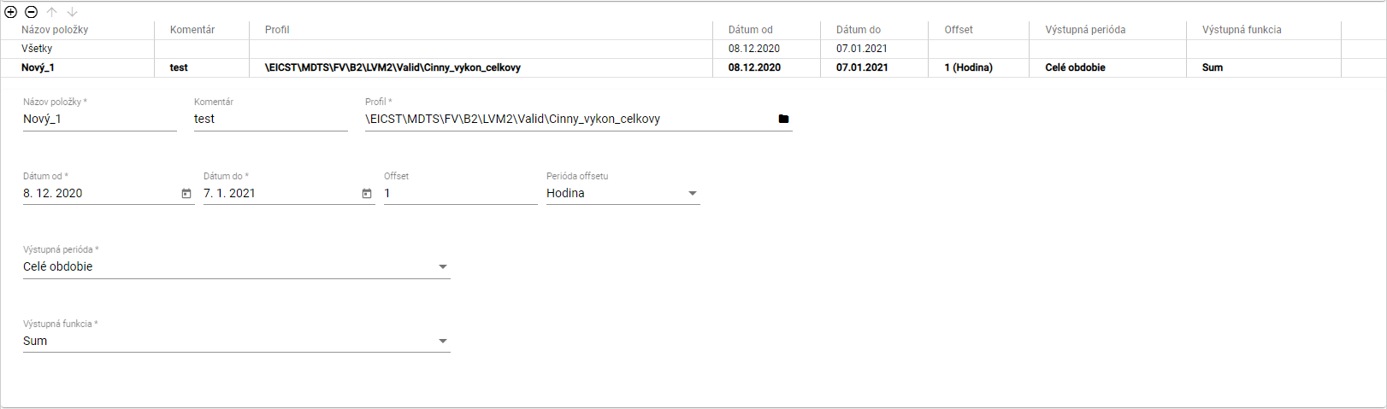

Picture 515: Filled-in data for item

* 1. You can also add the profile by dragging it from the tree structure to the table in the Report Manager bookmark. In the tree structure, click and drag the profile with your left mouse button and move it above the table. Release the profile to add it as a new item to the table.

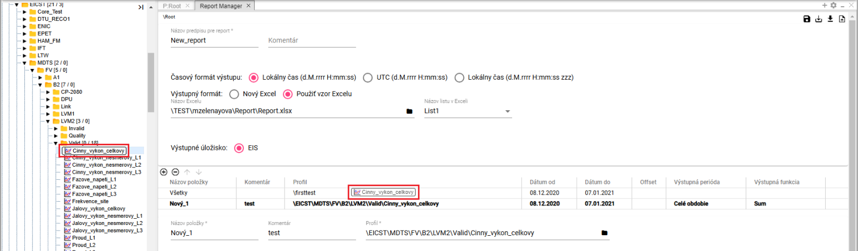

Image 516: Profile transfer from a tree structure to a table.



Picture 517: Added profile from tree structure

* 1. You can also add profiles to the 'Report Manager' bookmark from a browser extension. Click on the profiles you want to move to the 'Report Manager' table in the bookmarks window. Hold down the left mouse button on the profiles in the browser extension window and drag them above the table in the 'Report Manager' bookmark. Release the profiles. The profiles will be added to the 'Report Manager' table.

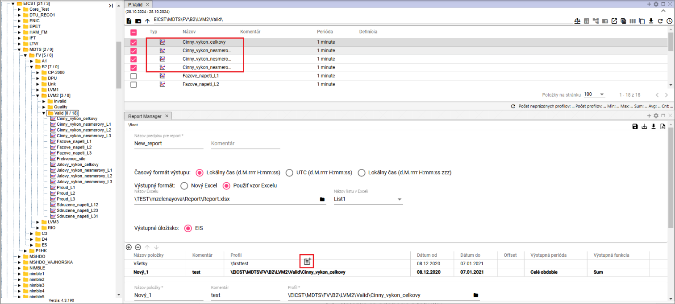

Image 518: Exporting profiles from a table to the Report Manager using the Drag and Drop function.

* 1. You can add another item by clicking on the button .
  2. If you want to remove an item, click on the item in the table and press the button . The item will be removed from the table.
  3. Column profiles in the table can be changed using buttons .
  4. You will save the report by clicking on the 'Save' button located in the top-right corner of the screen 'Report Manager'. The report will be saved to a folder in a tree structure where you created the report.



Image 519: Save button

* 1. If you want to save the report as a different recipient, click on the button "Save as".
  2. A window called 'New Report' will appear.
  3. In the menu "Path", set up a path to a new recipient or search for an address book using the button "."

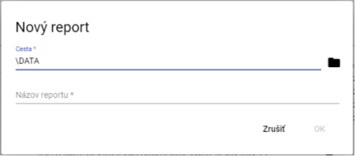

Image 520: Window "New Report"

* 1. In the field "Report title" write the title of the report.
  2. Save the report by pressing the 'OK' button.
  3. The report is generated by clicking on the button "Generate Report", which can be found in the top right corner of the screen "Report Manager".



Image 521: Generate Report button

* 1. A window titled 'Time range settings' will appear, where you select a time range.

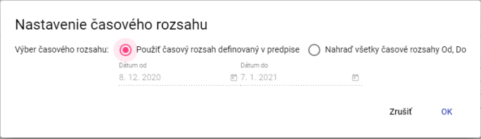

Image 522: Window "Time setting"

* 1. Press the "OK" button before generating the report.
  2. Click on the 'Export' button in the top toolbar after generating the report, which will display the 'Export' window.
  3. In the window "Export", click on the button "Download" located in the row of the generated report.

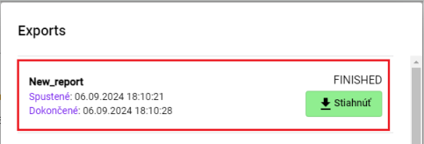

Image 523: Generated Report

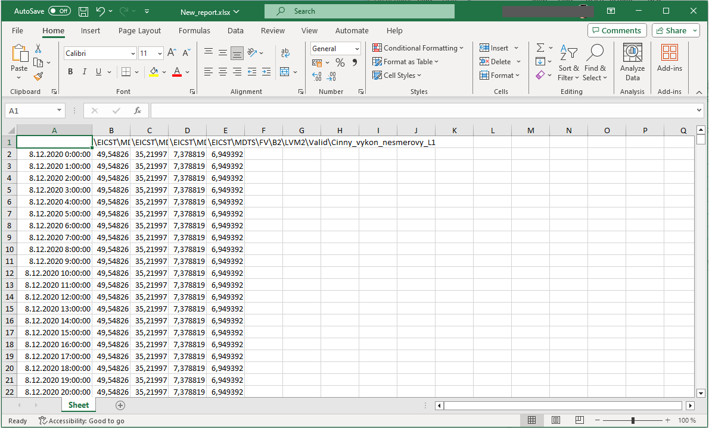

Image 524: Downloaded report

* 1. You can save the balance sheet in CSV or PGZ2 format. To download the balance sheet, press the 'Save balance sheet to disk...' button and select the format in which the report should be downloaded. The report will be saved among downloaded files on your computer.

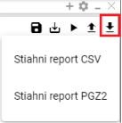

The image 525: Offers to print out the assembly list...

### Rights for Report Manager

Before the 'Report Manager' it is possible to set permissions:

* The reader does not have a right to „read“; he cannot open the form or pgz nor pgz2.
* The user does not have the right to "Create", is not allowed the button "Save as..." and will not appear in the menu "New..." option to create a "Report".
* The user does not have the right to "Write", is not allowed the button "Save" will be allowed only the button "Save as... " and save to disk.
* The user does not have permission to execute, the "Generate Report" button is disabled.

## If I restore deleted items from the basket

You will restore items from your basket:

1. Show the contents of the basket in a tree-like structure or in the Windows Explorer, 4.14.



Picture 526: Woodpecker in tree structure

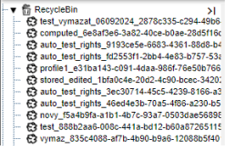

Image 527: Displaying content of a basket in a tree structure.

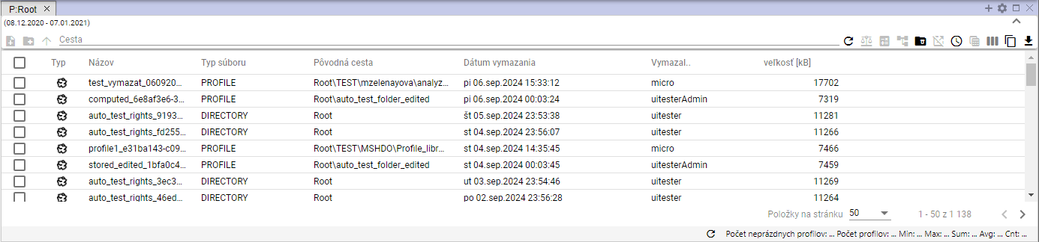

Image 528: Contents of a trash can displayed in the browser window

1. Click on the right mouse button on the item in your basket that you want to restore.
2. An offer will be displayed where you can choose 'Restore from cart'.

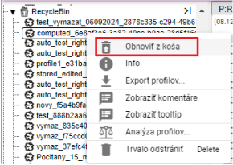

Picture 529: Item "Restore from trash"

1. A window called 'Recovery of Group' will appear.

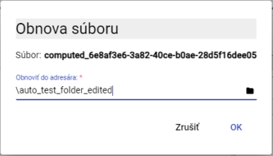

Image 530: Window "Revival of the Church"

1. In the folder "Restore to recipient" there is a path to the recipient from which the file was deleted. If you want the file to be restored in another recipient, enter the path to the recipient or search for the folder using the button .
2. After confirmation of the orchestra's revival, click on the 'OK' button.



2025 MicroStep – HDO Ltd. (in Czech Republic)

MicroStep and MicroStep-HDO are registered trademarks. This document is the intellectual property of company MicroStep-HDO s.r.o. and can be used only for purposes to which it was provided.

*MicroStep-HDO s.r.o., Vajnorská 158, 831 04  Bratislava*

*www.microstep-hdo.com, e-mail: info@microstep-hdo.sk*